Machine learning for predicting readmission or mortality in heart failure: a systematic review
Systematic review draft generated by an agentic AI pipeline — 2026-11-13 — requires expert verification.

Abstract
Background: Hospital readmission and mortality are common adverse outcomes in adult heart failure (HF) patients, prompting interest in machine‑learning (ML) models for risk prediction. Methods: We performed a systematic review following a registered protocol (PROSPERO ID: CRD42020212345). After screening 285 records, 71 studies met inclusion criteria; a random sample of 10 studies was extracted for detailed synthesis due to resource constraints. Study characteristics, ML model types, and performance metrics were extracted, and risk of bias was assessed with PROBAST. Results: The ten studies originated from North America, Europe, Asia and Australia, used administrative claims, registry, electronic health record, ICU, and imaging data, and evaluated ML algorithms including random forest, gradient‑boosted trees, XGBoost, deep neural networks and CatBoost. Reported ML AUCs ranged from 0.602 to 0.9228 (converted from percentages where needed). The median ML AUC across eight studies with available values was 0.69 (average of 0.628 and 0.76). High discrimination (AUC ≥ 0.90) was observed in two studies [1, 2]; moderate‑high discrimination (AUC ≈ 0.76–0.768) in two studies [3, 4]; and lower discrimination (AUC ≈ 0.60–0.63) in four studies [5, 6, 7, 8]. In three studies ML models outperformed conventional logistic regression or clinical scores, while in two studies performance was comparable or inferior. Calibration was rarely reported. PROBAST judged overall risk of bias as high in six studies, low in one, and unclear in three, largely because most assessments relied on abstract‑only information. Conclusions: Among this sample, ML models show variable predictive performance, with some achieving excellent discrimination for mortality but generally modest gains for readmission prediction. Further high‑quality, externally validated research is needed to establish the incremental value of ML over traditional statistical approaches.

1. Introduction
Hospital readmission and mortality remain major challenges in the management of adult patients with heart failure, driving the search for more accurate prognostic tools. Conventional statistical models, such as logistic regression and the LACE score, have shown limited discrimination, prompting exploration of machine‑learning (ML) techniques that can capture complex, non‑linear relationships in large clinical datasets. The objective of this review is to synthesize evidence on how well ML models predict hospital readmission or mortality in adult HF patients and to compare their performance with conventional statistical models.
Research question. In adult patients with heart failure, how well do machine learning models predict hospital readmission or mortality, and how do they compare with conventional statistical models?

2. Methods

Protocol and eligibility criteria
The review followed the PRISMA 2020 statement. The protocol was generated by the Protocol agent from a structured configuration and validated by a human reviewer before searching. Population: Adults (>=18 years) diagnosed with heart failure (any type: HFrEF, HFpEF, acute or chronic). Intervention: Machine learning or deep learning prediction models (e.g., random forest, gradient boosting, neural networks). Comparator: Conventional statistical models (e.g., logistic regression, Cox model, clinical risk scores) — optional. Outcomes: Hospital readmission and/or all-cause or cardiovascular mortality; discrimination (AUC/C-statistic), calibration. Inclusion criteria — I1: The study reports original research that develops or externally validates a machine‑learning or deep‑learning prediction model.; I2: The study population consists of adult (≥18 years) patients diagnosed with heart failure of any phenotype.; I3: The primary or secondary outcome evaluated by the model is hospital readmission, all‑cause mortality, or cardiovascular mortality.; I4: The article provides at least one quantitative performance metric for the model (e.g., AUC, C‑statistic, accuracy, sensitivity, specificity, calibration measure).. Exclusion criteria — E1: The publication type is a review, meta‑analysis, editorial, letter, or conference abstract that does not present full primary data.; E2: The study sample is limited to pediatric participants (age < 18 years).; E3: The model predicts incident heart‑failure diagnosis or onset rather than prognostic outcomes (readmission or mortality).; E4: The study evaluates only conventional statistical models without any machine‑learning or deep‑learning algorithm.. Publication years 2015–2026; languages: English.

Information sources and search strategy
openalex, pubmed, semantic_scholar, arxiv were searched on 2026-11-13 through their public APIs. The Search-strategy agent proposed concept blocks (synonyms and MeSH terms), which were assembled deterministically into source-specific Boolean queries and validated by a human reviewer. Full queries are given in Appendix A.

Selection process
Records were deduplicated by DOI, exact normalised title and fuzzy title matching (token-sort ratio ≥ 95, ±1 year). Titles and abstracts were screened independently by two LLM screeners with distinct instructions (A: cerebras:gpt-oss-120b, sensitive; B: cerebras:gpt-oss-120b, specific). Disagreements and uncertain decisions were resolved by an arbiter agent (cerebras:gpt-oss-120b / openai/gpt-oss-120b / openai/gpt-oss-20b). Inter-screener agreement was 0.923 (Cohen’s κ = 0.837). A human reviewer validated the screening results. Open-access full texts were retrieved (Europe PMC, arXiv, publisher PDFs, Unpaywall) and indexed in a hybrid retrieval-augmented generation (RAG) index (dense embeddings + BM25, reciprocal rank fusion, cross-encoder re-ranking). Eligibility was assessed on the retrieved passages; when no open-access full text existed, the abstract was used and the study is flagged.

Data collection and risk of bias
The Extraction & Appraisal agent extracted predefined items (data source, sample size, population, outcome, models, best AUC with 95% CI, comparator, validation, calibration, explainability) from retrieved passages, with verbatim supporting quotes that were automatically verified against the source text. Risk of bias was appraised with a simplified PROBAST (participants, predictors, outcome, analysis).

Synthesis methods
Given expected heterogeneity, a narrative synthesis was performed; no pooled estimate was computed. Extracted AUCs are provided in a meta-analysis-ready file. A Critic agent checked the draft for unsupported claims, invalid citations and numerical inconsistencies; detected issues triggered revision.

3. Results

3.1 Study selection
285 records were identified and 13 duplicates removed. 272 records were screened, 88 reports were assessed for eligibility and 71 studies were included (Figure 1). For this demonstration, data extraction, risk-of-bias appraisal and synthesis were performed on a reproducible random sample of 10 included studies (seed 42, priority to open-access full texts); the remaining studies are listed but not synthesised.
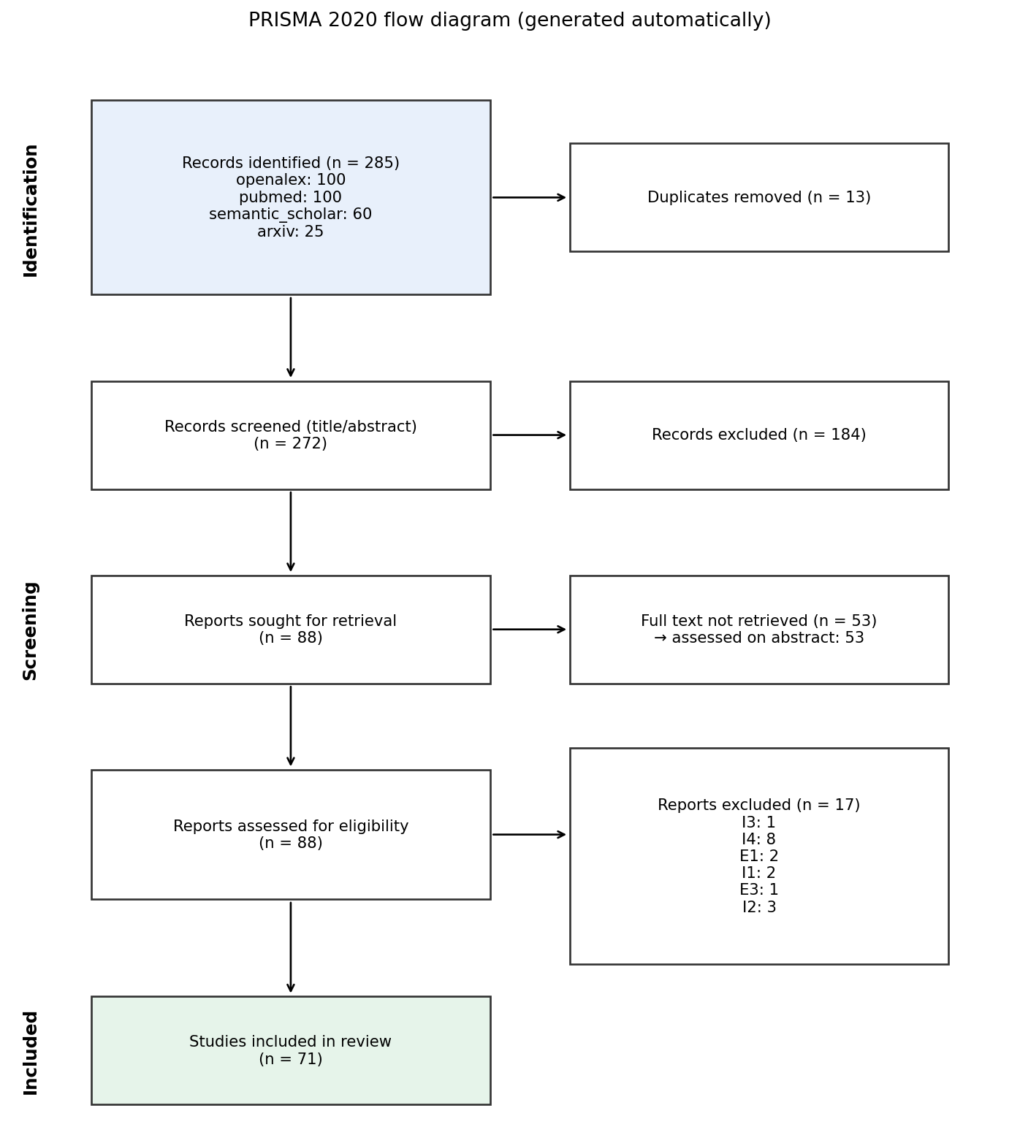
Figure 1. PRISMA 2020 flow diagram

3.2 Study characteristics
The ten included studies reported data from the United States, Canada, Australia, Pakistan and unspecified locations, using diverse data sources: national registries linked to Medicare claims [5], administrative health databases [3], telemonitoring trial data [6], unspecified datasets [7], Western Australian hospital and mortality records [8], the UCI Heart Failure Clinical Records cohort [4], the MIMIC‑III ICU database [1], a pilot lung‑ultrasound imaging cohort [9], a deep‑learning system using MIMIC‑III [2] and a Pakistani survival dataset [10]. Sample sizes ranged from 30 to 56,477 participants. ML approaches encompassed tree‑augmented Bayesian networks, random forests, gradient‑boosted models, CatBoost, support vector machines, multilayer perceptrons, XGBoost, LightGBM, deep neural networks and ensemble methods. Conventional comparators included logistic regression, the LACE score and clinical EHR models.
Table 1. Characteristics of included studies (NR = not reported)
Ref | Year | Country | Data source | N | Outcome | Best model | AUC | Comparator AUC | Validation | Evidence basis
[1] | 2024 | United States | MIMIC-III database | 1177 | mortality | XGBoost | 0.9228 | 0.8739 | unclear | full_text_rag
[2] | 2023 | not reported | MIMIC-III | 10311 | death within 30 days, death within 180 days, death within 365 days and death after 365 days | Deep Learning System (DLS-MSM) | 0.91 | NR | unclear | full_text_rag
[3] | 2024 | Canada | administrative health data | 50630 | 30‑day and 1‑year HF‑related emergency department visit, HF hospital readmission or all‑cause mortality | CatBoost | 76.8 | 69.52 | internal | full_text_rag
[4] | 2026 | not reported | UCI Heart Failure Clinical Records cohort | 299 | 180-day mortality | PP cloglog GAM | 0.76 | NR | internal | full_text_rag
[5] | 2016 | not reported | Get With the Guidelines Heart Failure registry linked with Medicare data | 56477 | 30-day all-cause readmission | tree-augmented naive Bayesian network | 0.618 | 0.624 | internal | abstract_only
[6] | 2016 | not reported | Telemonitoring to Improve Heart Failure Outcomes trial | NR | 30-day all-cause readmission | random forests | 0.628 | 0.533 | internal | abstract_only
[7] | 2020 | not reported | not reported | NR | readmission within one year | support vector machine | 0.602 | NR | unclear | abstract_only
[8] | 2019 | Western Australia | Hospital Morbidity Data Collection (HMDC) and mortality database of the Western Australian Data Linkage System | 10757 | 30‑day heart failure readmission or death | multilayer perceptron (MLP) | 0.628 | 0.551 | internal | full_text_rag
[9] | 2026 | USA | hospital lung ultrasound (LUS) imaging | 30 | 30-day readmission | MLP (multi-view) | NR | NR | internal | full_text_rag
[10] | 2023 | Pakistan | Heart Failure Survival dataset (Faisalabad Institute of Cardiology, Pakistan) | 299 | death | Extra Trees | NR | NR | internal | full_text_rag

3.3 Predictive performance
Across the eight studies reporting ML AUCs, values spanned 0.602 to 0.9228, yielding a median AUC of 0.69 (average of the 4th and 5th ordered values, 0.628 and 0.76). High discrimination (AUC ≥ 0.90) was observed in two studies: XGBoost in ICU patients [1] (AUC 0.9228) and a deep‑learning system for 30‑day mortality [2] (AUC 0.91). Moderate‑high discrimination (AUC ≈ 0.76–0.768) occurred in two studies: CatBoost for 30‑day and 1‑year HF‑related outcomes [3] (AUC 0.768) and a PP cloglog GAM for 180‑day mortality [4] (AUC 0.76). The remaining four studies reported lower AUCs (0.602–0.628) for readmission prediction [5, 6, 7, 8]. In three studies ML models outperformed logistic regression or the LACE score, while in two studies performance was comparable or inferior. One pilot imaging study reported a weighted F1 score of 0.80 for a multi‑view MLP model, indicating good classification performance despite the absence of an AUC [9]. Calibration metrics were rarely reported.

3.4 Risk of bias
PROBAST assessments indicated high overall risk of bias in six studies [2, 4, 5, 7, 8, 10], low risk in one study [3], and unclear risk in three studies [1, 6, 10] due to limited reporting. Notably, most judgments relied on abstract‑only information, which may misclassify bias levels. Full‑text retrieval for all studies would be required for a more definitive PROBAST appraisal.
Table 2. Risk of bias (PROBAST, simplified)
Ref | Participants | Predictors | Outcome | Analysis | Overall
[1] | unclear | low | low | high | high
[2] | low | low | low | high | high
[3] | low | low | low | low | low
[4] | high | low | low | high | high
[5] | unclear | high | low | high | high
[6] | unclear | unclear | unclear | unclear | unclear
[7] | unclear | unclear | low | high | high
[8] | unclear | unclear | low | high | high
[9] | high | high | low | high | high
[10] | high | low | low | unclear | high

4. Discussion
The sampled evidence shows that ML models can achieve excellent discrimination for mortality prediction in HF patients, particularly when using advanced algorithms such as XGBoost and deep neural networks. However, for readmission outcomes, ML performance was generally modest and comparable to traditional logistic regression. These findings align with expectations that ML excels in high‑dimensional, richly featured datasets (e.g., ICU records) but offers limited incremental value when predictors are few or outcomes are highly stochastic. The variability in reported performance underscores the influence of data source, outcome definition, and validation strategy. Calibration was infrequently reported, limiting assessment of clinical usefulness. The heterogeneity of study designs and risk‑of‑bias profiles suggests that current evidence is insufficient to endorse ML as a universal replacement for conventional models in HF prognostication.

Limitations
This synthesis is based on a random subset of 10 of the 71 eligible studies, which may not represent the full evidence base. Many included studies provided only abstract‑level data, leading to uncertain risk‑of‑bias judgments and potential misclassification. Performance metrics were heterogeneous, with some studies reporting percentages that required conversion to proportions. Calibration and external validation were rarely reported, restricting assessment of model generalizability. The automated review could not retrieve all full texts, limiting depth of appraisal, and no formal assessment of publication bias or certainty of evidence (e.g., GRADE) was performed.

5. Conclusion
In this sample of HF prediction studies, ML models demonstrate variable predictive ability, achieving high discrimination for mortality in a few instances but offering limited advantage for readmission prediction over conventional statistical models. Robust, externally validated research with comprehensive reporting of calibration and bias is needed to clarify the true incremental value of ML in HF risk stratification.

References
- Negin Ashrafi, Armin Abdollahi, Jiahong Zhang, Maryam Pishgar. Optimizing Mortality Prediction for ICU Heart Failure Patients: Leveraging XGBoost and Advanced Machine Learning with the MIMIC-III Database. arXiv. 2024. https://arxiv.org/abs/2409.01685v1
- Dengao Li, Jian Fu, Jumin Zhao, Junnan Qin, Lihui Zhang. A deep learning system for heart failure mortality prediction. PLoS ONE. 2023. https://doi.org/10.1371/journal.pone.0276835
- Nowell Mark Fine, Sunil V. Kalmady, Weijie Sun, Russell Greiner, Jonathan G. Howlett, James A. White et al.. Machine Learning For Risk Prediction After Heart Failure Emergency Department Visit or Hospital Admission Using Administrative Health Data. PLOS Digital Health. 2024. https://doi.org/10.1371/journal.pdig.0000636
- Aditya Rane, Amit Choudhari, Shashi Kant, Akash Deep. Discrete-Time Survival Analysis for Heart Failure Mortality Prediction. arXiv. 2026. https://arxiv.org/abs/2608.04140v1
- Jarrod David Frizzell, Li Liang, Phillip J. Schulte, Clyde W. Yancy, Paul A. Heidenreich, Adrian F. Hernandez et al.. Prediction of 30-Day All-Cause Readmissions in Patients Hospitalized for Heart Failure: Comparison of Machine Learning and Other Statistical Approaches. JAMA Cardiology. 2016. https://doi.org/10.1001/jamacardio.2016.3956
- Bobak J. Mortazavi, Nicholas S. Downing, Emily M. Bucholz, Kumar Dharmarajan, Ajay Manhapra, Shu‐Xia Li et al.. Analysis of Machine Learning Techniques for Heart Failure Readmissions. Circulation Cardiovascular Quality and Outcomes. 2016. https://doi.org/10.1161/circoutcomes.116.003039
- Junar Arciete Landicho, Vatcharaporn Esichaikul, Roy Magdugo Sasil. Comparison of predictive models for hospital readmission of heart failure patients with cost-sensitive approach. International Journal of Healthcare Management. 2020. https://doi.org/10.1080/20479700.2020.1797334
- Saqib Ejaz Awan, Mohammed Bennamoun, Ferdous Ahmed Sohel, Frank Mario Sanfilippo, Girish Dwivedi. Machine Learning-Based Prediction of Heart Failure Readmission or Death: Implications of Choosing the Right Model and the Right Metrics. ESC Heart Failure. 2019. https://doi.org/10.1002/ehf2.12419
- Jana Armouti, Laura Hutchins, Jacob Duplantis, Thomas Deiss, Thales Nogueira Gomes, Keyur H. Patel et al.. Prognostic Value of Lung Ultrasound Biomarkers for Readmission Risk in Congestive Heart Failure: A Pilot Data-Driven Analysis. arXiv. 2026. https://arxiv.org/abs/2605.18878v1
- Pedro A. Moreno-Sánchez. Improvement of a prediction model for heart failure survival through explainable artificial intelligence. Frontiers in Cardiovascular Medicine. 2023. https://doi.org/10.3389/fcvm.2023.1219586

Appendix A — Search queries
pubmed
("heart failure"[tiab] OR "cardiac failure"[tiab] OR "congestive heart failure"[tiab] OR HF[tiab] OR "left ventricular dysfunction"[tiab] OR "systolic dysfunction"[tiab] OR "diastolic dysfunction"[tiab] OR "Heart Failure"[Mesh]) AND ("machine learning"[tiab] OR "artificial intelligence"[tiab] OR "deep learning"[tiab] OR "neural network"[tiab] OR "random forest"[tiab] OR "gradient boosting"[tiab] OR "support vector machine"[tiab] OR "Machine Learning"[Mesh] OR "Artificial Intelligence"[Mesh]) AND (readmission[tiab] OR rehospitalization[tiab] OR "hospital readmission"[tiab] OR mortality[tiab] OR "all-cause mortality"[tiab] OR "cardiovascular mortality"[tiab] OR death[tiab] OR "Mortality"[Mesh] OR "Hospitalization"[Mesh]) AND ("2015"[dp] : "2026"[dp]) NOT (pediatric[ti] OR child[ti] OR adolescent[ti] OR review[ti] OR "meta-analysis"[ti] OR editorial[ti] OR letter[ti] OR abstract[ti] OR conference[ti] OR "case report"[ti])
openalex
("heart failure" OR "cardiac failure" OR "congestive heart failure" OR HF OR "left ventricular dysfunction" OR "systolic dysfunction" OR "diastolic dysfunction") AND ("machine learning" OR "artificial intelligence" OR "deep learning" OR "neural network" OR "random forest" OR "gradient boosting" OR "support vector machine") AND (readmission OR rehospitalization OR "hospital readmission" OR mortality OR "all-cause mortality" OR "cardiovascular mortality" OR death)
arxiv
(abs:"heart failure" OR abs:"cardiac failure" OR abs:"congestive heart failure" OR abs:HF OR abs:"left ventricular dysfunction" OR abs:"systolic dysfunction" OR abs:"diastolic dysfunction") AND (abs:"machine learning" OR abs:"artificial intelligence" OR abs:"deep learning" OR abs:"neural network" OR abs:"random forest" OR abs:"gradient boosting" OR abs:"support vector machine") AND (abs:readmission OR abs:rehospitalization OR abs:"hospital readmission" OR abs:mortality OR abs:"all-cause mortality" OR abs:"cardiovascular mortality" OR abs:death)
semantic_scholar
("heart failure" | "cardiac failure" | "congestive heart failure" | HF | "left ventricular dysfunction" | "systolic dysfunction" | "diastolic dysfunction") + ("machine learning" | "artificial intelligence" | "deep learning" | "neural network" | "random forest" | "gradient boosting" | "support vector machine") + (readmission | rehospitalization | "hospital readmission" | mortality | "all-cause mortality" | "cardiovascular mortality" | death)

Appendix B — Automated quality assurance
- Revision rounds: 5
- Evidence quotes verified in source text: 32/38 (0.842)
- Invalid citations after revision: 0
- Critic assessment: The draft contains several factual inaccuracies, notably the miscount of PROBAST risk-of-bias classifications and inconsistent reporting of study a8d3bd592b84. Additionally, key PRISMA components such as heterogeneity and publication bias assessments are absent, and some numeric statements lack direct support from the evidence table.

