CANopen over EtherCAT (CoE)
A deep dive — the mailbox, the messages, and CoE in TwinCAT

1. What CoE is, and where it sits
CoE — CANopen over EtherCAT — is the application-layer protocol that lets EtherCAT devices use the CANopen object model and device profiles while running over EtherCAT instead of the CAN bus. It is the most widely used of EtherCAT’s “mailbox” protocols, and for the great majority of EtherCAT I/O terminals and servo drives it is how you read parameters, configure the device, and map its real-time data.
CoE keeps three ideas straight from CANopen: the Object Dictionary (every parameter addressed by a 16-bit index and 8-bit sub-index), Service Data Objects (SDOs) for acyclic reads and writes of any dictionary entry, and Process Data Objects (PDOs) for the compact cyclic real-time image. What CoE changes is only the transport underneath.
The crucial thing to hold in your head is that CoE actually lives in two different places on the wire, and confusing them is the most common source of misunderstanding.

2. The two channels: process data vs. the mailbox
Every EtherCAT cycle carries two kinds of traffic, and CoE touches both:
- Cyclic process data — the fast, deterministic payload exchanged every cycle. In CoE terms this is the PDO image. It travels in the process-data Sync Managers (typically SM2 for outputs and SM3 for inputs) and is updated on every single frame.
- The acyclic mailbox — a slower, reliable, handshaked channel for everything that does not need to happen every cycle: parameter reads/writes, configuration, diagnostics, firmware. CoE’s SDO, SDO-Information and Emergency services all ride here, alongside the sibling mailbox protocols EoE, FoE, SoE and AoE.
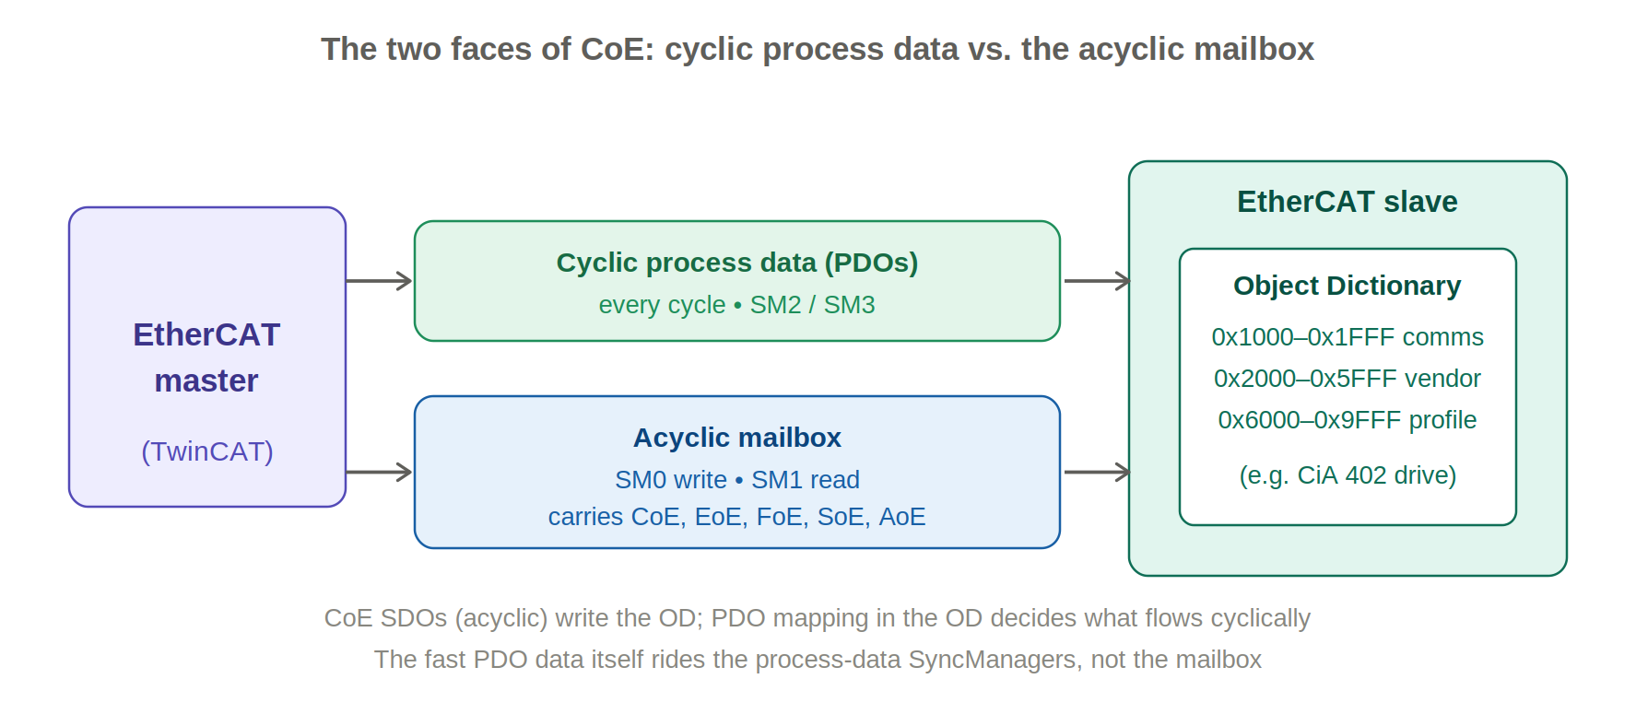
CoE configures the dictionary acyclically through the mailbox; the PDO data it maps then flows cyclically through the process-data Sync Managers.
A practical consequence worth stating plainly: the cyclic PDO data does not travel as CoE mailbox messages at runtime. CoE’s SDOs are used at start-up to tell the slave which objects to map into the PDO image; once running, that image is exchanged directly in the process-data Sync Managers. The CoE header does define TxPDO/RxPDO message types, but in normal cyclic operation they are not how the data moves.

3. How the mailbox system works
The mailbox is a small, reliable message channel implemented with two dedicated Sync Managers, one for each direction:
- SM0 — the write mailbox (master → slave). The master deposits a request here.
- SM1 — the read mailbox (slave → master). The slave places its response or an unsolicited message (such as an Emergency) here.
Each mailbox is a single buffer protected by the Sync Manager so that a half-written message can never be read. Because EtherCAT slaves cannot initiate traffic on their own, the master must poll the read mailbox to collect responses and slave-initiated messages. TwinCAT offers two polling strategies: read the mailbox on a fixed cycle, or — more efficiently — watch a mailbox-full status bit and only read when the slave signals data is waiting, which lets one LRD command check many slaves at once.
Every mailbox message begins with a 6-byte mailbox header followed by the protocol-specific payload. The header carries the data length, the originating address, a type field identifying which mailbox protocol the payload belongs to (CoE is type 3), and a small counter used to detect and discard repeated messages on a retry. A CoE payload then adds its own 2-byte CoE header, whose service field says what kind of CoE message this is.
One timing rule matters constantly in practice: the mailbox — and therefore the CoE dictionary — only becomes available from the PRE-OPERATIONAL state onwards. In INIT there is no mailbox and no SDO access. This is why a slave’s parameters can only be browsed once it is at least in PRE-OP.

4. The CoE message types — and when each is used
The service field in the CoE header selects one of the following message types. In day-to-day use you will overwhelmingly meet the SDO request/response pair, the SDO-Information service when a tool browses the dictionary, and the Emergency message when something goes wrong.
# | CoE service | Direction | Used for / when
1 | Emergency (EMCY) | slave → master | Asynchronous fault/error notification, pushed the moment an error occurs.
2 | SDO Request | master → slave | Acyclic read (upload) or write (download) of a dictionary entry: parameterization, configuration, diagnostics.
3 | SDO Response | slave → master | The slave’s reply to an SDO request (data, confirmation, or an abort).
4 | TxPDO | slave → master | Process-data input as a CoE message (rare; normally carried in process data).
5 | RxPDO | master → slave | Process-data output as a CoE message (rare; normally carried in process data).
6 | TxPDO remote req. | master → slave | Ask a slave to send a TxPDO on request (seldom used on EtherCAT).
7 | RxPDO remote req. | slave → master | Request an RxPDO (seldom used on EtherCAT).
8 | SDO Information | master ↔ slave | Read the dictionary structure: the object list, and object/entry descriptions — i.e. browsing the OD without an ESI/EDS file.

5. SDOs in depth: upload, download, and transfer modes
An SDO access is a confirmed request/response exchange. The first byte of the CoE SDO payload is the command specifier, which encodes whether this is a download (write) or an upload (read), whether the size is given, and which transfer mode is in use. The master is the client; the slave is the server.
There are three transfer modes, chosen automatically by the size of the data:
- Expedited — for payloads of up to 4 bytes, the data is carried directly inside the initiate frame, so a write or read completes in a single request/response round trip. This covers the great majority of parameters (a mode selection, a filter setting, a 32-bit limit).
- Normal / segmented — for larger payloads, or anything bigger than the mailbox, the transfer is split into segments. An initiate message declares the total size, then segments are exchanged one at a time. A toggle bit flips on each successive segment so a lost or duplicated segment is detected, and the final segment is flagged as the last.
- Complete access — an EtherCAT addition that transfers an entire object (all sub-indices at once) in a single SDO, rather than sub-index by sub-index. It is commonly used for reading or writing whole PDO-mapping records.
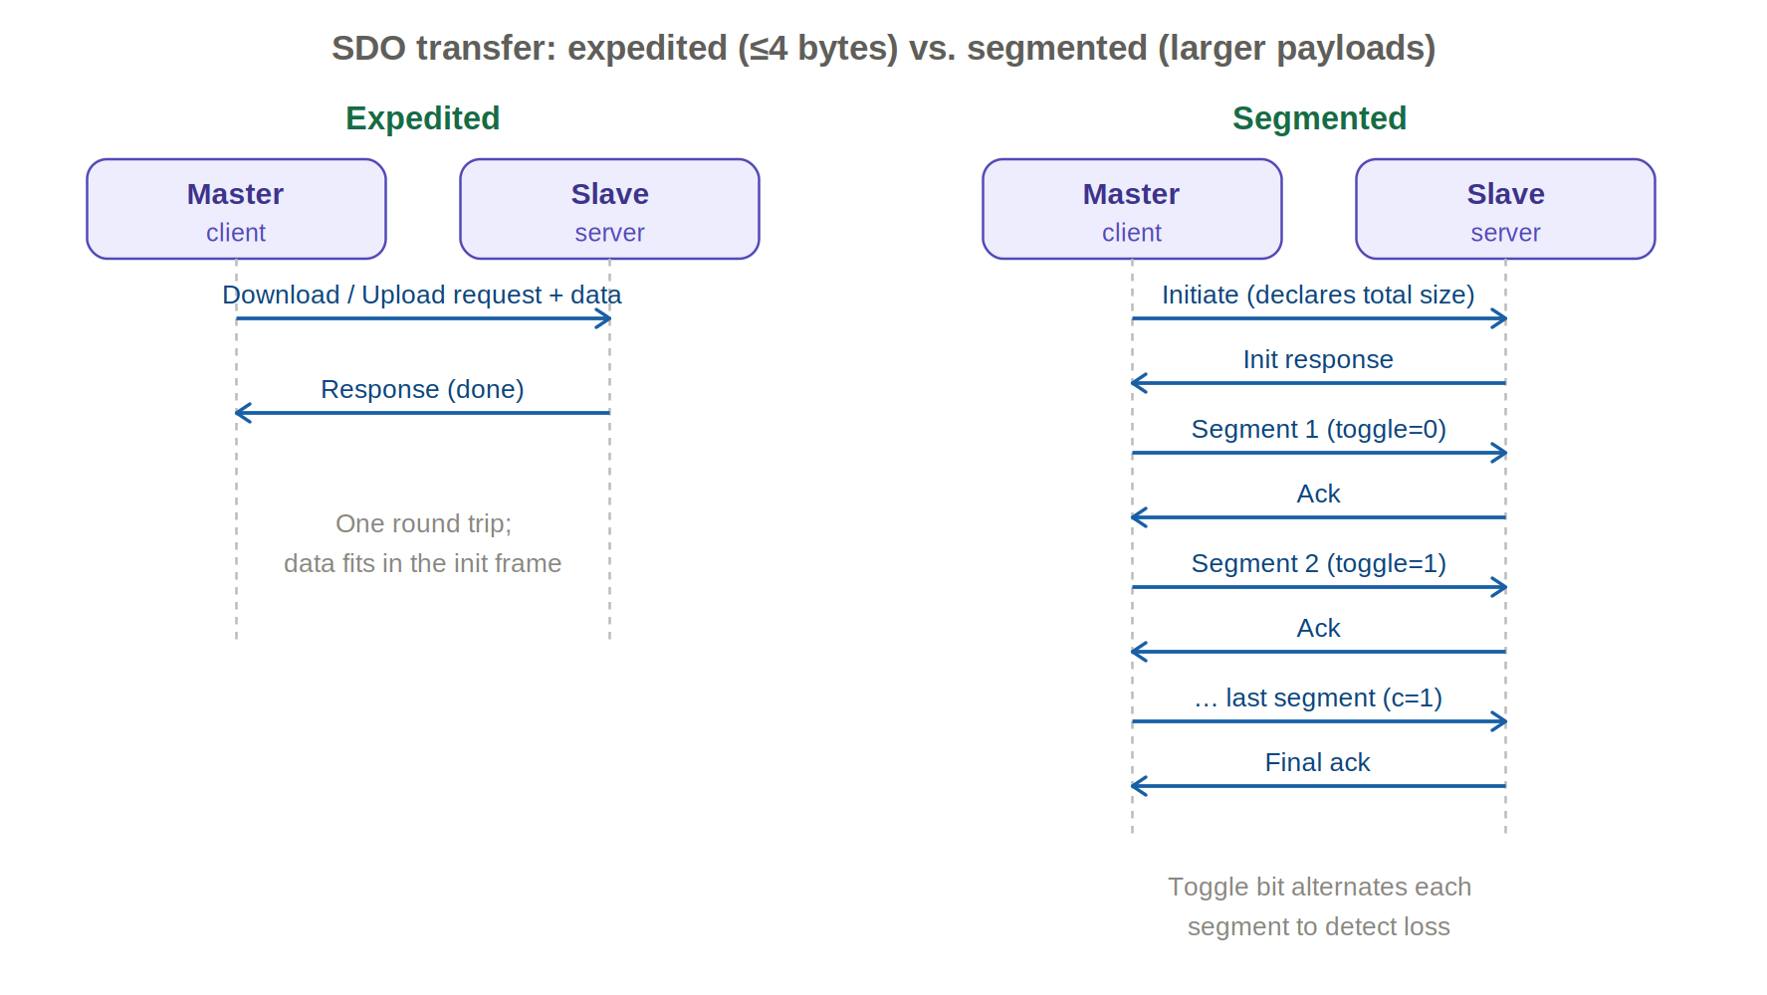
Small parameters complete in one round trip (expedited); larger ones are segmented with a toggle bit guarding against loss.
When an access cannot be served, the server returns an SDO Abort instead of a normal response, carrying a 32-bit abort code. These codes are standardized and are your first diagnostic when a write is rejected. A representative set:
Abort code | Meaning
0x05040000 | SDO protocol timed out.
0x05040001 | Client/server command specifier not valid or unknown.
0x06010000 | Unsupported access to an object.
0x06010001 | Attempt to read a write-only object.
0x06010002 | Attempt to write a read-only object.
0x06020000 | Object does not exist in the dictionary.
0x06040041 | Object cannot be mapped to a PDO.
0x06040042 | Mapped objects would exceed the PDO length.
0x06070010 | Data type/length of the service parameter does not match.
0x06090011 | Sub-index does not exist.
0x06090030 | Value range of the parameter exceeded (write).
0x06090031 | Value written is too high.
0x08000000 | General error.
0x08000022 | Cannot transfer/store due to the present device state.

6. The object dictionary
The dictionary is the structured table every CoE device exposes. Its address space is partitioned into well-known ranges, so an index alone tells you roughly what kind of object you are looking at:
Index range | Contents
0x0000–0x0FFF | Data type definitions.
0x1000–0x1FFF | Communication area (CiA 301): identity, PDO mapping, Sync Manager assignment.
0x2000–0x5FFF | Manufacturer-specific objects.
0x6000–0x9FFF | Profile-specific objects (e.g. CiA 402 for drives). Beckhoff’s modular model uses 0x6000 inputs, 0x7000 outputs, 0x8000 settings, 0x9000 info/diagnostics.
0xA000–0xFFFF | Reserved / extended profile area.

The most important communication-area objects, present on essentially every CoE slave:
Index | Object | Notes
0x1000 | Device Type | Identifies the device/profile.
0x1001 | Error Register | Single-byte summary of active error classes.
0x1008 | Device Name | Manufacturer device name string.
0x1010 | Store Parameters | Write the ‘save’ signature to persist settings to non-volatile memory.
0x1011 | Restore Defaults | Write the ‘load’ signature (0x64616F6C) to reset to factory values.
0x1018 | Identity | Vendor ID, Product Code, Revision, Serial Number.
0x1600–0x17FF | RxPDO mapping | Which objects make up each output PDO.
0x1A00–0x1BFF | TxPDO mapping | Which objects make up each input PDO.
0x1C00 | SM comms type | Declares the role of each Sync Manager.
0x1C12 | RxPDO assign | Which RxPDOs are assigned to the output SM (SM2).
0x1C13 | TxPDO assign | Which TxPDOs are assigned to the input SM (SM3).
0x1C32/0x1C33 | SM sync | Synchronization / Distributed-Clock parameters for the SMs.

Two of these deserve emphasis. 0x1018 Identity is how a master verifies it is talking to the device it expects (vendor, product, revision) before trusting the rest of the configuration. And the 0x1010 / 0x1011 store and restore pair is how settings are made persistent or reset — in TwinCAT a factory reset is often added as the very first entry in a slave’s start-up list so the device always begins from a known state.

7. PDO mapping and Sync Manager assignment
This is where the two channels connect. Defining the cyclic image is a two-level arrangement, and both levels are ordinary dictionary objects written by SDO at start-up:
- Mapping objects (0x1600… for RxPDO, 0x1A00… for TxPDO) list the dictionary entries that make up one PDO. Sub-index 0 holds the count; each further sub-index packs an object’s index, sub-index and bit-length.
- Assignment objects (0x1C12 for the output SM, 0x1C13 for the input SM) list which PDOs are actually active in each direction.
The reconfiguration sequence is strict and worth knowing, because doing it out of order fails: set the assignment count to zero, set the mapping count to zero, write the new mapping entries, restore the mapping count, then restore the assignment. On EtherCAT this is normally done only while the slave passes from PRE-OP to SAFE-OP, since the resulting process image must be fixed before cyclic operation begins. In TwinCAT you rarely hand-write this; choosing a PDO set in the Process Data tab generates the right start-up SDOs for you.

8. SDO Information and Emergency services
The SDO Information service is how a master or engineering tool discovers a dictionary it has never seen: it can request the list of object indices, then an object description, then a description of each entry (data type, access rights, name). This is exactly what powers TwinCAT’s ability to read a live device’s objects when you have no ESI/EDS file — the “online via SDO information” option.
An Emergency (EMCY) message is the slave’s way of raising its hand. When a fault occurs it places an unsolicited message in the read mailbox containing a standardized error code, a copy of the Error Register (0x1001) and a few bytes of manufacturer-specific detail. The master collects it on its next mailbox poll and surfaces it as a diagnostic event. Emergencies are asynchronous — they are not tied to any request.

9. The CiA 402 drive profile over CoE
The reason CoE matters so much for motion is CiA 402, the standardized profile for servo drives, inverters and steppers. Because the profile is just a defined set of dictionary objects, the same control logic works across vendors. Two objects anchor everything:
- 0x6040 Controlword — the master commands the drive’s state machine (enable, run, quick-stop, fault-reset) by setting bits here. It is normally mapped into an RxPDO so it can be written every cycle.
- 0x6041 Statusword — the drive reports its current state back here; mapped into a TxPDO. The master watches it to sequence the state machine.
The CiA 402 state machine steps through defined states — Switch-on disabled → Ready to switch on → Switched on → Operation enabled — and the master cannot skip steps; it walks the drive up by writing successive Controlword commands and confirming each via the Statusword. A Fault state is reached on error and cleared with a fault-reset bit. The selected behaviour depends on the mode of operation (0x6060), with the actual mode echoed in 0x6061. Key profile objects:
Index | Object
0x6040 | Controlword — commands the state machine
0x6041 | Statusword — reports drive state
0x6060 / 0x6061 | Modes of operation / display
0x607A | Target position
0x60FF | Target velocity
0x6071 | Target torque
0x6064 / 0x606C / 0x6077 | Actual position / velocity / torque
0x6098 | Homing method

Operating modes include Profile Position (PP), Profile Velocity (PV), Profile Torque (PT) and Homing (HM), plus the cyclic-synchronous modes CSP, CSV and CST (position, velocity, torque). CSP is the workhorse for coordinated multi-axis motion: the master sends a fresh target position every cycle and, with EtherCAT Distributed Clocks synchronizing all drives, the axes move in lockstep.

10. CoE in TwinCAT: the practical workflow
TwinCAT (the Beckhoff master and engineering environment) gives you three distinct ways to reach a slave’s CoE dictionary — two at engineering time and one at runtime.
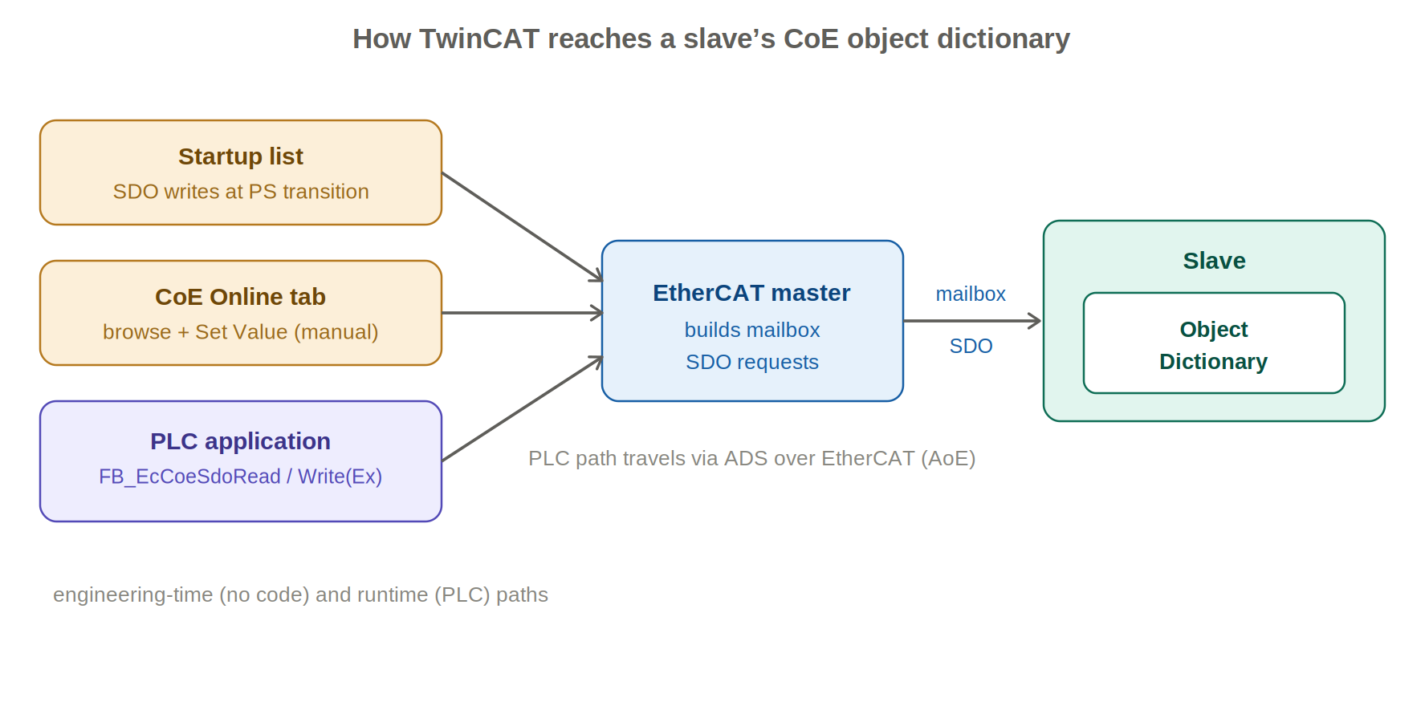
The start-up list and CoE-Online tab act at engineering/commissioning time; the PLC function blocks act at runtime over ADS-over-EtherCAT.

The slave in the I/O tree
Each EtherCAT slave appears in the TwinCAT I/O tree with a set of tabs. The ones that matter for CoE are Process Data (choose and inspect the PDO image), CoE-Online (browse and edit the live dictionary), Startup (the list of SDOs sent automatically on state changes), and Online/DC (state and clock). The slave’s PDO variables show up as linkable inputs and outputs that you wire to PLC variables.

The CoE-Online tab
This tab shows the object dictionary itself. Because the real dictionary is the “online” directory held in the device’s firmware, it is only readable once the slave is at least in PRE-OP and powered; TwinCAT loads it live via the SDO-Information service. When no device is present, TwinCAT instead shows the default copy from the ESI/EDS description so you can prepare settings offline. Double-clicking an entry opens a Set Value dialog that issues an SDO download — handy for trying a setting interactively, though such a change is not by itself persistent.

The Startup list
The start-up list is the backbone of repeatable configuration. It is a list of SDO downloads that the master sends automatically on a chosen EtherCAT state transition, so a freshly powered or replaced slave is always parameterized identically without any PLC code. The transition is usually PS (PRE-OP → SAFE-OP), the point at which the slave adopts its operational input configuration. Choosing a PDO assignment in the Process Data tab simply adds the corresponding mapping/assignment SDOs to this list. A factory-reset entry (a write to 0x1011) is frequently placed first so the device always starts from defaults before the intended values are applied.

Reading and writing CoE from the PLC at runtime
For values you need to change while the machine runs — or read on demand for an HMI — the Tc2_EtherCAT library provides function blocks that perform SDO access from PLC code:
Function block | Purpose
FB_EcCoeSdoRead | Read one dictionary entry (single sub-index) via SDO upload.
FB_EcCoeSdoWrite | Write one dictionary entry via SDO download.
FB_EcCoeSdoReadEx | As Read, with bCompleteAccess to read a whole object including sub-elements.
FB_EcCoeSdoWriteEx | As Write, with bCompleteAccess to write a whole object.

They share a common interface: sNetId (the AMS NetId of the EtherCAT master), nSlaveAddr (the slave’s address/port), nIndex and nSubIndex (the target object), a buffer pointer with length (pDstBuf/pSrcBuf, cbBufLen), a rising-edge bExecute trigger and tTimeout; outputs are bBusy, bError, nErrId and, for reads, cbRead. A minimal write:
fbSdoWrite : FB_EcCoeSdoWrite;
sNetId : T_AmsNetId := '172.16.2.131.2.1'; // EtherCAT master
nSlaveAddr : UINT := 1005; // slave port/address
nIndex : WORD := 16#8010; // object index
nSubIndex : BYTE := 13; // sub-index
nValue : UINT := 22; // value to write

fbSdoWrite( sNetId := sNetId,
nSlaveAddr := nSlaveAddr,
nIndex := nIndex,
nSubIndex := nSubIndex,
pSrcBuf := ADR(nValue),
cbBufLen := SIZEOF(nValue),
bExecute := bExecute );
Under the hood these requests travel as ADS over EtherCAT (AoE) from the PLC to the master, which builds the actual CoE mailbox SDO and sends it to the slave. AoE is also how TwinCAT reaches devices behind a gateway — for example addressing an individual IO-Link device sitting under an IO-Link master.
Because every SDO is an acyclic mailbox round trip, it is not deterministic. Do not poll cyclic values with SDOs — anything needed every cycle belongs in a PDO. Reserve SDOs for configuration, occasional reads, and diagnostics, and always drive the function blocks on an edge rather than holding bExecute true.

11. Choosing the right mechanism
- Needed every cycle, deterministic (setpoints, actual values, control/status words) → map it into a PDO. No SDO traffic at runtime.
- Set once at start-up (filter settings, scaling, PDO assignment, a factory reset) → put it in the Startup list as an SDO download on the PS transition.
- Changed occasionally at runtime or read on demand → an SDO from PLC code via FB_EcCoeSdoRead/Write(Ex), triggered on an edge.
- Interactive commissioning / one-off checks → the CoE-Online tab and its Set Value dialog.
- A fault occurred → the slave raises an Emergency; read it as a diagnostic rather than polling for trouble.

Sources
Compiled from the EtherCAT Technology Group device-protocol material (ETG.1000 / ETG.1000.6 CoE coding), the Beckhoff Information System (EtherCAT system documentation, CoE interface and parameter management, the Tc2_EtherCAT PLC library including the FB_EcCoeSdo function blocks and the mailbox protocol error-code list), CAN in Automation references for the CANopen SDO protocol and the CiA 402 profile, and EtherCAT master vendor documentation (acontis EC-Master, SOEM). Protocol constants and abort codes follow the EtherCAT/CANopen specifications.
Prepared as a technical reference. Verify device-specific object indices against the manufacturer’s ESI/EDS and documentation.

