EtherCAT, CoE, and IO-Link
A deep dive for the EtherCAT novice
EtherCAT is one of the more elegant pieces of engineering in industrial automation, and once the core trick clicks, the rest falls into place quickly. This guide builds it up from the bottom, then layers CoE and IO-Link on top — and flags one small framing issue along the way, because it matters for understanding where IO-Link sits.
One clarification up front: CoE really does run over EtherCAT in the literal sense. IO-Link does not — it is a separate point-to-point link that lives downstream of EtherCAT, reached through an EtherCAT device rather than carried as an EtherCAT protocol. That distinction is the single most clarifying thing for a novice.

How EtherCAT works
EtherCAT (Ethernet for Control Automation Technology) was developed by Beckhoff around 2003 and is now stewarded by the EtherCAT Technology Group (ETG); it is standardized in IEC 61158. It uses standard Ethernet cabling and physical layer, but it is emphatically not normal switched Ethernet, and the reason is the heart of the whole design.

The core trick — processing on the fly
In ordinary switched Ethernet, a frame travels to a node, gets received in full, stored, processed, and then a new frame is sent out — store-and-forward, with latency adding up at every hop. EtherCAT throws that out. Instead, the master sends one Ethernet frame that physically passes through every slave device in sequence, like a train passing through stations without stopping. As the frame streams through a slave’s dedicated hardware chip, that slave reads the bits addressed to it and inserts its own data into the frame in the same pass, with a hardware delay measured in nanoseconds. The frame is never stopped or copied at each node — it is modified in transit.
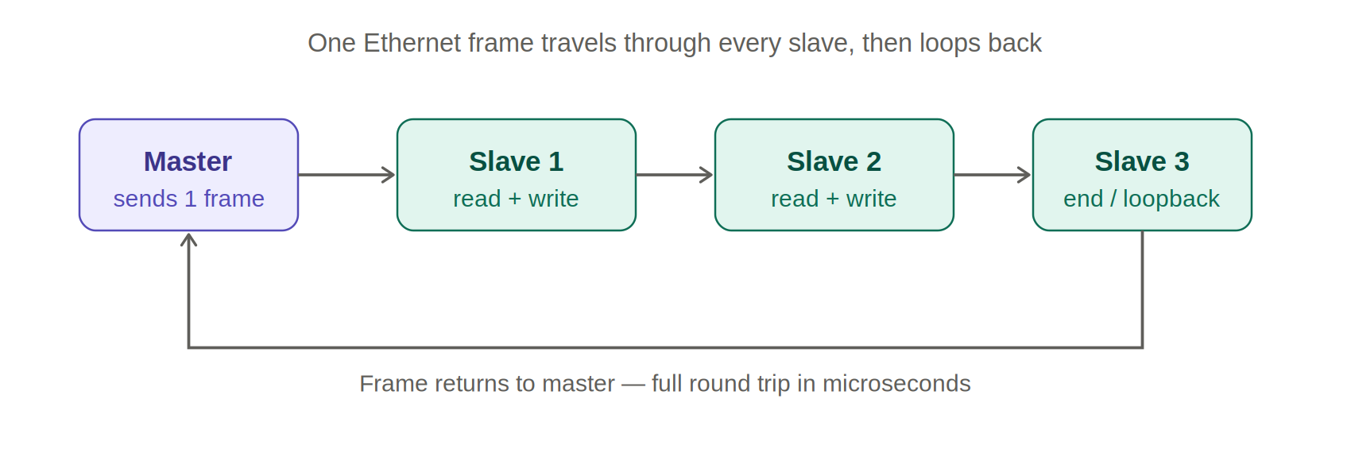
By the time the frame returns to the master, every slave’s inputs have been collected and every slave’s outputs have been delivered, all in a single frame round trip. This is why EtherCAT is so fast and deterministic: a thousand digital I/O points can be updated in roughly 30 microseconds, and bus efficiency is very high because one frame serves the whole network rather than one frame per device.

Frames, datagrams, and addressing
The frame carries one or more datagrams, each with an address and a command (read, write, or read-write). Slaves are addressed a few different ways: by physical position on the bus (auto-increment), by a configured station address, or — most powerfully — by logical addressing. With logical addressing the master builds one big shared process image and each slave is told (via a unit in its chip called the FMMU, Fieldbus Memory Management Unit) which slice of that image belongs to it, so it grabs and inserts exactly its own bits as the frame streams by.
A working counter in each datagram gets incremented by every slave that successfully handles its part, and the master checks that counter to confirm every expected device participated — a built-in integrity check on every cycle.
The dedicated chip in each slave is the EtherCAT Slave Controller (ESC). This is the secret to the speed: the on-the-fly read/write is done in silicon, not software, which is why the per-slave delay is nanoseconds. The master, by contrast, needs no special hardware at all — a standard Ethernet port on a PC or PLC is enough, because all the cleverness lives in the slaves. EtherCAT frames use their own EtherType, 0x88A4, so they are real Ethernet frames but not IP traffic.

Distributed Clocks
Distributed Clocks (DC) is EtherCAT’s synchronization mechanism. One slave acts as the reference clock; the master measures the tiny propagation delays to every other slave and distributes a corrected time so all slaves share a synchronized clock, typically within well under a microsecond. This is what lets a dozen servo axes execute a coordinated motion profile with no perceptible skew between them.

The state machine (ESM)
Every slave moves through a fixed set of states, which you will see constantly when commissioning:
- INIT — no communication; the master configures the slave.
- PRE-OP — only the acyclic mailbox channel is active, used for parameterization.
- SAFE-OP — the slave’s inputs are valid and being read, but its outputs are held safe.
- OP — full operation; inputs and outputs are both live.
A device getting “stuck in SAFE-OP” is one of the most common things you will troubleshoot, and it usually points at a configuration or sync mismatch.

The two communication channels
This is the key to understanding where CoE fits. Every cycle, EtherCAT carries two kinds of traffic:
- Process data — the fast, cyclic, deterministic payload (actual I/O values and setpoints), transferred every cycle in the on-the-fly frame.
- Mailbox — a slower, acyclic channel for things that need not happen every cycle: parameters, configuration, diagnostics, firmware. The mailbox is where the “X over EtherCAT” protocols live.
There is a whole family of mailbox protocols: CoE (CANopen over EtherCAT), SoE (Sercos/servo profile), EoE (Ethernet over EtherCAT, tunneling ordinary IP traffic), FoE (File access, used for firmware updates), and AoE (ADS over EtherCAT, a Beckhoff transport). CoE is by far the most common.

CoE — CANopen over EtherCAT
To understand CoE you have to understand CANopen first, because CoE is essentially CANopen’s brain on EtherCAT’s body.
CANopen is a higher-layer protocol that originated on the CAN bus (managed by CAN in Automation, CiA). Its central idea is the object dictionary: every parameter, setting, and data value a device exposes lives in a structured table, addressed by a 16-bit index and an 8-bit subindex. Want the control word of a drive? It is at index 0x6040. Status word? 0x6041. Target position? 0x607A. This standardized addressing is what makes devices from different vendors interoperable.
CANopen then defines two ways to touch that dictionary: SDOs (Service Data Objects) for acyclic, on-demand reads and writes of any entry, and PDOs (Process Data Objects) for the real-time, cyclic data that has been mapped into a compact process image.
CoE keeps all of that and simply swaps the transport from CAN to EtherCAT. The mapping is clean and maps onto the two channels above:
- SDO access (reading/writing object dictionary entries — configuration, diagnostics, parameterization) runs over the EtherCAT mailbox.
- PDO data (the cyclic real-time values) is carried in the EtherCAT process data. Mapping objects in the dictionary define what goes into the process image: 0x1600–0x17FF for received PDOs (master→slave) and 0x1A00–0x1BFF for transmitted PDOs (slave→master), with 0x1C12/0x1C13 assigning those PDOs to the slave’s SyncManagers.
The payoff is reuse: the entire library of CANopen device profiles carries straight over. The big one you will meet is CiA 402, the drive profile — it standardizes a drive’s internal state machine and its modes of operation (profile position, profile velocity, and the cyclic-synchronous modes CSP/CSV/CST for position, velocity, and torque). Combine CiA 402 in CSP mode with Distributed Clocks and you have the standard recipe for high-end coordinated motion control. The generic I/O profile CiA 401 covers digital and analog I/O modules.
In practice, CoE is the default application layer for most EtherCAT I/O and drives. When you buy an EtherCAT servo drive, coupler, or I/O block, odds are overwhelming you are configuring it through CoE objects.

IO-Link
Here is where the premise needs a gentle reframe, because it trips up almost everyone new to this. IO-Link is not a fieldbus, and it does not run “over” EtherCAT the way CoE does. It is standardized as IEC 61131-9, and it is a point-to-point serial link between a single IO-Link master port and a single IO-Link device (a smart sensor or actuator). People often call it “the USB of automation,” and that analogy is apt: it is the short last hop to one device, not a network.
So where does EtherCAT come in? The IO-Link master is the bridge. The master is itself a fieldbus node — frequently an EtherCAT slave (but it could just as easily be PROFINET, EtherNet/IP, etc.). The chain looks like this:
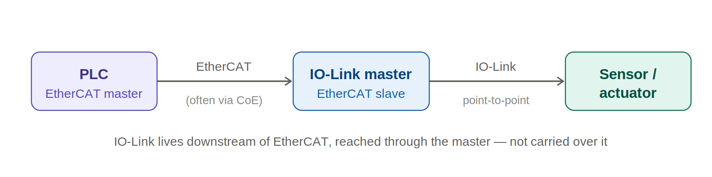
EtherCAT carries data between the PLC and the master; the master translates between EtherCAT and IO-Link; and IO-Link goes the final few meters to each individual device. That is why IO-Link lives downstream of EtherCAT rather than over it. When people say they are “reading an IO-Link sensor over EtherCAT,” what is physically happening is that the EtherCAT master talks to the IO-Link master (very often using CoE — the IO-Link master exposes its port process data in the EtherCAT process image and its acyclic parameter access through CoE mailbox objects), and the IO-Link master talks to the sensor. So CoE is frequently the glue that makes IO-Link data reachable through an EtherCAT network.
What makes IO-Link itself clever:
- It reuses ordinary sensor wiring. A traditional digital sensor uses a 3-wire connection: supply (L+), ground (L−), and a switching line. IO-Link repurposes that switching line — the C/Q line — for serial communication. A port can fall back to SIO mode (Standard IO), behaving as a plain digital input or output, so you can wire everything with standard unshielded M12 cables (up to ~20 m) and decide later whether a port runs as dumb digital I/O or smart IO-Link.
- Three transmission speeds exist, and the device dictates which: COM1 (4.8 kbit/s), COM2 (38.4 kbit/s), and COM3 (230.4 kbit/s).
- Three kinds of data flow over that one wire: process data (cyclic measurement or control values, up to 32 bytes per direction), on-request/service data (acyclic parameter access via the ISDU, for configuration and deep diagnostics), and events (asynchronous warnings and errors, like “sensor lens dirty”).
- The IODD (IO Device Description) is an XML file describing each device — analogous to EtherCAT’s ESI file — so engineering tools know what a sensor’s bytes mean.
- Automatic device replacement lets the master store a device’s full parameter set and re-download it to a replacement unit. Swap a failed sensor for a blank one of the same type and it is reconfigured automatically — no laptop, minimal downtime.
Where it is used: the very bottom layer of automation — photoelectric and inductive sensors, pressure/temperature/flow sensors, RFID readers, valve manifolds, signal towers, and so on. It excels where you want digital reliability (no analog signal degradation), remote configuration, and good diagnostics on inexpensive standard cabling.

How the three fit together in one machine
Picture a packaging line. A PLC sits at the top as the EtherCAT master. Down the EtherCAT line hang servo drives (each an EtherCAT slave speaking CoE, profile CiA 402, in CSP mode, synchronized by Distributed Clocks for coordinated motion) and I/O couplers (also CoE). One of those couplers is an IO-Link master: from its ports, individual IO-Link links run point-to-point out to the smart sensors watching the product and the valve banks driving the actuators.
In one breath: EtherCAT is the highway carrying everything deterministically; CoE is the language most devices on that highway speak; and IO-Link is the smart last-mile connection to each individual sensor at the edge.

Quick reference
 | What it is | Role / where used
EtherCAT | Real-time Ethernet fieldbus using on-the-fly frame processing (IEC 61158). | The deterministic backbone: one master, many slaves with dedicated ESC chips.
CoE | CANopen object dictionary and device profiles transported over EtherCAT. | The default application layer for most EtherCAT I/O and drives (e.g. CiA 402).
IO-Link | Point-to-point serial link to a single smart sensor/actuator (IEC 61131-9). | The last-mile connection at the edge, reached through an IO-Link master.

