IO-Link over EtherCAT
A deep dive — the master, the data paths, and IO-Link in TwinCAT

1. The key idea: IO-Link is not “over” EtherCAT the way CoE is
It is worth stating the central point before anything else, because the phrase “IO-Link over EtherCAT” invites a wrong mental model. IO-Link is not a fieldbus and IO-Link devices are not EtherCAT nodes. Where CoE is an application protocol that rides directly on EtherCAT — the device itself is the EtherCAT slave and you reach its object dictionary through the EtherCAT mailbox — IO-Link is a separate, self-contained point-to-point link that lives one layer below EtherCAT entirely.
IO-Link (standardized as IEC 61131-9, also called SDCI) connects a single smart sensor or actuator to a single port of an IO-Link master. That master is the device that sits on the fieldbus; in our case it is an EtherCAT slave. So “IO-Link over EtherCAT” really means: how the IO-Link master, acting as an EtherCAT slave, carries its devices’ data across EtherCAT to the controller. The EtherCAT network reaches the master; the master then speaks IO-Link the last few metres to each sensor.
The whole document hangs off that distinction, so the comparison table at the end is worth glancing at first if you have just read the CoE deep dive.

2. IO-Link fundamentals
An IO-Link system is just three things: an IO-Link master, one IO-Link device per master port, and an ordinary unshielded sensor cable between them (up to about 20 m). It deliberately reuses the long-established 3-wire sensor connection, which is a large part of why it caught on — no special cabling, no network design, no addresses to assign.

The physical link and its two modes
A standard 3-wire sensor uses three lines: 24 V supply (L+), ground (L−), and a switching line. IO-Link repurposes that switching line — pin 4, the C/Q line — to carry serial communication. The clever part is the fallback:
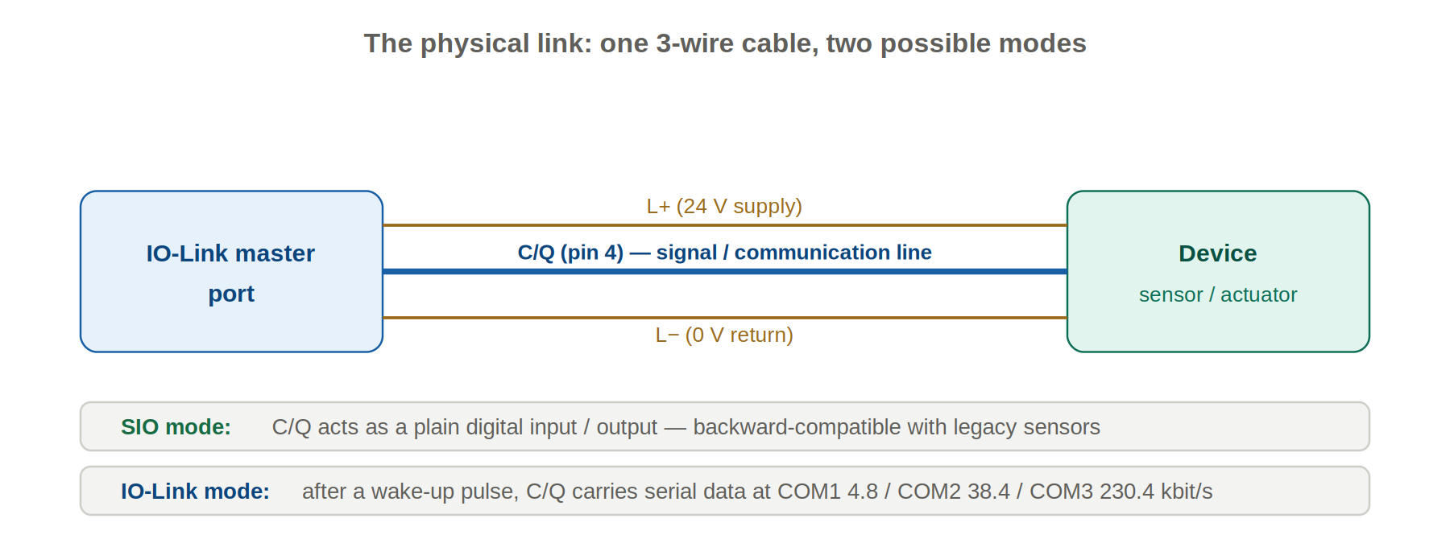
One cable; the C/Q line is either a dumb switch (SIO) or a serial channel (IO-Link), decided per port.
- SIO mode (Standard I/O) — the port behaves as a plain 24 V digital input or output, exactly like a legacy sensor. This keeps the whole installed base of ordinary sensors usable on the same hardware.
- IO-Link mode — when a port is set to communicate, the master sends a wake-up current pulse to bring the device from SIO into the digital communication state, then negotiates the data rate and begins exchanging frames.
There are three data rates: COM1 at 4.8 kbit/s, COM2 at 38.4 kbit/s and COM3 at 230.4 kbit/s. A device supports exactly one of them; a compliant master supports all three and adapts to whatever the device offers. (Port Class A leaves two pins vendor-defined; Port Class B uses them for an extra, separate power supply for higher-current actuators.)

3. The IO-Link data model
Across that single link, three distinct kinds of data flow — and keeping them separate is the key to understanding the EtherCAT integration later, because each takes a different path.

Process data (cyclic)
The real measurement or actuation values, exchanged continuously while the device is operational. Process data is small — up to 32 bytes per direction — and its meaning is device-specific (a pressure reading, a switch state plus a health flag, a set of valve coils). This is the data you ultimately want in the PLC every cycle.

On-request data (acyclic, via ISDU)
Parameters and identification, read or written on demand rather than every cycle, using the Indexed Service Data Unit (ISDU) mechanism. Each parameter is addressed by an index and an optional sub-index, mirroring CANopen’s scheme. A failed access returns a standardized ErrorType code. Every compliant device exposes a common set of standard parameters, which is what makes generic tooling possible:
ISDU index | Parameter | Notes
0x0000 / 0x0001 | Direct Parameter Pages 1/2 | Vendor ID, Device ID, frame/comms parameters.
0x0002 | System Command | Trigger device commands (e.g. restore factory settings).
0x000C (12) | Device Access Locks | Parameter-write / data-storage / local-UI locks.
0x0010 (16) | Vendor Name | Identification (read-only).
0x0012 (18) | Product Name | Identification (read-only).
0x0015 (21) | Serial Number | Identification (read-only).
0x0017 (23) | Firmware Revision | Identification (read-only).
0x0018 (24) | Application-Specific Tag | User-defined label; writable; preserved by data storage.
0x0024 (36) | Device Status | 0 OK, 1 Maintenance, 2 Out-of-spec, 3 Functional check, 4 Failure.
0x0025 (37) | Detailed Device Status | Itemized active diagnostics.
0x0040+ | Device-specific parameters | Thresholds, modes, scaling — defined by the IODD.

Events (asynchronous)
When something noteworthy happens — a fault, a warning, a maintenance hint — the device sets an event flag in its cyclic message; the master then collects the detail acyclically. An event carries a 2-byte event code whose meaning is given by the IODD or the device manual (“lens contaminated”, “over-temperature”, “short circuit”). Events are not polled; they are pushed by the device and surfaced by the master as diagnostics.

4. IODD, data storage, and automatic device replacement
Every IO-Link device ships with an IODD (IO Device Description) — an XML file describing its process data, parameters, events and identity. It is the IO-Link counterpart to EtherCAT’s ESI file or CANopen’s EDS, and it is what lets an engineering tool present a device’s bytes as named, typed, human-readable values.
The feature operators love most is data storage (the parameter server). With IO-Link V1.1, the master can keep a backup copy of a device’s parameter set. When a device is swapped for an identical replacement, the master detects the blank device and automatically downloads the stored parameters into it — no laptop, no manual setup, the line is back in seconds. The device declares which parameters participate; the Application-Specific Tag (0x0018) and the device’s settings block are typical examples. This requires both device and master to support the function.

5. How IO-Link rides on EtherCAT
Now the part that matters for this series. The bridge between the two worlds is the IO-Link master, which wears two hats at once.
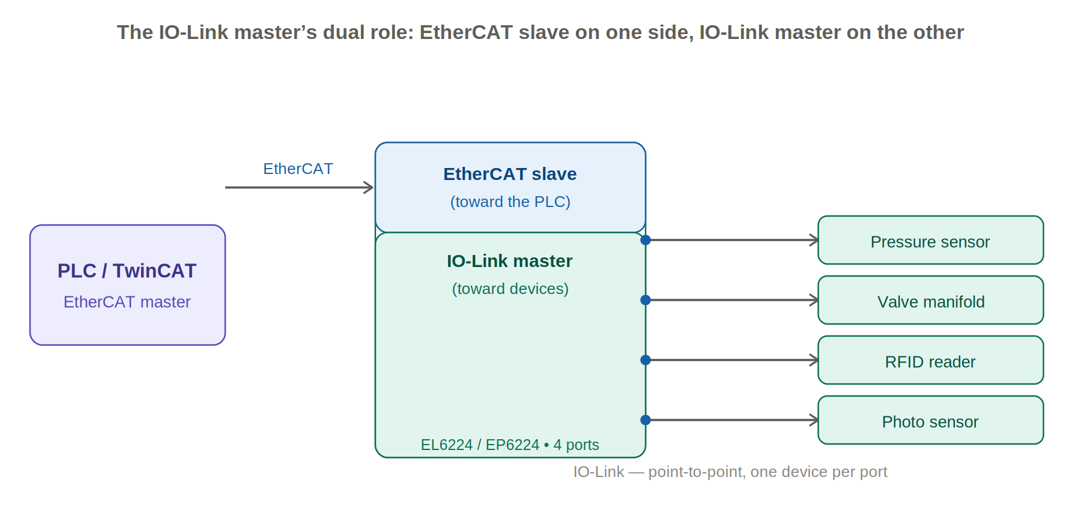
Toward the PLC the master is an ordinary EtherCAT slave; toward the sensors it is an IO-Link master with one device per port.
A Beckhoff EL6224 (or the IP67 box EP6224, or the EJ6224 plug-in module) is, in its own words, two services in one unit: an EtherCAT slave facing the TwinCAT master, and an IO-Link master facing up to four devices. The two kinds of IO-Link data then take two different routes across EtherCAT:
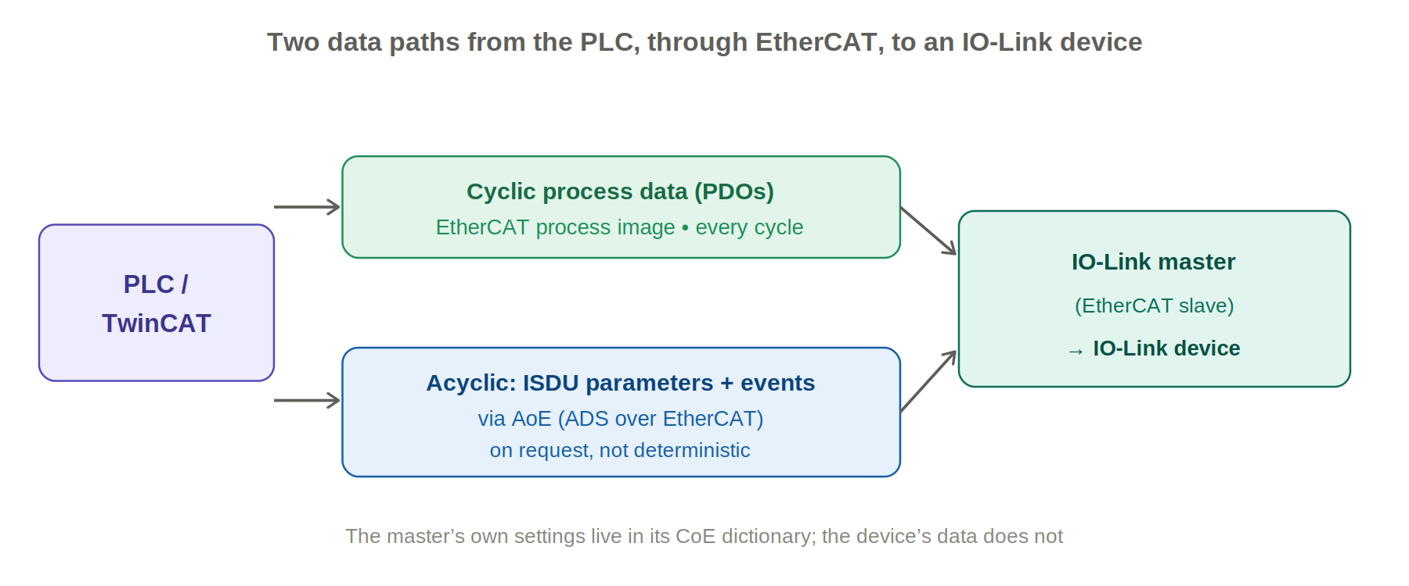
Cyclic device data is folded into the master’s PDOs; acyclic ISDU access and events are tunneled via ADS over EtherCAT.
- Cyclic process data → the EtherCAT process image. The master maps each port’s process data into its own PDOs, which appear in TwinCAT as linkable input/output variables and update every cycle — exactly like any other EtherCAT I/O.
- Acyclic ISDU and events → AoE (ADS over EtherCAT). To read or write a device parameter, TwinCAT addresses the master and tells it which port and which ISDU index to act on; the master performs the IO-Link transaction and returns the result. Events bubble up the same acyclic path as diagnostics.
This is the precise contrast with CoE, and it is worth being exact about it: you never do a CoE SDO to the IO-Link device itself — the device has no EtherCAT object dictionary and is not on EtherCAT at all. The CoE object dictionary that does exist belongs to the master (its own settings, typically in the 0x80n0 area, with info/diagnostics in 0x90n0). The device is reached only indirectly: through the master’s PDOs for cyclic data and through AoE for parameters.

6. IO-Link in TwinCAT: the practical workflow

The master terminal in the I/O tree
You add the IO-Link master (EL6224 / EP6224 / EJ6224) to the EtherCAT tree like any slave. By default its ports behave as plain 24 V digital inputs; each port is then individually switched to IO-Link mode and assigned a device. The master’s own configuration lives in its CoE dictionary and can be set in the CoE-Online tab or the start-up list, just as in the CoE deep dive.

The integrated IO-Link configuration tool
TwinCAT includes an IO-Link configuration (commissioning) tool built into the master’s configuration. You import the device’s IODD, scan the ports to detect what is actually connected, set each port’s mode, and parameterize the device through a readable, IODD-driven view rather than raw indices. This is the easiest path for commissioning and one-off changes, and it is where you enable data storage so replacements are handled automatically.

The device start-up sequence
When a port comes up in IO-Link mode, the master wakes the device, checks its identity against the configured device, and — for a V1.1 device with data storage active — reconciles parameters with the parameter server (if the stored and actual sets differ it holds the device while it resolves them). It then writes the cycle time and brings the device to its operational state, after which cyclic process data flows. If the wrong device type is connected, the port reports an error rather than exchanging bad data.

Reading and writing IO-Link parameters from the PLC
For runtime parameter access from PLC code, the Tc3_IoLink library provides function blocks that perform ISDU read/write over AoE:
Function block | Purpose
FB_IolRead | Read an ISDU parameter (index/sub-index) from the device on a given port.
FB_IolWrite | Write an ISDU parameter to the device on a given port.

They take the AMS NetId of the IO-Link master (not the PLC), the IO-Link port (nIolPort, e.g. E_IolPort.Port1), the ISDU nIndex and nSubindex, a buffer with length, and a rising-edge bExecute. Outputs include bBusy/bDone/bError plus two separate error sources: nAdsError (the transport) and nIolError (the IO-Link/ISDU ErrorType). A read of the Application-Specific Tag:
fbIolRead : FB_IolRead;
sTag : STRING(32);

fbIolRead.sNetId := F_CreateAmsNetId(sMasterNetId); // the master
fbIolRead.nIolPort := E_IolPort.Port1; // which IO-Link port
fbIolRead.nIndex := 16#18; // 24 = App-Specific Tag
fbIolRead.nSubindex := 0;
fbIolRead.pDSTBuf := ADR(sTag);
fbIolRead.cbBufLen := SIZEOF(sTag);
fbIolRead.bExecute := TRUE;
fbIolRead(); // poll until bDone, then read sTag
As with CoE SDOs, these are acyclic and non-deterministic: drive them on an edge, never hold bExecute true, and keep anything you need every cycle in the process data instead.

7. Choosing the right mechanism
- Needed every cycle (the measurement, the switch state, the actuator command) → the master’s PDOs, linked to PLC variables. No ISDU traffic.
- Set up once at commissioning (thresholds, modes, the device tag) → the IO-Link configuration tool with the IODD; enable data storage so it survives replacement.
- Changed or read occasionally at runtime → FB_IolRead / FB_IolWrite over AoE, triggered on an edge.
- A device fault or warning occurs → read the event/diagnostic the master surfaces; check Device Status (0x0024) for a quick health summary.
- Configuring the master itself (port modes, cycle behaviour) → its CoE dictionary via the CoE-Online tab or start-up list.

8. IO-Link Safety and IO-Link Wireless
Two extensions are worth knowing about. IO-Link Safety adds a functional-safety communication layer on top of the standard master and device stacks, allowing safety-rated sensors and actuators to use the same wiring and concepts. IO-Link Wireless replaces the cable with a radio link engineered for industrial latency and reliability, letting one wireless master serve many devices while still carrying process data, parameters and diagnostics — useful for rotating or moving machinery where cables are impractical. Both preserve the familiar IO-Link data model.

9. CoE vs. IO-Link over EtherCAT, at a glance
The capstone contrast for anyone reading this alongside the CoE deep dive:
Aspect | CoE | IO-Link over EtherCAT
What is the EtherCAT node? | The device itself is the EtherCAT slave. | The IO-Link master is the slave; the device is not on EtherCAT.
Where the device lives | On the EtherCAT line. | Point-to-point off a master port.
Cyclic data path | Device PDOs in the process image. | Device PD folded into the master’s PDOs.
Acyclic data path | CoE SDO via the EtherCAT mailbox. | ISDU via AoE (ADS over EtherCAT).
Addressing | Slave address + OD index/sub-index. | Master address + port + ISDU index/sub-index.
Engineering tool | CoE-Online tab + start-up list. | IO-Link configuration tool + IODD.
PLC function blocks | FB_EcCoeSdoRead/Write (Tc2_EtherCAT). | FB_IolRead/FB_IolWrite (Tc3_IoLink).
Device description | ESI / EDS. | IODD.
Persistence / replacement | 0x1010 store / 0x1011 restore. | Data storage / parameter server (auto-replace).

Sources
Compiled from the IO-Link community specification material (IEC 61131-9 / SDCI, the IO-Link Interface and System Specification, and standard parameter/ISDU and ErrorType definitions), the Beckhoff Information System (EL6224 / EP6224 / EJ6224 IO-Link master documentation, IO-Link system communication via PDO and AoE, and the Tc3_IoLink PLC library including FB_IolRead / FB_IolWrite), vendor IODD interface descriptions (ifm, Banner, Festo) for the standard parameter indices, and IO-Link organization material on IO-Link Safety and Wireless. Device-specific indices and process-data layouts always follow the individual device’s IODD.
Prepared as a technical reference. Verify port wiring, device identity and ISDU indices against the device’s IODD and the master’s documentation.

