Weak Prompt:
- Explain regression
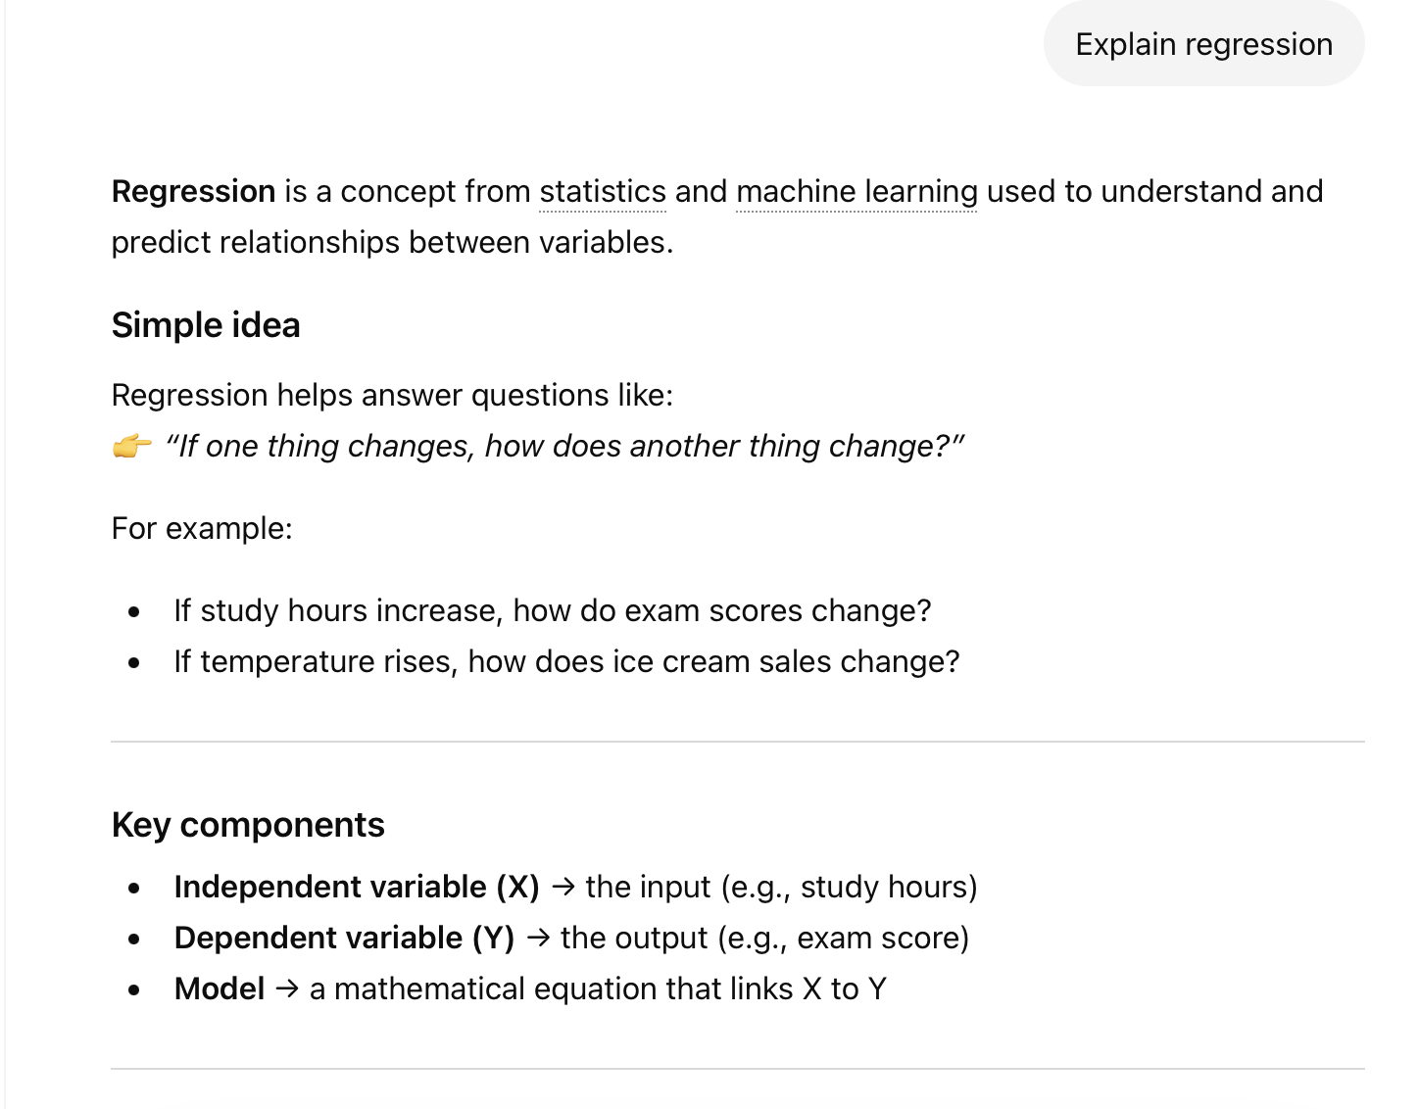
4.a) Improved Prompt:
Explain linear regression in simple terms for a beginner. Include a clear definition, a real-world example, and explain key terms like dependent and independent variables. Keep the explanation under 150 words.

4.b) screenshot :

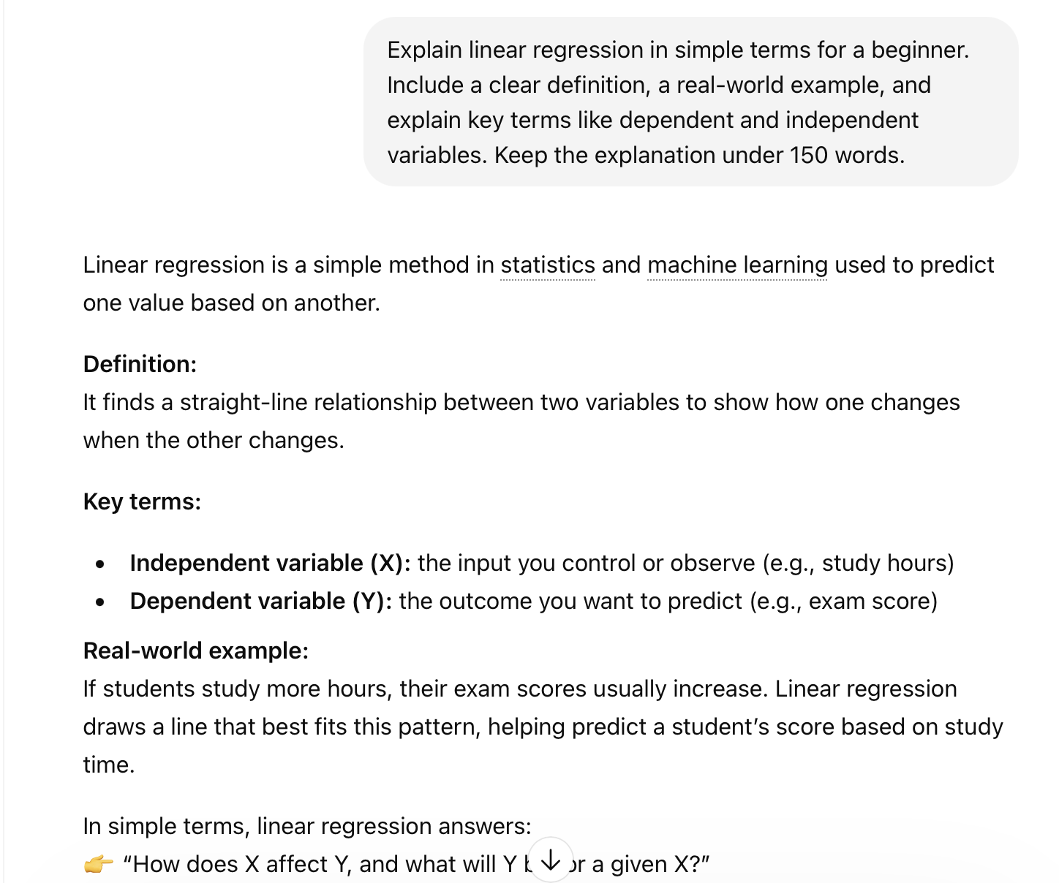
4.c) Why this is stronger:
This prompt is clearer and more specific. It defines the type of regression, the audience (beginner), and what to include, which helps the AI give a focused and useful answer.
3.b) Help me understand SGL 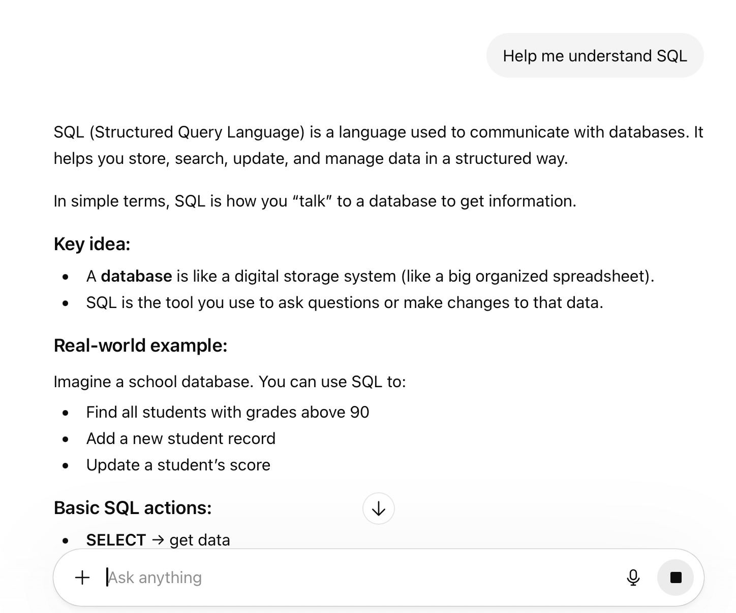
Improved prompt :
Teach me the basics of SQL as a beginner. Explain what SQL is, what databases are, and show simple examples of SELECT, INSERT, and WHERE queries. Keep it easy to understand with examples.
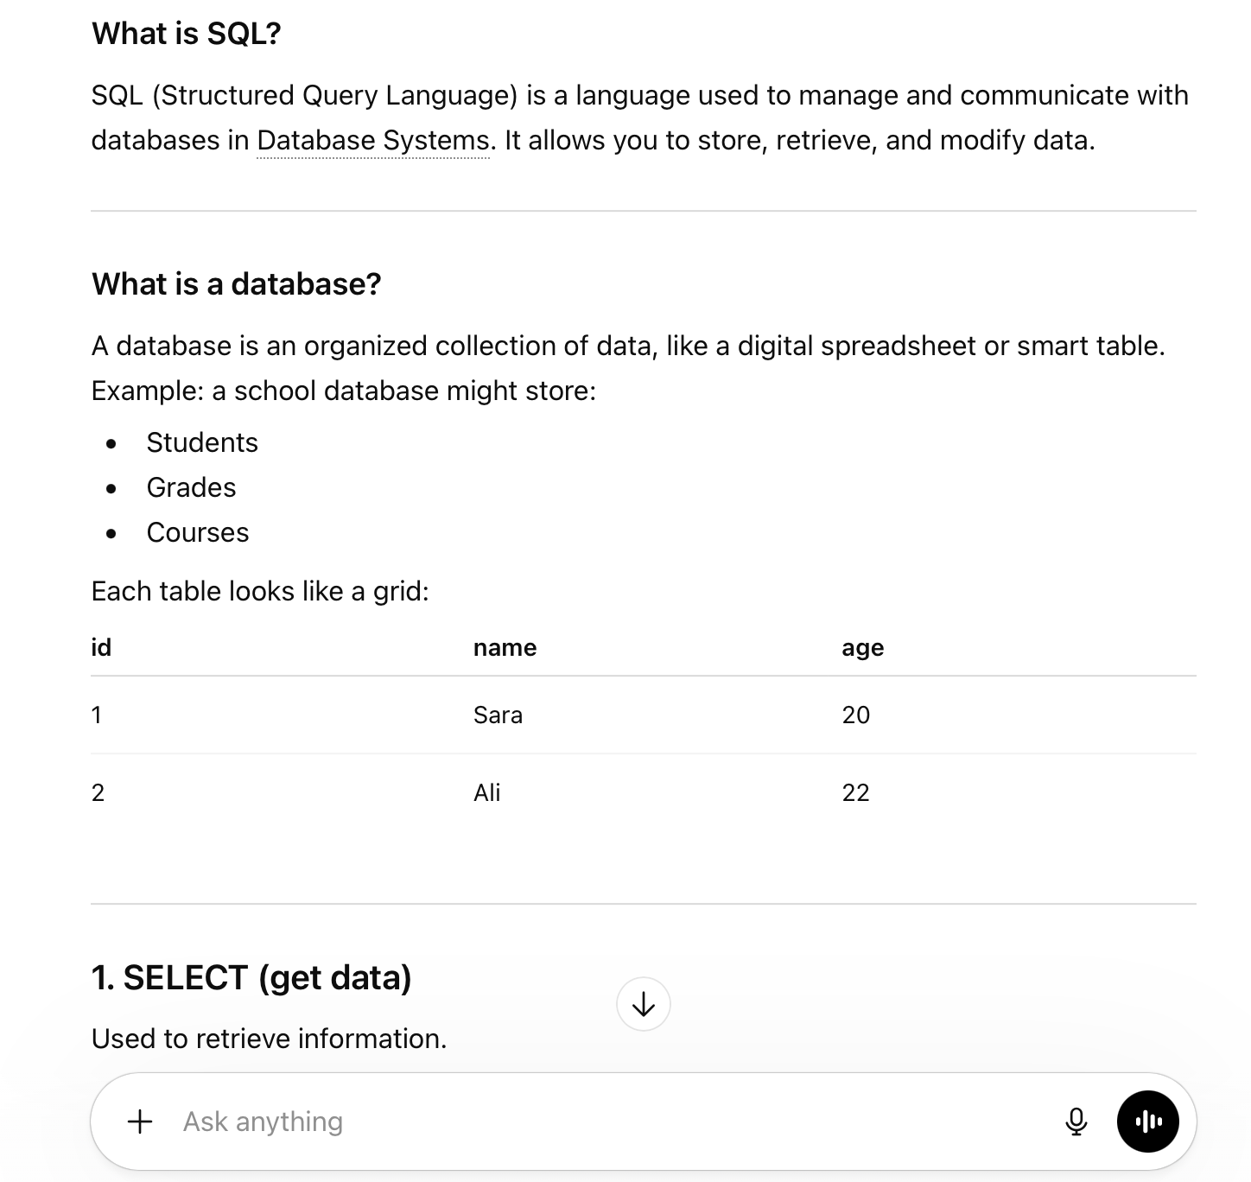

Why this is stronger :
This prompt clearly defines what to explain and asks for examples, making the response more structured and useful

