Application

Architecture
Chat room service
Chat room UI
Friend-list UI
Friend-list service
Login UI
Registration UI

Directory client
Application core
Figure 1: The talk application’s architecture

Application core
The application core is responsible for controlling and instantiating the different components of the Talkie program. Initially, it obtains the user provided data from the Login UI or the Registration UI in order to sign-in or register the user through the Directory client (see 1.5) respectively. Subsequently, the application core receives the network and user generated events and either instantiates the visual components of the application or commands the initiation of network commands to remote peers through the interfaces that are provided by its peripheral components (see Figure 1).

Friend-list service
The Friend-list service maintains a list of friends, along with their endpoint, and is responsible for sending them notifications to inform them about a change in the current user’s status. The user’s status can be any of the following:

- ONLINE – indicates that the user is successfully connected to the network and is able to initiate and receive chat requests
- BUSY – is exactly the same as the ONLINE status but implies that the user is busy and does not wish to engage in a conversation
- IDLE – is exactly the same as the ONLINE status but implies that the user has not interacted with his/her computer for a long period of time
- OFFLINE – indicates that the user is not connected to the network
- UNDEFINED – indicates that the state of the user cannot be determined, so the other end is responsible for trying to contact this specific user through the last known endpoint and determine his/her status

Additionally, the Friend-list service is responsible for notifying a remote friend for the completion of a pending authorization request or a positive authorization reply (see 2.3.2). Despite the fact that all the aforementioned notifications are exchanged through the UDP protocol, a chat request, which is also the responsibility of the Friend-list service, is communicated over TCP.

Through the application’s lifetime the Friend-list service, periodically queries the status of the friends that appear in its list and whose status is anything but OFFLINE in case a UDP notification from the other end was lost.

Chat room service
The chat room service encompasses the core communication functionality of the talkie application. Whenever a chat request is initiated or received by a remote peer, the Chat room service is responsible for the distributed construction and maintenance of a sensible route that interconnects all the peers that are participating in the chat. The chat room service at any given time may be in one of the following phases:

- The initiator phase, during which the initiator of the chat is responsible for sending chat requests to all the participants and as soon as they reply that there are willing to participate, it sends them the topology array (see 1.4.1).
- The connection phase, during which a host that receives the topology array from the initiator of a chat, connects to its designated parent node.
- The established phase, during which the all the connections between the peers are established and messages can be safely exchanged between them.
- The repair phase, during which a host that discovers that its parent node was disconnected, removes the failed node from its topology array and tries to connect to another parent node.

Initiator phase
The most important step of the initiator phase is the construction of the topology array. The topology array is nothing more than an ordered array of the peers that participate in the chat. The order of the participants in the array is randomly determined with the exception of the first element which is always associated with the node that initiated the chat. An example topology array for the nodes A, B, C, D, E, F, G with A initiating the chat, could be: T = [A, C, B, D, E, G, F]. Naturally, all the participating nodes receive and maintain the same topology array.

Connection phase
As soon as a peer that wants to participate in a chat receives the topology array, it calculates its designated parent’s position in the array by dividing its own position minus one to the degree of the tree. The degree of the tree determines the maximum number of connections (children nodes) a peer can accept. Thus, if the degree of the tree is D and the topology array is T, then a node in the array with position Ni calculates the position of its parent as: Pi = (Ni – 1) / D. Therefore, the peer’s parent node is T[Pi].

A
D
C
B
E
F
G
Figure 2: The connections for D = 4 and topology array T = [A, B, C, D, E, F, G]

The degree of the tree, in the current implementation, is statically chosen to be two. That is, each node may have at most two children which are connected to it. However, nothing prevents the dynamic determination of the optimal degree that will minimize the number of connections per node by propagation delay product for a given number of peers. This possibility will be considered in future versions of the application.

Established phase
During the established phase, where all the connections between the nodes are active, a peer that wishes to send a message to the other participating nodes firstly forwards it recursively through its current parent to the root node, which then initiates the recursive propagation of it through its children. That way, the ordering of the messages that finally arrive to the participating peers is globally consistent.

A
D
C
B
E
F
G
Figure 3: Node F sends a message which is firstly forwarded to the root node (A) and then is propagated to all the participating peers

Repair phase
When a node among the participating peers gets disconnected, obviously, only its parent and its children discover it. Thus, instead of renegotiating the connections from the beginning as in the initiator and the connection phase, the affected children nodes remove the failed parent node from their topology array and try to connect to their designated parent according to the new topology array T’. That way, the other unaffected connections are not disturbed and the overall repair phase is quite fast. As soon as a node repairs its connection, it independently notifies about the previous failure of the node using the forward-propagate method (see 1.4.3). Redundant messages about a node failure are discarded by the peers.

There are two problems with the aforementioned approach. First, a node can end up with more connections than the limit decided by the degree of the connection tree. That may happen because of the fact that the previously established connections remain unaffected and thus an orphan node may choose to connect to a “fully connected” node. Specifically a node may end up with D – 1 more connections, where D is the degree of the connection tree. However, the maximum number of connections is more of a suggestion than a hard limit. Second, it is possible that while the affected peers are trying to reconnect to the network they may miss some messages as the unaffected peers have no problem in communicating and thus can continue the conversation. However, practically, the connection process is fast and the possibility of missing messages is small and not very annoying if it ever happens.

A
D
C
B
E
F
G
Figure 4: Node A and B get disconnected, so the affected peers try to establish connections with other running peers in order to maintain a route

Node addition
It is possible for any participating peer to add another peer to the chat session. When this happens, the inviting node plays the role of the initiator (see 1.4.1) and sends to the invitee its topology graph with the newly added node appended. Thus, as soon as the invitee connects to its designated parent (see 1.4.2), it informs the other nodes about its presence through the forward-propagate method (see 1.4.3). The problem with this approach is that if more than one node tries to “invite” another peer to the chat room they may all connect to the same parent node as they have different topology graphs during their connection phase. However, as soon as they get connected and inform the other peers about their presence, provided that the “node addition” message will eventually reach them also, they can determine whether their local topology array is consistent with the global one and if not they can try to connect with their “correct” parent. Of course, this is possible because the “node addition” messages are globally ordered.

Directory client
The Directory client is the component that is responsible for interfacing with the Directory server (see 2.3) to either extract information about the current user and its friends or to request some actions that have as a result the modification of the user’s data. Specifically, the Directory client is responsible for:

- Registering a new user to the directory
- Authenticating and extracting the user’s information, friend list, offline messages, and authorization requests
- Requesting the addition of a new friend
- Requesting the removal of a friend
- Authorizing the addition of a friend to the user’s friend list
- Dispatching messages to a user that is considered offline

Directory Server Architecture

The directory server is the global directory of the system where user records are stored. However the directory in the system is not centralized but distributed among peers that form a DHT network. In this section we will first describe the overall picture of our network then the contents of user records that are stored in the directory, the design of the Directory Server front-end and finally some implementation details of the underlying Chord DHT.

Network Topology

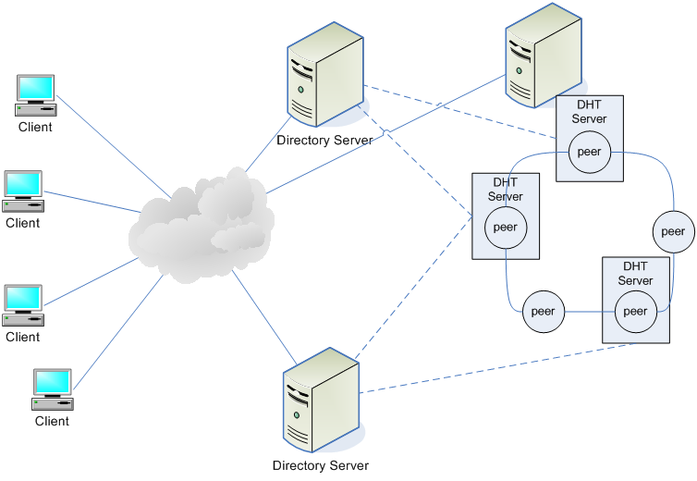
Figure 5: Network topology

The client applications of the network connect to a Directory Server of the Chord directory. Directory servers have the typical role of a server in a classic client-server architecture model. However these servers contain no user data. They are just a front-end for the clients to contact the distributed hash table.

Behind the directory servers a Chord distributed hash table (DHT) network is running. The peers connected in an overlay network form a circular topology with fingers among them creating shortcuts in the routing. In the DHT, data are stored in a { key, value } mapping where key is a fixed size large integer while value is an arbitrarily large data buffer.

User Records

Each user that joins the talkie IM network stores a record in the users’ Distributed Directory. This record contains users’ personal info: username, full name, displayed picture, status information and her last known endpoint. The last known endpoint that the user logged in is used to enable others that want to communicate with the user to know where to find her. This entry is updated automatically every time a user logs in the system. This information is also shared with the user’s friends. A friend of the user is another user that has been authorized by the first to be in his contact list.

Apart from the user personal info the directory record of a user contains her password for identity checking, a friend list containing the usernames of users included in the contact list and a queue of pending actions. The friend list contains only the usernames of user’s friends which is used as a pointer (key) to retrieve their personal information from the directory upon request from the client. This choice was made for conservation of storage space as opposed to the approach of storing a friend’s full personal information. Moreover it also avoids multiple updates when a user changes her personal data that would require updating all occurrences of her record.

The queue of pending actions for each user stores requests placed from other users or the directory while the she was offline and unable to respond. Currently there are three distinct types of pending actions. The first one is when user A invites user B as her friend but user B is offline. An invitation message is stored in her queue in order to be notified when she logs in and either accept or reject user’s A invitation. Respectively user A waits an acceptance/rejection of her invitation. If the reply from user B arrives when user A is offline the acceptance/rejection is stored in user’s A pending queue in the directory for retrieval on login. The last pending action stored in the directory is offline messages. These are messages that user A sent to user B while the latter was offline. These messages are stored in the directory along with their author and are propagated on login to the corresponding client.

Directory Server

The Directory Server is a typical server of the client/server model however is a gateway to the actual directory of the network. In the deployment there are several Directory Servers that are listening to client requests and propagate them in the DHT network.

Their role however is more than a mere beacon in the network. Chord DHT is agnostic about the data stored in it thus unable to do some ‘intelligent’ processing on them considering that is nothing more than a distributed data structure. In an instant messaging network (IM) clients expect more ‘intelligence’ from their directory than that. An ‘intelligent’ server is also needed for updating user’s info and handle invitations, authentications and bookkeeping. It is also able to introduce clients to new Directory Servers in order for clients to send requests in parallel to the network and have alternative contact point in case a directory server leaves the network.

Directory Server is also responsible for the replication of records and restoration of lost replicas in the directory as Chord DHT does not provide any mechanism for these operations. User records are mapped to the DHT using as a key, the value generated by a hash function applied on the username of the record. The directory server replicates the data by applying the same hash function on the resulted hashed key generating a new key which can map the record. The replication factor in the current implementation is set to four. Every time a record is requested the directory requests all of its instances in the DHT. If some instances is missing it is able to restore it. For efficiency reasons the client is served when the first instance of the record arrives. However replication causes inevitably consistency issues as user records are mutable. Due to time constraints data consistency has not been dealt yet; however is one of our top future work plans. At the moment there is the possibility that a user may face consistency issues.

Directory Servers can either run as stand alone daemons on machines contacting DHT peer via network or they can run in the same process with a DHT peer and also be a part of the DHT network. It is also possible for a directory server to be integrated to the talkie application client making the client able to be a part of the peer-to-peer network.

As examples of the Directory Server’s functionality we describe below the most complicated processes it handles, login and user invitation. The rest processes such as register or logout are rather simple consisting of a pair of request and reply message exchange with the appropriate status changes done from the part of the directory.

Login process
When a user wants to login to the network her client will send a login message to the directory specifying the username and password of the user. The directory then looks up the DHT network for the user’s record and validates her password. Along with the login response it sends user’s personal information and her friend list, a list of usernames of her contacts.  After login the client requests the queue of pending events from the directory and handles each action accordingly. Also it requests the user information for each of her friends from the directory in order to populate its contact list. | Figure 6: Login process
  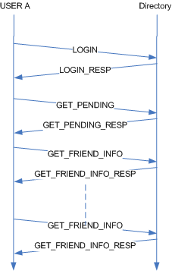

Add Friend process
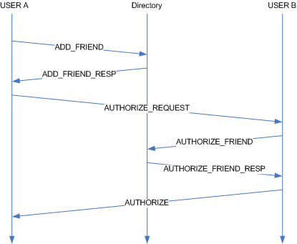
Figure 7: Add Friend process

In order for a user to add a friend in her contact list she has to specify a username. Suppose that user A wants to add user B to her contact list. User A sends an add friend request to the directory with the username of user B. The directory locates user’s B record in the DHT and adds in his pending queue an invitation from user A as well as an authorization pending event in the pending queue of user A and respond to A with the endpoint of user B. B may or may not be online at that time. User A tries to contact B and ask for authorization if B is online then she receives the request immediately otherwise she retrieves from the directory in her next login. In order for B to reply to the invitation she sends an authorize friend request to the directory with either an acceptance or a rejection. If it is an acceptance the directory servers appends each user to the friend list of the other and removes the corresponding events from the pending queue of each user. If it is a rejection it just removes the events from the pending queue. It finally replies to B sending the endpoint of A to inform her about her decision.

As the process described the directory remains passive in the process in the sense that it does not try to reach any user and it just replies to requests. Because the directory is closer to the typical server semantics of a distributed application we chose to avoid making it complicated in order to sustain in high traffic and increase its throughput.

Chord DHT

As mentioned earlier the directory is not centralized but distributed in a DHT over the network. We chose to implement Chord DHT from scratch. The implementation separates the two functionalities of Chord the overlay routing and the storage functionality. The overlay module handles the connectivity of nodes, their finger table the joins and leaves from the network as well as the find successor operation of the network. The DHT module handles the storage of { key, value } mapping. The mappings are also stored in persistent storage (hard-disk) and loaded at the bootstrapping of a DHT peer.

