Property | Rule | MicroUI
StringProperty | DataFlowType is In or InOut | 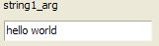
StringProperty | DataFlowType is Out | 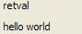
BooleanProperty | DataFlowType is In or InOut | 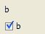
BooleanProperty | DataFlowType is Out | 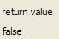
NumericProperty | DataFlowType is In or InOut | 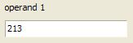
NumericProperty | DataFlowType is Out | 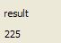
AggregateProperty | DataFlowType is In or InOut | 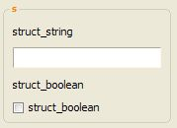
AggregateProperty | DataFlowType is Out | 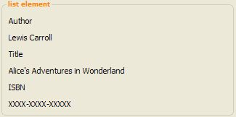
ListProperty | DataFlowType is In or InOut | 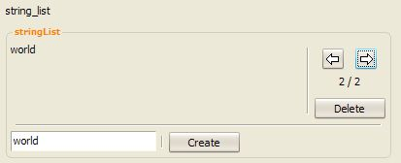
ListProperty | DataFlowType is Out | 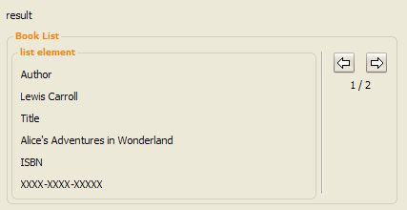
VectorProperty | DataFlowType is In or InOut | 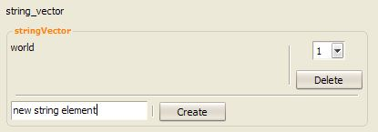
VectorProperty | DataFlowType is Out | 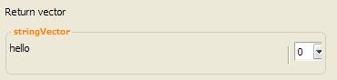
ArrayProperty | DataFlowType is In or InOut | 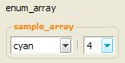
ArrayProperty | DataFlowType is Out | 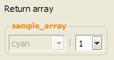
EnumeratedProperty | DataFlowType is In or InOut and elements are less than 6 | 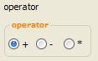
EnumeratedProperty | DataFlowType is In or InOut and elements are more than or equal to 6 | 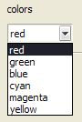
EnumeratedProperty | DataFlowType is Out | Same as above but with the control in disabled state (subject to change).
UnionProperty | DataFlowType is In or InOut | 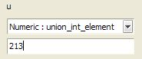
UnionProperty | DataFlowType is Out | Same as above but with the control in disabled state (subject to change).

