Property | Widget | Screenshot
AggregateProperty | wxPanel consisting of microUIs | 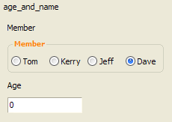
BooleanProperty | wxCheckBox | 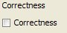
EnumeratedProperty | wxChoice, wxRadioBox (both implement wxControlWithItems) | 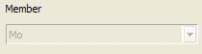  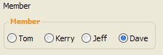
IntRangeProperty | wxSlider | 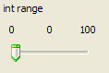
NumericProperty | NumericCtrl (inherits from wxTextCtrl) | 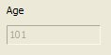
OperationProperty | wxPanel + other microUIs + OperationButton (inherits from wxButton) | 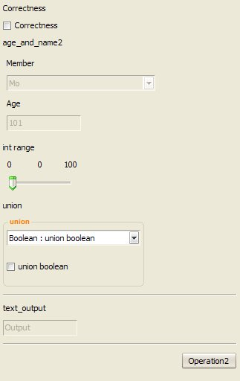
StringProperty | wxTextCtrl | 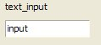
UnionProperty | wxChoicebook | 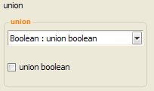
ListProperty | ListPanel | 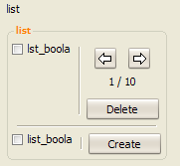
All operations | wxTreeBook | 