Algorithms
Tutorial on Linux, Editor, Compiler, Debugger and so on
0. Objectives
This tutorial goes through many important skills (such as Linux, editors, compilers, debuggers) that you will need in the class. You are strongly recommended to run the tutorial on EDA union lab machines.

1. Getting Started
1.1 Get an account in EDA union lab
Please get an account in the class.
You can get more information about EDA union lab at
http://edaunion.ee.ntu.edu.tw/

1.2 Connecting to EDA union server
You need a ssh client to connect to the server. We recommend PieTTY. PieTTY is a free SSH client based on PuTTY and dedicated to multilingual (especially CJK) environments, accessibility, and simpler user interface. SSH is a network protocol that allows data to be exchanged using a secure channel between two networked devices.
You can download it at here: http://ntu.csie.org/~piaip/pietty/

Xming is a software that allows you to display X-windows from a remote server.
You can download Xming at http://sourceforge.net/projects/xming/

Other client software
Here are some other clients:
PuTTY: http://www.chiark.greenend.org.uk/~sgtatham/putty/download.html
MobaXterm: http://mobaxterm.mobatek.net/en/
MobaXterm is an all-in-one solution combining ssh, X-server, and ftp. You will need to type
“ssh your_id@edaunion.ee.ntu.edu.tw -p 400XX” to connect to servers.
If you use MobeXterm, then you don’t need Xming.

Step by step instruction:
- Open Xming
We can see Xming application icon at the right bottom status bar.
You can just open it without any setting.
- Connect to EDA UNION lab machines
Open pietty application and input host name and port
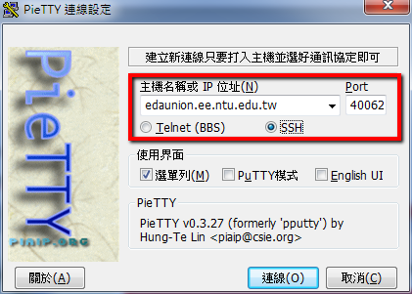

To balance the load, please connect to your default server.
account | ip:port | Server name
alg_001~alg_010 | edaunion.ee.ntu.edu.tw:40051 | edaU1
alg_011~alg_020 | edaunion.ee.ntu.edu.tw:40052 | edaU2
alg_021~alg_030 | edaunion.ee.ntu.edu.tw:40053 | edaU3
alg_031~alg_040 | edaunion.ee.ntu.edu.tw:40054 | edaU4
alg_041~alg_050 | edaunion.ee.ntu.edu.tw:40055 | edaU5
alg_051~alg_060 | edaunion.ee.ntu.edu.tw:40056 | edaU6
alg_061~alg_070 | edaunion.ee.ntu.edu.tw:40057 | edaU7
alg_071~alg_080 | edaunion.ee.ntu.edu.tw:40058 | edaU8
alg_081~alg_090 | edaunion.ee.ntu.edu.tw:40059 | edaU9
alg_091~alg_100 | edaunion.ee.ntu.edu.tw:40060 | edaU10
alg_101~alg_110 | edaunion.ee.ntu.edu.tw:40061 | edaU11
alg_111~alg_120 | edaunion.ee.ntu.edu.tw:40062 | edaU12
alg_121~alg_130 | edaunion.ee.ntu.edu.tw:40063 | edaU13
alg_131~alg_140 | edaunion.ee.ntu.edu.tw:40064 | edaU14

- Enable X11 forwarding
If this is the first time you open this program, before logging in, press Ctrl and right-click on the window, this will open the context menu. (right-click without Ctrl is “paste” )
Then select “Change Settings”.
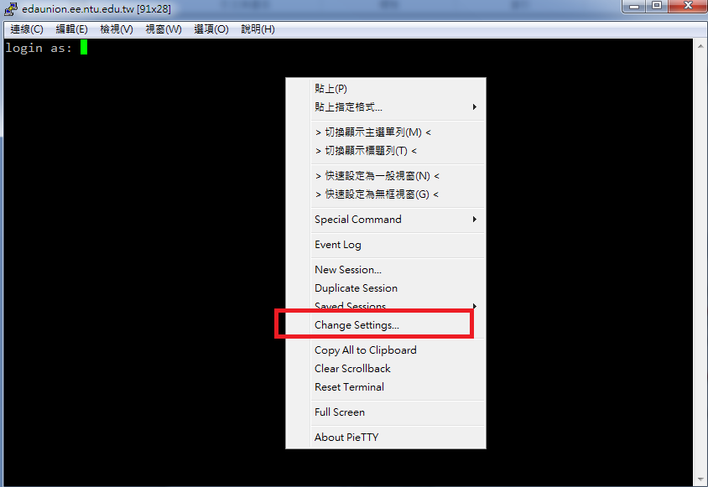

Connection->SSH->X11: Enable X11 forwarding
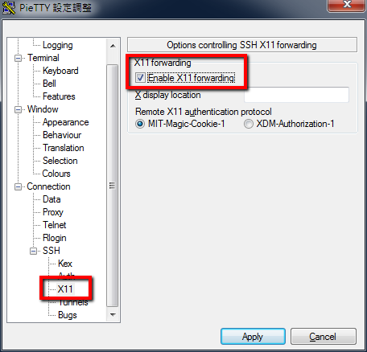
Click apply to store the setting, this will be automatically applied to future connections.
- Log in with your account id and password.
- Test an X-11 application by typing
xclock &
‘xclock’ shows a small clock in a window. The “&” sign allows this application to run in the backward so that we can still use the shell.
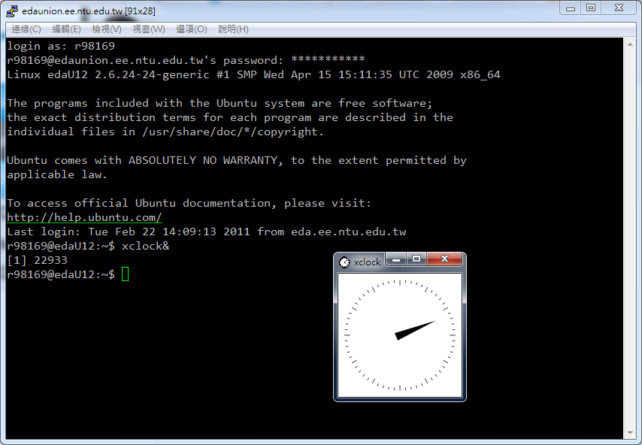
1.3 Useful Linux commands
Command | Expressions
ls [-l ] [-a] | list files
mkdir <dir> | make a new directory, called <dir>
cd <dir> | Change directory to <dir>
cd .. | Change to upper directory
rm <file> | delete file (be careful, NOT reversible!)
rm –r <dir> | Delete directory (be careful, NOT reversible!)
mv <original> <new> | Change name or move files from original to new
tar -zxvf <file.tgz> | decompress .tgz file into the current directory
tar -zcvf <file.tgz> <dir> | compress all files in directory into a .tgz file
man <command> | Help the command
pwd | Display current path
cp <original> <new> | Copy files
cp <original> <new> -r | Copy directories .
more <file> | View text (ex. your code) in the terminal.
passwd | Change your password.
make | compile using the makefile script
./<executable_file> | execute the file in this directory  ./ means the path is the current directory

1.4 Uploading files
Please download the tutorial demo file Tutorial.tgz from ceiba, and upload it to your EAD union lab account. There are several ways to do it:
(1) Using PieTTY:
Simply drag and drop the files from your windows explorer to PieTTY window, PieTTY will ask you where you want to put the files (default location is the home directory).
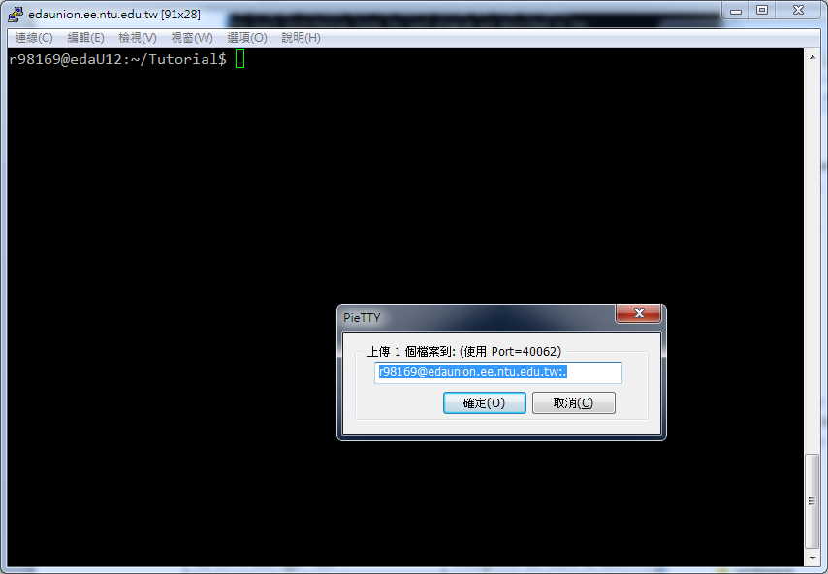
After clicking OK, you will need to provide your password.
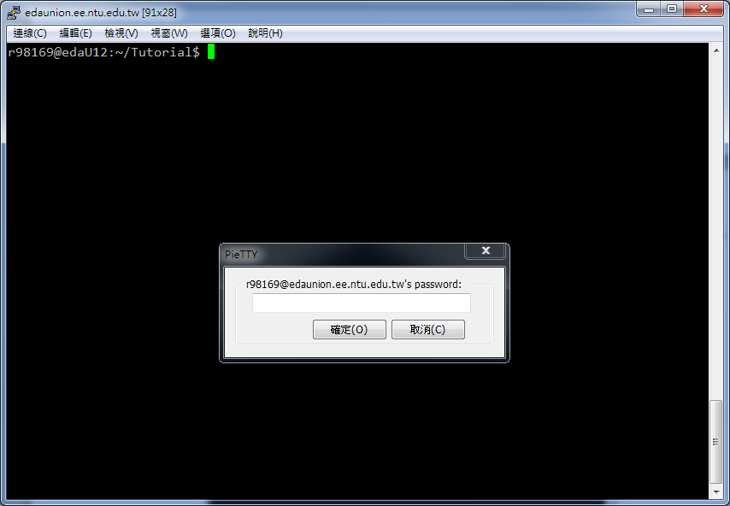

(2) Using other FTP clients:
Here we demonstrate the setting in FileZilla (http://filezilla-project.org/). Notice that you need to use SFTP protocol.
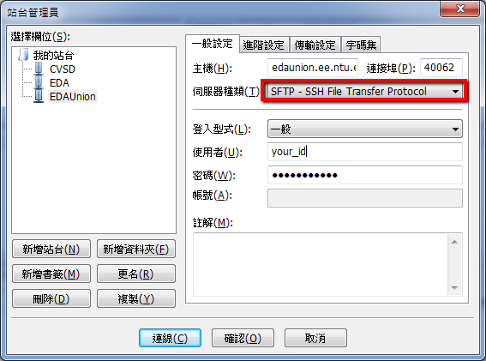
After that, you can type “tar -zxvf Tutorial.tgz” to decompress the files.

1.5 Editors
There are many text editors we can use such as vim, emacs and etc. vim is faster because it needs no windows but it has no GUI. Emacs has a user friendly window but maybe slower.
1.5.1 vim http://www.vim.org
Mastering vim is not easy, so we will only cover the basics here. There are millions of vim tutorials on the internet (literally). You should consult them if you really want to learn about using this editor.
To envoke vim, simply type:
vim [filename]
where [filename] is an optional argument.
In vim, there are normal mode and insert mode. In insert mode, you can edit file content. In normal mode, you can apply command. Initially, we are in normal mode.
- In normal mode, up. down. left. right arrow or h. j. k. l to move the cursor.
- in normal mode, x will delete a single character
- i changes normal mode to insert mode. You can then type in your text.
- <ESC> changes from insert mode back to normal mode

Here is a summary of useful vim commands.

Undo | u
Search string | / <string>
edit file | :e <filename>
Save | :w
save and quit | :wq
Quit | :q
without save and quit | :q!
Help | :help

1.5.2 Emacs http://www.gnu.org/software/emacs/
emacs is a powerful GUI editor that can greatly help your C++ coding. To invoke emacs in an X window, simply type
emacs &
To open a new file, simply left-click on the left most white button (the one with a white paper icon). Enter your file name at the bottom of the window. If your file name ends with ‘.cpp’, emacs will automatically enter the C++ mode.
- Emacs nicely color your source code so that you can clearly see keywords. If you cannot see the correct coloring, you have to check your spelling.
- Emacs check your matching of parenthesis. When you type the right parenthesis, emacs show you the location of the left matching parenthesis. If you cannot see the matching parenthesis, your code has something wrong.
- Emacs automatic do the indentation. At the beginning of each line, type ‘TAB’ to do the indentation. If your indentation is not correct, check your code for grammar errors (like missing ‘;’).
- To open a directory, just left-click on the folder icon and a enter the directory name at the bottom. A directory will appear in your editing area. In that directory, you can middle-click on any filename to edit that file. Or you can change directory by middle-clicking on any directory name. Clicking on the “..” brings you up a level to the parent directory. Clicking on a .tgz file will automatically show you the contents in the compressed file.
- To save the file, click on the disk icon. The old copy of this file is saved with the same name ending with ‘~’ just in case you want to undo the change.
- You can press Control-s and ‘I-search’ will appear at the bottom. Type in the words you want to search and your cursor will advance as you type in each letter. This is an “Incremental search”. If you want to search the next occurrence of the same word, just keep pressing Control-s.
- If you open a second file, the first file still remains in the buffer. Just click on the ‘buffer’ on the top of the menu. If you want to quite a file out of the buffer, just click on the ‘X’ icon.
- If you feel using mouse is too slow, you can define your own hot keys. It is called “key bindings” in Emacs. You can copy my sample key binding file, .emacs, to your own home directory. After copying, the key bindings will automatically take effect when you start a new emacs.

Other editors
You can also write your codes on local machine, and upload them afterwards. However, please make sure your programs can be compiled and executed correctly on EDAUnion servers. No credits will be given if your programs cannot be compiled on EDAUnion servers.
Here are some editors on Windows platform:
Eclipse: http://www.eclipse.org/
Microsoft Visual Studio: http://download.cc.ntu.edu.tw/
Notepad++: http://notepad-plus-plus.org/
If you use Dev-C++, you change the compiler to newer versions of GCC.

1.6 Resources
Learn more about linux
http://linux.vbird.org
Learn more about X window
http://linux.vbird.org/linux_basic/0590xwindow.php
Learn more about using vim
http://www.study-area.org/tips/vim/
Learn more about using emacs
http://homepage.mac.com/yenlung/WebWiki/EmacsNotes.html

2. Insertion Sort
Please try our first program, the insertion sort. Please go to the insertion sort directory by typing
cd Tutorial/insertionsort
Use your texteditor to open the file insertionsort.cpp
/*
Program: Insertion Sort
Author Name:
Usage: insertionsort
Revision: V.2010.2.1
*/

#include <iostream>
using namespace std;
#define ELEMENTS 6

void insertion_sort(int x[],int length)
{
int key,i;
for(int j=1;j<length;j++)
{
key=x[j];
i=j-1;
while(x[i]>key && i>=0)
{
x[i+1]=x[i];
i--;
}
x[i+1]=key;
}
}

int main()
{
int A[ELEMENTS]={5,2,4,6,1,3};
int x;

cout<<"NON SORTED LIST:"<<endl;
for(x=0;x<ELEMENTS;x++)
{
cout<<A[x]<<endl;
}
insertion_sort(A,ELEMENTS);
cout<<endl<<"SORTED LIST"<<endl;
for(x=0;x<ELEMENTS;x++)
{
cout<<A[x]<<endl;
}
return 0;
}

to compile it, type
g++ insertionsort.cpp -o insertionsort
or
make insertionsort
to execute , type
./insertionsort

3. Using Sort Function in STL
C++ STL is a standard template library, which contains useful containers, adaptors, iterators, function objects and algorithms. Now we show a simple example using the STL function ‘sort’.
cd ../STL
open the stlsort.cpp file and check the difference. Note that two lines are changed from the last example.
#include <iostream>
#include <algorithm> // This line is different
using namespace std;
#define ELEMENTS 6

int main()
{
int A[ELEMENTS]={5,2,4,6,1,3};
int x;
cout<<"NON SORTED LIST:"<<endl;
for(x=0;x<ELEMENTS;x++)
{
cout<<A[x]<<endl;
}
sort (A, A+ELEMENTS); // This line is different
cout<<endl<<"SORTED LIST"<<endl;
for(x=0;x<ELEMENTS;x++)
{
cout<<A[x]<<endl;
}
return 0;
}
then compile and execute.
g++ stlsort.cpp –o stlsort ( make stlsort )
./stlsort
4. Makefile
In a large project, source codes are separated into many files. For example, we may decide to have different sorters, each of which is an independent file. Please change the directory,
cd ../makefile_demo
Now main.cpp is like this. Please note that the replaceable_sorter() is no longer defined here in main.cpp. To make sure the compilation is successful, we must include a new header file replaceable_sorter.h. To compile this main.cpp
g++ -c main.cpp -o main.o
#include <iostream>
using namespace std;
#include "replaceable_sorter.h" // add this line
#define ELEMENTS 6

int main()
{
int A[ELEMENTS]={5,2,4,6,1,3};
int x;

...
replaceable_sorter(A,ELEMENTS); // change this line
...

return 0;
}
You will see a main.o object file generated. Please note that the –c option tells the compiler to generate an object file only ⎯ no linking is done for now.
The replaceable_sorter.h file jus provides the forward declaration of the function.
void replaceable_sorter(int x[],int length);
Suppose we have two implementations of the replaceable_sorter: one is insertionsort and the other is the stlsort. You can check the stlsorter.cpp file to see the details. To compile the stlsort, type
g++ -c stlsort.cpp -o stlsort.o
#include <algorithm>
using namespace std;
void replaceable_sorter(int x[], int length)
{
sort (x, x+length);
}
Now, we can link the object files to produce an executable file demo_stl.
g++ main.o stlsort.o –o demo_stl
The other implementation can also be compiled in the same way.
g++ -c insertionsort.cpp -o insertionsort.o
g++ main.o insertionsort.o –o demo_is

As you can see, this process is very long and tedious. So we can write all this compilation instructions into a makefile like the following.
# CC and CFLAGS are variables
CC=g++
CFLAGS = -c
# -c option ask g++ to compile the source files, but do not link.

all : demo_stl demo_is

demo_stl : main.o stlsort.o
$(CC) main.o stlsort.o -o demo_stl

demo_is : main.o insertionsort.o
$(CC) main.o insertionsort.o -o demo_is

main.o : main.cpp replaceable_sorter.h
$(CC) $(CFLAGS) main.cpp

stlsort.o : stlsort.cpp
$(CC) $(CFLAGS) stlsort.cpp

insertionsort.o : insertionsort.cpp
$(CC) $(CFLAGS) insertionsort.cpp

# clean all the .o and executable files
clean:
rm -rf *.o demo_is demo_stl
CC and CFLAGS are variables that will be used in the following text. The structure of makefile is simply ‘target: source /n command’. For example, the two lines in bold means to compile the stlsort.o, we need stlsort.cpp. And the command is g++ -c stlsort.cpp. The makefile can also be written in a more concise way by neglecting some common commands and variables that will be automatically generated with system default behaviors. An example is makefile_2.
To compile stlsort.o, please type
make stlsort.o
To compile and link demo_stl, please type
make demo_stl
If you want to remove all the .o and executable file, simply type
make clean
Actually, you can compile both demo_stl and demo_is in just one step.
make

5. File IO
Now we learn how to read/write files in c++.
cd ../fileIO/
Use your texteditor to open fileIO.cpp. This file contains two functions.
#include <iostream>
#include <fstream>
using namespace std;

int Max (int a, int b)
{
if (a> b) return a;
else return b;
}

int main ()
{
ifstream inFile("test.in");
ofstream outFile("test.out");
int a,b;
inFile >> a;
inFile >> b;
outFile << Max(a, b) << endl;
outFile.close();
inFile.close();
return 0;
}
Also open the file test.in and you will see two numbers.
To compile it, type this command,
g++ fileIO.cpp -o fileIO (make fileIO)
To execute , type this command
./fileIO
Check the results in test.out.
cat test.out
6. Debugger (DDD http://www.gnu.org/software/ddd/ )
GNU DDD is a graphical front-end for command-line debuggers such as GDB.
6.1 How to use DDD
Change directory to ddd. Compile debug.cpp with –g. Then start ddd.
cd ../ddd
g++ -g debug.cpp –o debug
ddd ./debug
You can set break point by click stop break bottom.
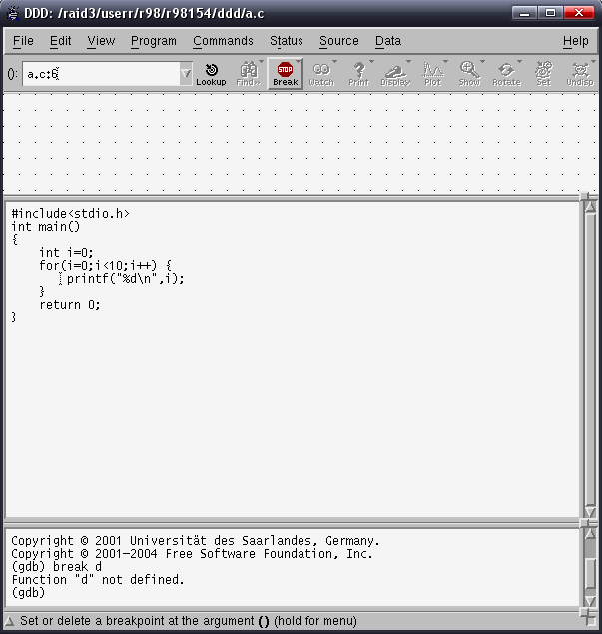

Click run to run program
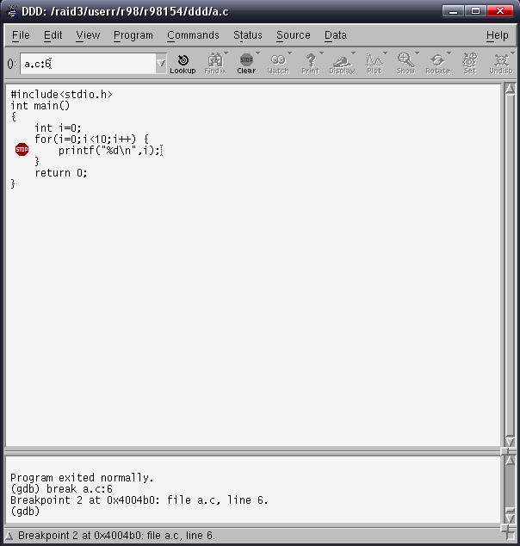
Click next to run program and it will stop at break point.
We can see that output console print variable i is 0.
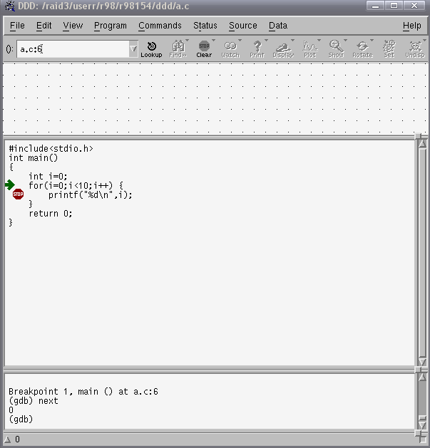
Continue to run program click Next or click Step to run program step by step ( line by line)
We also can see local variable by choosing view->Data windows and Data->Display Local Variables
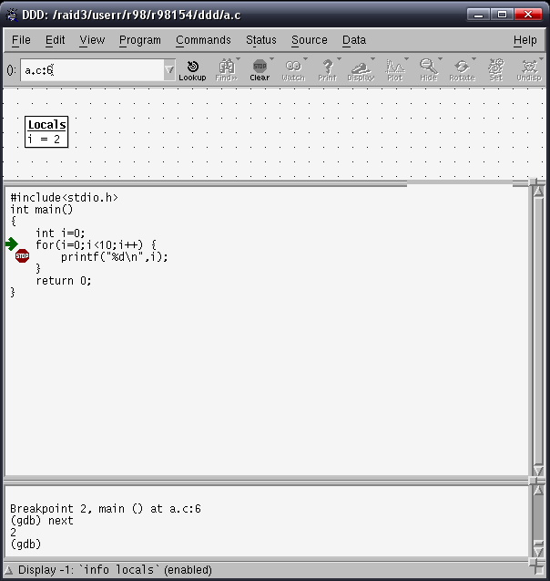

6.2 Segmentation fault example
Compile the outOfRang.cpp code. Try to run it and you will see segmentation fault because the array is out of range. Start ddd to debug this problem. Just click run and it will indicate the problem in source code.
We can find that it is out of index range.
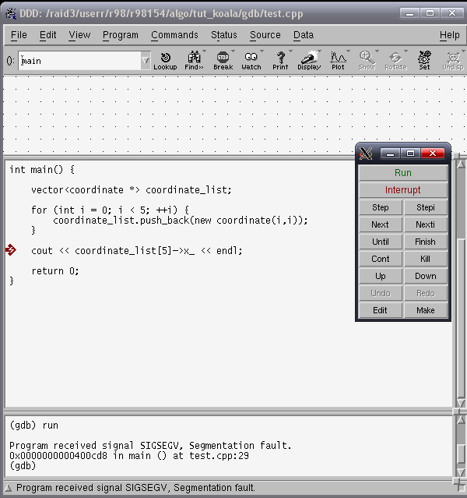
Using DDD to debug is too slow, so you can use gdb without gui.
Learn more about gdb
http://www.gnu.org/software/gdb/
http://www.cis.nctu.edu.tw/~is93007/acd.htm

6.3 Other Debuggers
You can also use other debuggers to debug your codes on windows. For example, Microsoft Visual Studio has a much more powerful and user-friendly debugger. However, the same source code might behave differently in different environment, even your program is correct in windows, it might not be correct on EDAUnion. Please make sure your program runs correctly on EDAUnion servers.

