FOUNDATION FOR INTELLIGENT PHYSICAL AGENTS

FIPA Modeling: Agent Class Diagrams

Document title | FIPA Modeling: Agent Class Diagrams
Document number | TBA | Document source | FIPA TC Modeling
Document status | Preliminary | Date of this status | 2003/mm/dd
Supersedes
Contact | M.P.Huget@csc.liv.ac.uk or Bernhard.Bauer@informatik.uni-augsburg.de
Change history
2003/mm/dd | First proposal

© 2000 Foundation for Intelligent Physical Agents - http://www.fipa.org/
Geneva, Switzerland
Notice
Use of the technologies described in this specification may infringe patents, copyrights or other intellectual property rights of FIPA Members and non-members. Nothing in this specification should be construed as granting permission to use any of the technologies described. Anyone planning to make use of technology covered by the intellectual property rights of others should first obtain permission from the holder(s) of the rights. FIPA strongly encourages anyone implementing any part of this specification to determine first whether part(s) sought to be implemented are covered by the intellectual property of others, and, if so, to obtain appropriate licenses or other permission from the holder(s) of such intellectual property prior to implementation. This specification is subject to change without notice. Neither FIPA nor any of its Members accept any responsibility whatsoever for damages or liability, direct or consequential, which may result from the use of this specification.
Foreword
The Foundation for Intelligent Physical Agents (FIPA) is an international organization that is dedicated to promoting the industry of intelligent agents by openly developing specifications supporting interoperability among agents and agent-based applications. This occurs through open collaboration among its member organizations, which are companies and universities that are active in the field of agents. FIPA makes the results of its activities available to all interested parties and intends to contribute its results to the appropriate formal standards bodies.
The members of FIPA are individually and collectively committed to open competition in the development of agent-based applications, services and equipment. Membership in FIPA is open to any corporation and individual firm, partnership, governmental body or international organization without restriction. In particular, members are not bound to implement or use specific agent-based standards, recommendations and FIPA specifications by virtue of their participation in FIPA.
The FIPA specifications are developed through direct involvement of the FIPA membership. The status of a specification can be either Preliminary, Experimental, Standard, Deprecated or Obsolete. More detail about the process of specification may be found in the FIPA Procedures for Technical Work. A complete overview of the FIPA specifications and their current status may be found in the FIPA List of Specifications. A list of terms and abbreviations used in the FIPA specifications may be found in the FIPA Glossary.
FIPA is a non-profit association registered in Geneva, Switzerland. As of January 2000, the 56 members of FIPA represented 17 countries worldwide. Further information about FIPA as an organization, membership information, FIPA specifications and upcoming meetings may be found at http://www.fipa.org/.

1 Scope 1
2 What is an agent? 2
3 Generic agent definition 3
4 Agent class diagram attributes 4
4.1 Capabilities Description 4
4.1.1 Content 4
4.1.2 Notation 4
4.1.3 Examples 4
4.2 Service Description 4
4.2.1 Content 4
4.2.2 Notation 4
4.2.3 Examples 4
4.3 Protocol Description 4
4.3.1 Content 4
4.3.2 Notation 4
4.3.3 Examples 4
4.4 Agent Communication Language Description 4
4.4.1 Content 4
4.4.2 Notation 5
4.4.3 Examples 5
4.5 Accepted Communicative Acts Description 5
4.5.1 Content 5
4.5.2 Notation 5
4.5.3 Examples 6
4.6 Ontology Description 6
4.6.1 Content 6
4.6.2 Notation 6
4.6.3 Examples 6
4.7 Knowledge Description 6
4.7.1 Content 6
4.7.2 Notation 6
4.7.3 Examples 6
4.8 BDI Modalities Description 6
4.8.1 Content 6
4.8.2 Notation 6
4.8.3 Examples 6
4.9 Goals Description 6
4.9.1 Content 6
4.9.2 Notation 6
4.9.3 Examples 6
4.10 Actions Description 6
4.10.1 Content 6
4.10.2 Notation 6
4.10.3 Examples 6
4.11 Events Description 6
4.11.1 Content 6
4.11.2 Notation 6
4.11.3 Examples 6
4.12 Mobility Description 7
4.12.1 Content 7
4.12.2 Notation 7
4.12.3 Examples 7
4.13 Persistence Description 7
4.13.1 Content 7
4.13.2 Notation 7
4.13.3 Examples 7
5 Specific agent definitions 7
5.1 Reactive agents 7
5.2 Hybrid agents 7
5.3 BDI agents 7
6 Graphical notation 7
7 References 8

Scope
This document contains specifications for the FIPA AUML Agent Class Diagrams. The FIPA AUML Agent Class diagrams are based on UML class diagrams. UML defines as follows a class diagram: “A diagram that shows a collection of declarative (static) model elements such as classes, types, and their contents and relationships” [Booch, 1999]. Due to the relative complexity of agent design and the many differences that exist between an agent and an object [Odell, 2002], FIPA AUML class diagrams extend UML class diagrams to cover needs for agent design. In the context of agents and multiagent systems, FIPA AUML class diagrams describe the agents and their architectures.

What is an agent?
At present, there is no common agreement on the term agent and what it encompasses. Wooldridge and Jennings define the term agent as follows:
“a hardware or (more usually) software-based computer system that enjoys the following properties:
- autonomy: agents operate without the direct intervention of humans or others, and have some kind of control over their actions and internal state;
- social ability: agents interact with other agents (and possibly humans) via some kind of agent-communication language;
- reactivity: agents perceive their environment, (which may be the physical world, a user via a graphical user interface, a collection of other agents, the INTERNET, or perhaps all of these combined), and respond in a timely fashion to changes that occur in it;
- pro-activeness: agents do not simply act in response to their environment, they are able to exhibit goal-directed behaviour by taking the initiative” [Wooldridge, 1995]
A second more recent definition can be found in [Wooldridge, 2002]:
“An agent is a computer system that is situated in some environment, and that is capable of autonomous action in this environment in order to meet its design objectives”

Defining the term agent is frequently biased by what are the intentions of who defines it and what kind of agents, s/he decides to design. Maybe Russell and Norvig’s answer is the most true: “The notion of an agent is meant to be a tool for analysing systems, not an absolute characterization that divides the world into agents and non-agents” [Russell, 1995]. It is not possible to give a definition that will please everybody. However, it is possible to extract some characteristics that agents exhibits:

- autonomy: agents act without external interventions (humans or agents). Agents can say ‘go’ [Odell, 2000];
- situated: agents are situated in a real or virtual environment;
- reactivity: agents perceive the environment and act in this environment;
- pro-activity: agents do not simply act in response to their environment but they are able to define goals and plans to achieve their objectives;
- social ability: agents interact with other agents (and possibly humans) via some kind of agent communication language;
- intelligent: agents encompass knowledge (beliefs, desires, intentions and goals);
- organized: agents are organized into societies that follow structures defined in human or in ecological societies;
- mobile: agents are able to move from sites to sites. Moving implies that both code and mental states follow the agent.

Several agent types exist in the literature:
- reactive agent: these agents are based on work done in ethology—ants for instance—and describe agents that have a perception/action cycle. They receive stimuli from the environment then react to them by modifying their behaviours and possibly, the environment. Reactive agents do not have knowledge and representation of their world. Agents interact with other agents through really simple communication mechanisms such as pheromones;
- hybrid agent: these agents encompass reactive behaviours as defined above and deliberative behaviours. Their cycle is perception/decision/action. Agents perceive their environment, make some assumptions on it, then react by modifying their behaviours and possibly, the environment. Agents handle knowledge about themselves, the environment and other agents. Agents communicate with other agents through communicative acts and agent communication languages;
- BDI agent: even if BDI agents are distinguished from hybrid agents, they are not different since they have as well reactive skills. A BDI agent is an agent that has beliefs, desires and intentions [Wooldridge, 2000]. [Certainly a little paragraph on BDI, try to find a description somewhere]. Agents perceive their environment, have a representation of it and can react to environment modifications. Agents communicate with other agents through communicative acts and agent communication language.
[Is this taxonomy correct? Do we have to put mobile agents as another type?]

Generic agent definition
Section 2 described what is an agent and particularly, some possible different types of agents: reactive, hybrid and BDI. Even if these agents are different in their purpose, they contain some common characteristics: identifier, role and organization. This section presents a generic agent class diagram that exhibits these common characteristics. In Section 5, we will present specific agent types such as the ones defined in Section 2. These specific agents will be derived from the generic agent. [Do we need to use the word abstract instead of generic?]

Three characteristics seem to belong to all the different agent types:
- identifier: this characteristics uniquely identify each agent in the multiagent system. Such examples are Mario or Mario:1099@acme.org
- role: a role defines the behaviour of an agent into the society, for instance, Seller or Buyer. Agents can have multiple roles in the multiagent system or they can change from role to role during the execution of the multiagent system. UML refers this point as, respectively, multiple and dynamic classification. Multiple and dynamic roles in the context of multiagent systems are explained in [Odell, 2003]
- organization: agents evolving in multiagent systems belong to one or several organizations. These organizations define the agent roles and the relationships between these roles. Organizations adhere generally to human or animal organizations such as hierarchies, markets, groups of interest or herds.

The generic agent class diagram is rendered as follows (as shown in Figure 1): the agent class diagram is depicted as a rectangle that contains the attributes associated to the agent, here the identifier, the roles and the organizations. Each attribute is stored in a compartment. UML class diagram extensibility allows designers to define as many compartments as they need and in any order they want. For sake of presentation, this specification will always follow the same presentation defined below.

The first compartment contains the agent identifier preceded by the stereotype <<agent>>. The stereotype <<agent>> is added to ease the distinction between agent class diagrams and class diagrams.

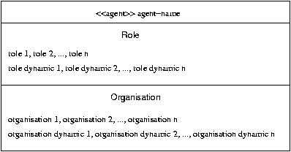
Figure 1: Generic Agent Notation

[I remove agent class, I am not sure that this information will appear here since normally if an agent inherits from another class, this information should appear as a generalization]
The second compartment describes the roles played by the agent. The keyword role is used to denote the compartment. Two pieces of information appear in this compartment: (1) the set of roles that the agent can play during its execution and (2) the role dynamics. As stated in [Odell, 2003], agents can use multiple and dynamic role classification. It means that agents can play several roles at the same moment or they can leave a role to another one. The role dynamics depicts which roles can be performed concurrently and what the conditions to move from one role to another one based on the current roles in which the agent is involved. Role dynamics is denoted as a set of automata defined outside the agent class diagram.
The last compartment deals with the organisations. It defines in which organisations the agent is involved. The keyword organisation is used to denote the compartment. Two pieces of information appear in this compartment: (1) the set of organisations in which the agent is involved and (2)_the organisation dynamics. Agents can belong to several organisations as the same moment; the set of organisations give the list of organisations in which the agent can enter in a past, present or future moment. The organisation dynamics describes under what conditions the agent can be involved in an organisation or move from one organisation to another one. The organisation dynamics is depicted through automata.
This generic agent class diagram makes neither assumptions about the agent architecture (reactive agent, hybrid agent or BDI agent). This point will be addressed when this generic agent will be instantiated to a specific agent type as sketched in Section 5 nor how this generic agent is implemented. It does not describe how roles are defined within the agents. [That’s a problem for me, I don’t know how to manage abstraction level since we can have really two different agents according we consider this high-level view or a programmatic view. Any idea to put together these two conflicting views? Do we need to address how to pass from a high-level view to a programmatic view?]

Agent class diagram attributes

Capability Description

Content
A capability in multiagent systems describe what an agent is able to do and under what conditions. Wickler in his thesis addressed the question of capability and its representation through a language called Capability Description Language (CDL) [Wickler, 1999].
- input : this part of the capability representation specifies the objects an agent possessing this capability receives as inputs to this capability. This part of the representation will be a syntactically defined expression containing symbolic variables with the actual inputs will have to match ;
- output : this part of the capability representation specifies the objects that will be the outputs this capability generates. Again, this part of the representation will be a syntactically defined expression containing symbolic variables with the actual outputs will have to match ;
- input constraints : this part of the capability representation defines the constraints that are expected to hold in the situation before the capability can be performed, i.e. the constraints for the capability to be applicable. Free variables in these constraints can only be from the syntactic expression which describes the inputs ;
- output constraints : this part of the capability representation defines the constraints that are expected to hold in the situation after the capability has been performed. Free variables in these constraints can only be from the syntactic expression which describes the inputs ;
- input-output constraints ; this part of the representation describes the constraints across input and output situations that must hold. Free variables in these constraints can be from the expressions describing the inputs or the outputs.
We would like to add name that identifies the capability and description that gives a natural language description of the capability to this capability description.

Notation
Capabilities are defined as associated classes [I use link for the moment since I don’t know exactly how to cast this relationship : is it an association or a dependency ?] to the agent class diagrams as shown on Figure 2. The first compartment contains the stereotype <<capability>> to identify the class as capability and the capability name. It follows seven compartments : compartment 2 with the inputs for the capability, compartment 3 for the outputs, compartment 4 for the input constraints, compartment 5 for the output constraints, compartment 6 for the input-output constraints and finally compartment 7 for the description.

Inputs and outputs are defined as attributes in class diagrams. Input constraints, output constraints and input-output constraints might be defined as OCL expression or logical expression as sketched in Figure 2.

Examples
Figure 2 gives the example of an agent called sum that has two capabilities : addition and substraction. In both capabilities, the input variables are two integers x and y. The output variable for the addition capability is s and d for the substraction capability. Both are integers. The substraction capability add one input constraints : x and y must be positive and an input-output constraints : the substraction between x and y must be positive or null.
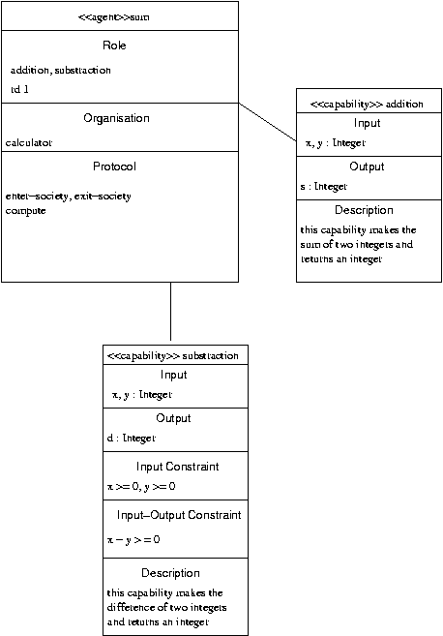
Figure 2 : Capability Description Notation

Service Description

Content
A service is an activity that an agent can perform and is provided to other agents. Such services can be for instance computing an addition or booking multi-leg travel. [My definition is rather simple and weak. Don’t find one for the moment…]
Several pieces of information appear in a service description as defined in FIPA [Don ‘t find what is the document number] :
- name: the name of the service
- description : a description in natural language of the service
- type: the type of the service
- protocol: a list of interaction protocols supported by the service
- agent communication language : a list of agent communication languages used in this service
- ontology: a list of ontologies supported by the service
- content language: a list of content languages supported by the service
- properties: a list of properties that discriminate the service

Notation
A service description is defined as an associated class to the agent class diagram as depicted in Figure 3. This service class is composed of nine compartments corresponding to the fields given above. The first compartment contains the stereotype <<service>> to identify this class as a service description followed by the service name. The compartment description is defined as a text. The compartment type gives a string corresponding to the type of the service. The compartment protocol gives the list of protocols. These protocols must be defined elsewhere through an interaction diagram. [I don’t know how accurate we need to be, find quite stupid that a list is composed of text strings, etc. I know it is a specification, maybe we can do that after finding agreement on content]

Examples
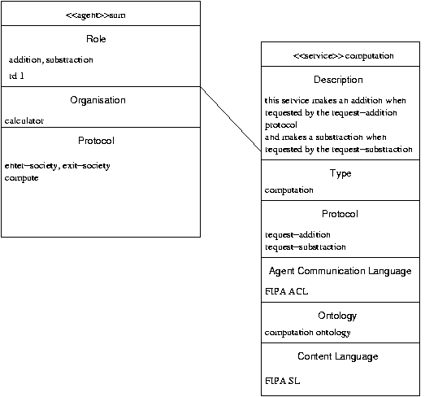
Figure 3 : Service Description Notation

Protocol Description

Content
Interaction protocols are the most usual medium for agents to communicative with other agents. Since interaction protocols can be consequent, the aim of this attribute is not to describe the different protocols—designers can use to this purpose the FIPA Interaction diagrams—but to refer to them. Agents in multiagent systems may play multiple roles and it is particularly the case in interaction protocols where an agent can both play the role of seller and the role of buyer. Designers can describe as well the roles played by the agents in a specific interaction protocol.

Notation
The protocol description is given as a compartment in agent class diagrams prepended by the stereotype <<protocol>>. Each line in this compartment is defined as follows:
protocol name: role₁, role₂,..,role_{n}
protocol name corresponds to the name of the protocol. Agent class diagrams assume that this protocol is defined elsewhere. role₁, role₂,..,role_{n} correspond to the different roles that the agent played in this protocol. A comma separates each role from others. The roles defined in agent class diagrams should match the roles defined in the interaction protocols.

Examples

Agent Communication Language Description

Content
In order to communicate with other agents, agents use protocols and a specific agent communication language that describes the semantics associated to communicative acts. It means that if agents are using FIPA ACL and the communicative act inform, the sender believes the content of the message and it believes as well that the recipients do not know the content.

The piece of information agent communication language is of great importance to allow interoperability between agents as well as ontologies defined in Section 4.6. At moment, there is two major agent communication languages: KQML and FIPA ACL.

If agents strictly conform to the agent communication language, there is no need to add more information. If agents use specific communicative acts that are not included into the agent communication language, designers have to provide these different communicative acts, a short description in natural language and the semantics attached to this communicative act.

Notation
The agent communication language is written as a string in agent class diagrams prepended by the stereotype <<acl>>, for instance: <<acl>> FIPA ACL. When agents employ communicative acts that are not in the agent communication language, designers have to provide an attached document containing the different communicative acts, a short description, the content of the message and the semantics. A possible structure for the document could be:

Communicative act name: name of the communicative act added to the agent communication language. The name is written as a string.
Description: description of the intent of this communicative act in natural language. The description is written as a text.
Message content: description of the content associated to this communicative act.
Semantics: description of the intent of this communicative act through a set of mathematical formulae. Designers can use SL to this purpose.

The document is linked to the agent class diagrams by the stereotype <<ca document>>.

Examples

Accepted Communicative Acts Description

Content
Generally, agents use interaction protocols to communicate with other agents but it is also possible that agents just need to send a message outside protocols, for instance to inform an agent every cycle of time. Using a protocol in this case will be cumbersome. The aim of this attribute is to describe all the communicative acts that are accepted to send and receive without referring to a protocol.

Notation
The compartment for the accepted communicative acts is prepended by the stereotype <<ca>>, then follows a list of communicative acts. A string corresponding to the document reference if the communicative act does not belong to an agent communication language follows the communicative act.

Examples

Ontology Description

Content

Notation

Examples

Knowledge Description

Content

Notation

Examples

BDI Modalities Description

Content

Notation

Examples

Goals Description

Content

Notation

Examples

Actions Description

Content

Notation

Examples

Events Description

Content

Notation

Examples

Mobility Description

Content

Notation

Examples

Persistence Description

Content
User and interface agents are two specific kinds of agents that need to store data and context to be retrieved and reactivated when required hence called persistent agents. Persistent agents have to be distinguished from agents that store data since in this case, persistent agents can be shut down and reactivated; agents still have their ongoing processes and their mental states. The aim of this attribute is to store whether the agent is persistent.

Notation
Persistent agents are defined through the stereotype <<persistent>>. To clarify the agent class diagram, it is better to put this attribute in the attribute compartment.

Examples

Specific agent definitions

Reactive agents

Hybrid agents

BDI agents

Graphical notation

References
[Bauer, 2000]
[Booch, 1999]
[Huget, 2002]
[Odell, 2000]
[Odell, 2002]
[Odell, 2003]
[Russell, 1995]
[Wickler, 1999]
[Wooldridge, 1995]
[Wooldridge, 2000]
[Wooldridge, 2002]

We gather characteristics either for reactive agents, hybrid agents or BDI agents.

