Equations written in Word (Office Math)
The quadratic formula:
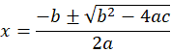
Euler's identity, inline in a sentence:
A sum:
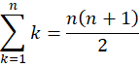
A Gaussian integral:
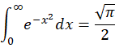
A limit:
A matrix:
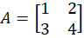
Maxwell (Greek and vectors):
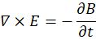
Text after the equations: the end.

