Usecase Analyse

Client
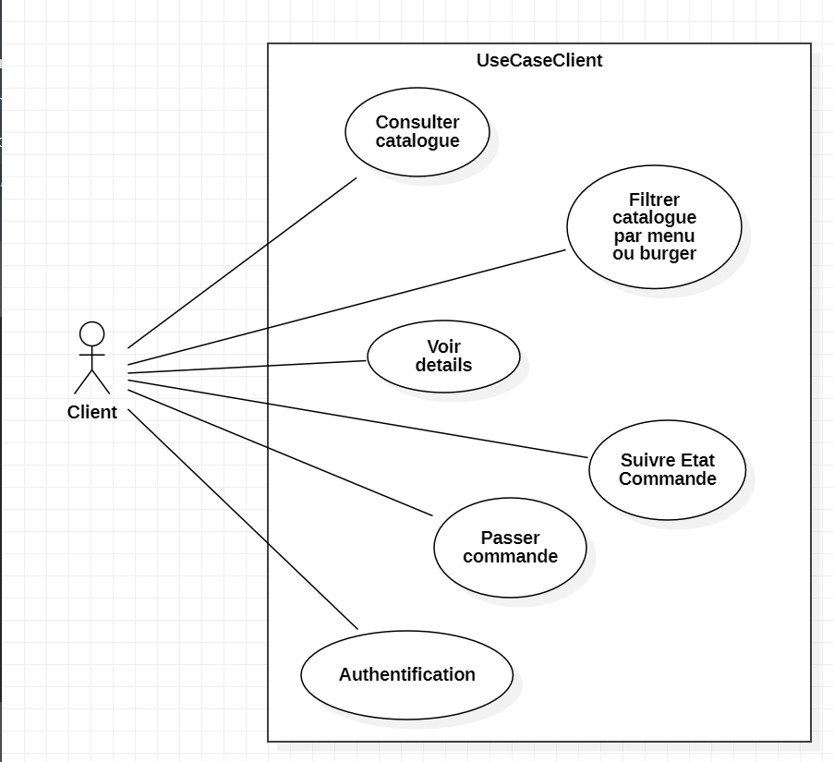
Gestionnaire
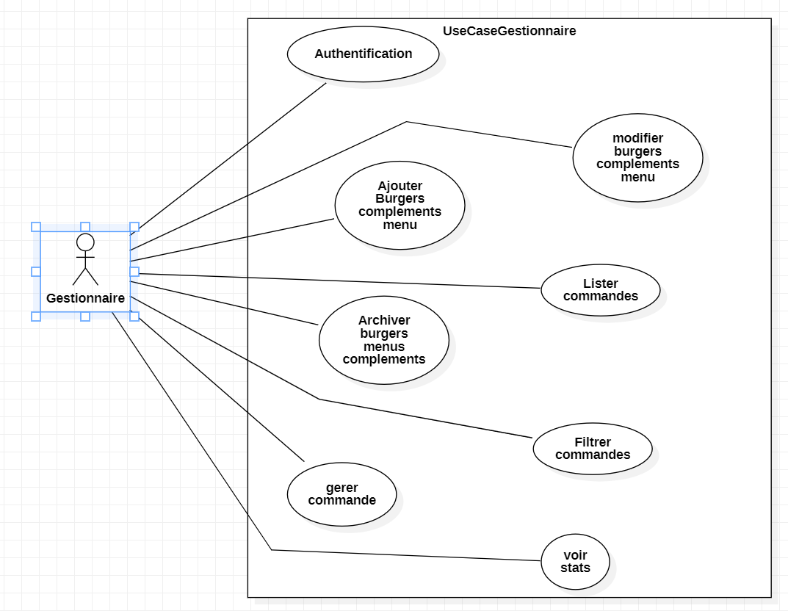

UseCase Conception

Client
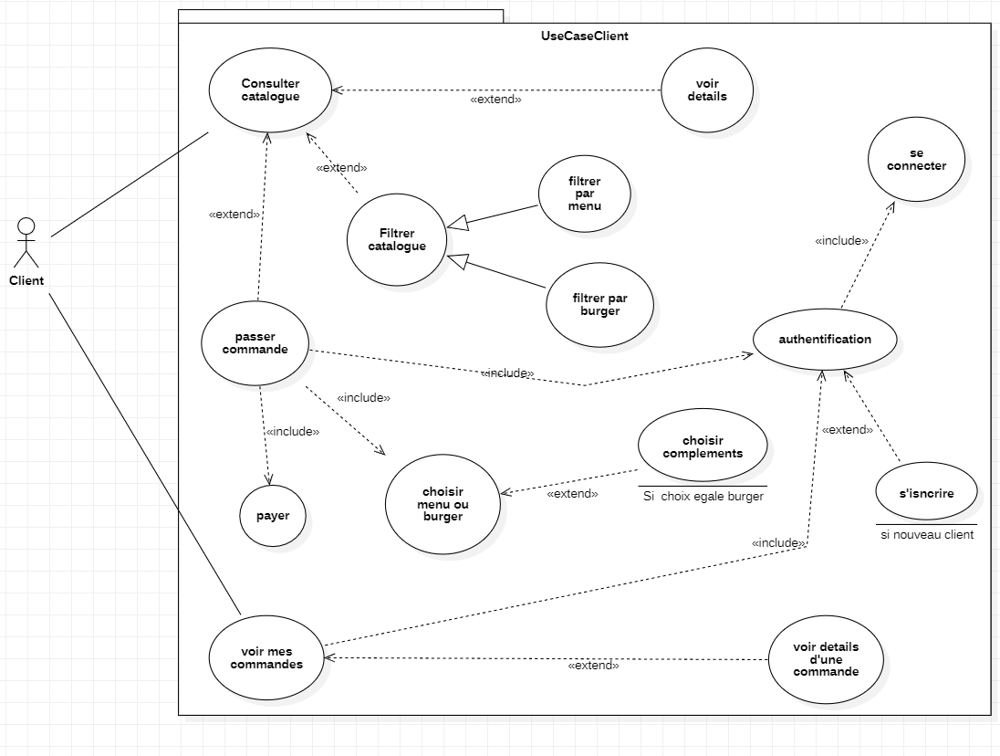

Gestionnaire
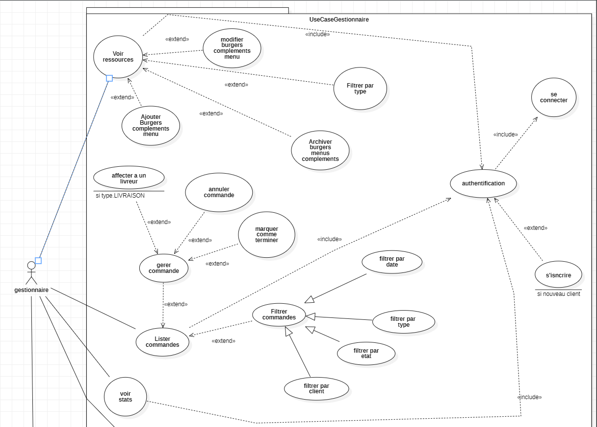
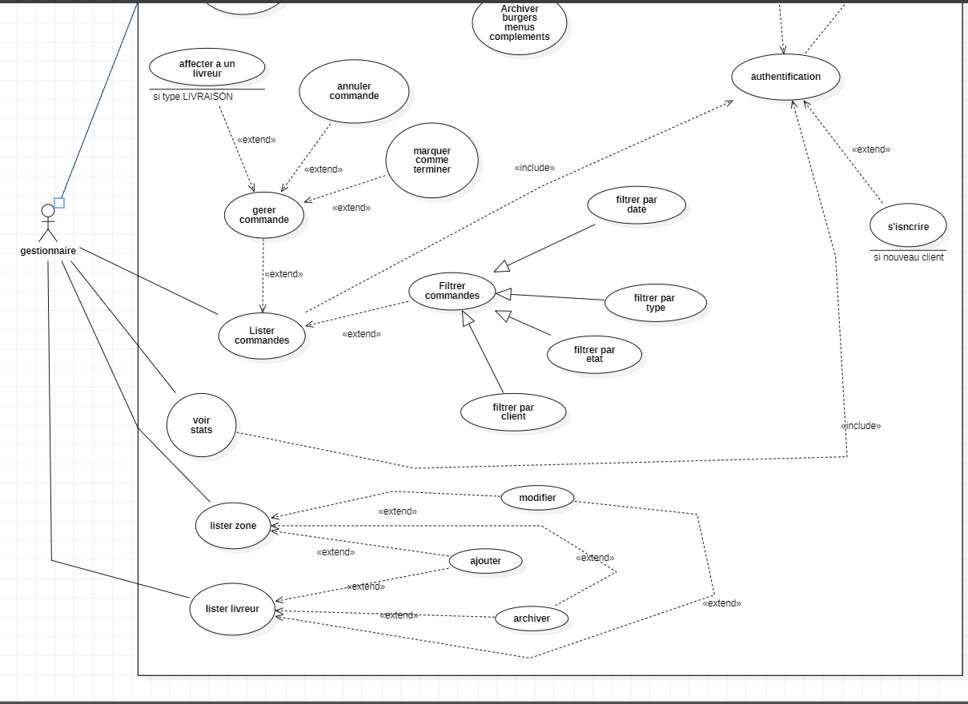

Class Diagram Analyse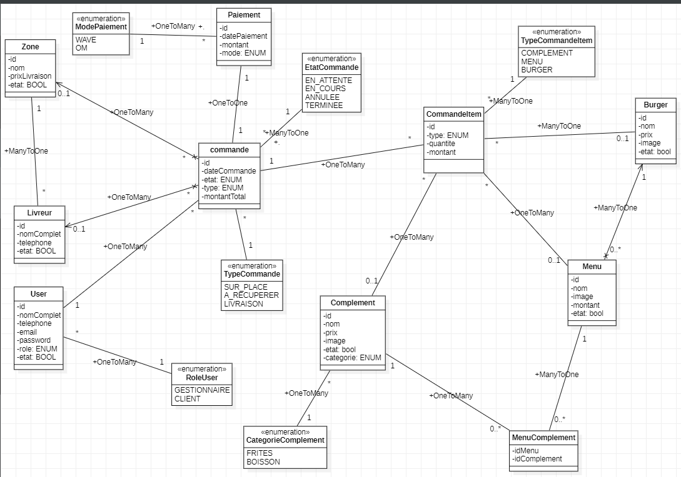

Classe Diagram Java

Entity
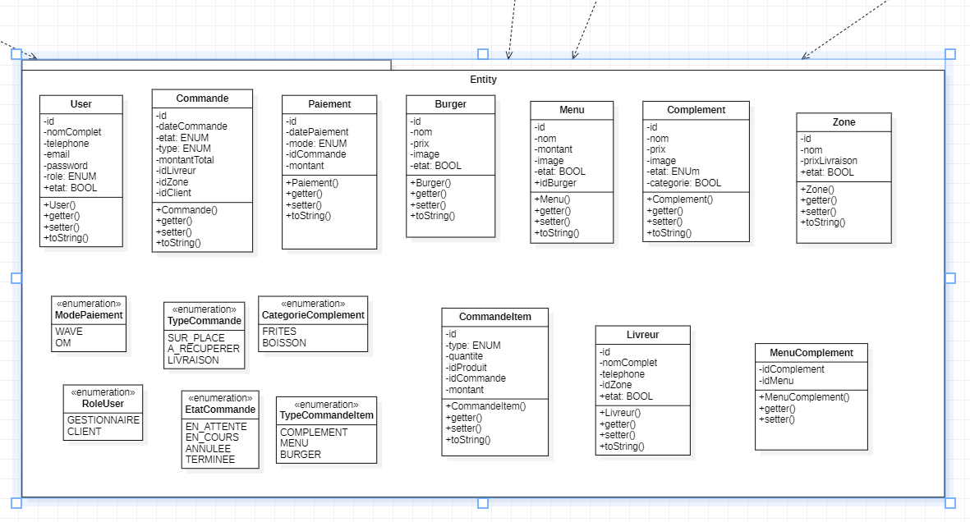

Repository et Services
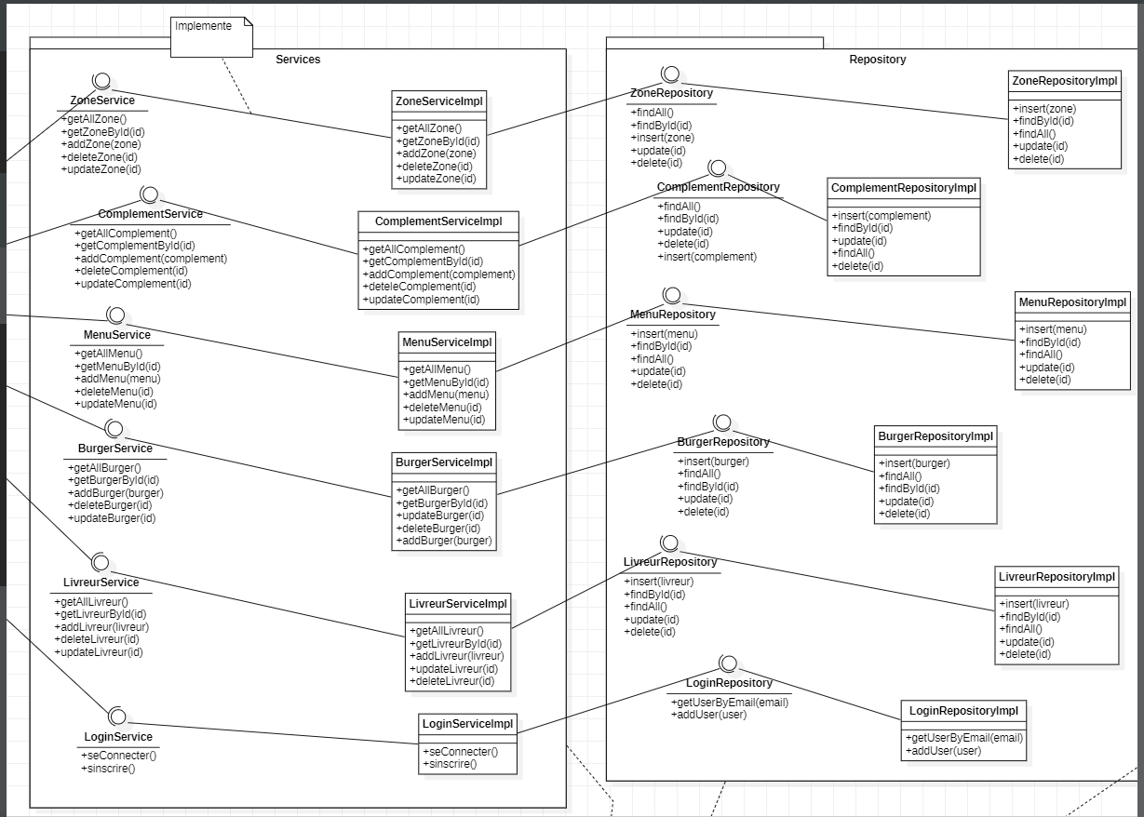

Views
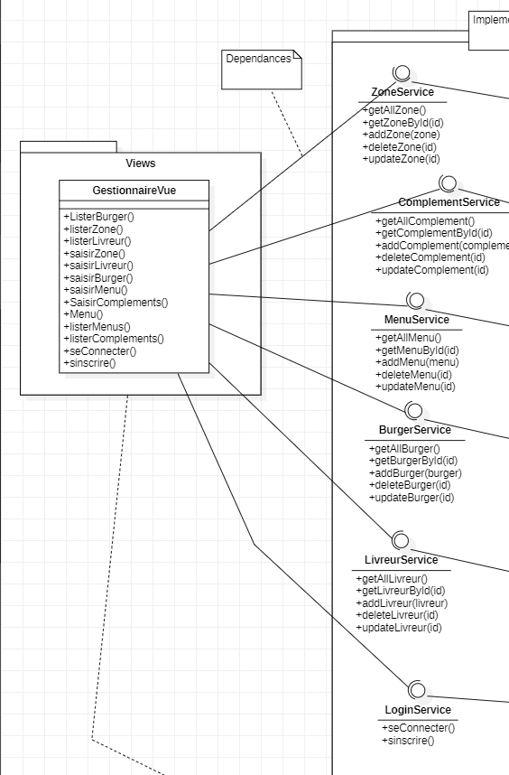

Config
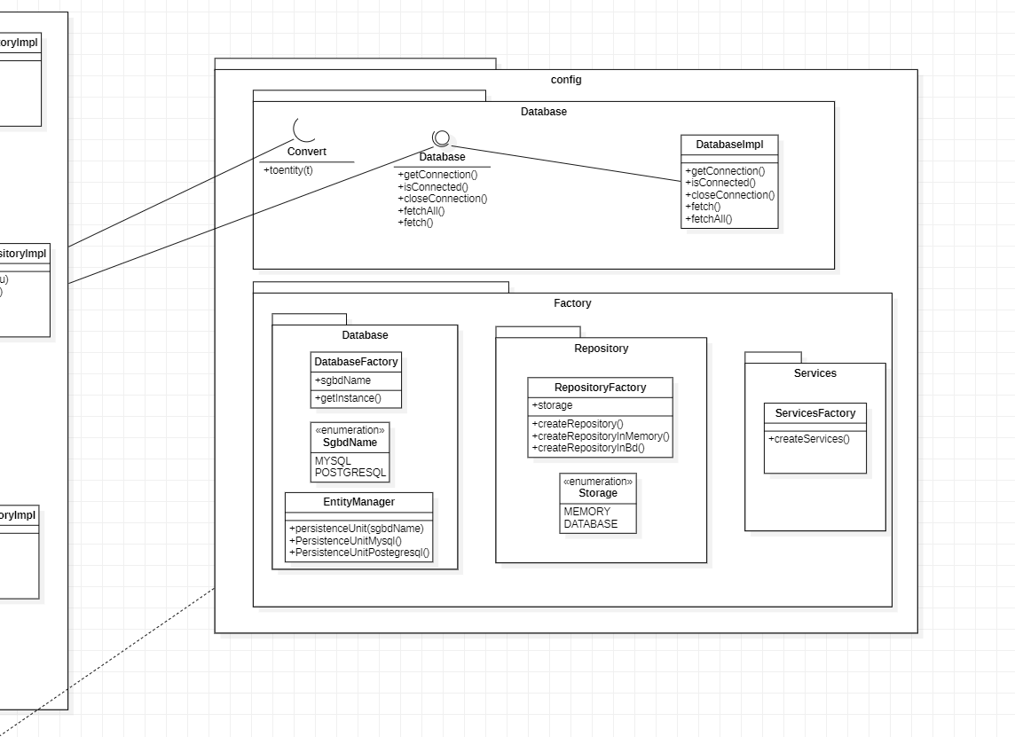

Classe Diagram C#

Models
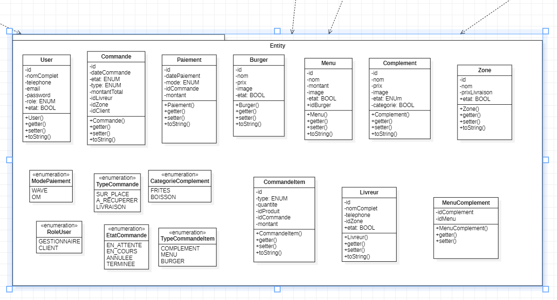
Data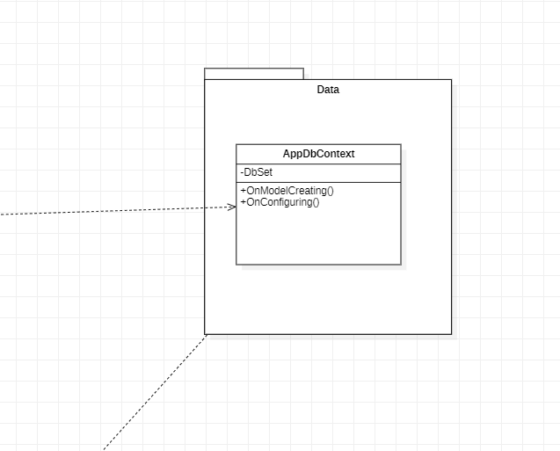

Services
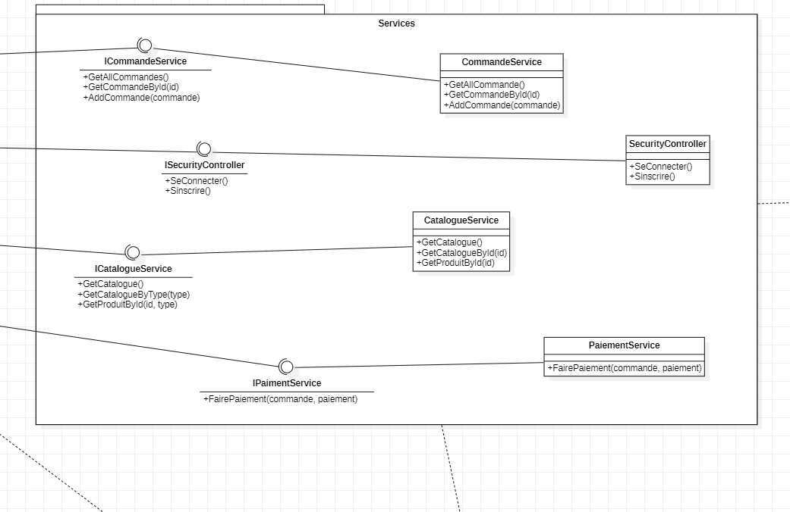

Controllers
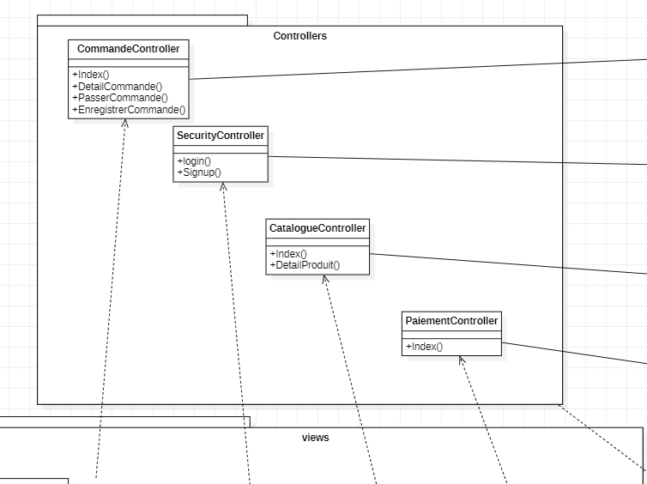

Views
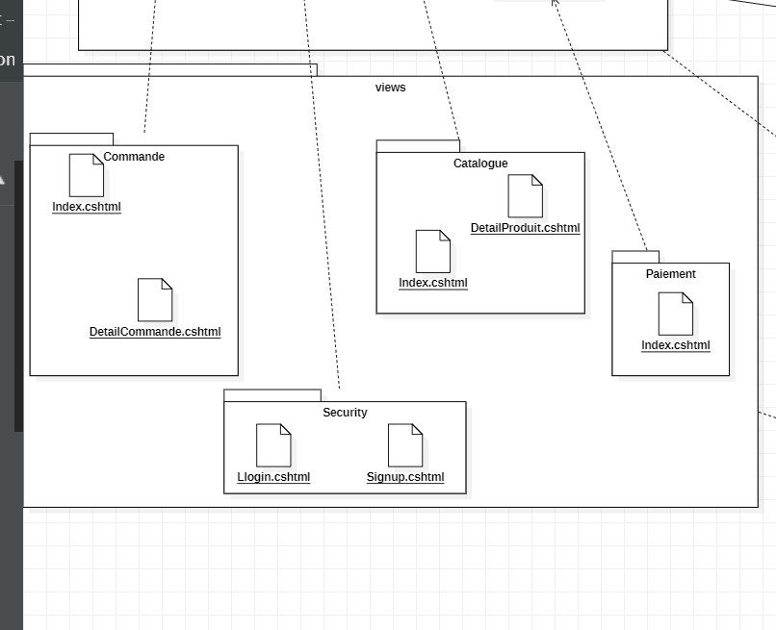

Classe Diagram Symfony

Entity


Services
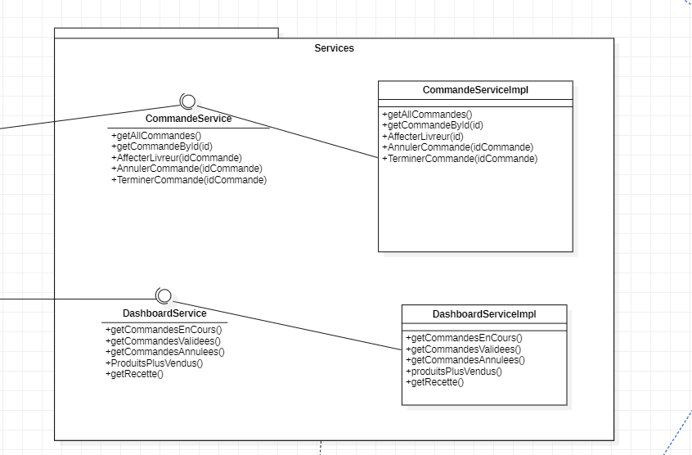

Controller
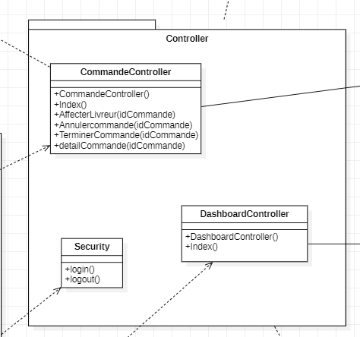

Form
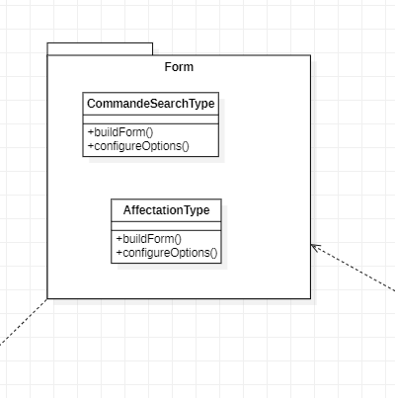

DTO

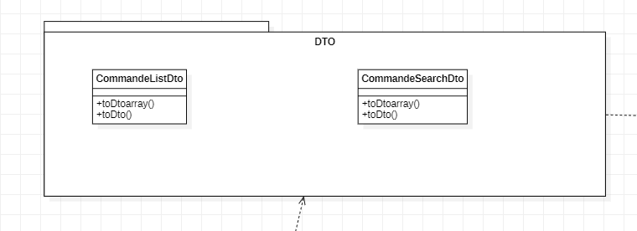

Templates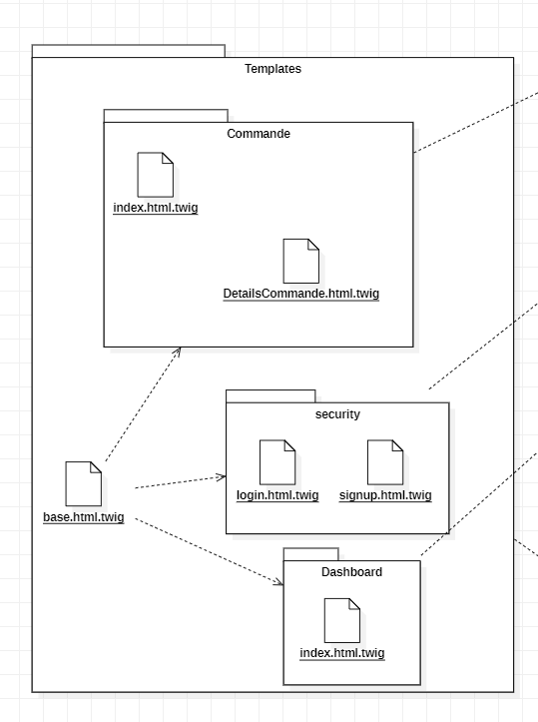

MLD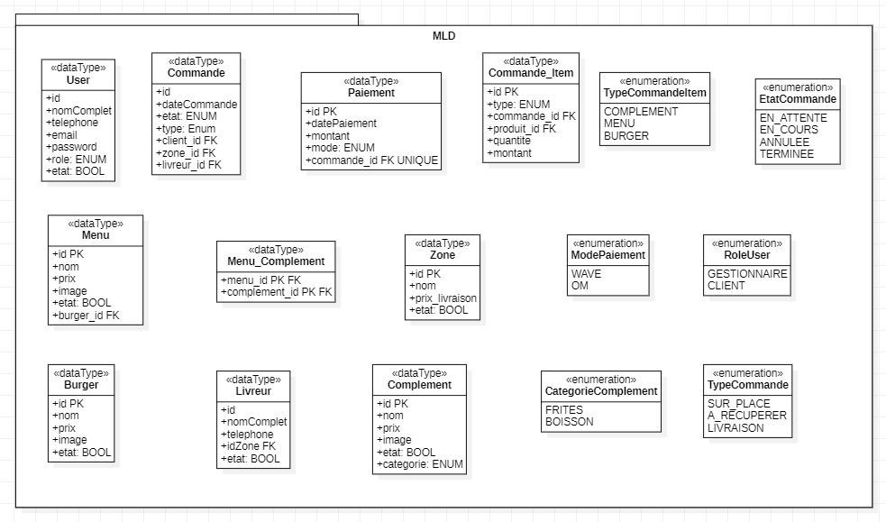

Sequence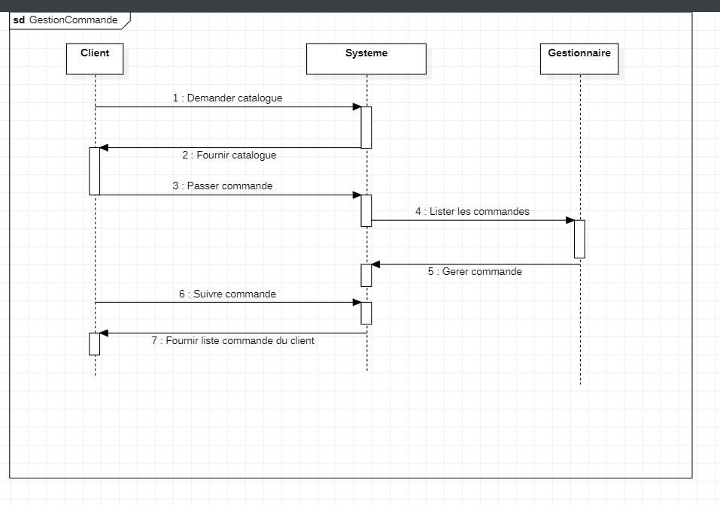

Script SQL

-- DATABASE : BRASIL BURGER
-- SGBD : PostgreSQL

DROP DATABASE IF EXISTS brasilBurger;
CREATE DATABASE brasilBurger;
\c brasilBurger;

-- ENUMS
CREATE TYPE mode_paiement AS ENUM ('OM', 'WAVE');
CREATE TYPE role_user AS ENUM ('GESTIONNAIRE', 'CLIENT');
CREATE TYPE type_commande AS ENUM ('SUR_PLACE', 'A_RECUPERER', 'LIVRAISON');
CREATE TYPE etat_commande AS ENUM ('EN_ATTENTE', 'EN_COURS', 'TERMINEE', 'ANNULEE');
CREATE TYPE categorie_complement AS ENUM ('FRITES', 'BOISSON');
CREATE TYPE type_commande_item AS ENUM ('BURGER', 'MENU', 'COMPLEMENT');

-- TABLES

-- User
CREATE TABLE "user" (
id SERIAL PRIMARY KEY,
nom_complet VARCHAR(150) NOT NULL,
telephone VARCHAR(20) UNIQUE NOT NULL CHECK (telephone <> ''),
email VARCHAR(150) UNIQUE NOT NULL CHECK (email <> ''),
password VARCHAR(255) NOT NULL,
role role_user NOT NULL,
etat BOOLEAN NOT NULL DEFAULT TRUE
);

-- Zone
CREATE TABLE zone (
id SERIAL PRIMARY KEY,
nom VARCHAR(100) NOT NULL,
prix_livraison NUMERIC(10,2) NOT NULL CHECK (prix_livraison >= 0),
etat BOOLEAN NOT NULL DEFAULT TRUE
);

-- Livreur
CREATE TABLE livreur (
id SERIAL PRIMARY KEY,
nom_complet VARCHAR(150) NOT NULL,
telephone VARCHAR(20) UNIQUE NOT NULL CHECK (telephone <> ''),
zone_id INT NOT NULL REFERENCES zone(id) ON DELETE CASCADE,
etat BOOLEAN NOT NULL DEFAULT TRUE
);

-- Burger
CREATE TABLE burger (
id SERIAL PRIMARY KEY,
nom VARCHAR(150) NOT NULL,
prix NUMERIC(10,2) NOT NULL CHECK (prix >= 0),
image TEXT,
etat BOOLEAN NOT NULL DEFAULT TRUE
);

-- Menu
CREATE TABLE menu (
id SERIAL PRIMARY KEY,
nom VARCHAR(150) NOT NULL,
image TEXT,
etat BOOLEAN NOT NULL DEFAULT TRUE,
montant NUMERIC(10,2) NOT NULL CHECK (montant >= 0),
burger_id INT NOT NULL REFERENCES burger(id) ON DELETE CASCADE
);

-- Complement
CREATE TABLE complement (
id SERIAL PRIMARY KEY,
nom VARCHAR(150) NOT NULL,
prix NUMERIC(10,2) NOT NULL CHECK (prix >= 0),
image TEXT,
etat BOOLEAN NOT NULL DEFAULT TRUE,
categorie categorie_complement NOT NULL
);

-- MenuComplement (ManyToMany)
CREATE TABLE menu_complement (
menu_id INT NOT NULL REFERENCES menu(id) ON DELETE CASCADE,
complement_id INT NOT NULL REFERENCES complement(id) ON DELETE CASCADE,
PRIMARY KEY(menu_id, complement_id)
);

-- Commande
CREATE TABLE commande (
id SERIAL PRIMARY KEY,
dateCommande TIMESTAMP NOT NULL DEFAULT CURRENT_TIMESTAMP,
etat etat_commande NOT NULL DEFAULT 'EN_ATTENTE',
type type_commande NOT NULL,
montant_total NUMERIC(10,2) NOT NULL CHECK (montant_total >= 0),
client_id INT NOT NULL REFERENCES "user"(id),
zone_id INT REFERENCES zone(id),
livreur_id INT REFERENCES livreur(id)
);

-- CommandeItem
CREATE TABLE commande_item (
id SERIAL PRIMARY KEY,
commande_id INT NOT NULL REFERENCES commande(id) ON DELETE CASCADE,
type type_commande_item NOT NULL,
produit_id INT NOT NULL,
quantite INT NOT NULL CHECK (quantite > 0),
prix_unitaire NUMERIC(10,2) NOT NULL CHECK (prix_unitaire >= 0)
);

-- Paiement
CREATE TABLE paiement (
id SERIAL PRIMARY KEY,
date_paiement TIMESTAMP NOT NULL DEFAULT CURRENT_TIMESTAMP,
montant NUMERIC(10,2) NOT NULL CHECK (montant >= 0),
mode mode_paiement NOT NULL,
commande_id INT NOT NULL UNIQUE REFERENCES commande(id) ON DELETE CASCADE
);

-- INDEXES
CREATE INDEX idx_commande_client ON commande(client_id);
CREATE INDEX idx_commande_etat ON commande(etat);
CREATE INDEX idx_commande_date ON commande(dateCommande);
CREATE INDEX idx_commande_type ON commande(type);
CREATE INDEX idx_commande_zone ON commande(zone_id);
CREATE INDEX idx_item_commande ON commande_item(commande_id);
CREATE INDEX idx_item_type ON commande_item(type);

Maquette Figma

Lien de maquette: https://www.figma.com/design/XNQLPBfOKQTGRJNWlJvBRv/Brasil-Burger?node-id=5-1403&t=FlkwLD4AvoDVqVkG-1

