1- Hero section:
Hero section heading:
Intelligent AI Solutions for (white color)
- Construction Companies
- Facade Engineering
- Aluminium Manufacturers
- Engineering Consultants
- Project Management Teams
- Infrastructure Projects (all these in olive colour, and comes one after the other).
Paragraph existing.
CTA
Book Consultation
Explore Solutions
2- Who We help (Already done where you have shown trade cards).
3- Why Construction Companies Choose AI (design left)

4- Our Services
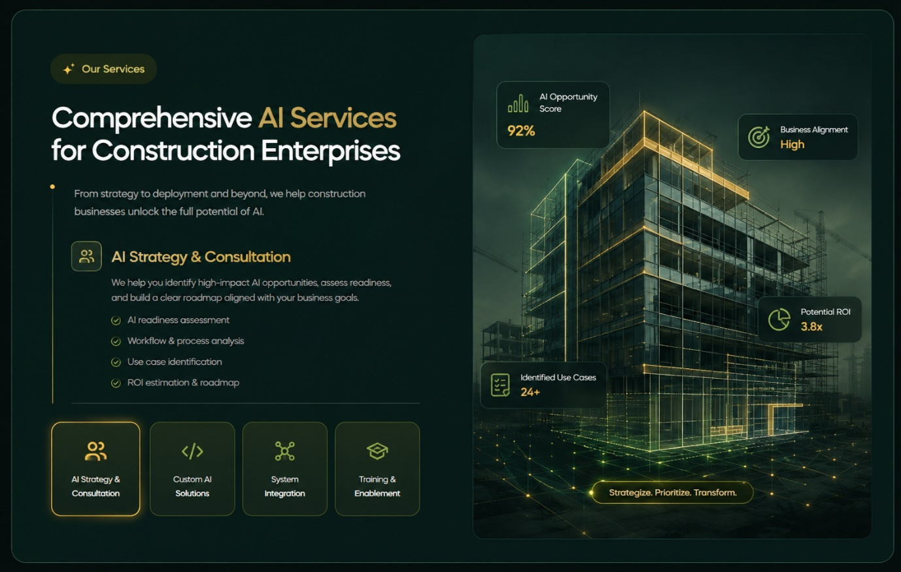
Make sure when user clicks on specific service button, it should show that service content. Keep the right side image same even if user switches between services.
Note:
I’ll provide the content to be written in service section later. I’ll also provide the image to be placed on right side. For now use the same content as written in the above image. Also use any stock image in right side.
5- Our featured Solutions, make cards like this. 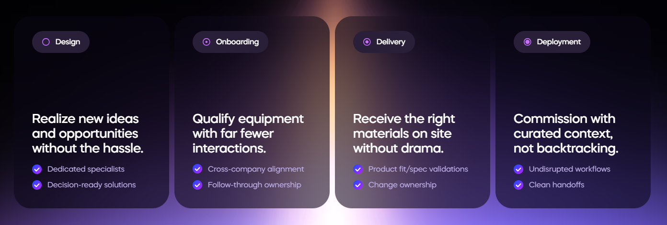
When user hovers over a card, it should show a button (view Solution), like Show me More button in the below image.
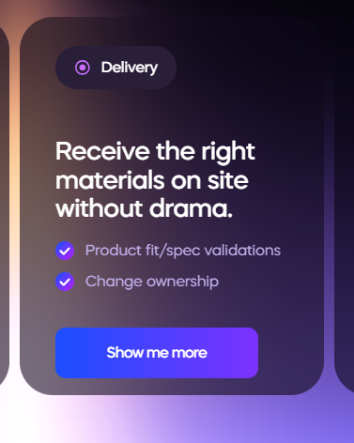
6- Our AI Transformation Framework
Make this section looks like Storyline
Discover -> Consult ->Design ->Develop -> Integrate -> Train -> Optimize
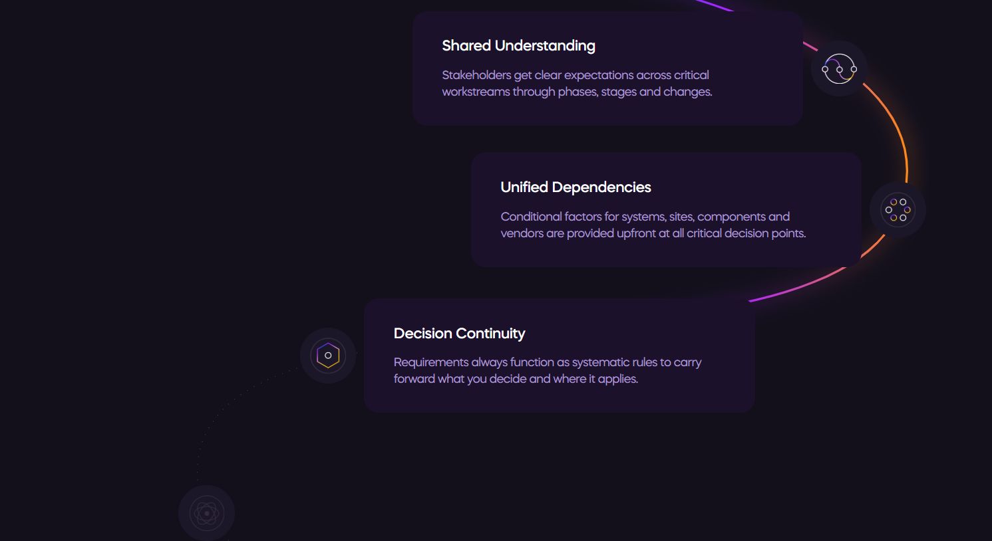
Use this content: (Don’t use the structure and style of the image below, just use its Text), but make the story line as given in the reference website (above image).
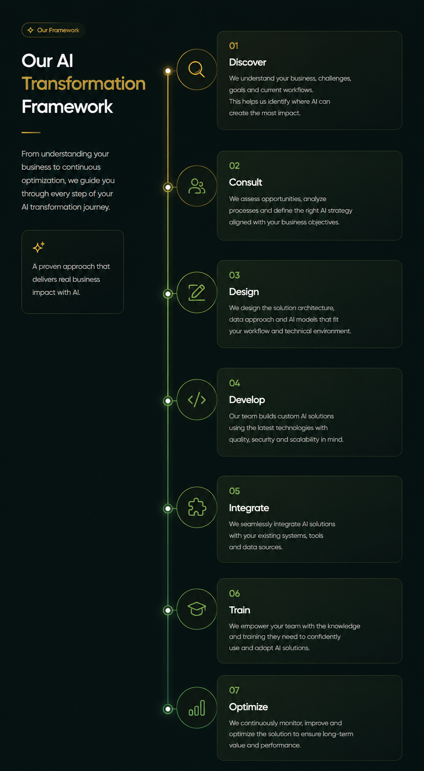

7- Trusted By section (You already done)
8- Why work with us (Design left)
9- FAQ section
Make FAQ section like this: (use any icon on the left side instead of color full graphics like this). When user clicks on down arrow , it should show the answer below like the first question in the image.
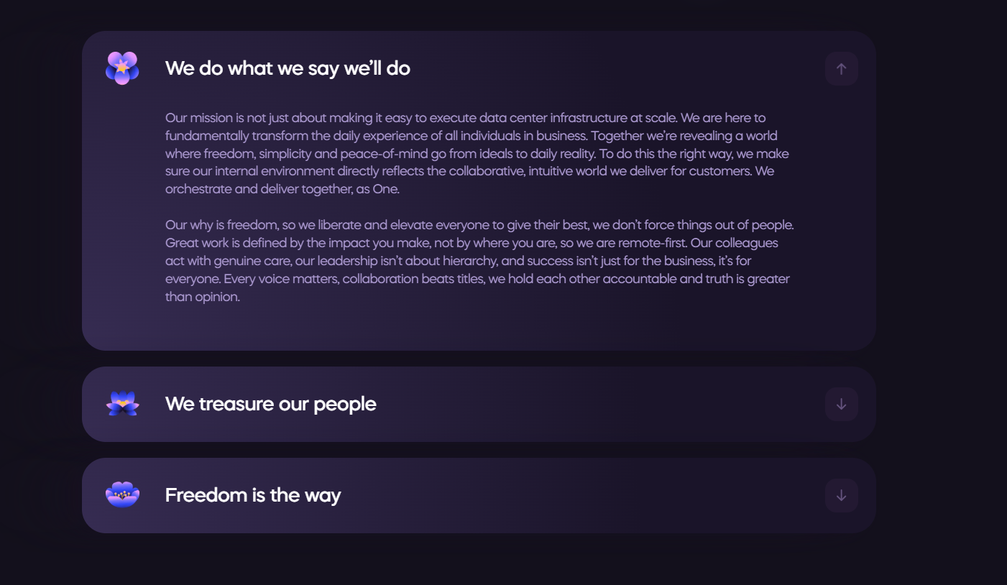
10- Testimonials
11- Final CTA
12- Footer

