Changes:
- Add delay effect on all the text on the website. Currently the content feels static. Make sure when user scrolls to a section only then its content should appear.
- Increase the timing of popup on hero section. Make it to 8 seconds after loading the website, because 3 seconds are taken by Splash screen.
- Either make All the words in badge capital letters or make all the words Camel Case.
- On Landing page, the timeline section has missed the badge, heading and paragraph. It just starts with the first Discover card. Make sure to add heading paragraph, badge above before the timeline.
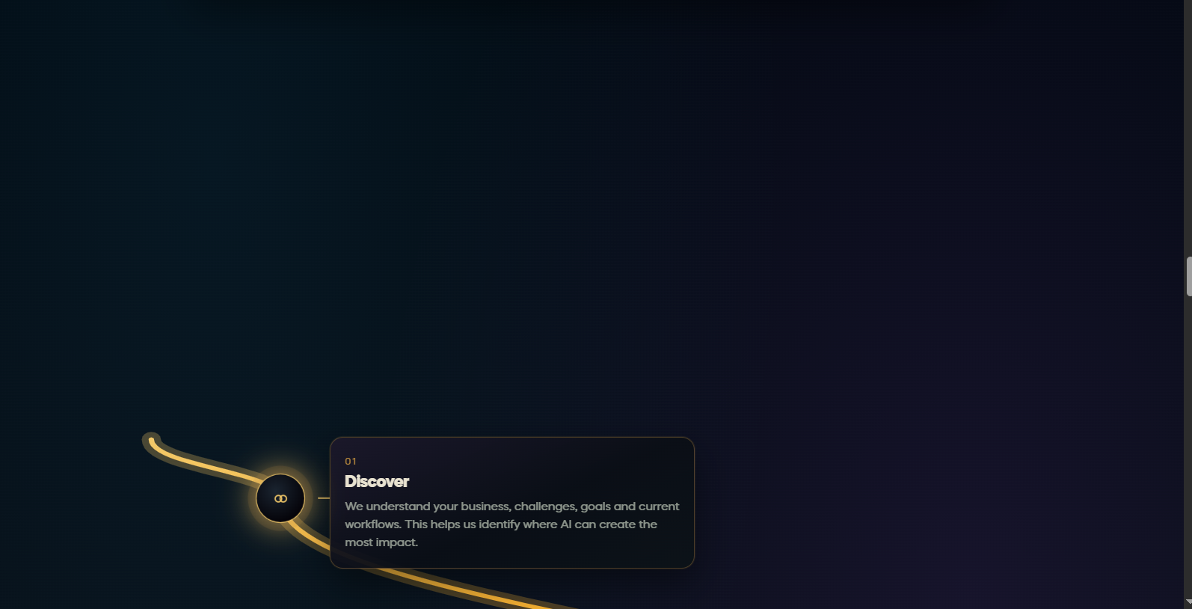
5-Just write solution name in this badge (below image). Remove the star icon from this badge.
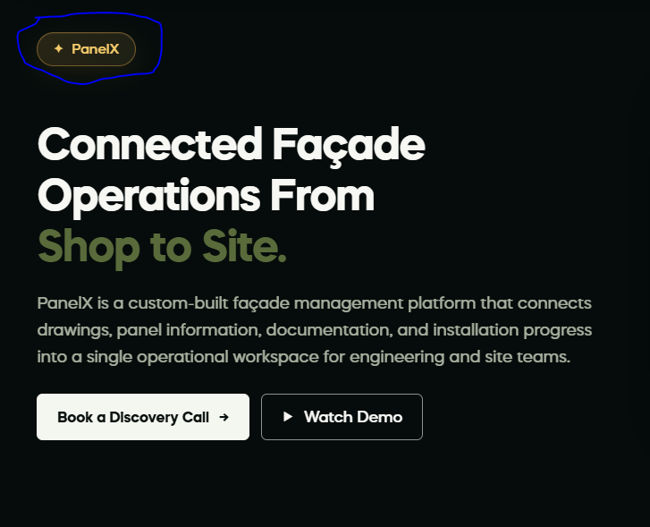

6- All the buttons on the website should follow the same color and style. The solutions page has different buttons.
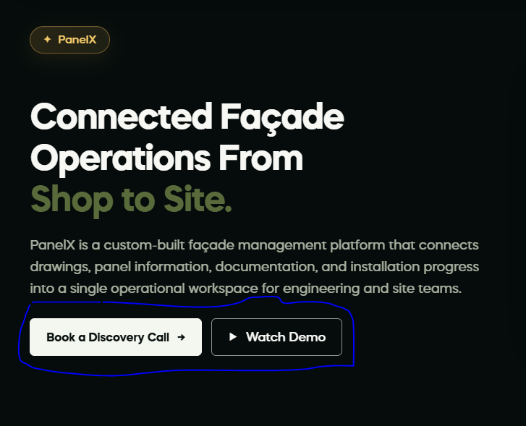

7-All the system should have same background color (don’t use black as background color. Currently The individual solutions page and all solutions page have black background color. Make it dark olive, deep forest and gradient color, instead of black.
In this image you can see the background color is black, which is wrong.
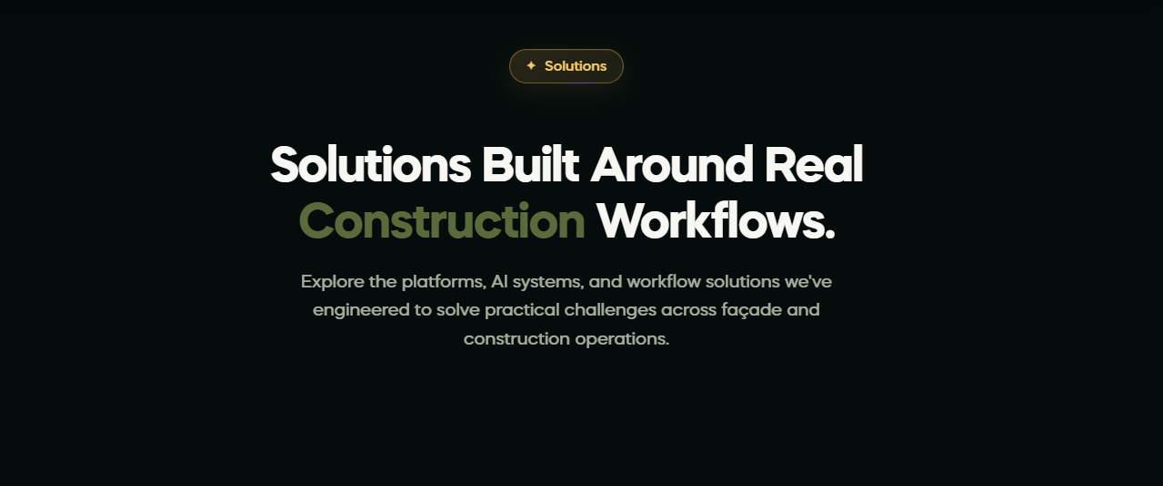
8- On Façade trades page. The highlighted information should be shown after some delay. After loading the hero section, then these stats should be shown.

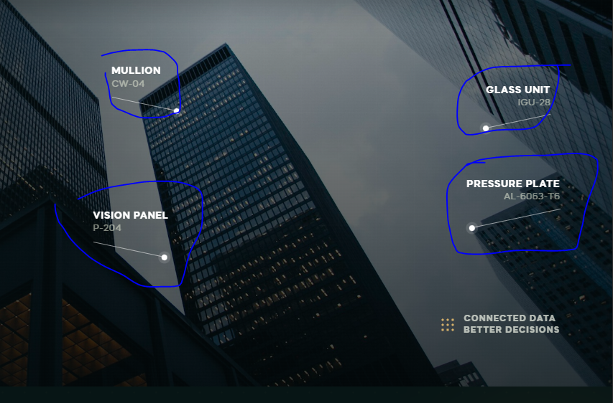
9-All CTA sections should have same color scheme. Like same background color, same border color , same buttons color. Below 2 images have different CTA background color. Make sure every CTA section should have same background color and same buttons color to ensure consistency.
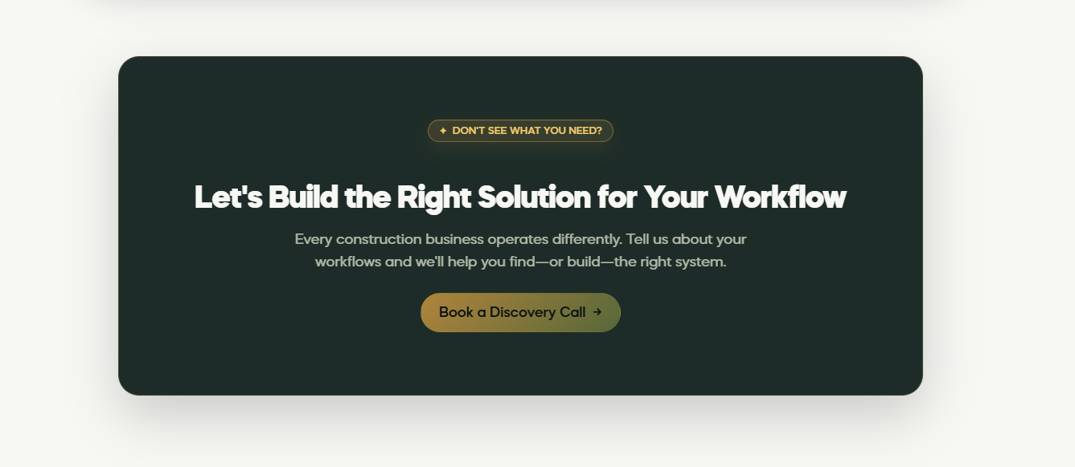
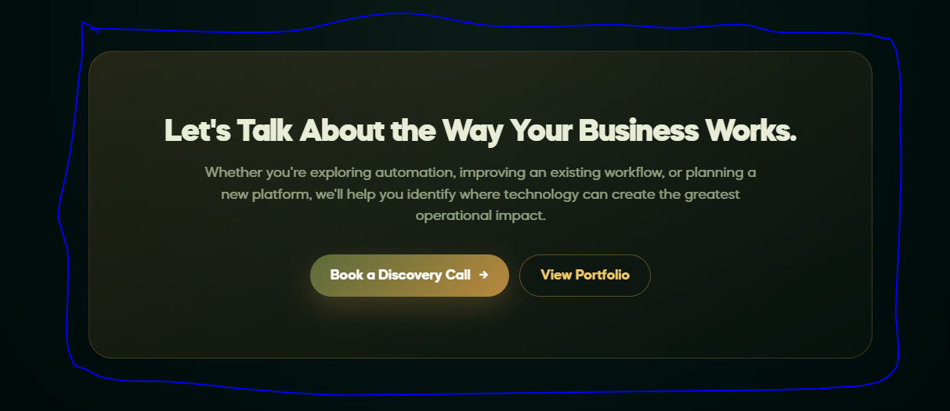
10-Make sure every section on the website should follow the complete color scheme like olive and warm golden. At some places it just uses golden color only. In below images you cann see there is only golden color is used. Use olive as well to make theme consistent.
