Portfolio Page
1-Hero:
Badge: SELECTED WORK
Heading: Technology Built for Real-World Operations.
Paragraph: From façade management platforms to AI-powered workflow automation, our work brings together industry knowledge, intelligent technology, and practical software engineering to solve complex operational problems.
Then a subtle line:
Client systems · Internal products · Emerging solutions

2-Featured Work
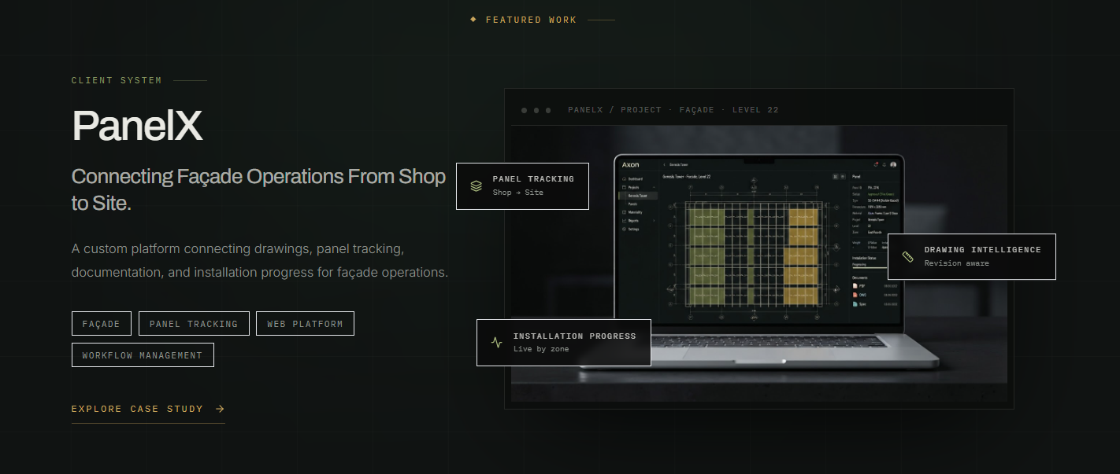
3-Solutions Display with category:
- -Client system
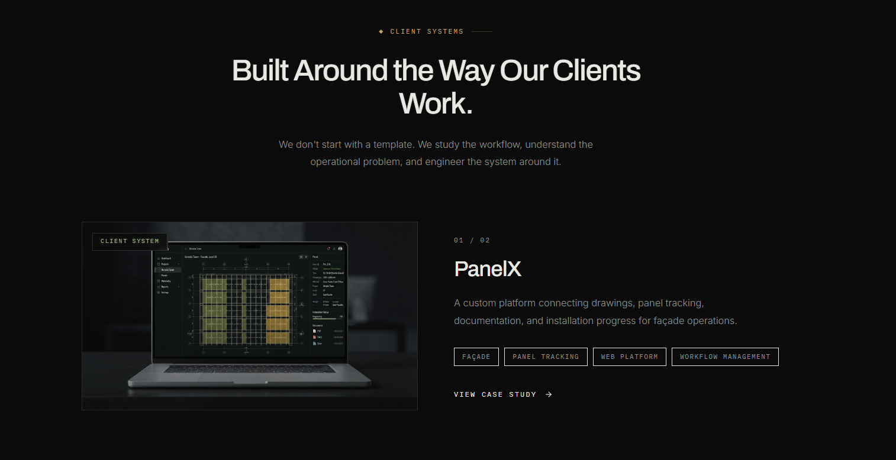
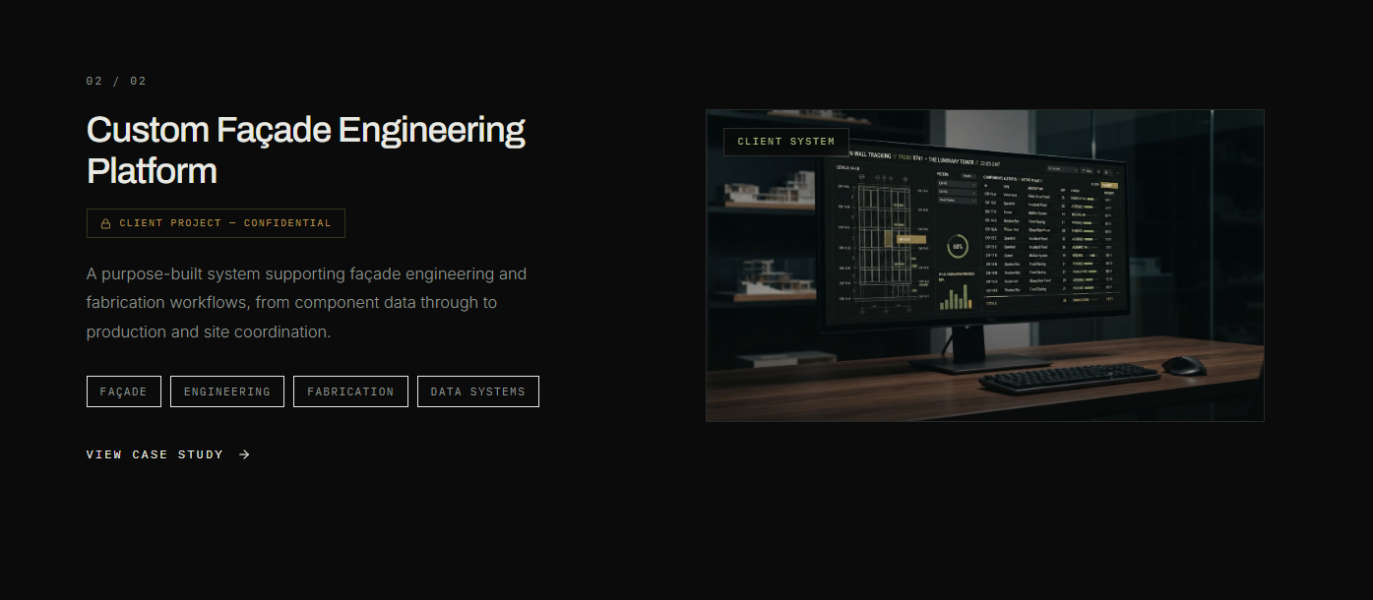
- -Internal products section:
Note: (Instructions for the below image)
- Keep the heading and paragraph of this section in centre of page instead of Left, right partition.
- Below heading and paragraph show solutions grid – 2 solutions in a row.
- Add “Learn More” button in each solution card.

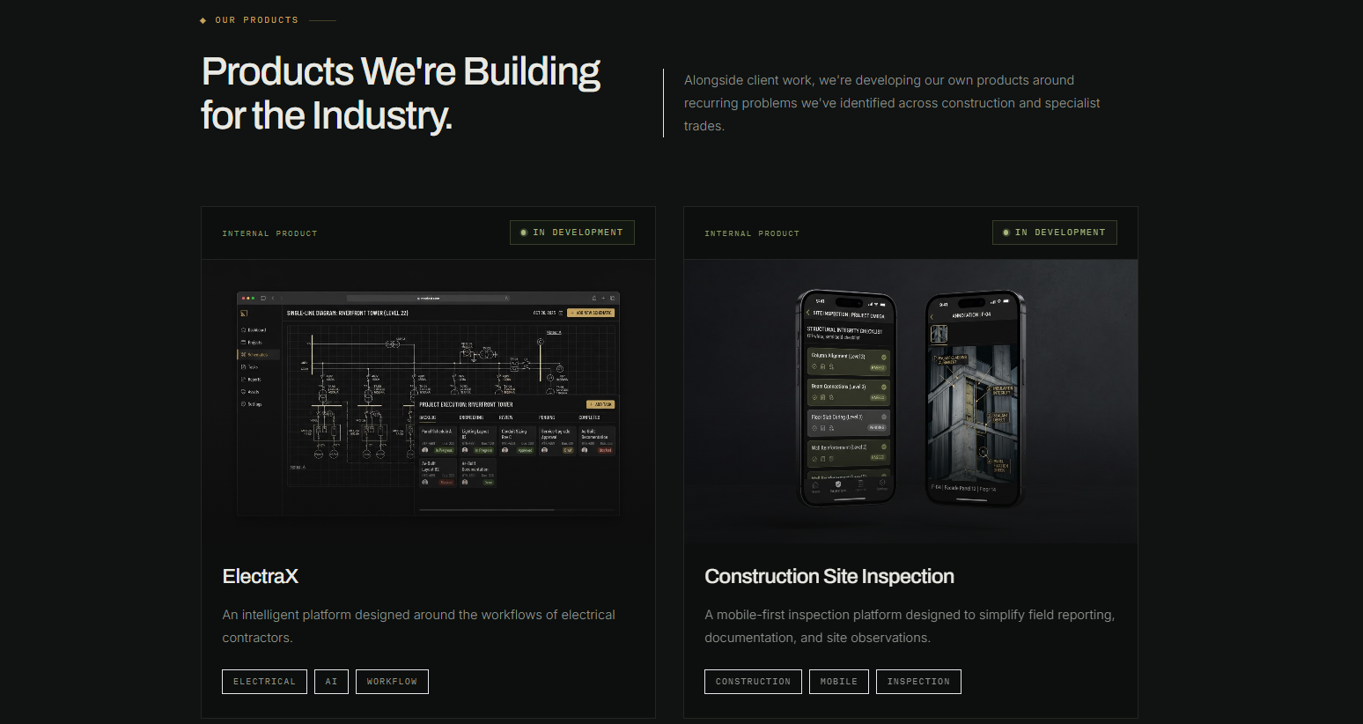
- -Workflow Solutions
Badge: Workflow Solutions
Heading: Turning Complex Workflows into Intelligent Systems.
Paragraph: From estimating and permitting to drawing analysis and material optimization, we explore how AI and automation can remove repetitive work.
Same card as Client systems: Total make 4 cards.

4-Experience In Industry 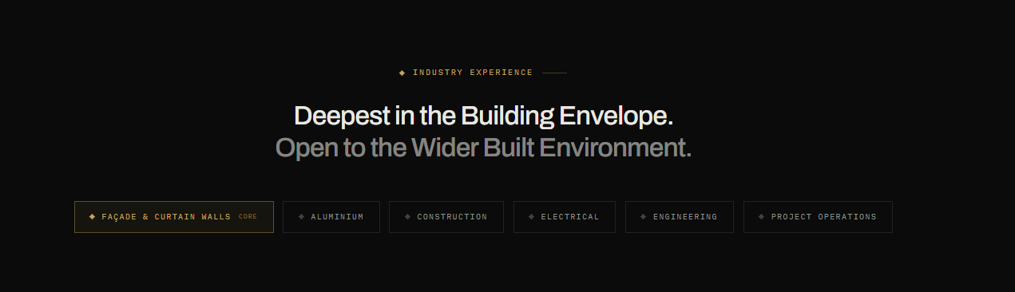
5-CTA
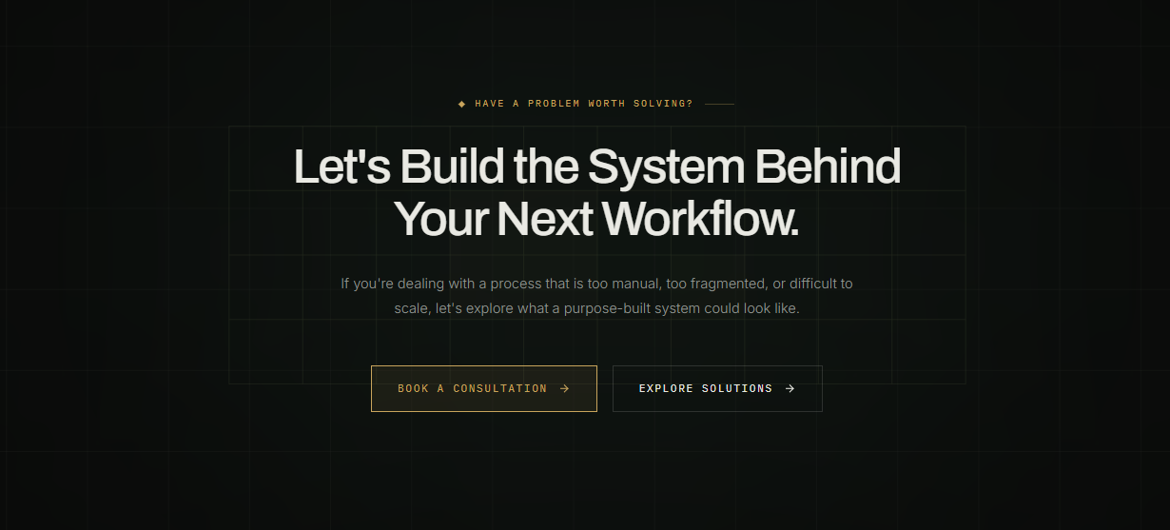
Note: Keep the design of CTA as other pages. Just follow this structure and content.

