Facade & Curtains Wall Trade:
1-Hero section
- Add a HD facade building Image in the background.
- Follow the below image for content
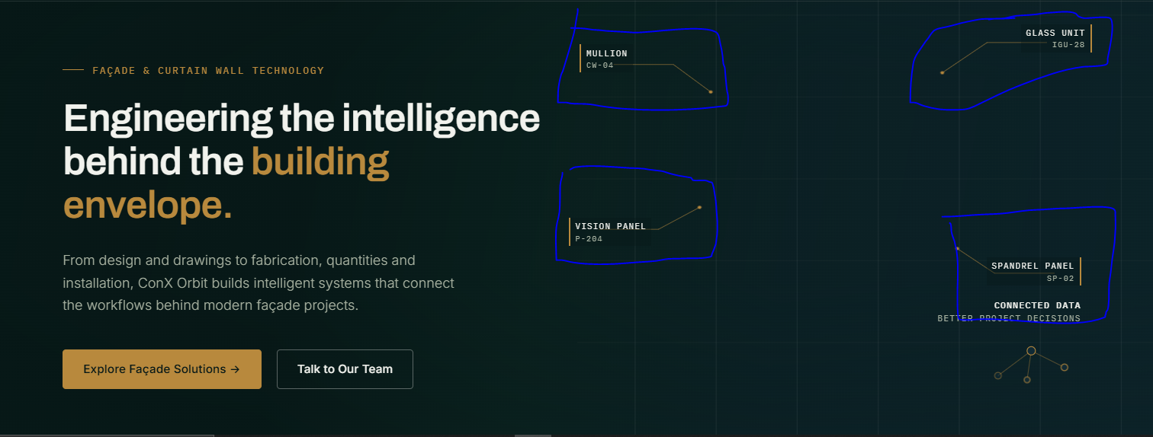
Hero section Reference: Follow this image For structure and styling.
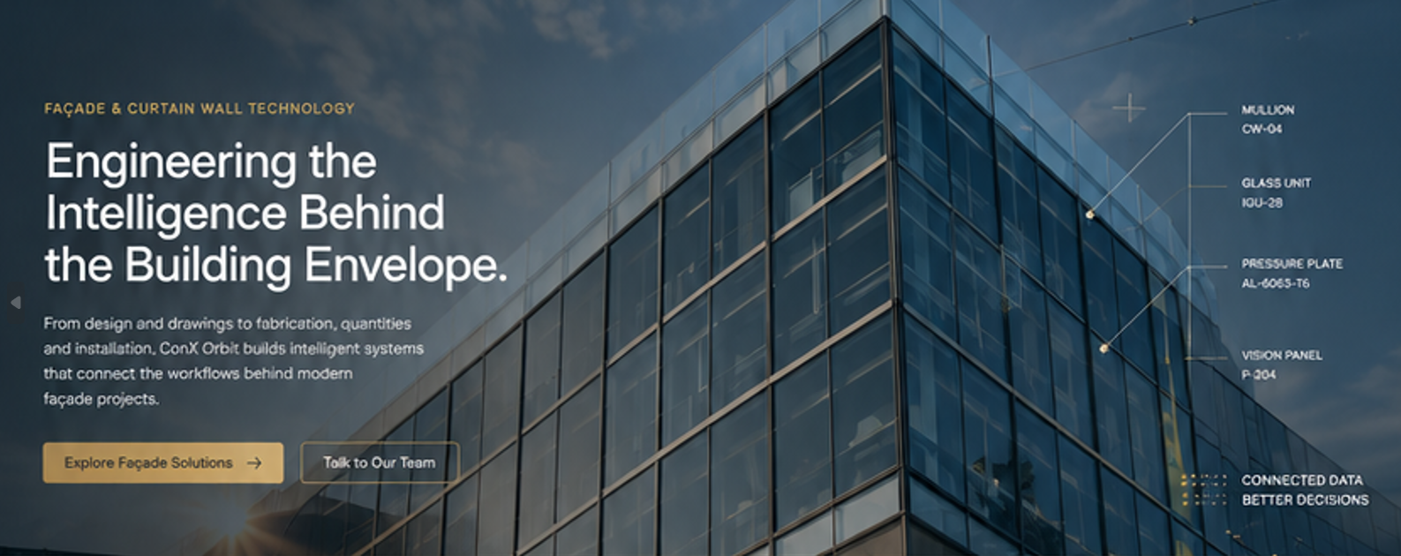

2-The Façade Workflow Section
Badge: THE FAÇADE WORKFLOW
Heading: From Design Intent to Installed Panel.
Paragraph: A façade project moves through interconnected stages — each producing information that the next team depends on.
Note: Make it like a progress bar or storyline.

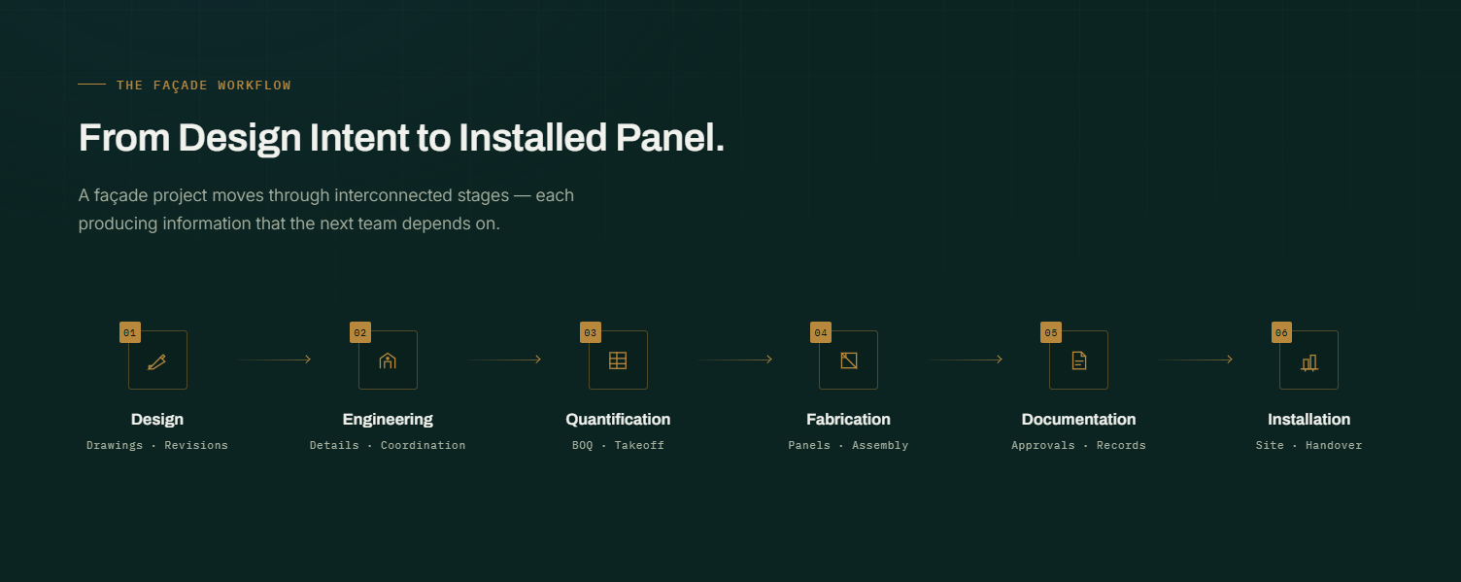

3-Where Complexity Builds
Badge: WHERE COMPLEXITY BUILDS
Heading: The Façade Is More Than a Building Skin.
Paragraph: Behind every panel is a chain of drawings, quantities, documents, components and decisions. When that information becomes fragmented, small inefficiencies multiply across the project.
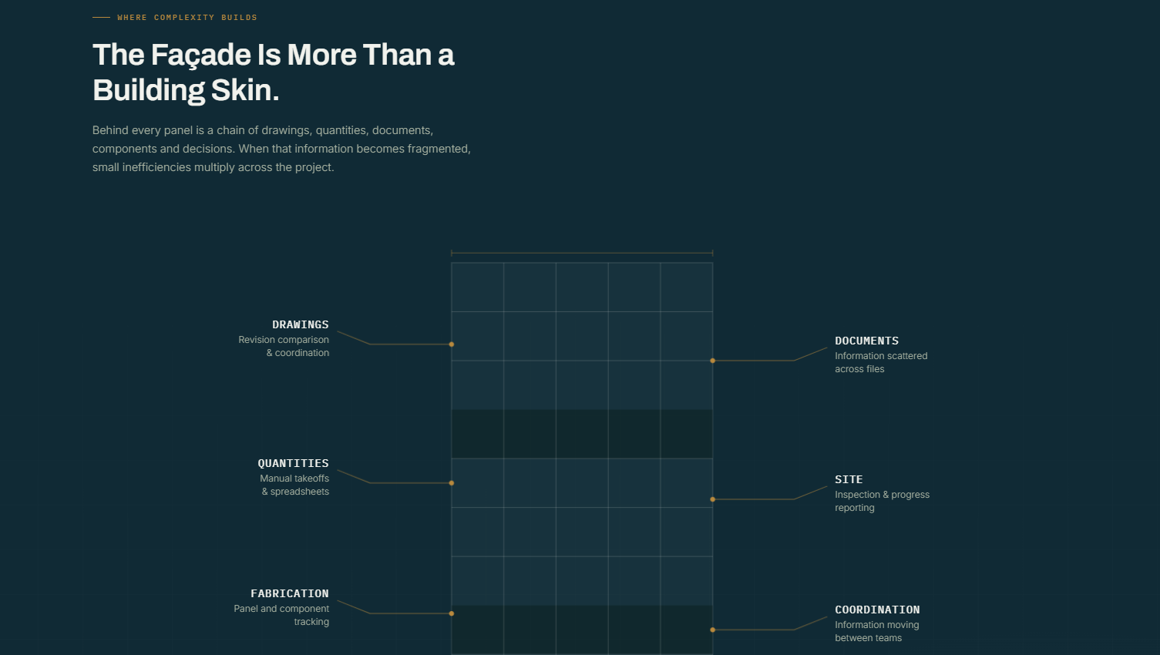
Note: In centre add a 3D building blueprint and around it show stats lines.
4-Featured Façade System — PanelX
Badge: FEATURED FAÇADE SYSTEM
Heading: PanelX — A Digital Layer for Façade Operations.
Paragraph: PanelX brings drawings, panel information, documentation and field activity into one connected environment — giving façade teams a clearer view of what is happening across the project.
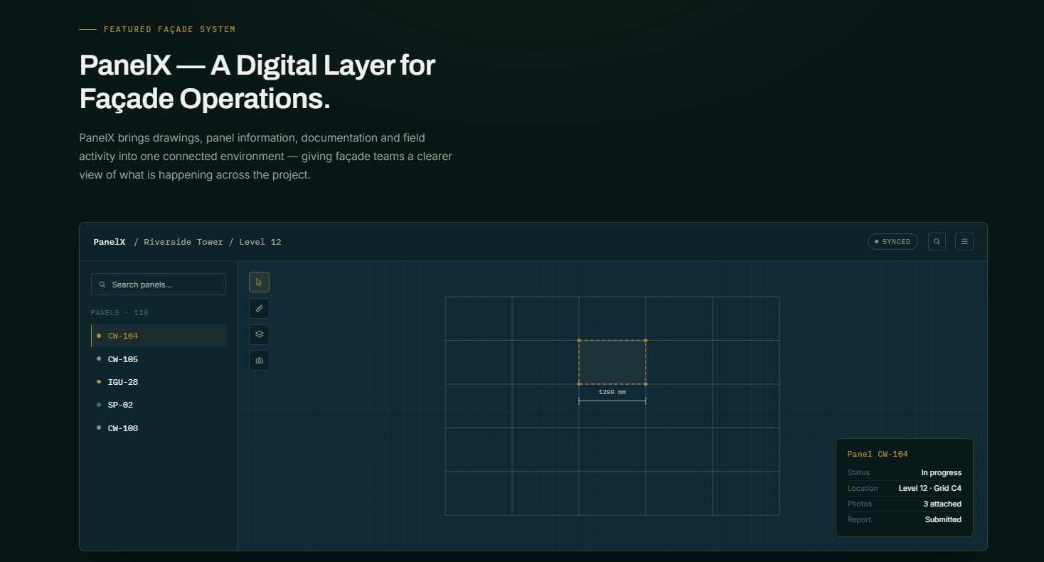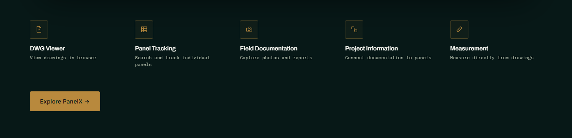
5-Façade Solutions
Badge: OUR FAÇADE SOLUTIONS
Heading: Purpose-Built Systems for Complex Façade Work.
Paragraph: From drawing intelligence to field operations, our solutions are designed around specific points where façade teams lose time, information or accuracy.
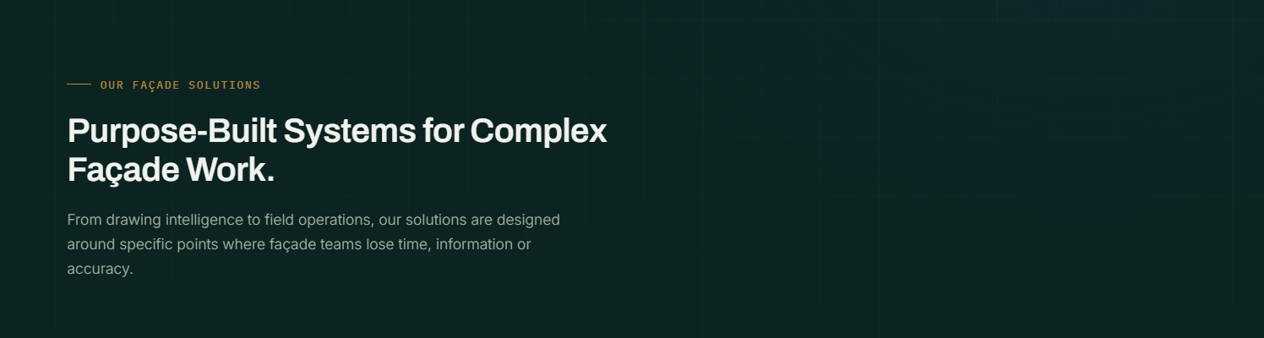
Below this, show a solutions cards grid, With only 3 solutions. Add View Solution Button on each solution card.

6-AI behind the Workflow
Badge: INTELLIGENT FAÇADE TECHNOLOGY
Heading: Where Façade Expertise Meets AI.
Paragraph: We apply AI where it can meaningfully reduce manual work — from understanding drawings and documents to extracting quantities, comparing revisions and automating repetitive decisions.
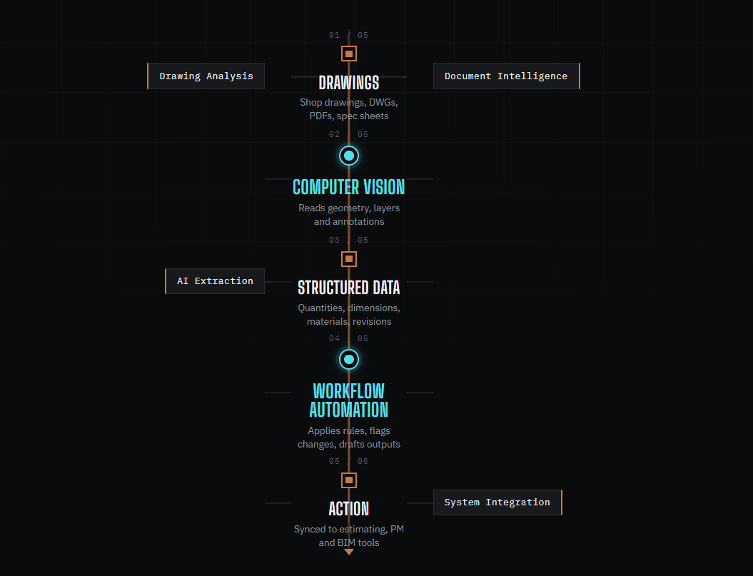
Note: Follow the structure of storyline like this, and follow this content, but don’t use these colours. Keep it minimal.

7- CTA
Badge: FAÇADE WORKFLOW
Heading: Have a Façade Workflow Worth Improving?
Paragraph: Tell us where the process gets difficult. We'll explore whether AI, automation or a purpose-built system can make it work better.
CTA Primary: Book a Discovery Call →
CTA Secondary: Explore Our Solutions

