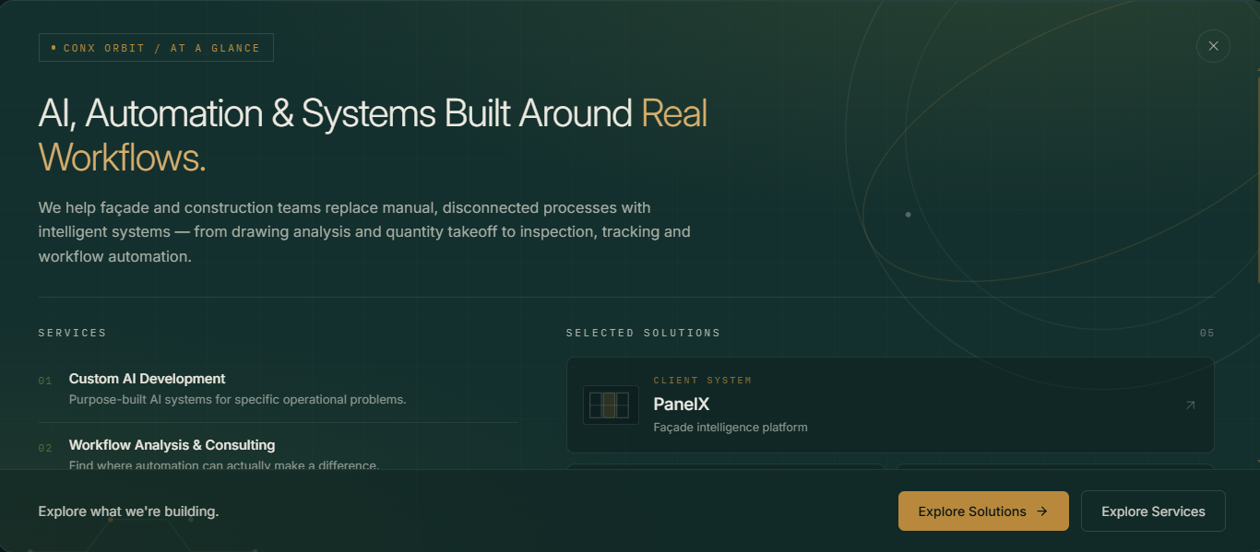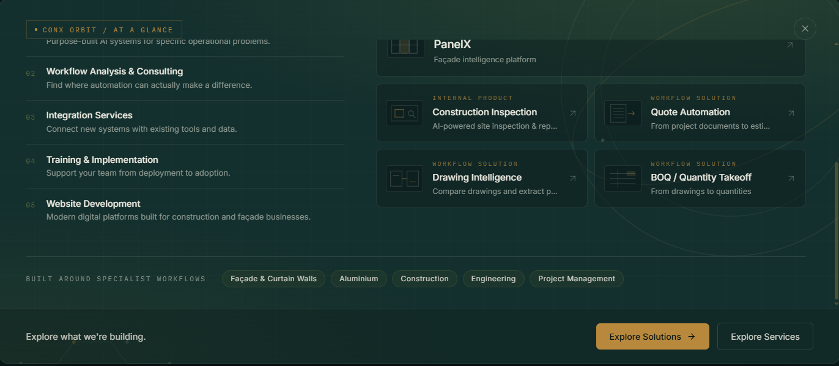
- Keep the background plane dark gradient (no shapes, circles, graphics in the background of this model.
- On left side show services. On right side show Solutions.
- Keep it minimal and to the point

