Frontend changings:
Admin portal>> Add new solution.
Categories doesn’t allow me to add more categories via comma separator. It doesn’t allow me to right comma.
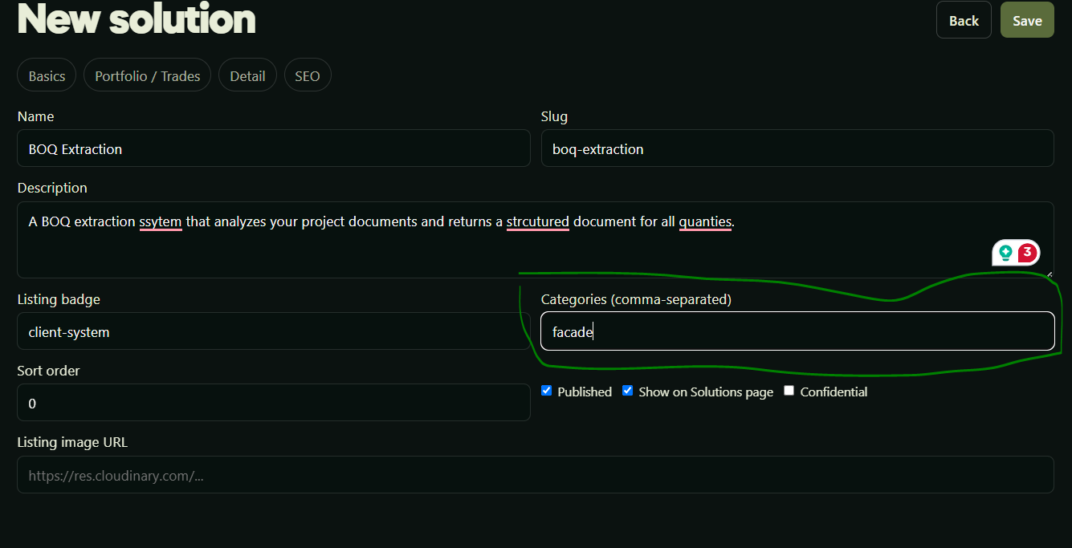
ADD Choose file button on every page where URL is being asked
Add Choose file button for all images, and demos for solutions, case studies etc. Don’t ask the user to enter URL on any page on admin portal. The chosen file would be stored on cloudinary and its url would be atomically stored in the database. And image would be fetched from database to show on website.
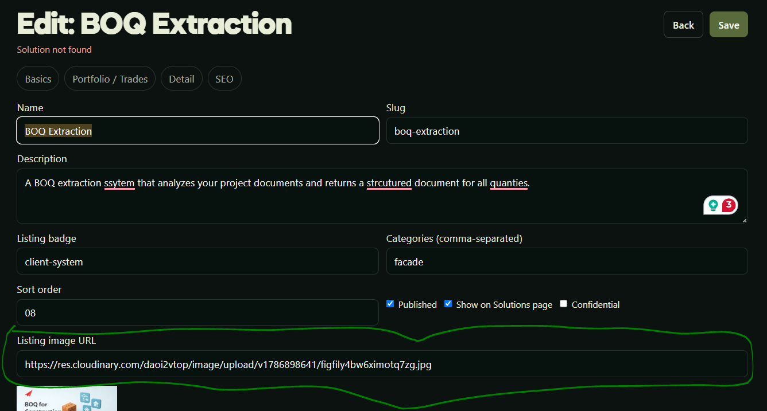

Admin portal:
Add offers on admin portal, from where admin can add offers. Offers schema is there. Create admin portal accordingly. For now don’t create frontend on which the offers would be shown on the website.

All solutions Page:
Don’t show too many categories here. Because we don’t have solutions for all these categories. Only show categories for which the solutions exist in our database.
And make the filter in form of dropdown. Rather than all filters written.
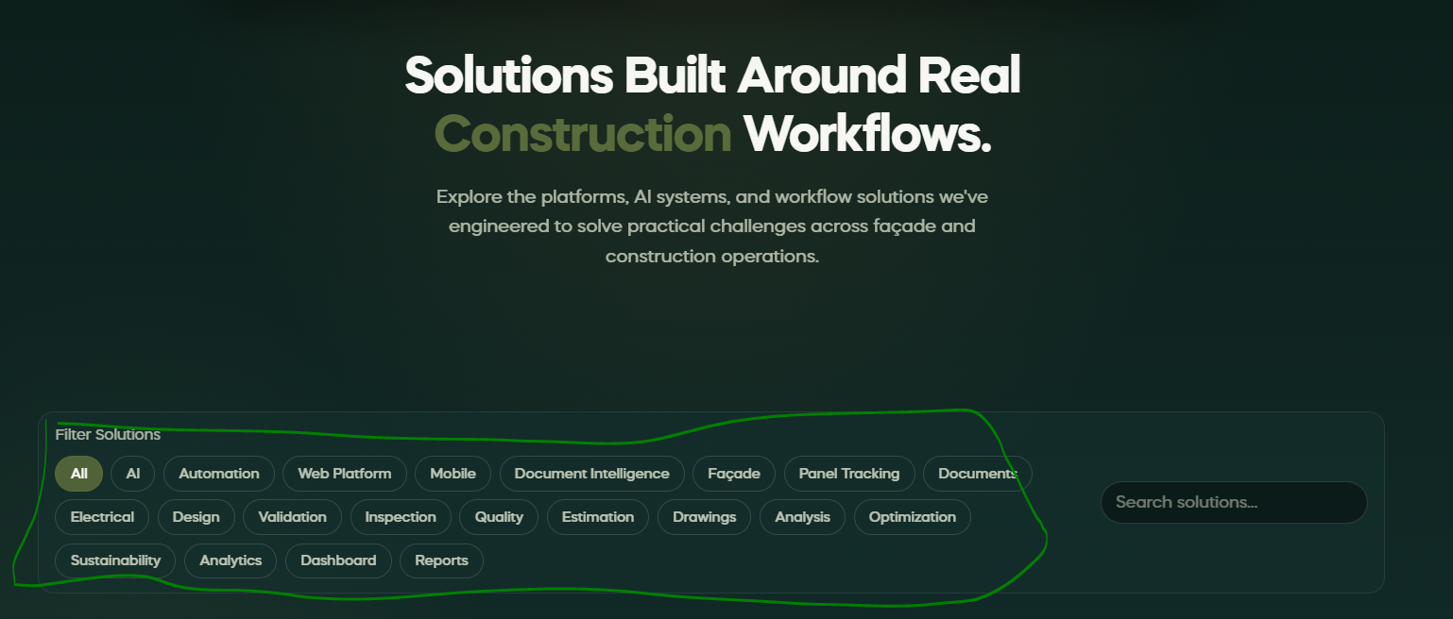

Backend:
- Schema Updated:
- For solutions, only 2 things would be stored in cloudinary:
1-Mockupp image for hero section
2- Demo video
- For case study:
only 1 image for hero mockup.
- For teams:
only 1 image for profile picture:
- For offers:
1 picture possible (optional)

Note: I have updated my schema to store only these media/assets in the cloudinary. I removed all the other field like thumbnail etc. So, update the admin portal accordingly.

- Complete the flow from admin portal. Like admin adds the solution information, attach its image, and demo video, this image and video would be stored on cloudinary, its link would be stored in database, and other solution information would also be stored in database. Then this whole information, image, demo video would be shown on website.
- Do the same for case studies, teams, and offers. Only add those fields on admin portal that are present in schema files.
- Seed the database with some initial solutions, initial case studies, initial team members information (only 2,3 for now). add any image/video for now. Later on I’ll update media from admin portal.
- When media is updated from admin portal, make sure the database stores the link of new media, remove the link to older media.
- Make sure the admin portal works perfect according to the new database schema.
- Make sure data is stored in the database.
- Make sure content on frontend is being fetched from database.
- Make sure media is stored in cloudinary.
- Make sure every media is stored in its own folder on cloudinary. Like Solutions’ media should be stored on solution folder on cloudinary. Case study media should be stored in case study folder in cloudinary, and so on. I have created a root folder in cloudinary, named Conx-orbit.
Note:
I have created schema files, cloudinary environment variables in env file. Just complete the specific controllers.

