Navbar >> Services
Individual Service Page
All services pages follow same structure.
Example:
Custom AI Development Page.
- Hero Section:
The below image is just for Structure and content. For the design reference use the next image.
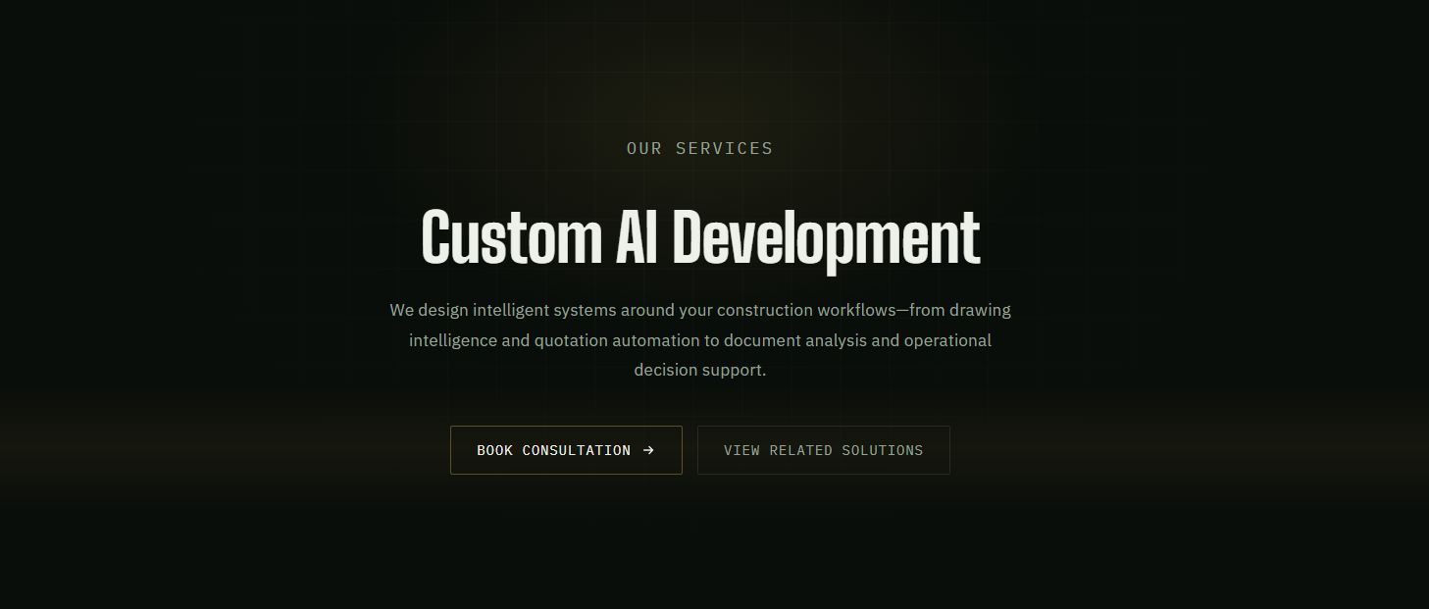
Design Reference: Below Image (Use anamorphism effect in background)


- Where It Creates Value section
Use the below image for content and structure. For design use the next image.
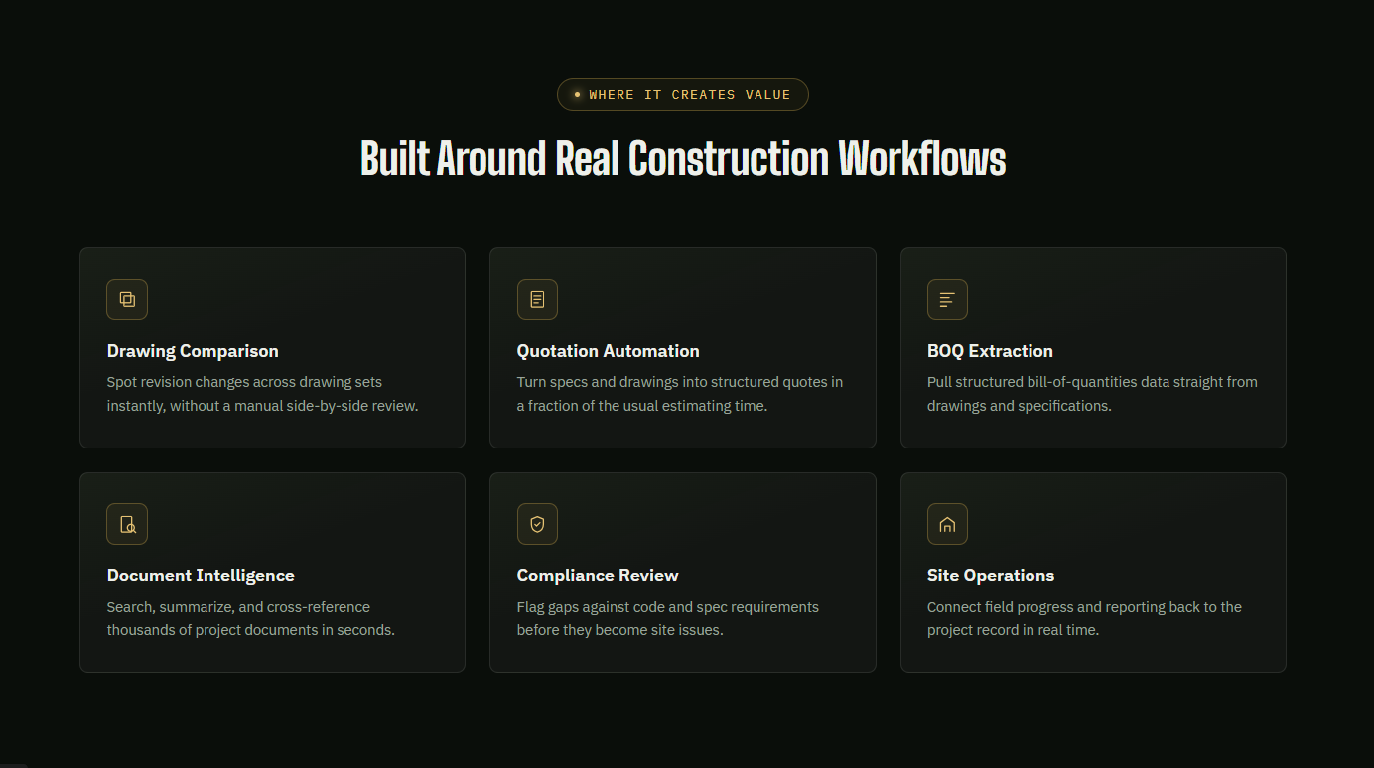
For design use the Image below.
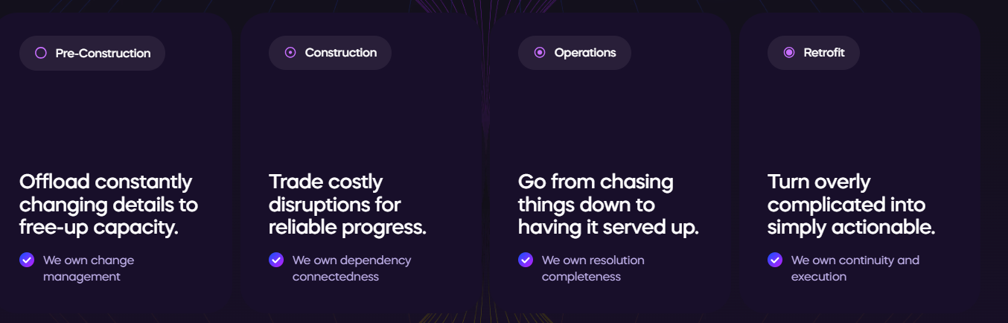

- How We Deliver it section
Badge: Our Approach
Heading: Every AI System Starts with Understanding Your Workflow
Timeline: Understand -> Analyse -> Prototype -> Develop ->Deploy ->Support
Structure and content:
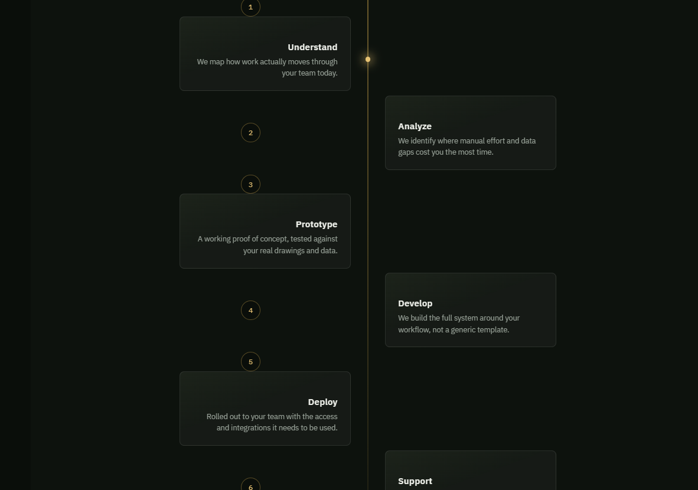
Note:
- Use icons on each card.
- When user scrolls, then next card is shown. Means user first user will scroll down then the analyse card will be shown. Then user scrolls down it should show Prototype card, then user scroll down and it shows Develop card.
- But make timeline like the above image (1 card on left and the other card on right but a little bit below than the left).
- Don’t use numbering like the above image.

- Capabilities section
Badge: Capabilities
Heading: Engineering Intelligent Systems Around Your Operations.
Paragraph: Every capability we build is designed to solve a real operational challenge—from interpreting technical drawings and automating workflows to connecting data, documents, and teams through intelligent software.
Then 8 cards like this:
Content of Cards:
- Drawing Intelligence
Interpret, compare, and extract valuable information from technical drawings to reduce manual review and improve engineering accuracy.
Graphic:
3D blueprint
2. Intelligent Document Processing
Convert specifications, reports, contracts, and project documents into structured, searchable information using AI.
Graphic
Floating document stack
3. Workflow Automation
Replace repetitive manual processes with intelligent workflows that improve speed, consistency, and operational efficiency.
Graphic
Connected workflow nodes
4. Custom AI Assistants
Purpose-built AI assistants trained around your projects, documents, and internal knowledge—not generic chatbots.
Graphic
Glass chat bubble
5. System Integration
Connect new platforms with your existing software, drawings, databases, and business workflows.
Graphic
Connected cubes
6. Construction Analytics
Turn operational data into dashboards and insights that support better planning, tracking, and decision-making.
Graphic
Dashboard visualization
7. Computer Vision
Analyze images, drawings, and site data using AI to automate inspections, detection, and visual analysis tasks.
Graphic
Camera scanning object
8. Digital Platforms
Build scalable web and mobile platforms tailored to construction operations, collaboration, and long-term growth.
Graphic
Laptop + mobile mockup

5-Featured Solutions section
Same as Homepage Featured solutions (add 2 solutions Panel Xand Flatforge)
6- Why Conx Orbit
Badge: WHY CONX ORBIT
Heading: Built Like an Engineering Partner, Not Just a Development Agency.
Paragraph: Every solution is shaped around your operations, your people, and the way your projects move—not around pre-built templates or generic AI tools.
Button: Book Consultation →
Cards:
1-Construction First
We understand drawings, fabrication, inspections, and delivery before designing the system.
2- Workflow Before Technology
Technology should adapt to your operations—not force your team into new processes.
3-Founder-Led Collaboration
You'll work directly with the engineers designing and building your solution.
Make cards like this:
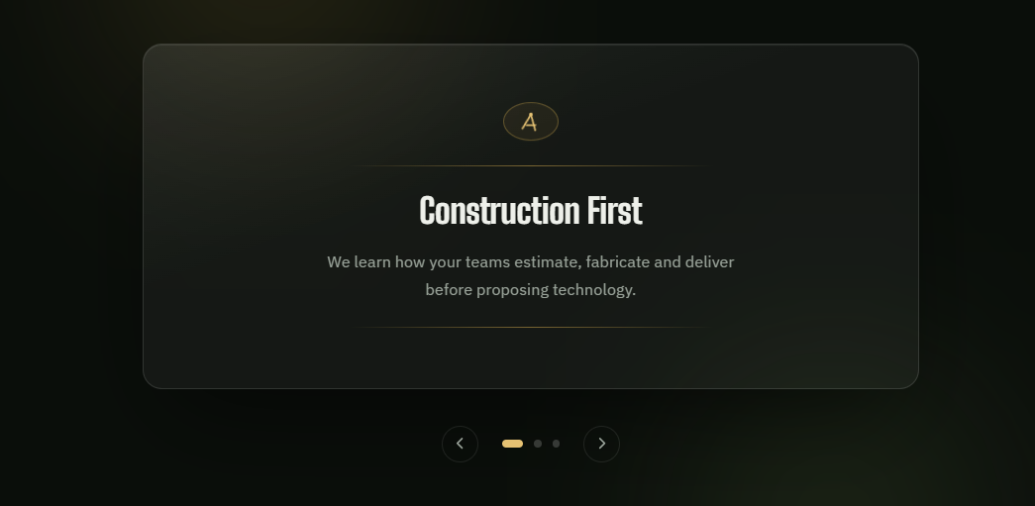
Note:
- First badge, then heading then paragraph, then cards. (all in centre of page)
- Use big numbering on each card. Write number on top left corner of card in very light color.
7-FAQ (same as home)
8- Final CTA
Badge: DISCUSS YOUR WORKFLOW
Heading: Let's Talk About Your Workflow.
Paragraph: Whether you're exploring AI, replacing manual processes, or planning a custom platform, we'd love to understand your goals and discuss what's possible.
Buttons: Book a Discovery Call, Explore Solutions

