On trades >>facade &curtain wall page. Make it as timeline. Like as user scrolls down then the below lines should be shown. Currently they are just static lines.
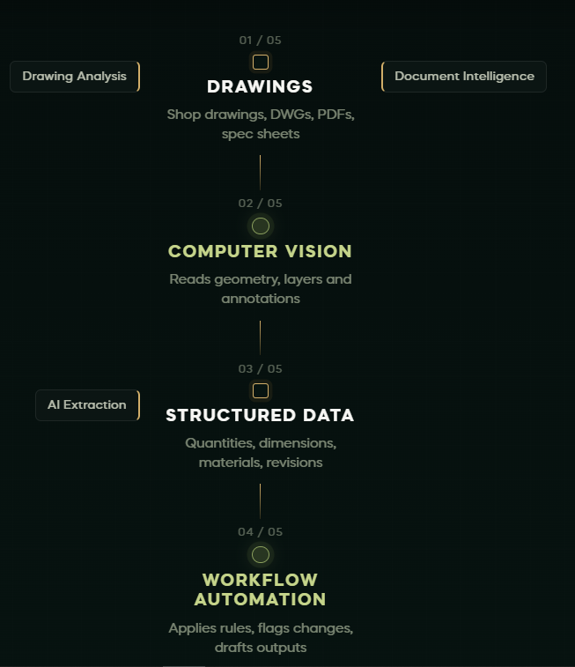

Remove these sections from Trades Page.
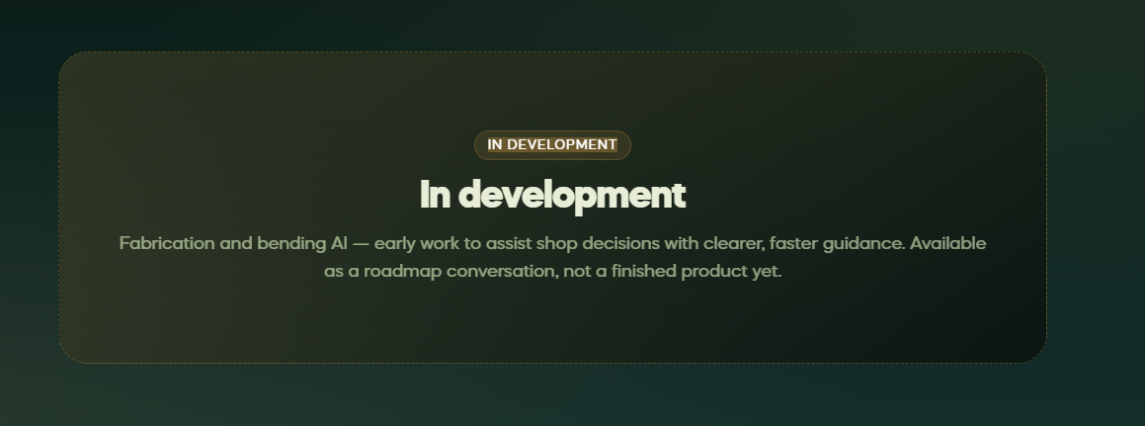
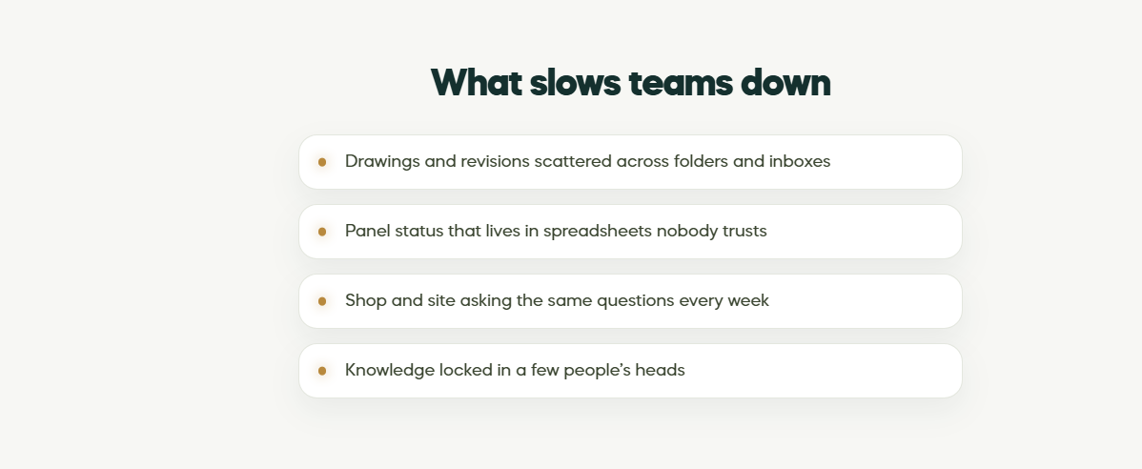
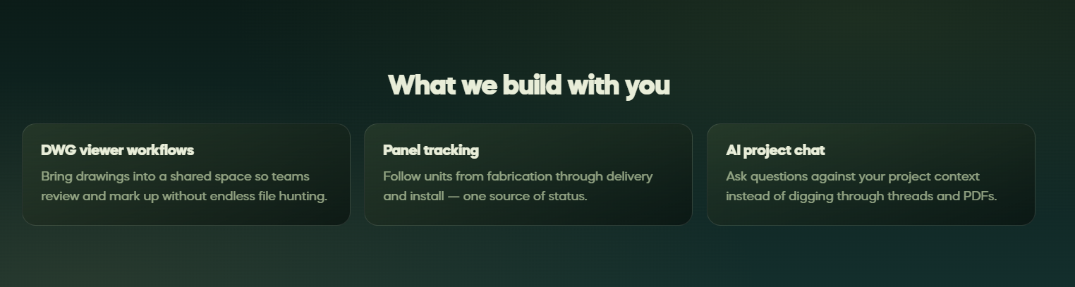
On Portfolio page. Make this line as a horizontal moving strip.
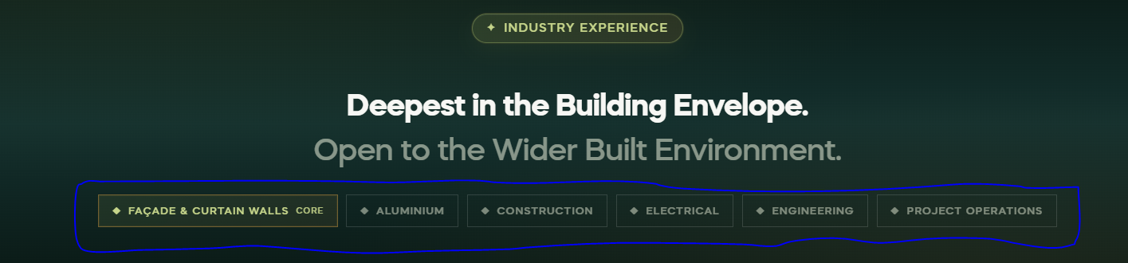

On Landing Page – Where we create Impact section
Add CTA to this section.
CTA: Explore your Workflow
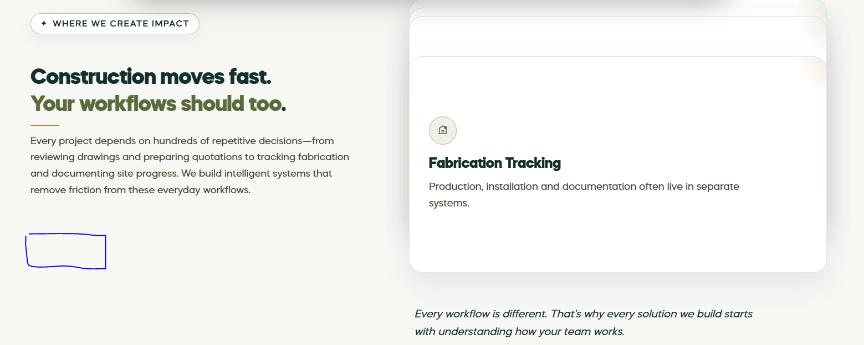
When user clicks on this CTA, it should Open a large, centred modal / interactive panel.
Model screens:
1- Workflow
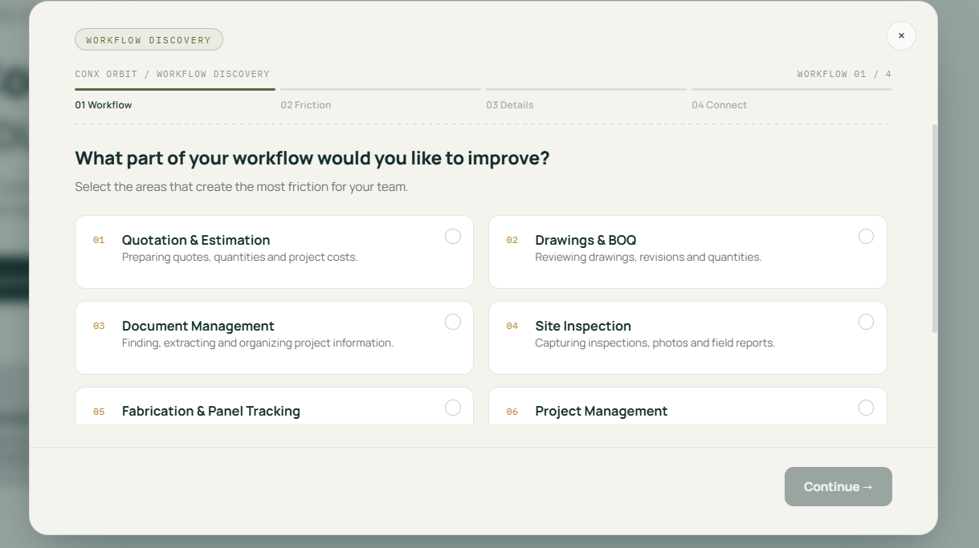
2-Friction
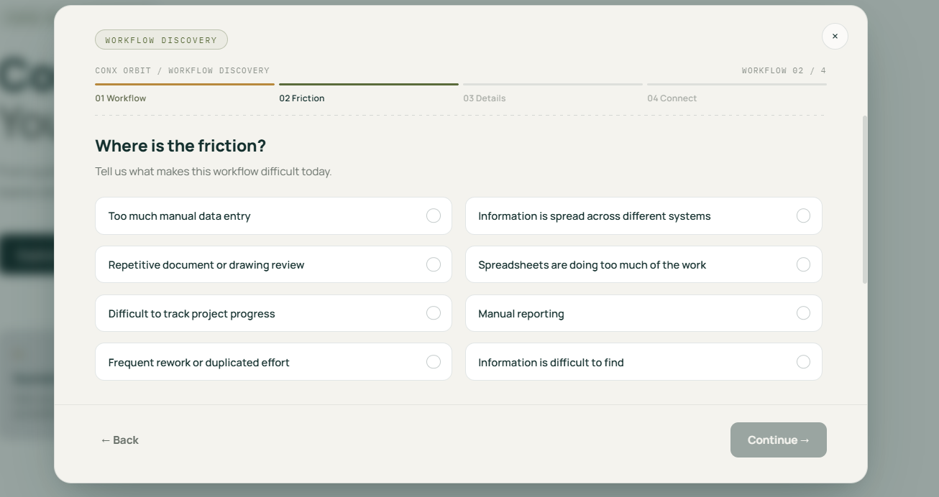

Part 2 of friction page:
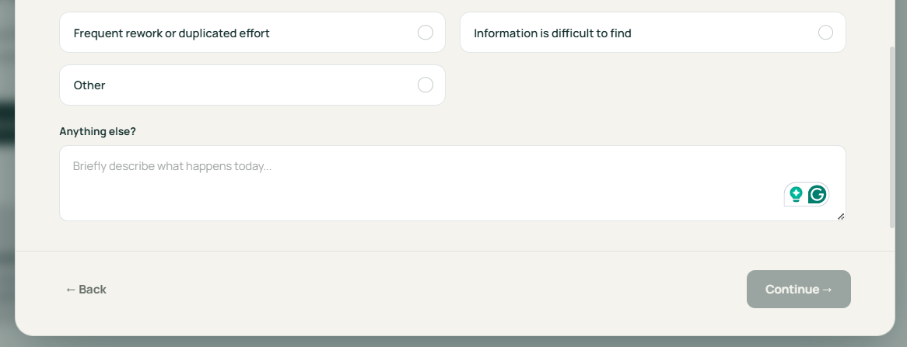

3-Details
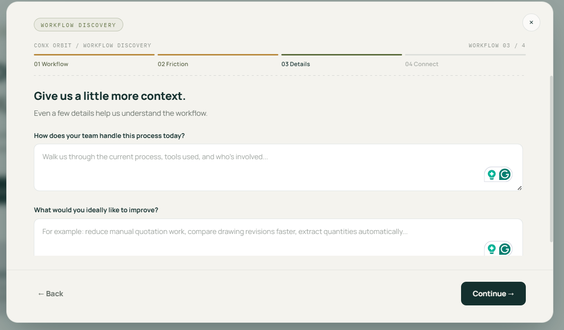
4-Connect
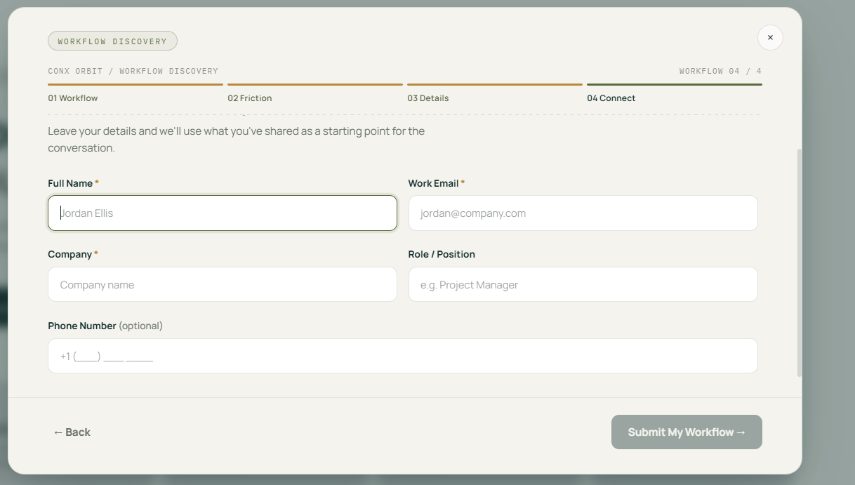
When user clicks on the submit my workflow button it should show a success popup like below:
