1. Home — Low-fidelity wireframe
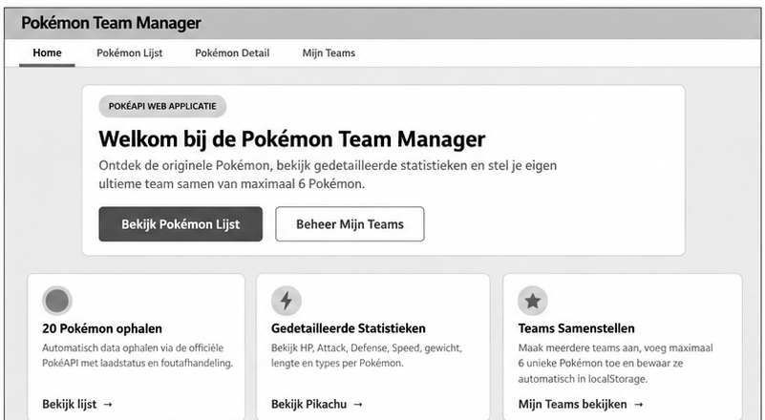

2. Pokémon Lijst — Low-fidelity wireframe
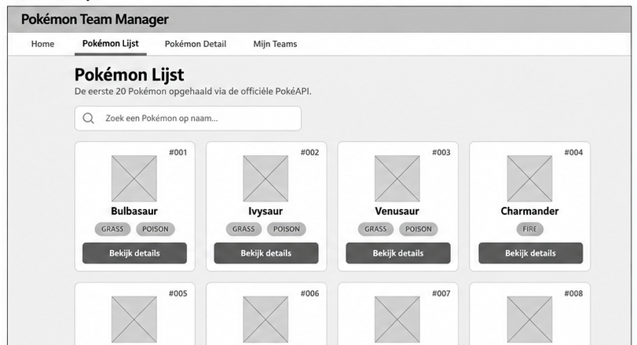

3. Pokémon Detail — Low-fidelity wireframe
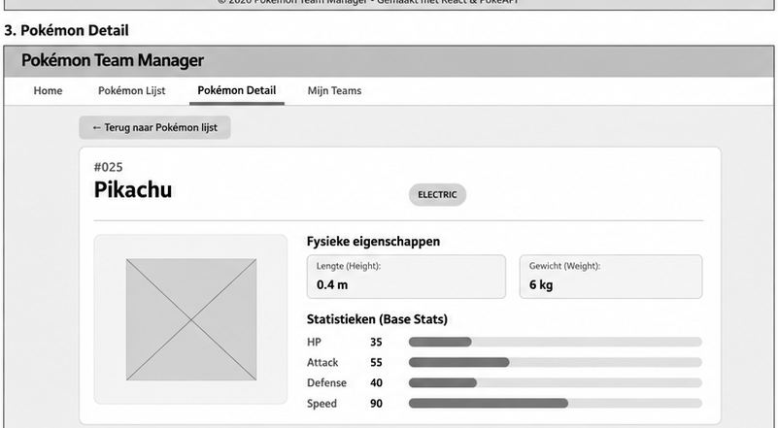

4. Mijn Teams — Low-fidelity wireframe


