3.2 Bias Analysis Over Time
This section introduces our longitudinal evaluation framework, whose objective is to determine whether political bias in Large Language Models (LLMs), previously measured at a single time point, evolves across successive model releases and alignment stages. Instead of treating models as static artifacts, we view them as temporal systems whose ideological neutrality may decay or improve as training strategies, scaling laws, and alignment pipelines evolve over time. The goal of this analysis is to quantify whether Prediction Inconsistency (IC) remains stable, increases, or decreases across model generations.
Our temporal evaluation is conducted on the same set of political entities, sentence templates, and Target-Oriented Sentiment Classification (TSC) setup described in Section 3.1. This reuse ensures that the only changing variable in our experiment is the model version, allowing a controlled assessment of temporal bias dynamics.
A visual overview of the experimental pipeline is presented in Figure X.
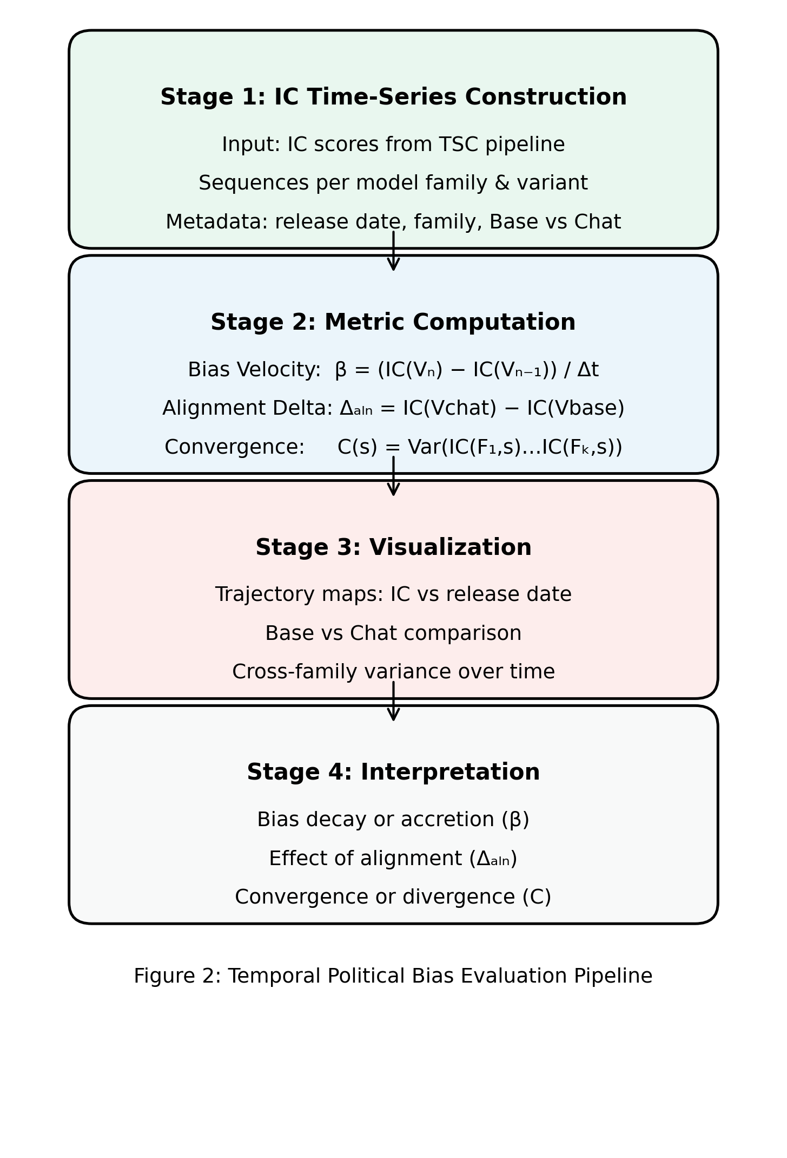

3.2.1 Model Reuse and Temporal Extension
Rather than modifying the workload or introducing a new sentiment evaluation procedure, we build directly on the previously established TSC pipeline. All inference procedures, prompt structures, entity substitutions, and IC computations follow the methodology defined in Section 3.1, with no alterations to data or prompting design. This ensures comparability between static and temporal evaluations.
The key extension is the introduction of model lineages. For each model family F (e.g., LLaMA, Qwen, Mistral), we collect a chronologically ordered sequence of versions {V₁, V₂, …, Vₙ}. For each version Vᵢ, we compute an IC score using the IC metric defined in Section 3.1.3, producing a temporal sequence:
S_F = { IC(V₁), IC(V₂), …, IC(Vₙ) }
Each IC value in the sequence reflects the static bias of a single version, while the sequence as a whole reflects the evolution of bias across releases.

3.2.2 Longitudinal Metrics
To characterize how IC evolves over time, we introduce three metrics: Bias Velocity, Alignment Delta, and Cross-Family Convergence.

(A) Bias Velocity
Bias Velocity quantifies the rate of change in political bias across consecutive versions. For two successive releases Vᵢ₋₁ and Vᵢ, we compute:
β(Vᵢ) = ( IC(Vᵢ) − IC(Vᵢ₋₁) ) / Δtᵢ
where Δtᵢ denotes the time interval between releases. A negative β indicates bias decay (improved neutrality), while a positive β indicates bias accretion (worsened neutrality).

(B) Alignment Delta
LLMs are often released in both Base and Chat variants. To isolate the effect of alignment tuning, we compute:
Δₐₗₙ(Vᵢ) = IC(Vᵢ^{chat}) − IC(Vᵢ^{base})
A negative Δₐₗₙ indicates that alignment mitigates political bias, while a positive Δₐₗₙ indicates that alignment introduces or amplifies bias.

(C) Cross-Family Convergence
To assess ecosystem-wide dynamics, we measure whether model families converge toward similar neutrality levels. At time index s, we compute:
C(s) = Var( IC(F₁,s), …, IC(Fₖ,s) )
A decreasing C(s) implies convergence toward shared neutrality norms, whereas an increasing C(s) implies persistent geopolitical or training-driven divergence.

3.2.3 Experimental Fit to Metrics
The outputs of our temporal experiment directly populate the metrics above:
1. IC sequences support computation of Bias Velocity (Eq. 5)
2. Base/Chat IC pairs support computation of Alignment Delta (Eq. 6)
3. Cross-family IC values support computation of Convergence (Eq. 7)
Together, these components enable temporal inference about political bias trajectories across the LLM ecosystem.

