Sota: Political Bias and Temporal Dynamics in LLMs
- Background
Large Language Models (LLMs) have become central intermediaries in how individuals access, interpret, and evaluate political information. Their widespread use in tasks such as summarization, explanation, and question-answering grants them substantial power in contemporary digital spheres. However, as Buyl et al. (2026) point out, the behavior of LLMs is far from ideologically neutral; instead, it is shaped by architectural choices, training data composition, and post-training alignment procedures. When models systematically favor or disfavor certain political ideologies or figures, they may function as implicit instruments of digital soft power, particularly when deployed at scale across languages and regions (Buyl et al., 2026).
Empirical evidence increasingly demonstrates that LLMs express consistent evaluative patterns when discussing political topics, suggesting that political bias is not merely a byproduct of isolated prompts but a structural property of model behavior (Buyl et al., 2026). Moreover, prior work has shown that LLMs may exhibit Bias Amplification, whereby biases present in the training data are not only reproduced but potentially intensified in model outputs, thereby reflecting and exacerbating existing societal prejudices (Zhu et al., 2024). This concern motivates a growing body of work that seeks to measure, interpret, and compare political bias across models. ⸻

2. Theoretical Framework
Buyl et al.(2026) define ideology as a systematic worldview concerning social organization, power distribution, and moral evaluation. From this perspective, political bias in LLMs manifests through evaluative discourse, how models morally frame political actors, movements, and doctrines. In operational terms, ideology is quantified as positive or negative preferences toward political labels, and usually measured via sentiment and moral evaluation scores.
While political bias research typically treats models as temporally fixed artifacts, Zhu et al.(2024) introduce a complementary conceptual lens centered on temporal generalization. They define temporal generalization as a model’s ability to reason accurately across past, present, and future contexts. Several key concepts emerge from this framework:
- Temporal Generalization: LLMs' ability to align with the contexts of the past, present, and future.
- Nostalgia Bias: Over-reliance on historical data when generating text.
- Neophilia Bias: Overemphasis on novelty and future trends
- Temporal Degeneration: Decline in LLM’s performance after it is released

If LLMs degrade unevenly over time, then political biases themselves may shift, intensify, or invert across successive model generations. This insight motivates the need to integrate temporal dynamics into the study of political bias.

3. Methodological Landscape
Existing studies adopt diverse evaluation strategies to probe LLMs bias and temporal robustness. Table 1 compares the datasets, metrics, and limitations of the three core works reviewed here.

Table 1. Comparison of Methodologies in Related Work
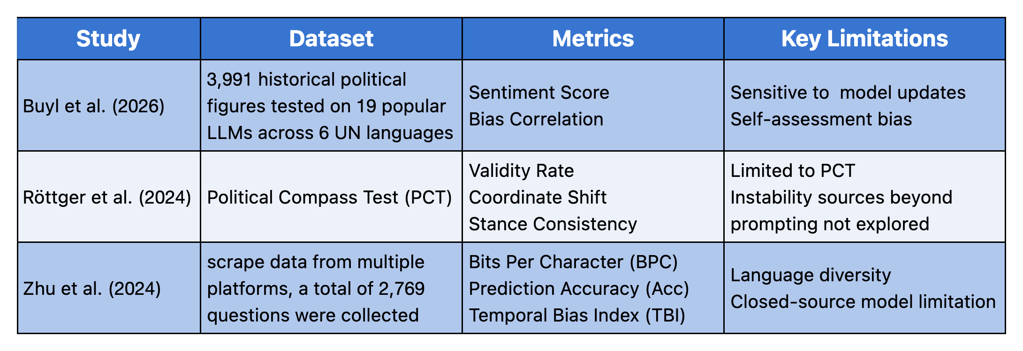

Buyl et al. (2026) adopt a two-step prompting strategy, first eliciting descriptive text and then asking the model to self-assess its moral stance using a Likert scale. This design enables large-scale cross-model comparison but risks underestimating implicit biases due to reliance on model introspection. Röttger et al. (2024) critically examine commonly used political evaluation tools, demonstrating that multiple-choice surveys such as the Political Compass Test are highly unstable. Minor paraphrases can produce dramatic shifts in inferred political positions, raising concerns about the validity and robustness of forced-choice evaluations. Zhu et al. (2024), focus more on temporal robustness rather than ideology. Their FreshBench framework reveals systematic performance decay over time, offers valuable reference for longitudinal analysis.

4. Research Gap
Despite methodological advances, current research exhibits a shared limitation: political bias is predominantly studied as a static property of a single model snapshot. Models are evaluated at one point in time, and differences across architectures or developers are interpreted synchronically. There is limited understanding of whether political biases are stable design features or evolving artifacts shaped by iterative model development.

⸻

References
Buyl, M., et al. (2026). Large language models reflect the ideology of their creators. Artificial Intelligence, 2(1), 7.
Röttger, P., et al. (2024). Political compass or spinning arrow? Towards more meaningful evaluations for values and opinions in large language models. In Proceedings of the 62nd Annual Meeting of the Association for Computational Linguistics (Volume 1: Long Papers).
Zhu, C., et al. (2024). Is your LLM outdated? A deep look at temporal generalization. arXiv preprint arXiv:2405.08460.

