LAB 1 : SAMPLE PROGRAMS:

1.
counter=100
miles=1000.0
name="John"
print(counter)
print(miles)
print(name)
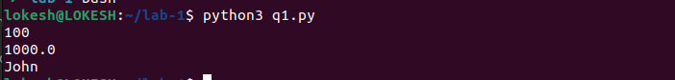

2.
a=b=c=1
a,b,c=1,2,"john"
print(a)
print(b)
print(c)
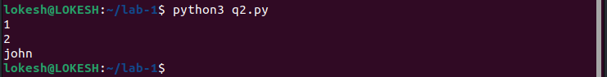

3.
a = 5 # integer assignment
b= 4.56 #floating point assignment
#mathematical operations with scalar variables
print (5*a)
print (a/2)
print(a**2)

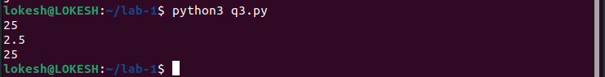

4.
str = 'Hello World!'
print (str) # Prints complete string
print (str[0]) # Prints first character of the string
print (str[2:5]) # Prints characters starting from 3rd to 5th
print (str[2:]) # Prints string starting from 3rd character
print (str * 2) # Prints string two times
print (str + "TEST") # Prints concatenated string
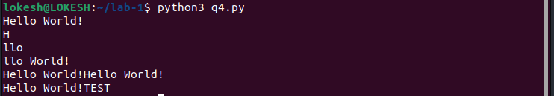

5.
var1 = 'Hello World!'
print ("Updated String :", var1[:6] + 'Python')
#string formatting
print( "My name is %s and weight is %d kg!" % ('Abay', 55))
#built-in string methods
str = "this is string example wow!!!";
print ("using of capitalize\n"+str.capitalize())
#counting the number of occurences of the substring
str = "this is string example ... wow!!!";
n=str.count('s')
print("s occured %d times in the string" %(n))
n=str.find('example')
print("Example is at %dth index in the string" %(n))
str = "THIS IS STRING EXAMPLE ... WOW!!!";
print (str.lower())
str = "this is string example ... wow!!! this is really string.................replace";
print (str.replace("is", "was"))
str = "this is string example ... wow!!!...................sWapCasE";
print (str.swapcase())
str = "this is string example ... wow!!!..........title";
print (str.title())
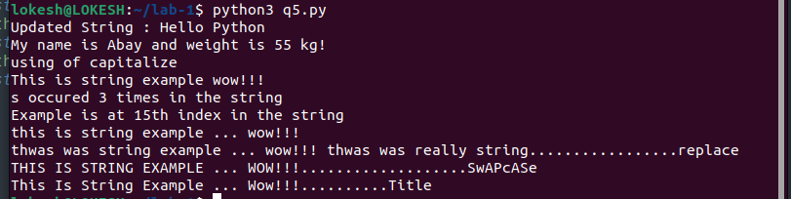

6.
list = [ 'abcd', 786 , 2.23, 'john', 70.2 ]
tinylist = [123, 'john']
print (list)
print (list[0])
print (list[1:3])
print (list[2:])
print (tinylist * 2)
print (list + tinylist)
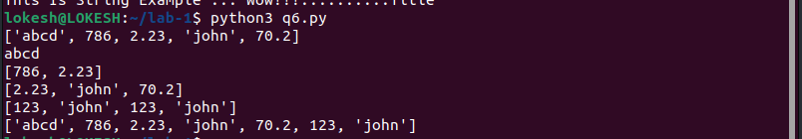
7.
list = ['physics', 'chemistry', 1997, 2000];
list.append('maths')
print("appending")
print(list)
del list[2]
print("AFter deleting")
print(list)
print("Check if present in list or not");
n='physics' in list
print(n)
n='english' in list
print(n)
print("Length function usage");
print(len(list))
print("Counting no.of occurences")
n=list.count("physics")
print(n)
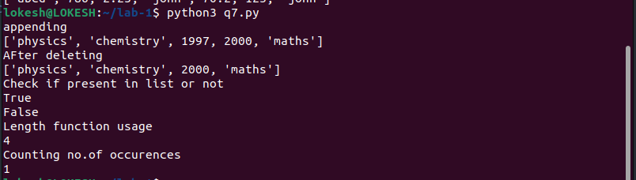

8.
list = ['physics', 'chemistry', 1997, 2000];
list.pop()
print(list)
list = ['physics', 'chemistry', 1997, 2000];
list.insert (2, "maths")
print("After inserting:")
print(list)
#list = ['physics', 'chemistry', 1997, 2000];
list.remove("chemistry")
print("After deleting:")
print(list)
list = ['physics', 'chemistry', 1997, 2000];
list.reverse()
print("After reversing:...")
print(list)
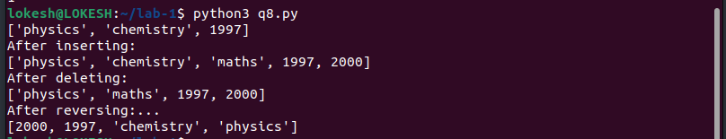

9.
tuple = ( 'abcd', 786 , 2.23, 'john', 70.2 )
list = [ 'abcd', 786 , 2.23, 'john', 70.2 ]
tuple[2] = 1000 # Invalid syntax with tuple
list[2] = 1000 # Valid syntax with list
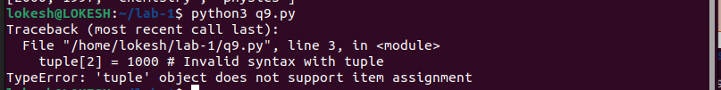

10.
num=float(input(‘Enter a number:’))
num=float(input('Enter a number:'))
if num>0:
print('pos number')
elif num==0:
print('zero')
else:
print('Neg number')

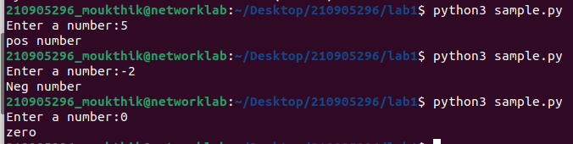

11.
x=float(input('Enter a number:'))
if x<10:
print('smaller')
if x>20:
print('bigger')
print('Finished')
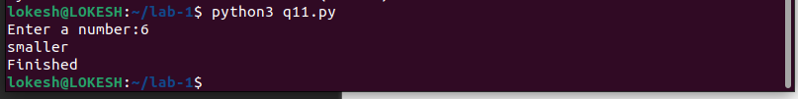

12.
x=5
print('Before 5')
if x==5:
print ('this is 5')
print('still 5')
print('After 5')
print('Before 6')
if x==6:
print('this is 6')
print('After 6')
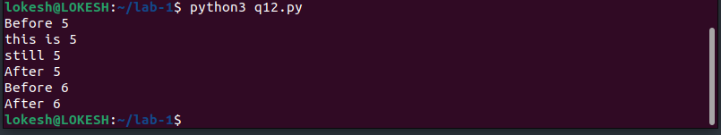

13.
x=float(input('Enter a number:'))
if x<20:
print('Below 20')
elif x<10:
print('Below 10')
else:
print('something else')
#below 10 would never be printed
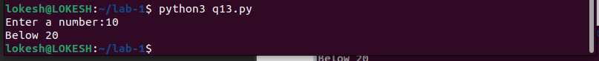

14.
x=42
if x>1:
print('above one')
if x<100:
print('less than 100')
print('All done')
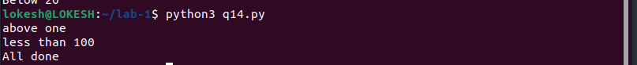

15.
age=18
b=('kid' if age<18 else 'adult')
print(b)

age=19
b=('kid' if age<18 else 'adult')
print(b)
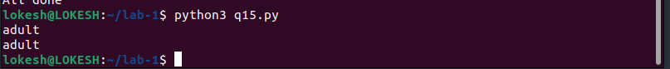
16.
#1
print("......1.......")
for val in [5,4,3,2,1]:
print(val)
print('Done')
#2
print("......2.......")
stud=['Ram','Vijay','Nithya','Anu','Ramesh','suja']
for k in stud:
print('Hello:', k)
print('done')
#3
print("......3.......")
for i in range(5):
print(i)
if i>2:
print('Bigger than 2')
print('Done with i',i)
#4
print("......4.......")
x=int(input('Enter a number:'))
for i in range(1,x+1):
if x%i ==0:
print(i)
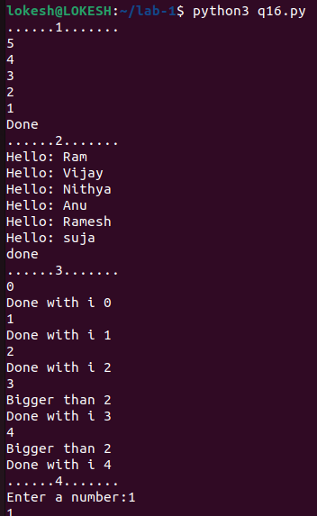

17.
from math import *
x= [9, 41, 12, 3, 74, 15]
Largest=−inf
for i in x:
if i>Largest:
Largest=i
print(Largest)

18.
from math import *
x= [9, 41, 12, 3, 74, 15]
smallest=inf
for i in x:
if i<smallest:
smallest=i
print(smallest)

19.
from math import *
x= [9, 41, 12, 3, 74, 15]
count=s=avg=0
for i in x:
count=count+1
s=s+1
avg=s/count
print(count)
print(s)
print(avg)
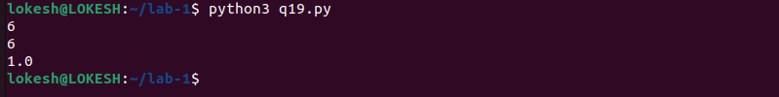

20.
x= [9, 41, 12, 3, 74, 15]
for i in x:
if i>20:
print(i)
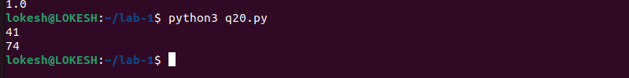

21.
x= [9, 41, 12, 3, 74, 15]
res=[]
for i in x:
if i>20:
res.append(i)
print(res)

22.
import numpy as np
x= [9, 41, 12, 3, 74, 15]
y=np.zeros(len(x))
for i in range(len(x)):
if x[i]>20:
y[i]=x[i]
print(y)

23.
price = 100
if price > 100:
print("price is greater than 100")
elif price == 100:
print("price is 100")
elif price < 100:
print("price is less than 100")

24.
i=1
n=5
# while loop from i = 1 to 5
while i <= n:
print(i)
i=i+1
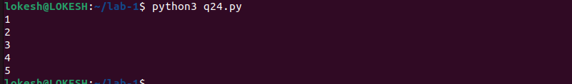

25.
total = 0
number = int(input('Enter a number: '))
# add numbers until number is zero
while number != 0:
total += number
number = int(input('Enter a number: '))
print('total =', total)

