PYTHON BASICS PRACTICE 3 -----------WEEK3
Sample program:
Code:
import numpy as np
import random as rd
A=np.array([2,5,10])
print(A.dtype)
B=np.array ([2.4,10.6,5.2])
print(B.dtype)
A=np.array([(3,4,5),(12,6,1)])
Z=np.zeros((2,4))
print(Z)
S=np.arange(10,30,5)
print(S)
B=np.arange(0,2,0.3)
print(B)
C=np.linspace(0,2,9)
print(C)
n=rd.choice([1,2,3,45,5])
print(n)
n=rd.choice('python')#, will pick one character from the string randomly
print(n)
n=rd.randrange(25,50)#, will pick one integer between 25 to 50
print(n)
n=rd.randrange(25,50,2)#, will pick one integer between 25 to 50 with step size of 2
print(n)
n=rd.random()#, will pick a random number between 0 to 1
print(n)
n=rd.uniform(5,10)#, will pick a floating point number between 5 to 10
print(n)
li=[1,2,3,4,5]
rd.shuffle(li)#, will shuffle the list elements
print(li)
rd.seed(10)#, to get same random value during every execution
print(rd.random())
a = np.arange(15).reshape(3, 5)
print(a)
print(a.shape)
print(a.T)
c = np.arange(24).reshape(2,3,4)
print(c)
a = np.array( [20,30,40,50] )
b = np.arange( 4 )
c = a-b
print(c)
print(b**2)
print(10*np.sin(a))
A = np.array( [[1,1],[0,1]] )
B = np.array( [[2,0],[3,4]] )
print(A*B)#multiplying the elementwise for a matrix
print(A.dot(B))#matrix multiplication
b = np.arange(12).reshape(3,4)
print(b.sum(axis=0))
print(b.sum(axis=1))

a = np.arange(10)**3
print(a)
print(a[2:5])
print(a[0:6:2])
b=np.array([[0,1,2,3],[10,11,12,13],[20,21,22,23],[30,31,32,33]])
print(b[2,3],'\n',b[0:5,1],'\n',b[:,1])
for row in b:
print(row)
for element in b.flat:
print(element)
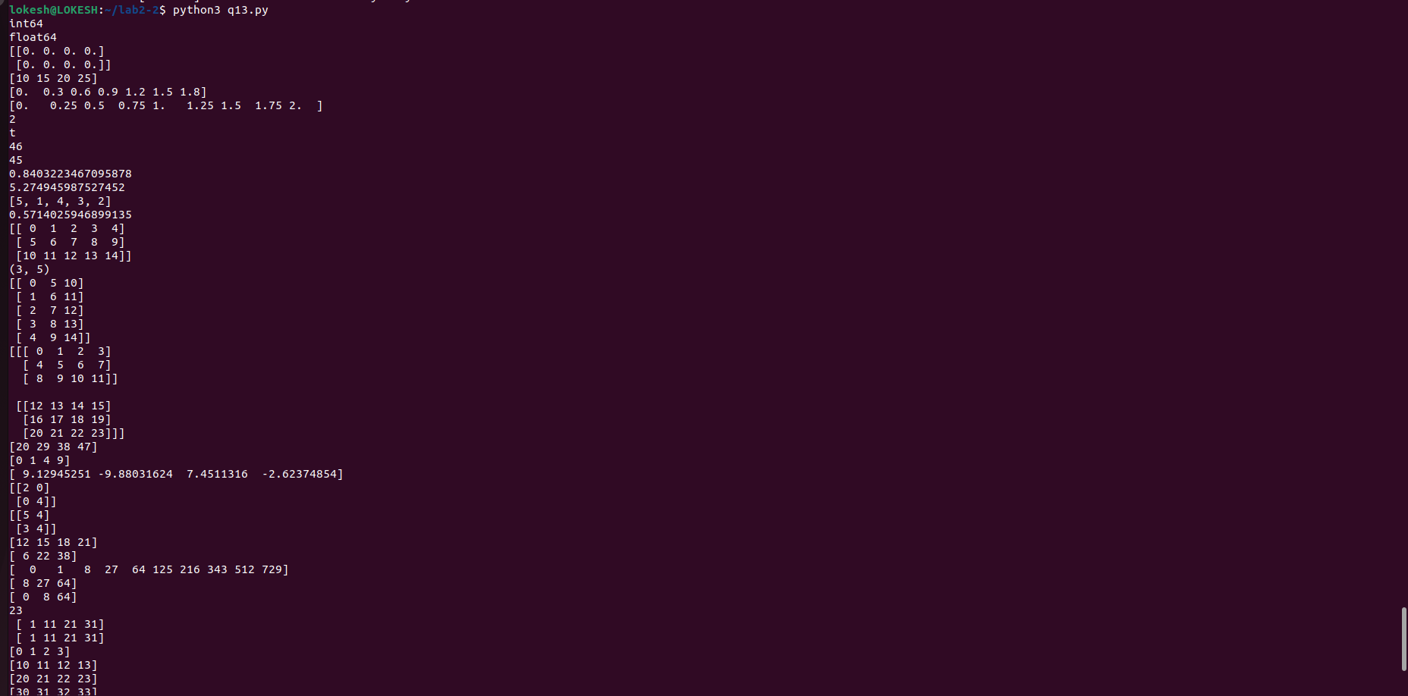

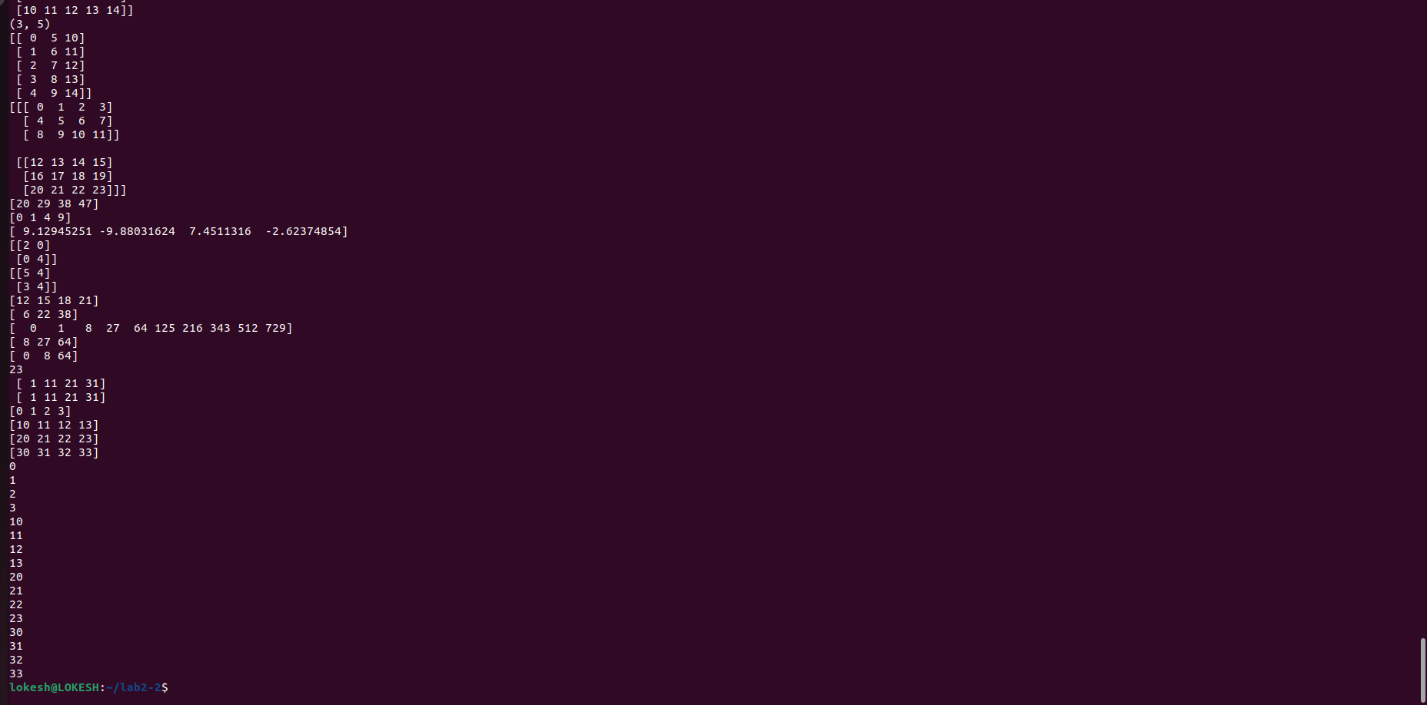

Code:
import numpy as np
import random as rd

b=np.array([[0,1,2,3,4],[10,11,12,13,14],[20,21,22,23,24],[30,31,32,33,34]])

'''for row in b:
print(row)
for element in b.flat:
print(element)'''

b.ravel()
B1=b.reshape(4,5)
print(B1)
A1=np.array([(3,4,5),(12,6,1)])
A2=np.array([(1,2,6),(-4,3,8)])
D1=np.vstack((A1,A2))
print(D1)
D2=np.hstack((A1,A2))
print(D2)
a = np.array([4.,2.])
b = np.array([3.,8.])
c=np.column_stack((a,b))
print(c)
print(np.hstack((a,b)))
newaxis=1
print(np.hstack((a[newaxis],b[newaxis])))
a = np.arange(12)**2
i = np.array( [ 1,1,3,8,5 ] )
print(a[i])
j = np.array( [ [ 3, 4], [ 9, 7 ] ] ) # a bidimensional array of indices
print(a[j])

a=np.array([(3,2,9),(1,6,7)])
s1=0
for row in a:
for col in row:
s1+=col
print(s1)

a=np.array([(3,2,9),(1,6,7)])
s=0
for i in range(a.shape[0]):
for j in range(a.shape[1]):
s+=a[i,j]
print(s)
