LAB 2: PYTHON BASICS – II

1.
import pandas as pd
import numpy as np
s=pd.Series([3,9,-2,10,5])
print(s.sum())
print(s.min())
print(s.max())

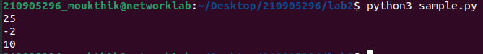
2.
import pandas as pd
data = [['Dinesh',10],['Nithya',12],['Raji',13]]
df = pd.DataFrame(data,columns=['Name','Age'])
print(df)
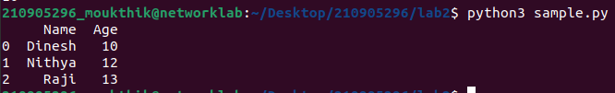
3.
import pandas as pd
data = {'Name':['Kavitha', 'Sudha', 'Raju','Vignesh'],'Age':[28,34,29,42]}
df = pd.DataFrame(data, index=['rank1','rank2','rank3','rank4'])
print(df)
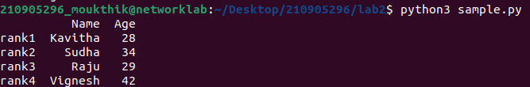
4.
import pandas as pd
import numpy as np
df=pd.DataFrame({'A':pd.Timestamp('20130102'),'B':np.array([3]*4,dtype='int32'),
'C':pd.Categorical(['Male','Female','Male','Female'])})
print(df)
print(df.shape)
print(df.dtypes)
print(df.head())
print(df.tail())
print(df.describe())
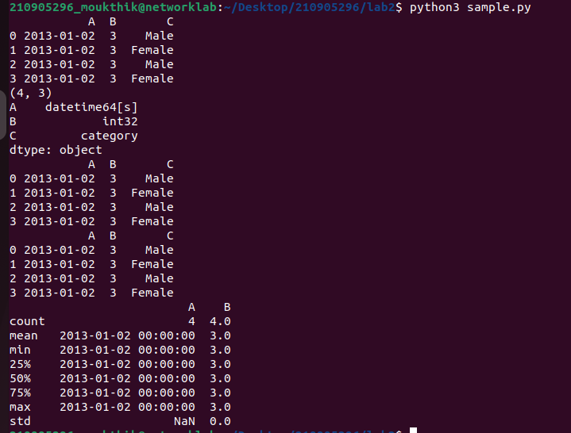
5.
import pandas as pd
import numpy as np
df=pd.read_csv('~/Desktop/Distributed Systems Lab2024/Datasets for Distributed Systems Lab-2024/Lab 2 required files/xyz.csv',header=None)
print(df)
print(df.head())
print(df.tail())
print(df.describe())

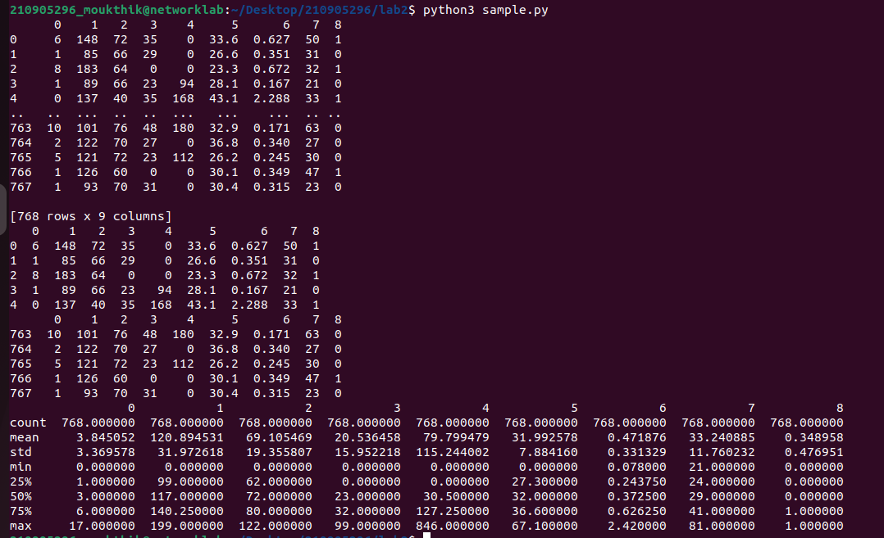
6.
import pandas as pd
import numpy as np
dates=pd.date_range('20130101', periods=100)
df = pd.DataFrame(np.random.randn(100,4), index=dates, columns=list('ABCD'))
print(df.head())
print(df.tail())
print(df.index)
print(df.columns)
print(df.T)
df.sort_index(axis=1, ascending=False)
print(df.head())
df.sort_values(by='B')
print(df.head())
print(df[0:3])
print(df['20130105':'20130110'])
print(df.iloc[0])
print(df.iloc[0,:2])
print(df.iloc[0,0])
print(df['A'])
print(df[['A','B']])
print(df[['A','B']][:5])

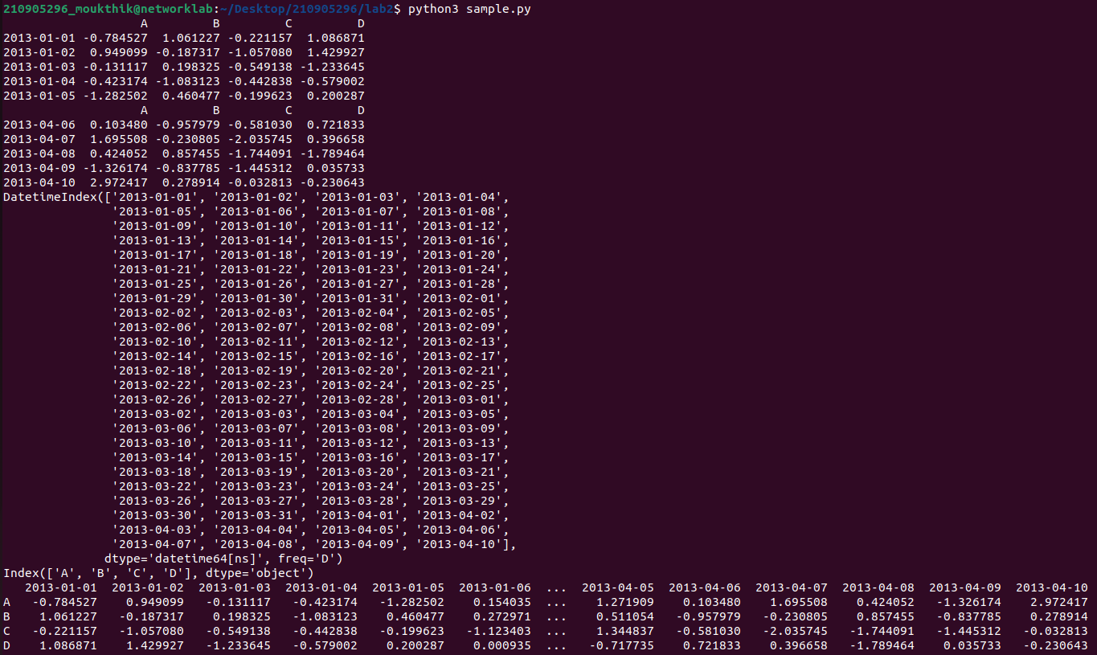
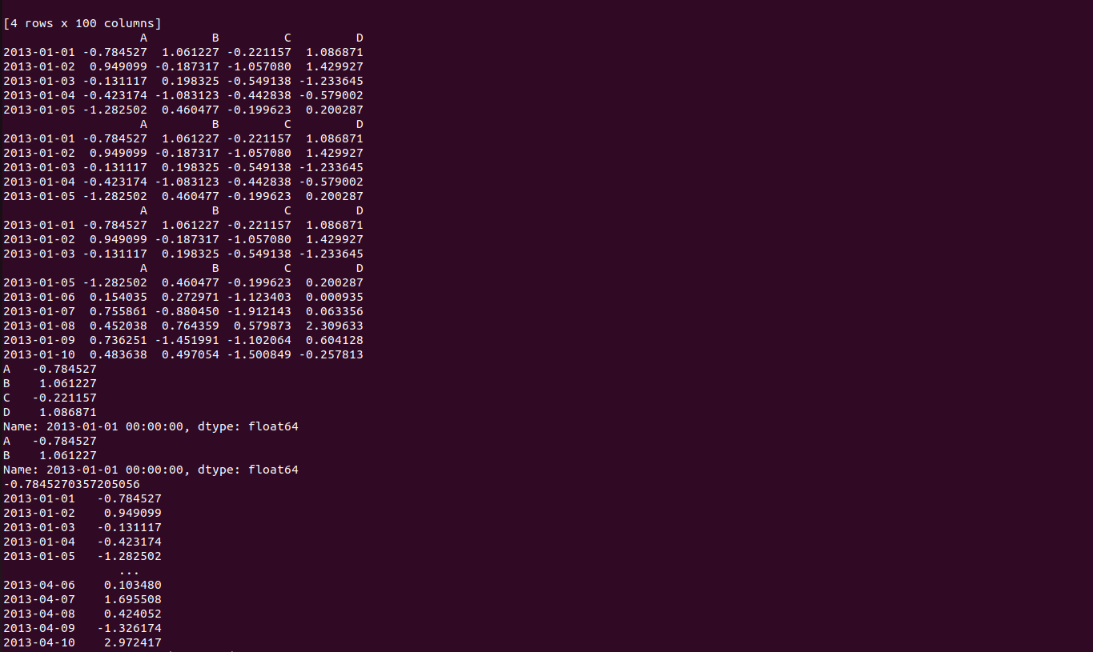
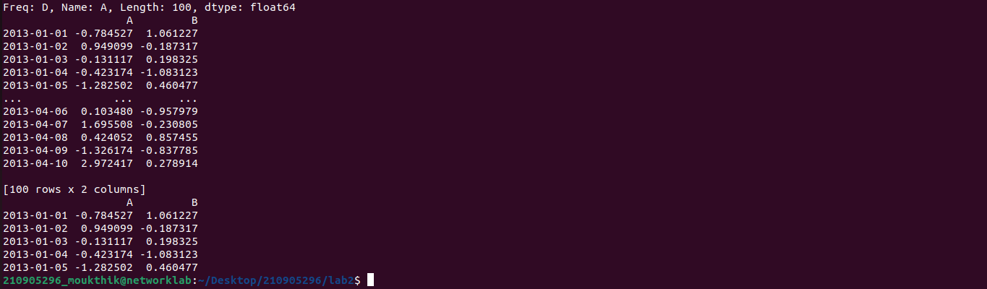

7.
Boolean Indexing

import pandas as pd
import numpy as np
dates=pd.date_range('20130101', periods=100)
df = pd.DataFrame(np.random.randn(100,4), index=dates, columns=list('ABCD'))
print(df[df.A>0].head())
df['F'] = np.random.choice(['Male', 'Female'], size=len(df))
print(df)

df.loc[:,'D']=np.array([5]*len(df))
print(df)
df.drop ('D', axis =1, inplace=True)
print(df)
df.drop ('20130102', axis =0, inplace=True)
print(df)

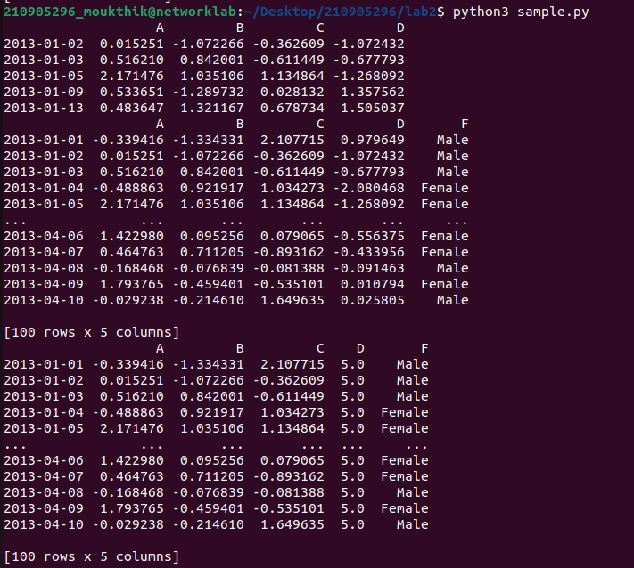

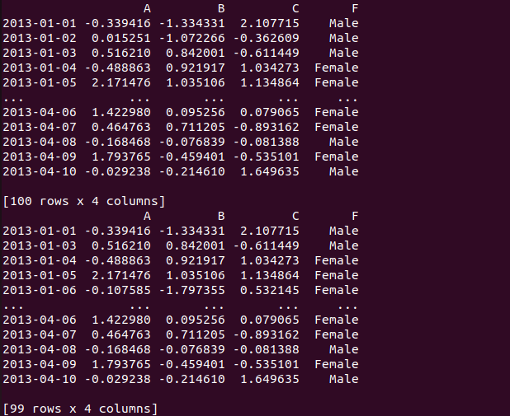
8.
import pandas as pd
import numpy as np
dates=pd.date_range('20130101', periods=100)
df = pd.DataFrame(np.random.randn(100,4), index=dates, columns=list('ABCD'))
df1=df.head()
df2=df.tail()
df_new=pd.concat([df1,df2],axis=1)
print(df_new.shape)
9.
import pandas as pd
import numpy as np
df=pd.read_csv('~/Desktop/Distributed Systems Lab2024/Datasets for Distributed Systems Lab-2024/Lab 2 required files/xyz.csv',header=None)
print(df)
print("HEAD")
print(df.head())
print("TAIL")
print(df.tail())
df.columns=['preg','glu','bp','sft','ins','bmi','dpf','age','class']
print("Columns")
print(df.head())

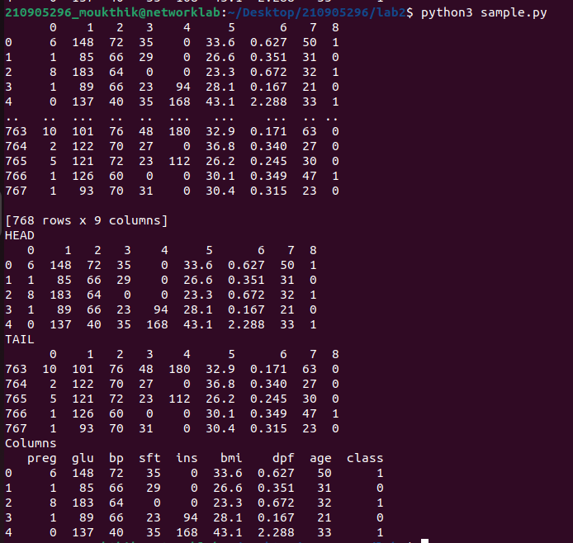
10.
import pandas as pd
import numpy as np
import matplotlib.pyplot as plt

# Omit header=None to let pandas infer column names
df = pd.read_csv('~/Desktop/Distributed Systems Lab2024/Datasets for Distributed Systems Lab-2024/Lab 2 required files/xyz.csv')
df.columns=['preg','glu','bp','sft','ins','bmi','dpf','age','class']
plt.scatter(df['bmi'], df['glu'])
plt.xlabel('BMI')
plt.ylabel('Glucose')
plt.show()
df['age'].hist()
plt.show()

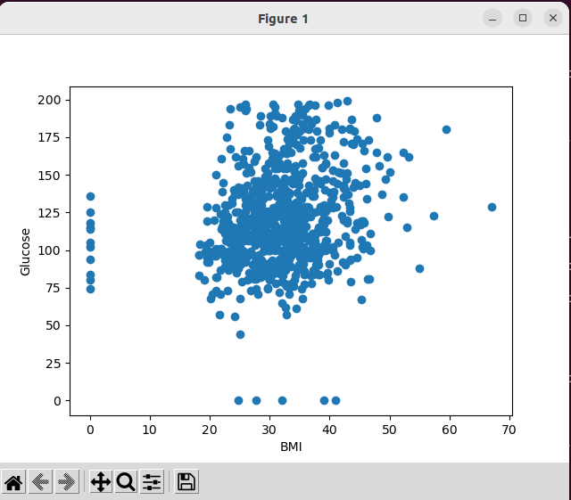
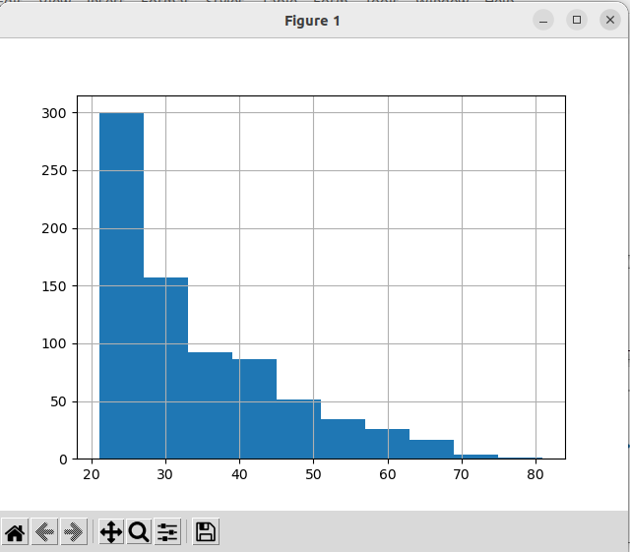

11.XLS READING
import pandas as pd
import numpy as np
import matplotlib.pyplot as plt

# Omit header=None to let pandas infer column names
W = pd.read_csv('~/Desktop/Distributed Systems Lab2024/Datasets for Distributed Systems Lab-2024/Lab 2 required files/wine_for_Week2.xls',header=None)
print(W.head()) #XLS file format also, we can read using pd.read_csv
D= np.loadtxt('xyz.txt',delimiter=",")
print(D[:5,:]) # this file is loaded in Numpy 2D array format
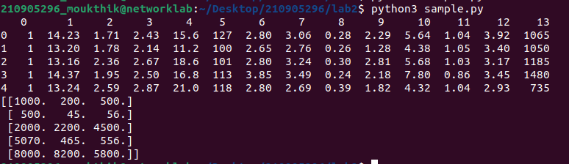
12.
import pandas as pd
import numpy as np
import matplotlib.pyplot as plt

# Omit header=None to let pandas infer column names
G=pd.read_excel('xyz.xlsx',sheet_name='Sheet1')
print(G.head())
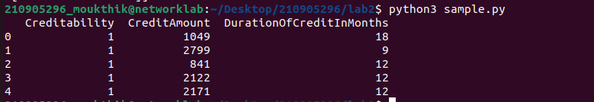
13.
B = pd.read_html('http://www.fdic.gov/bank/individual/failed/b
anklist.html')
# Reading a TXT file format
H = pd.read_table('HR.txt')
H.head()
f=H['Department'].value_counts()

..........

import pandas as pd
import numpy as np
import matplotlib.pyplot as plt

# Omit header=None to let pandas infer column names
#B = pd.read_html('http://www.fdic.gov/bank/individual/failed/banklist.html')
#print(B.head())
# Reading a TXT file format
H = pd.read_table('xyz.txt')
print(H.head())
f=H['Department'].value_counts()
print(f)
f.plt(kind='bar')
plt.show()

