State-Wise Effects of Internet Access & Study Time on Student Performance in India

1.Project Overview:
This study examines how key resources — namely home internet access, tutor support, and overall resource availability — together with weekly study time, influence student performance (as measured by subject scores, total marks and average marks). The analysis will explore how these factors vary across states, identify where high resource availability and strong study habits translate into better performance, and uncover where performance lags despite good access.
2.Dataset Summary:
- Number of records (rows): 700
- Number of columns (variables): 25
- Dataset is for students across various Indian states, covering internet access, tutor support, study time, performance and other attributes.

3.Exploratory data analysis using python:
This section describes the key steps performed to explore and understand the dataset, identify patterns and anomalies, and prepare the data for further analysis.
3.1 Data Loading and Initial Inspection
- Loaded the data-fil e into the analysis environment (Python/pandas).
- Recorded the dataset size: 700 rows × 25 columns
- Checked data types, number of missing values, and first/last few rows to understand the structure.
e.g., df.info(), df.describe(), df.head().
- Verified that column names match the data dictionary (for example: marks_in_physics, study_time_weekly, internet_facility, etc).
3.2 Data Cleaning & Pre-processing
- Identified and handled missing values (e.g., using df.isnull().sum()), and documented how many records/columns had missing data.
- Removed duplicate records if present.
- Converted categorical columns (e.g., internet_facility, tutor_support, performance) into appropriate data types.
- Created derived variables:
  - total_marks = Physics + Maths + Chemistry
  - Average_marks = total_marks / 3
  - Any grouping flags (for example “high study time”, “resource rich” vs “resource poor”).
- Ensured units and formats were consistent (e.g., study_time_weekly in hours, family_income_in_lakhs in lakhs INR).
3.3 Univariate Analysis
- For numeric variables (such as marks_in_physics, Average_marks, study_time_weekly, absences, family_income_in_lakhs):
  - Plotted histograms and density plots to inspect distributions and detect skewness/outliers.
  - Generated boxplots to visualise extreme values.
  - Computed descriptive statistics: mean, median, standard deviation, min, max.
- For categorical/boolean variables (such as internet_facility, tutor_support, performance, gender):
  - Produced count plots to show frequency of each category.
  - Tabulated value counts and proportions (e.g., % of students with internet facility = “Yes”).
3.4 Bivariate / Relationship Analysis
- Explored relationships between key independent variables and performance outcome(s):
  - Example: study_time_weekly vs Average_marks – created scatter plot, computed correlation.
  - Example: internet_facility (Yes/No) vs Average_marks – created boxplot grouped by internet access.
- Calculated a correlation matrix of numeric features and visualised via heatmap to identify strong associations among variables (e.g., study time, family income, absences, average marks).

4.Data Analysis using SQL:
This section outlines how SQL was used to query, transform, aggregate, and analyse the dataset to support the research questions of the project.
1) counts of the male and female students by region wise
SELECT gender,region,count(*) as student_count FROM student_performance group by region,gender;
Result:
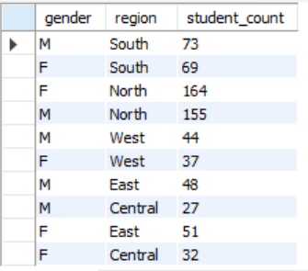
2) finding out the top performer in the examination by using sub queries?
select * from student_performance where Average_marks=
(select max(Average_marks) from student_performance);

3) finding out the top 3 states in terms of highest average marks?
select max(Average_marks) as max_avg_marks,
state from student_performance group by state order by max_avg_marks desc limit 3; 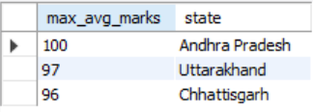
4) # Performance by resource availability (internet + tutor support)
/* Insight: a less no of students with having resources
(internet + tutor support) getting good marks than those who is not having resources*/

select Resource_availability,round(avg(Average_marks)) as
average_marks,count(*) as no_of_students
from student_performance group by Resource_availability;

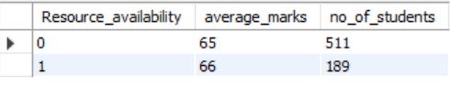
5) city wise perfromance

select * from student_performance where (city,Average_marks) in
(select city,max(Average_marks)
from student_performance group by city having max(Average_marks)>90);
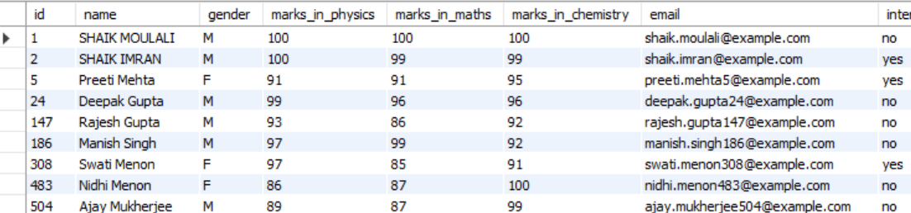

6) # gender wise average marks

# insights male students are slightly getting higher average marks than female students

select gender,round(avg(Average_marks)) from student_performance group by gender;
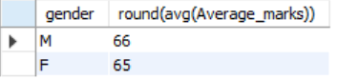

7) highest scored student in both male and female

select * from student_performance where
(gender,total_marks) in(select gender,max(total_marks)
from student_performance group by gender) limit 2;

5.Student performance analysis using dashboard:

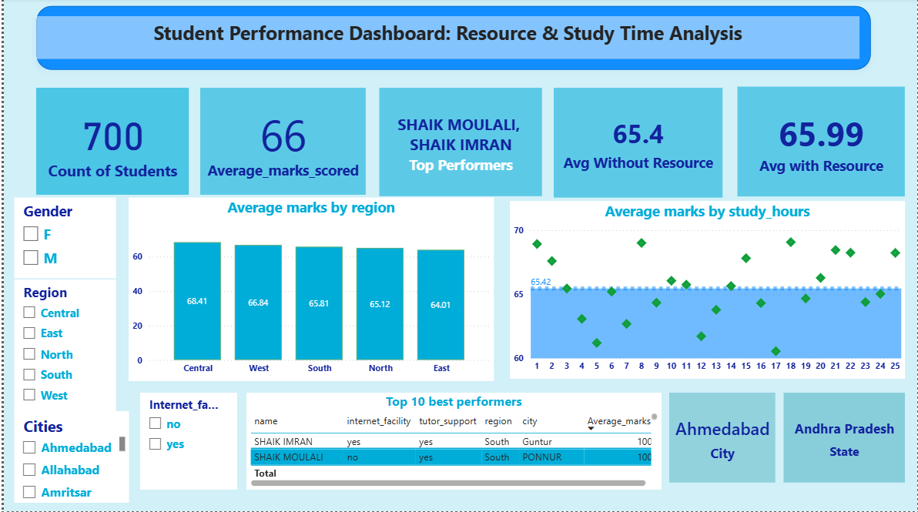

- Created a card visual showing total student count.
- Created a card visual showing average marks scored by students.
- Created a card visual showing top performers.
- Created a card visual showing student average marks with resources available vs without resources available.
Slicer Setup Steps for Student Performance Dashboard:
Selected major filtering dimensions relevant to business questions:
- Internet access (“internet_facility” = Yes/No) → to compare students with vs without internet.
- Region (“region” field) → to filter and compare performance by region of India.
- Gender (“gender” field: Male/Female) → to examine performance differences by gender.
- City (“city” field) → to identify which specific city has the highest marks.
These slicers align with the goal of understanding how resource-availability and student attributes affect performance across states, regions and groups

Charts :
- Created a column chart for comparing the average marks by region wise (North,South,East,West,Central) part of india.
- Created scatter plot to examine the the average marks scored in terms of weekly hours
- Created a table metrics with top 10 students with the highest marks

