Connecting to GIT with SSH

Below are the steps which needs to be followed for connecting GIT with SSH:

**Step #1:** [Check for existing SSH keys](https://help.github.com/articles/checking-for-existing-ssh-keys).

**Step #2:** Generate a new SSH key.

**Step #3:** Add SSH key to ssh-agent.

**Step #4:** Add newly generated key to GIT account.

**Step #1:** [**Check for existing SSH keys**](https://help.github.com/articles/checking-for-existing-ssh-keys)

1. Open Git Bash by right clicking on Desktop and selecting ***Git Bash*** Here.

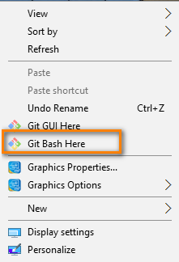

1. Enter ***ls -al ~/.ssh*** command to see if existing SSH keys are present.

ls -al ~/.ssh

# Lists the files in your .ssh directory, if they exist

1. Check the directory listing to see if you already have a public SSH key. (**If you already have SSH key skip step #2)

**Step #2: Generate a new SSH key**

1. Execute the command ***ssh-keygen -t rsa -b 4096 -C*** [***your_email@example.com***](mailto:your_email@example.com)

ssh-keygen -t rsa -b 4096 -C [brastogi@cisco.com](mailto:brastogi@cisco.com)

Generating public/private rsa key pair.

1. When you're prompted to "Enter a file in which to save the key," press Enter. This accepts the default file location.

Enter file in which to save the key (/c/Users/brastogi/.ssh/id_rsa):[Press enter]

1. At the prompt, type a secure passphrase.

Enter passphrase (empty for no passphrase): [Type a passphrase]

Enter same passphrase again: [Type passphrase again]

**Step #3: Add SSH key to ssh-agent.**

1. Start ssh-agent by executing ***eval $(ssh-agent -s)*** command.

# start the ssh-agent in the background

eval $(ssh-agent -s)

Agent pid 59566

1. Add SSH key to the ssh-agent using ***ssh-add ~/.ssh/id_rsa*** command.

**Step #4: Add newly generated key to GIT account.**

1. Copy the SSH key to your clipboard using ***clip < ~/.ssh/id_rsa.pub*** command.

*Tip: If clip isn't working, you can locate the hidden .ssh folder (default location:* C\Users\you\.ssh\id_rsa*), open the file in your favorite text editor, and copy it to your clipboard.*

$ clip < ~/.ssh/id_rsa.pub

# Copies the contents of the id_rsa.pub file to your clipboard

1. Login to your GIT account. (URL: <https://gitscm.cisco.com/projects/LJT>)
2. Click on Manage Account.

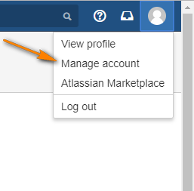

1. Select SSH keys option.

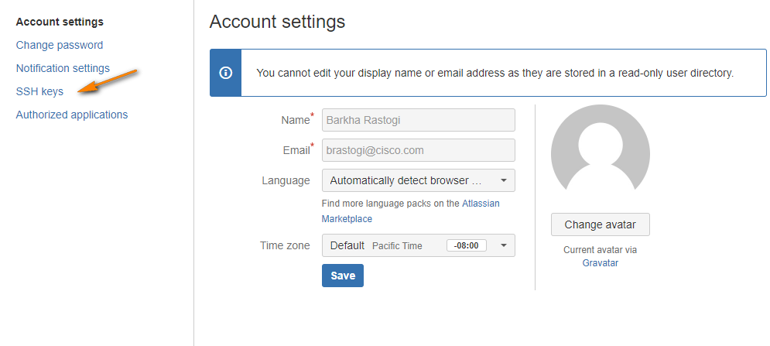

1. Click on Add key button.

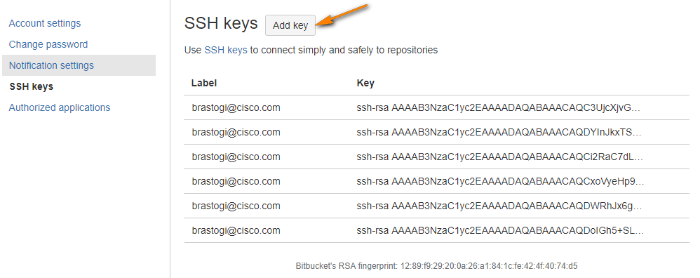

1. Paste the copied ssh key and click on Add key button.

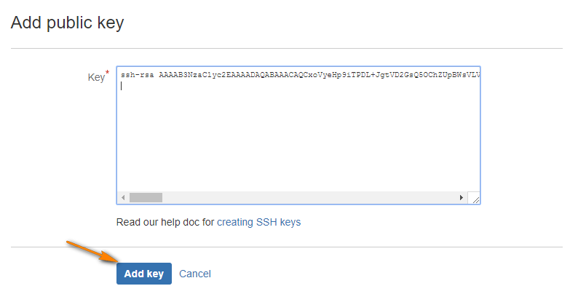

After following above steps, you will be able to commit any project to GIT repository using SSH.