APACHE SQOOP L1

MYSQL :

1. List out all the databases available in your environment.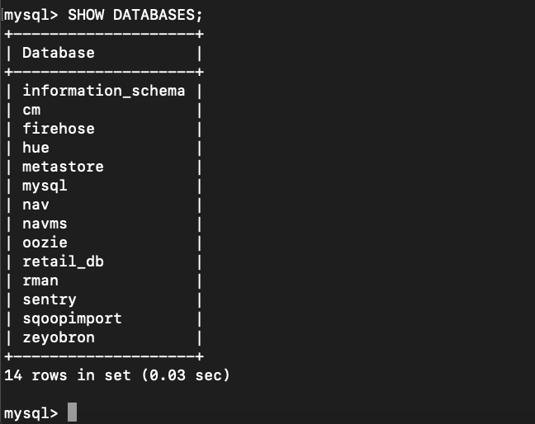

2. Create 3 databases and name it as TG_1, TG_2, TG_3 in mysql.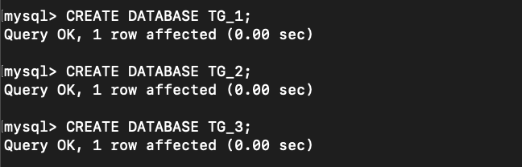

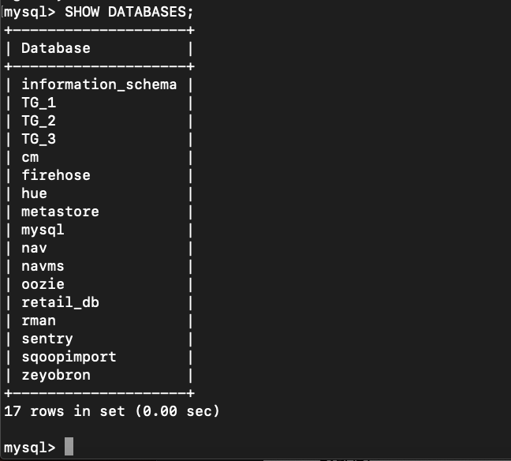

3. make TG_1 as active database and create following tables avaliable.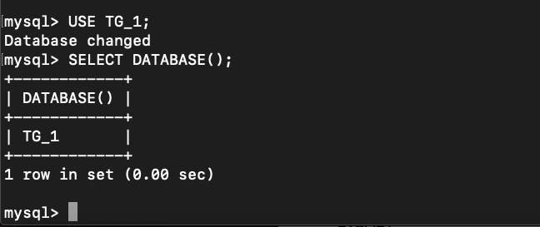

empdata:

ename,empno,sal,deptno

khyathi,101,5000,10

srinidhi,102,3500,20

sravani,103,4400,10

charan,104,4200,20

saikrupa,105,3900,10

yashaswi,106,4000,20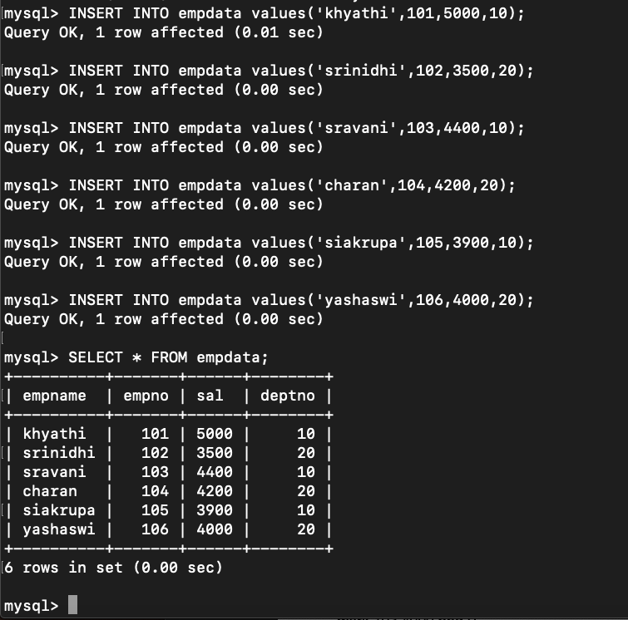

dpt_data :

deptno,dname

10, IT

20,Sales

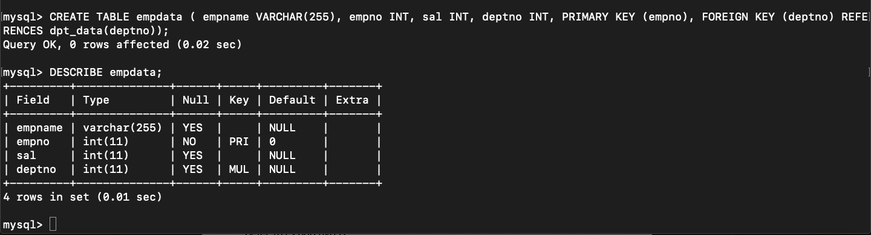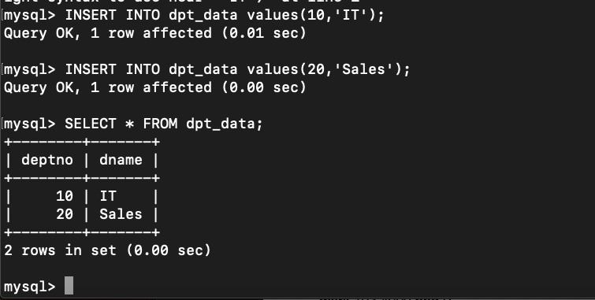

3. Display metadata of above tables you created.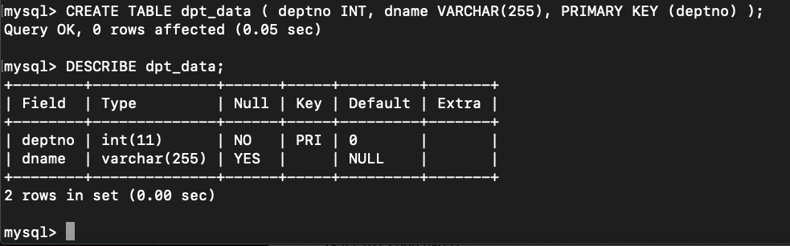

Import in sqoop :

4. import above two tables one by one into TG_1.

sqoop import --connect jdbc:mysql://localhost/TG_1 --username root --password cloudera --table empdata --m 1 --warehouse-dir /user/cloudera/topgearsqoop

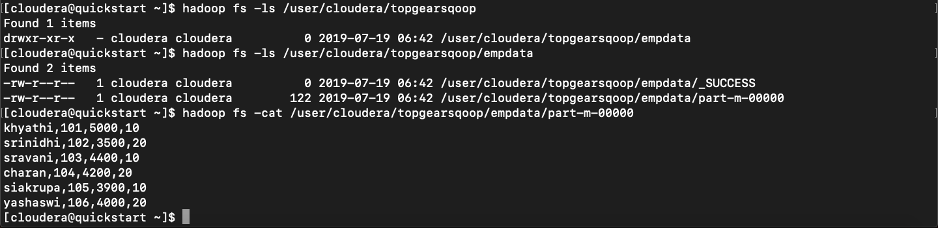

sqoop import --connect jdbc:mysql://localhost/TG_1 --username root --password cloudera --table dpt_data --m 1 --warehouse-dir /user/cloudera/topgearsqoop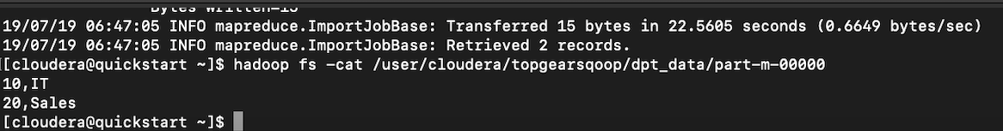

5. import above two tables at a time into TG_2.

sqoop import-all-tables --connect jdbc:mysql://localhost/TG_1 --username root --password cloudera --m 1 --warehouse-dir /user/cloudera/topgearsqoop2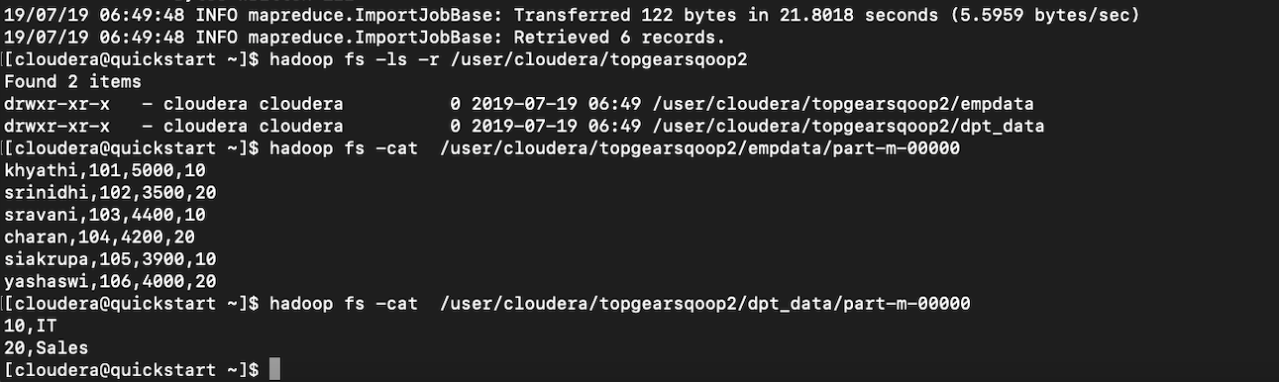

6. import first table data whose deptno is 10 into TG_3

sqoop import --connect jdbc:mysql://localhost/TG_1 --username root --password cloudera --table dpt_data --where "deptno=10" --m 1 --warehouse-dir /user/cloudera/TG_3

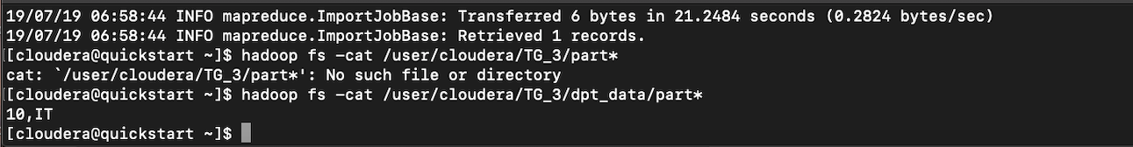

7. import first table data whose deptno is 20 appending into above table from TG_3.

sqoop import --connect jdbc:mysql://localhost/TG_1 --username root --password cloudera --table dpt_data --where “deptno=20” —append —m 1 --warehouse-dir /user/cloudera/TG_3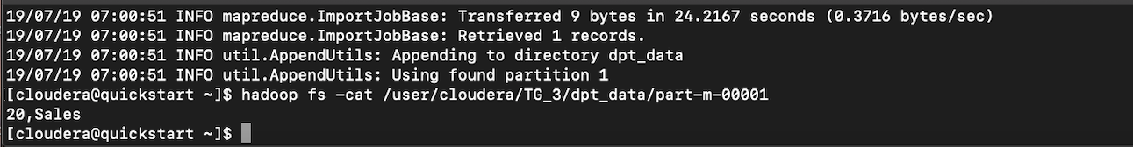

8. import join result of above two tables using a query and load into hdfs.

sqoop import --connect jdbc:mysql://localhost/TG_1 --username root --password cloudera --query 'SELECT empdata.empname, empdata.empno,empdata.sal,empdata.deptno, dpt_data.dname FROM empdata INNER JOIN dpt_data ON empdata.deptno = dpt_data.deptno WHERE $CONDITIONS' --m 1 --target-dir \user\cloudera\jointables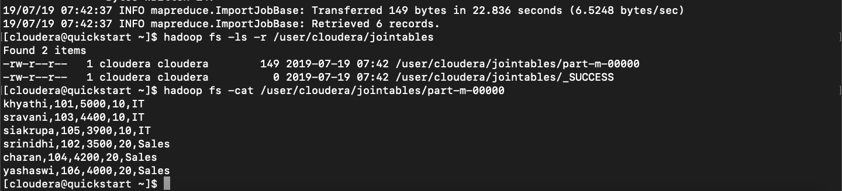

EXPORT :

Consider following hdfs file.

empdtls:

ename,empno,sal,loc,dept

peter,101,2000,hyd,IT

sam,102,3900,pune,SALES

mark,103,4000,bng,IT

blake,104,5400,chn,mrktng

smith,105,3200,delhi,sales

ram,106,2300,kochi,mrktng

seshu,107,4400,hyd,sales

sindhu,108,5500,mysore,IT

bindu,109,5600,kolkata,SALES

9. export this file from hdfs to mysql.

sqoop export --connect jdbc:mysql://localhost/TG_1 --username root --password cl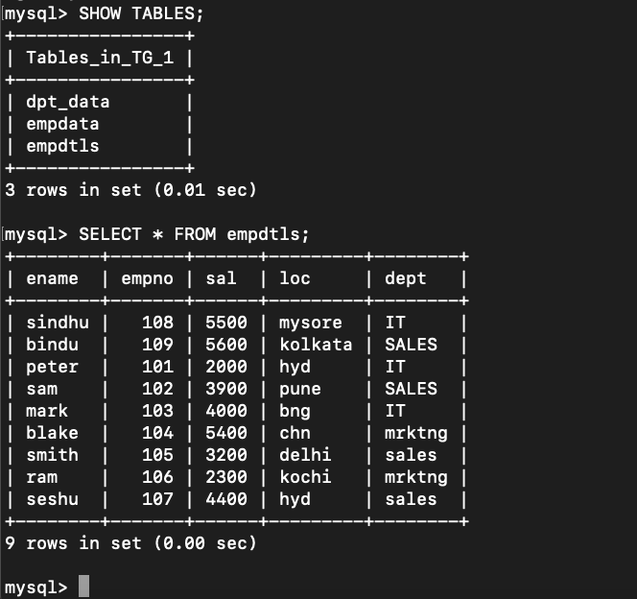oudera --table empdtls --export-dir /user/cloudera/TG_1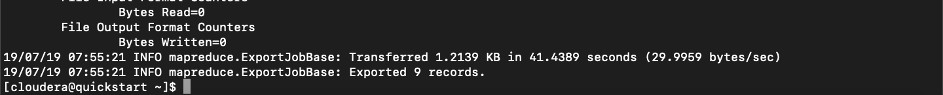

10. display structure of this exported file and display contents.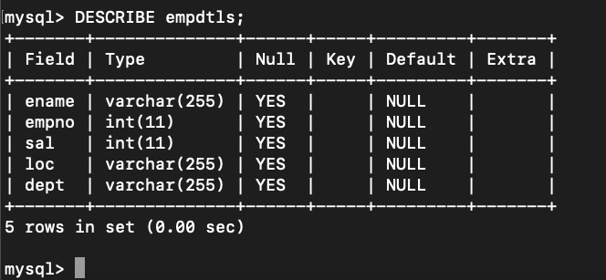

11. add few records in hdfs file and export them to mysql.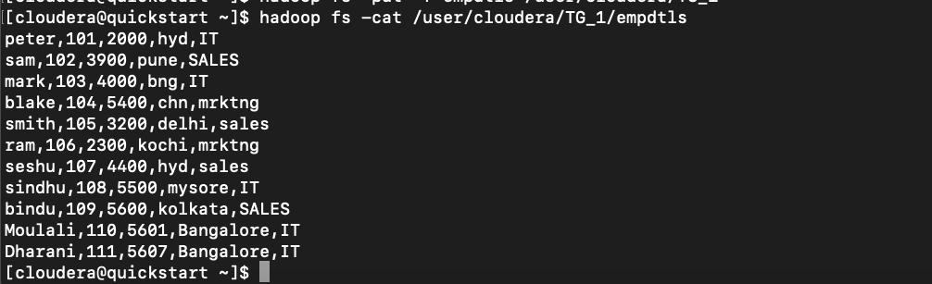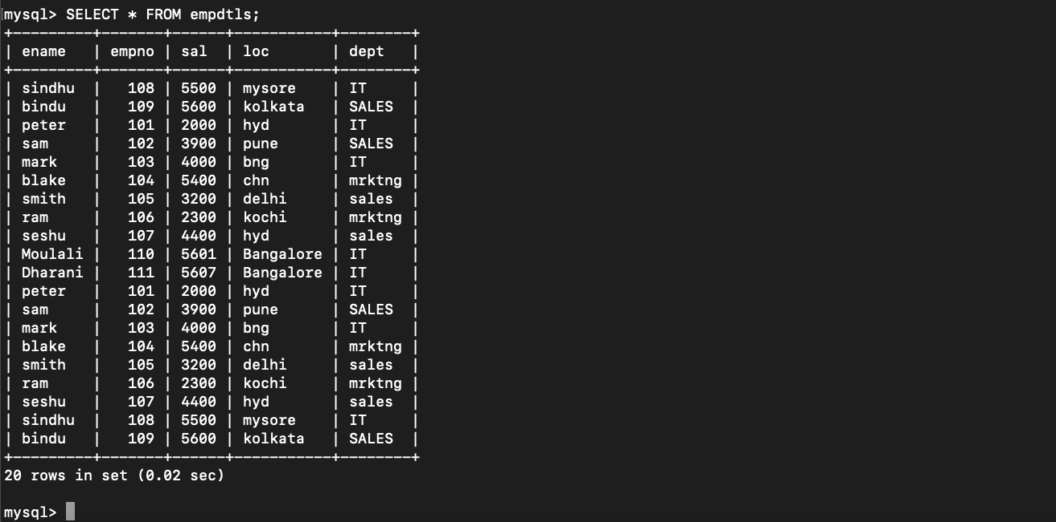

12. add couple of records into hdfs file with nulls(numeric) and export them to mysql.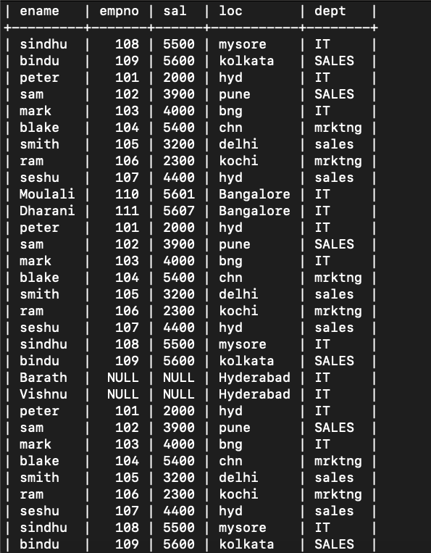

13. verify data from hdfs file and mysql file. update all nulls to -1

sqoop export --connect jdbc:mysql://localhost/TG_1 --username root --password cloudera --table empdtls —input-null-non-string '-1' --export-dir /user/cloudera/TG_1

Handling NULL values in snoop export is not possible…

CODEGEN :

14. Create a database in mysql , name it as TG_4.

15. create above table empdtls into TG_4.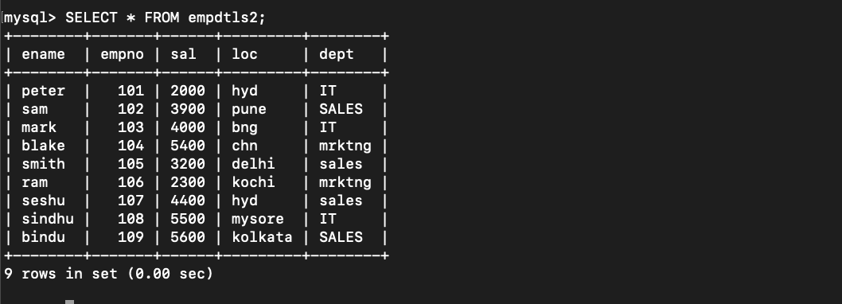

16. Develop a javacode for importing empdtls table to hdfs. ( Attach or copy .java file while submiting)

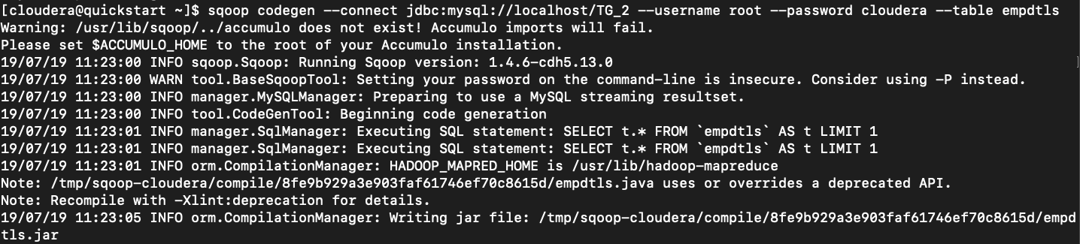



17. Develop a javacode for exporting hdfs file to a table in mysql. ( Attach or copy .java file while submiting)

Not able to find…

Unable to differentiate between the sqoop import and sqoop export codegen