Buoyancy-Driven CFD Study of a Ceiling-Cassette-Cooled Room
Transient conjugate-free simulation of a sloped-roof occupied space in OpenFOAM

Solver: buoyantPimpleFoam (transient, cold-started) Toolchain: FreeCAD 0.21 · OpenFOAM v2012 · VTK/matplotlib · ffmpeg
Date: September 2026 Prepared with: Claude (Cowork), on the author's workstation
Summary
A ~79 m³ single-storey room with a mono-pitch (sloping) roof, three seated occupants, an equipment box and a solar-loaded window is cooled by a ceiling-cassette diffuser. The geometry was built parametrically in FreeCAD, meshed with a body-fitted hexahedral block (~72k cells, checkMesh clean) and solved as a compressible buoyant flow with k-ω SST turbulence. Ventilation is 0.26 kg/s (≈10 air changes per hour) of 16 °C supply air against a ~609 W sensible load. The transient run reproduces the expected mixing-ventilation pattern: a cold ceiling jet drops to the floor centre, spreads, and drives corner recirculation, with a warmer stratified layer under the high side of the roof. This report documents the model, a ventilation-flux defect found and fixed during setup, the results, and a roadmap of follow-on studies.

1 Introduction and objectives
The purpose of this study was to stand up a complete, physically consistent CFD workflow for a realistically loaded occupied room and to use it to examine how a ceiling-cassette air-conditioner distributes cooling in a space with an asymmetric (sloping) ceiling. The room is intended as a reusable baseline: the geometry is parametric, the boundary conditions are explicit and traceable to a heat balance, and the case is structured so that ventilation rate, supply temperature, diffuser design and return location can be swept in later work.
Three questions motivated the model. First, does a downward ceiling-cassette jet mix the room or short-circuit to the return? Second, how does the sloping roof bias the flow, given that one side of the ceiling sits ~0.8 m higher than the other? Third, is the occupied zone kept within a comfortable temperature band without generating a cold-draught nuisance under the diffuser? The transient solution answers the first two directly and gives a first, conservative read on the third.

2 Geometry and computational domain
The enclosure is a single room measuring 5.5 m (x) by 4.5 m (y) in plan, with a mono-pitch roof falling from 3.6 m on the high wall to 2.8 m on the low wall, giving an internal volume of approximately 79 m³. The geometry was authored as a parametric FreeCAD Part macro so that dimensions, occupant positions and the window opening can be regenerated on demand and exported to STL/STEP for meshing.
Internal heat sources are represented as solid obstacles carved from the fluid domain: three standing/seated occupant blocks (0.4 × 0.35 × 1.7 m) and one equipment box (0.6 × 0.6 × 0.9 m). A 2.4 × 1.5 m window (0.9 m sill) sits on one long wall and carries an external convective load. The ceiling-cassette supply and return are represented as a concentric diffuser on the sloped roof — an outer supply ring feeding a downward jet and a central return — rather than as a protruding cassette body (see §5).
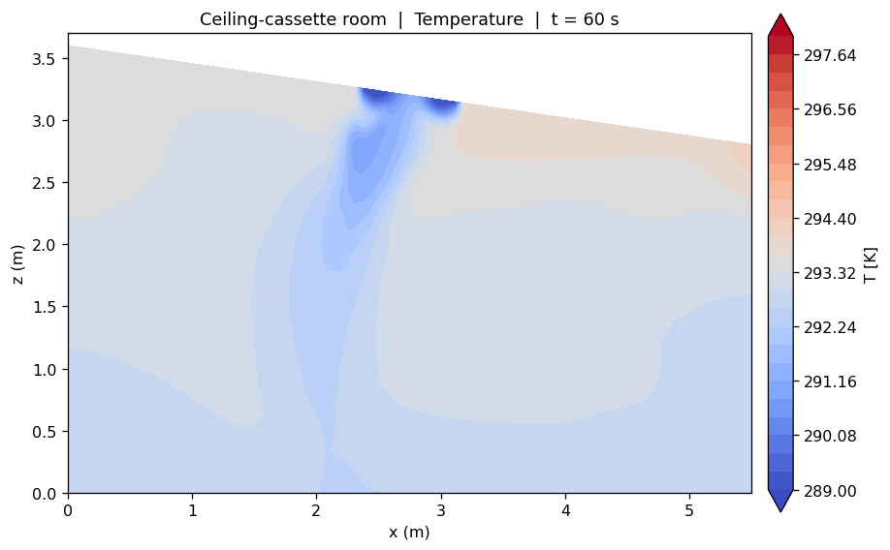
Figure 1 — Vertical mid-plane (y = 2.25 m) temperature field at t = 60 s. The cold cassette jet descends from the ceiling and a warm layer collects under the high side of the roof (upper right).

3 Thermal loads and heat balance
All internal gains were prescribed as fixed sensible heat rates so that the total load is exact and auditable, rather than being back-calculated from surface temperatures. Occupants are modelled at 75 W each (seated, sensible fraction only); the equipment box at 200 W; and the window as a convective boundary with an outside air temperature of 40 °C and a film coefficient of 5.7 W/m²K, which delivers roughly 181 W at the simulated wall temperature. All other room surfaces are treated as adiabatic, isolating the internal-gain response from envelope conduction for this baseline.
Heat source | Model / boundary condition | Sensible load
Occupants (×3) | externalWallHeatFlux, fixed power 75 W each | 225 W
Equipment box | externalWallHeatFlux, fixed power | 200 W
Window (solar/conduction) | convective, h = 5.7 W/m²K, Tₐ = 40 °C | ≈ 181 W
Other walls, floor, roof | adiabatic (zeroGradient T) | 0 W
Total sensible load |  | ≈ 609 W

At 0.26 kg/s of supply air the ventilation delivers roughly 10 air changes per hour. For a sensible load of ~609 W, the steady-state supply-to-return temperature rise implied by an energy balance is only about 2.3 K (Q = ṁ·cp·ΔT), which is consistent with the ~0.6 K rise measured across the still-developing transient at t = 60 s and confirms the loads and flow rates are self-consistent.

4 Boundary conditions and numerics
The flow is compressible and buoyant (heRhoThermo, perfectGas, sensibleEnthalpy) with gravity acting in −z. Turbulence uses the k-ω SST RAS model with high-Reynolds wall functions. Pressure is split into a hydrostatic-referenced p_rgh with fixedFluxPressure at walls. The key field boundary conditions are summarised below.
Patch | Velocity | Temperature | Pressure (p_rgh)
Supply (diffuser ring) | flowRateInletVelocity, 0.26 kg/s downward | 289 K (16 °C) | fixedFluxPressure
Return (diffuser centre) | pressureInletOutletVelocity | inletOutlet | fixedValue 1e5
Occupants / equipment | no-slip | fixed-power flux | fixedFluxPressure
Window | no-slip | convective (h, Tₐ) | fixedFluxPressure
Walls / floor / roof | no-slip | adiabatic | fixedFluxPressure

The case is run as a transient buoyantPimpleFoam solve (PIMPLE, 2 outer / 2 inner correctors, one non-orthogonal correction), cold-started from a uniform 20 °C, still-air field, with an adjustable time step capped at Courant number 2. Convection used bounded Gauss upwind for stability on the internal shear layers; Laplacian terms used corrected (non-orthogonality-aware) schemes, with wall distance computed by the meshWave method. Linear solvers were GAMG for p_rgh and PBiCGStab for the remaining fields. (A steady buoyantSimpleFoam initialisation is a natural refinement but was not used here; the results below are therefore an early, developing transient — see §6.3.)

5 Mesh generation and a ventilation-flux correction
The domain is meshed with a single body-fitted hexahedral block whose top face is inclined to follow the mono-pitch roof, so the sloped ceiling is represented by true hex faces rather than a stair-stepped snappyHexMesh surface. The four internal heat-source obstacles are carved from this block, and the diffuser and window patches are cut deterministically from clean boundary faces using topoSet (boundaryToFace intersected with a bounding box) followed by createPatch. The final mesh is roughly 72,000 cells across 13 patches and passes the standard checkMesh with no failed checks.
A defect worth recording. An earlier version modelled the cassette as a protruding body and carved the supply and return from the baffle faces on its underside. Because those baffles are internal (two-sided) faces, the face-area vectors of the carved patch very nearly cancelled — the net area was about 0.002 m² out of 0.88 m² of face — so the prescribed inlet momentum was almost annihilated and the measured supply flow collapsed to ~0.0012 kg/s against an intended 0.42 kg/s. The temperature field that resulted was physically meaningless. The fix was to drop the protruding cassette, carve the diffuser from the clean, single-sided sloped-roof faces, and prescribe the inlet by mass flow rate (flowRateInletVelocity) rather than a fixed velocity. After the change the patch net-area ratio was 1.00 and the transient mass flux held steady at ±0.26 kg/s across supply and return.
The general lesson — verify that a carved inlet/outlet patch has a net area equal to its true open area before trusting any downstream field — carries over to any snappyHexMesh workflow where diffusers are cut from meshed surfaces.

6 Results

6.1 Flow structure
The velocity field shows a textbook mixing-ventilation pattern. Cold air leaves the diffuser as a downward jet reaching ~0.55–0.58 m/s, penetrates to the floor near the room centre (x ≈ 2.3 m), impinges and spreads laterally, and rolls up into recirculation cells in the lower corners. The occupied zone away from the jet sees gentle air speeds below ~0.1 m/s. The jet is slightly biased toward the low side of the roof, and a quiescent, weakly recirculating pocket forms under the high side — the geometric asymmetry of the mono-pitch ceiling is visible directly in the flow.
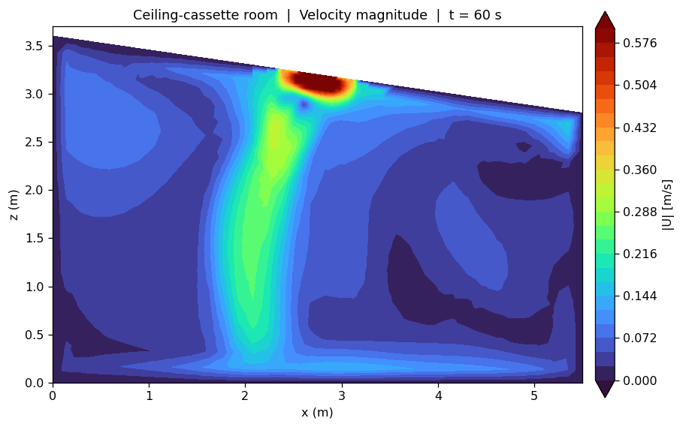
Figure 2 — Velocity magnitude on the same mid-plane at t = 60 s. The high-speed cassette jet (red), its descent to the floor, the floor-impingement spread and the lower-corner recirculation cells are all resolved.

6.2 Temperature and stratification
The temperature field confirms the flow interpretation. The coldest air (down to ~289 K / 16 °C) tracks the jet core; the bulk of the occupied zone sits near 293 K (~20 °C); and a warmer band (up to ~295–296 K) collects under the high side of the roof, where the recirculating pocket exchanges little air with the jet. This is mild thermal stratification driven by buoyancy — exactly what a single downward cassette in an asymmetric ceiling would be expected to produce.
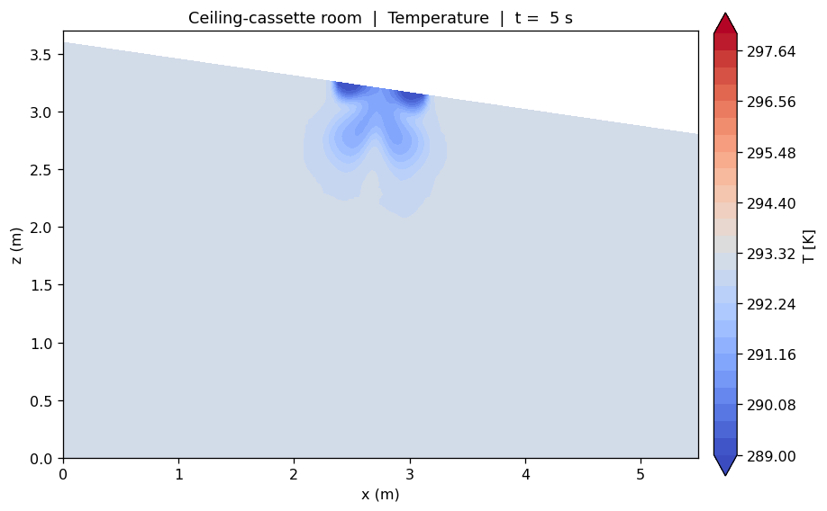
Figure 3 — Temperature at t = 5 s, early in the transient. The jet is just forming and the cold plume has not yet reached the floor; comparison with Figure 1 shows the room filling from the ceiling downward.

6.3 Bulk quantities
Quantity | Value at t = 60 s | Comment
Supply mass flow | 0.26 kg/s (≈ 10 ACH) | prescribed, verified at patch
Return mass flow | ≈ 0.26 kg/s | closes to within solver tolerance
Supply temperature | 16 °C (289 K) | prescribed
Room mean temperature | ≈ 20 °C (293 K) | volume-averaged
Return temperature | ≈ 16.6 °C | still rising — see note
Peak jet velocity | ≈ 0.58 m/s | diffuser core
Total sensible load | ≈ 609 W | see §3

Note on convergence. At t = 60 s the room has exchanged only about one-sixth of its air volume, so the transient is still developing and the return temperature has not yet reached its steady value. The bulk temperatures are therefore indicative of the early cooling-down phase, not of a settled steady state. A longer transient, or the steady buoyantSimpleFoam solution run to full residual convergence, is needed before quoting comfort metrics as final.

7 Engineering inferences
Several conclusions can be drawn directly from the baseline, with the convergence caveat above in mind.
- Mixing, not short-circuiting. The downward jet reaches the floor and drives full-height recirculation, so the cassette mixes the room rather than short-circuiting supply air straight to the central return. That is the intended behaviour for a mixing diffuser.
- The sloped roof biases the flow. A warm, weakly ventilated pocket forms under the high side of the ceiling. In a real installation this is where stale, warm air would accumulate — a candidate location for a secondary return or for shifting the diffuser off-centre toward the high wall.
- Envelope-adjacent load is significant. The window alone carries ~30% of the sensible load (~181 of ~609 W). With the other walls adiabatic here, a real building's conduction and solar gains would raise the load further, so the window/envelope treatment is the first thing to refine for design use.
- Draught risk is localised. Air speeds exceed ~0.3 m/s only in and just below the jet; the occupied zone is otherwise calm. If an occupant were seated directly under the diffuser, however, the impinging jet could be a cold-draught nuisance — worth checking against a draught-rate (DR) metric once the field is settled.
- Not yet steady. The most important caveat: 60 s is early. Comfort numbers (PMV/PPD, DR, ADPI) should be computed from a converged field, not from this developing transient.

8 Recommended studies

8.1 Comfort and air-distribution metrics
With a converged field, post-process standard indices to move from a flow picture to a comfort assessment: PMV/PPD in the occupied zone, local draught rate (DR) under the diffuser, the Air Diffusion Performance Index (ADPI) to score the diffuser, and a local mean age-of-air (via a passive scalar transport) to quantify ventilation effectiveness and locate the stagnant pocket under the high roof.

8.2 Parametric sweeps
The case is built to be swept. The highest-value parameter studies are: ventilation rate (e.g. 6 / 8 / 10 / 12 ACH) against comfort and the return temperature; supply temperature (14–18 °C) against draught risk and cooling capacity; return location (central vs. relocated to the high side) against the stagnant-pocket volume; and diffuser throw/angle against floor-impingement velocity. Each is a single boundary-condition change on the existing mesh.

8.3 Envelope and physics fidelity
For design-grade results, replace the adiabatic walls with conducting boundaries (or a conjugate heat-transfer solid region), add a radiation model (e.g. P1 or view-factor) so that mean radiant temperature — which dominates perceived comfort — is captured, resolve the near-wall and jet shear layers with prism layers instead of wall functions, and, for occupied-comfort work, add latent load and a CO₂ tracer to assess air quality alongside temperature.

9 Project directions
The baseline supports several larger pieces of work that connect to broader building-physics and optimisation themes:
- Comfort-versus-energy optimisation. Treat ACH, supply temperature and diffuser geometry as design variables and minimise cooling energy subject to a PMV/DR comfort constraint — a constrained-optimisation problem well suited to a surrogate/response-surface approach over the parametric case.
- Diffuser-shape optimisation. Parameterise the cassette outlet (ring geometry, discharge angle) and optimise for uniform floor coverage and minimal draught — a shape-optimisation study analogous to internal-flow device optimisation.
- Displacement versus mixing ventilation. Reconfigure the same room with a low-level displacement supply and high return, and compare stratification, age-of-air and energy against the mixing baseline.
- Reduced-order model / digital twin. Use the parametric sweeps as training data for a fast reduced-order model of room temperature and comfort, enabling near-real-time what-if studies or control co-design.
- Validation against a benchmark. Reproduce a documented room-ventilation benchmark (e.g. the IEA Annex-20 room) with this workflow to quantify model accuracy before trusting it on novel geometries.

10 Files and reproducibility
The complete case lives under HVAC_claude/room_hvac_case on the workstation. Geometry is regenerated by the FreeCAD macro build_room.py; the mesh by blockMesh + topoSet/createPatch (the Allmesh script); fields and numerics are in 0/, constant/ and system/. The transient animations (T_animation.mp4, U_animation.mp4) were rendered off the OpenFOAM case with a VTK + matplotlib + ffmpeg pipeline (render.py), slicing the field at y = 2.25 m. Re-running Allmesh then buoyantPimpleFoam reproduces the results in this report.
End of report.

