**Dataset_1**

***Original*** ***K Means***

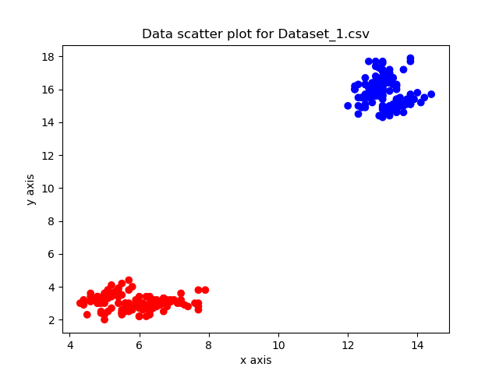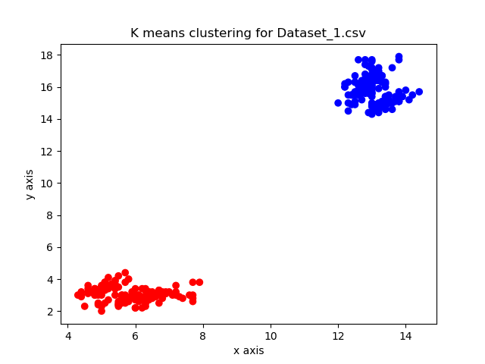

***Farthest center clustering*** ***Spectral Clustering***

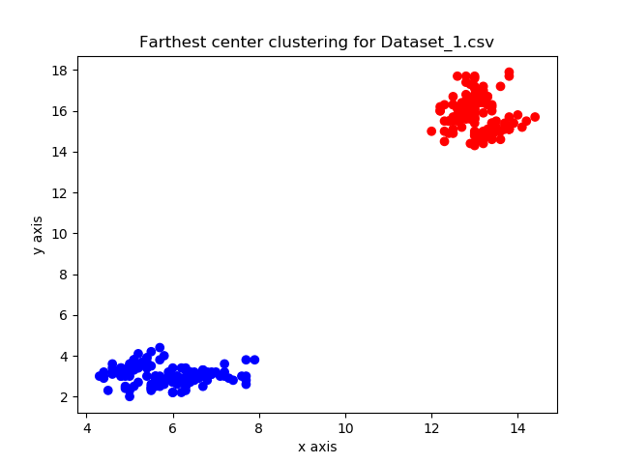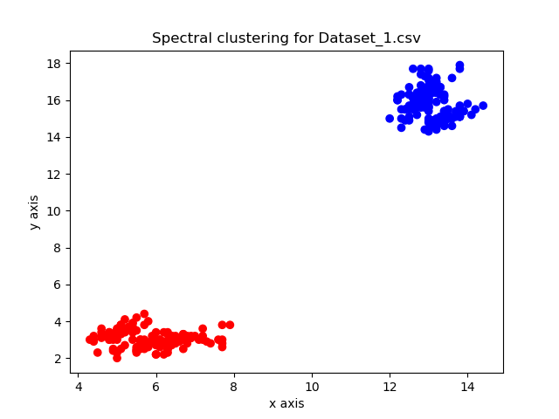

For the above figures we find that the data points are originally evenly distributed between two groups and the distance between the nearest points of the two groups is very large. This is well-suited for all three clustering algorithms to correctly form two clusters for the data.

**Dataset_2**

***Original*** ***K means***

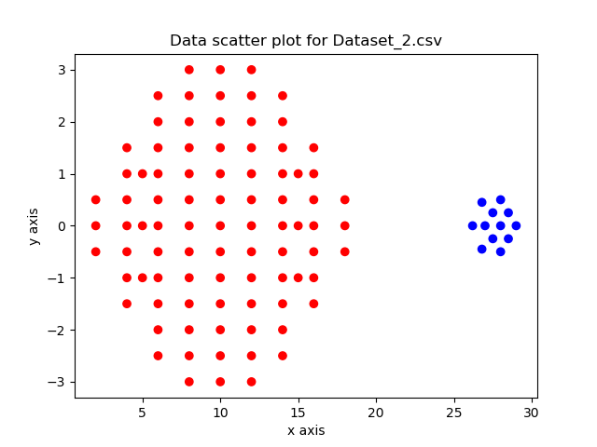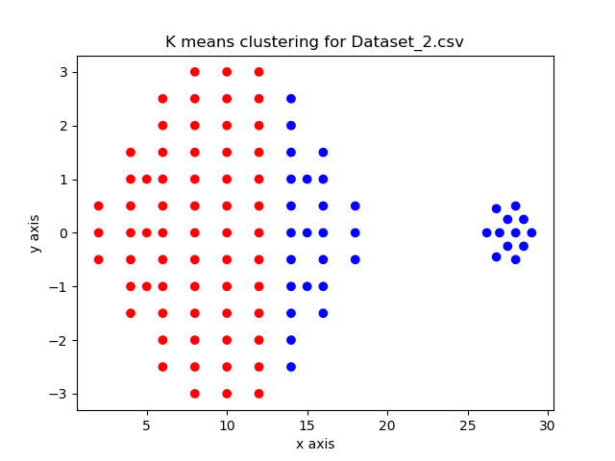

***Farthest center clustering*** ***Spectral clustering***

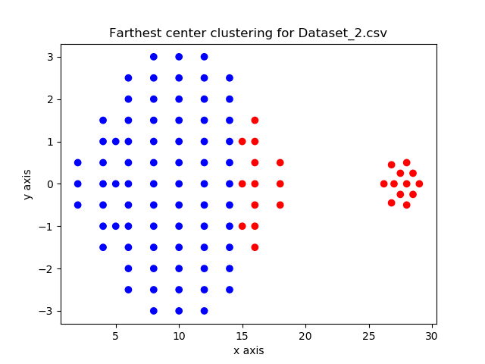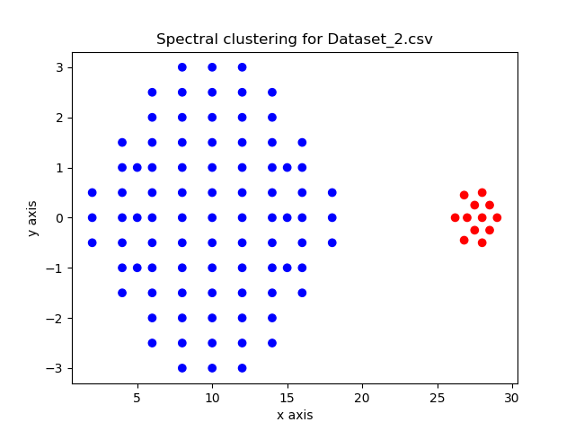

In dataset 2, all the data points are not evenly distributed into two groups. As one group has significantly more data than the other, the k-means algorithm is likely to select two centroids from the larger group. This can affect the final clustering by including parts of the larger group in the same cluster as the points in the smaller group.

The issue for the farthest clustering algorithm is that its objective function is not appropriate for this dataset. The larger group from the dataset is significantly wider than the smaller group and due to their proximity, the optimal clustering to reduce the size of the largest diameter will place points from the larger group into the same cluster as the smaller group.

**Dataset_3**

***Original*** ***K means***

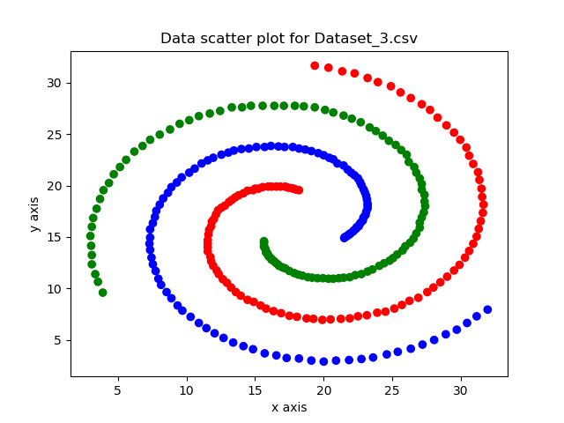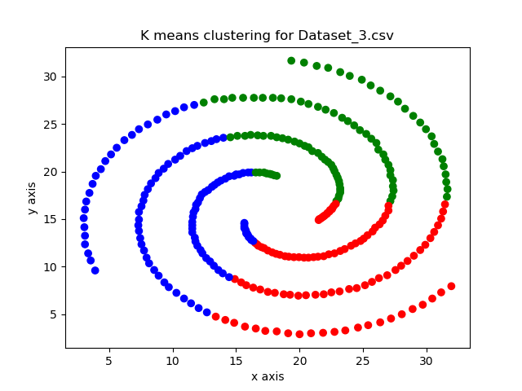

***Farthest center clusterin***g ***Spectral Clustering***

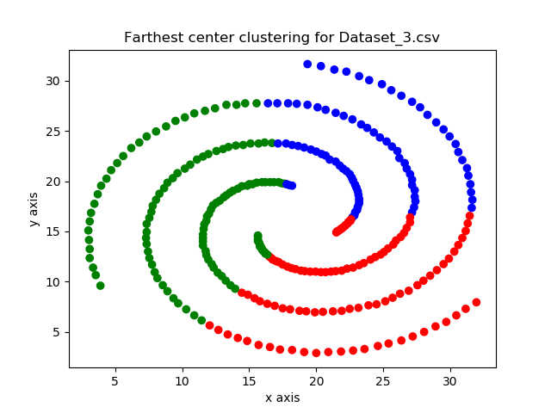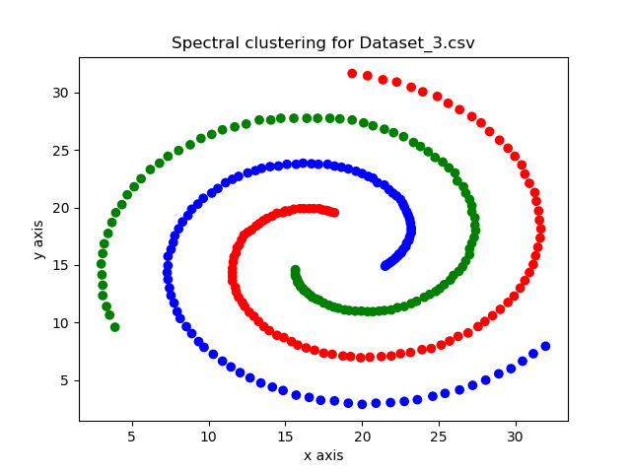

In Dataset 3, spectral clustering performs best due to the nature of the data. K-means and farthest center clustering work well to cluster data when the clusters are globular and linearly separable. As this data’s groups spiral around each other, spectral clustering outperforms the other 2 algorithms as it is affinity based (i.e. similar types of data points are arranged together) and uses PCA. This allows spectral clustering to assign clusters non-linearly and so we get three correctly defined clusters.