**CSE 572**

**Assignment 1**

**Task 1:** Calculate Pearson Correlation: Pearsonr correlation is calculated from library scipy for calculating the pearson correlation.

The pearson correlation between Population and Deaths is 0.9399210630849444.

**Task 2:** The bar graph for the Opioid Death Density for different states is given below. The values are scaled by a factor of ${10}^{6}$ for simplicity in viewing.

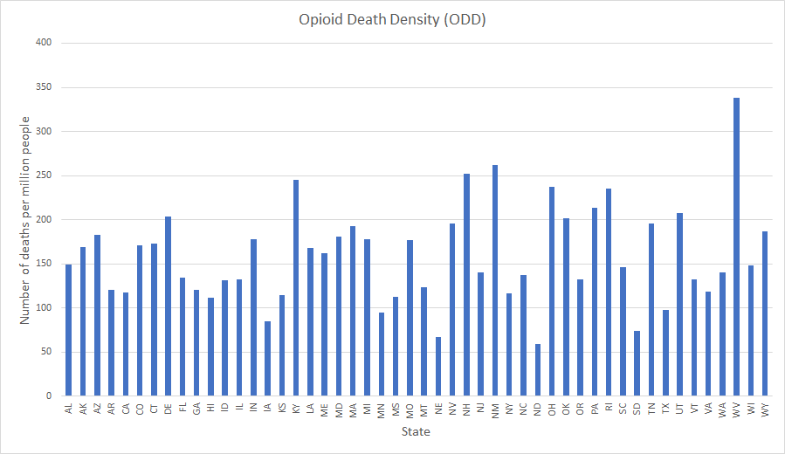

**Task 3:**

First, we take the max and min value from the ODD data and calculate their euclidean distance to get the value for maxdistance. Then for all pairs x, y in ODD we calculate the similarity as:

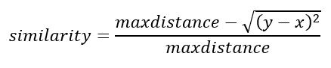

The file **‘task3.xls’** contains the similarity matrix for the states. The states with minimum similarity are ND and WV.