Task 1

Model Parameters:

Predicted Values:

|  |  |  |  |  |
| --- | --- | --- | --- | --- |
| 488.30 | 1445.77 | 689.46 | 632.86 | 1077.24 |
| 1344.62 | 579.17 | 1495.52 | 1411.00 | 1521.92 |
| 704.84 | 1400.65 | 1442.57 | 1512.84 | 976.25 |
| 788.18 | 862.04 | 829.18 | 1118.04 | 1125.72 |
| 1100.41 | 1402.82 | 931.00 | 897.57 | 1214.35 |
| 1489.30 | 1511.58 | 752.47 | 1122.94 | 1298.82 |

Plot:

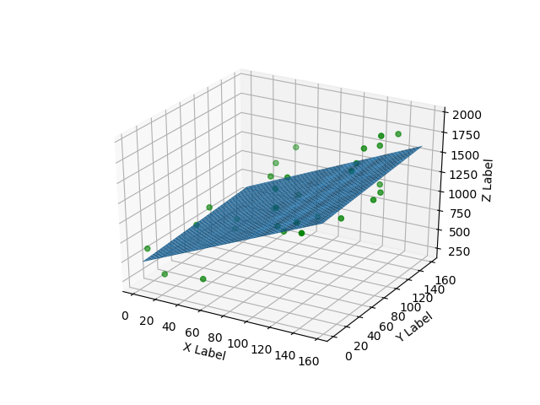

Mean-squared Error: 83358.73

Y-value:

Task 2

Model Parameters:

Predicted Values:

|  |  |  |  |  |
| --- | --- | --- | --- | --- |
| 1472.86 | 1329.55 | 1491.54 | 606.01 | 291.46 |
| 1139.75 | 964.43 | 378.62 | 658.72 | 1102.72 |
| 506.75 | 645.54 | 459.51 | 1209.94 | 506.46 |
| 854.95 | 778.90 | 459.98 | 713.91 | 1561.16 |
| 1472.57 | 587.53 | 1226.41 | 834.41 | 646.08 |
| 796.55 | 1075.83 | 291.53 | 718.84 | 687.61 |

Plot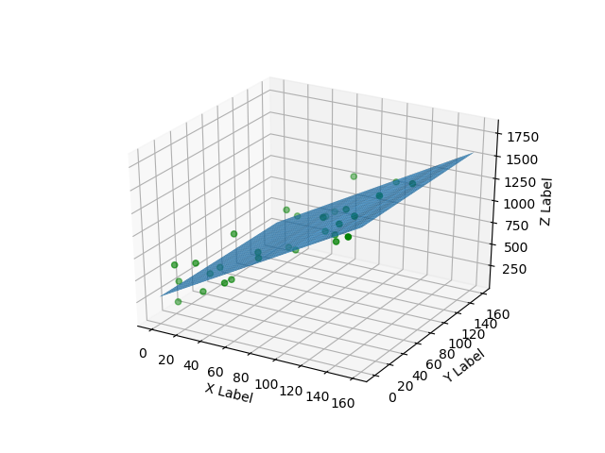

Mean-squared Error: 24691.88

Y-value:

Task 3

Accuracy: 100%

Predicted Values:

Task 4:

Accuracy: 36.67%

Predicted Values: