Project proposal for DST & Texas Instruments Inc. India Innovation Challenge Design Contest 2018 Anchored by NSRcEL, IIM Bangalore

**VR Based Telerobot**

PES INSTITUE OF TECHNOLOGY

|  |  |  |  |  |
| --- | --- | --- | --- | --- |
| **NAME** | **COLLEGE ID** | **UG/ PG** | **COURSE/BRANCH** | **SEMESTER** |
| Moulesh | 1PE16EC088 | UG | BE/ECE | 5 |
| Jahnavi | 1PE16EC096 | UG | BE/ECE | 5 |
| Sai Sreeram | 1PE16EC133 | UG | BE/ECE | 5 |
| Monisha | 1PE16EC087 | UG | BE/ECE | 5 |
| Deekshith Patil | 1PE16EC099 | UG | BE/ECE | 5 |

Introduction

* In today’s generation, nothing can sound more interesting than having to experience something without actually spending time and money to be there. For example, in the air force, the new pilots can perform their flight manoeuvres and other training programmes without having to crash a million-dollar plane using VR. There are many such instances where we would prefer experiencing certain things without physically being there.
* In order to make things more emotionally relatable, we are going to integrate virtual reality with robotics to enable us to see and communicate at a place remote from where we presently are.

Project Specifications

* We make use of a robot with a camera mounted on it along with a microphone module. On the user end, we provide a virtual reality experience through virtual reality headset along with earphones, enabling end to end communication. Additionally, the user is also provided with a joystick to control the movement of the robot.
* This robot is equipped with a rocker bogie mechanism which enables it with an ability to climb staircase effortlessly and navigate through rough terrains easily.

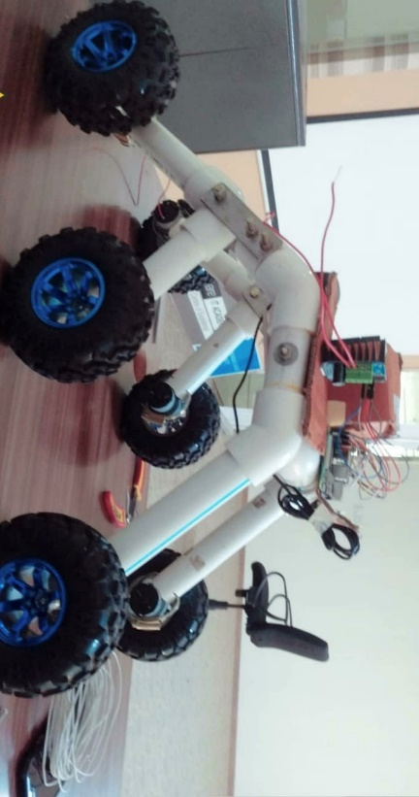

* The gyroscope is used for tracking the user’s head position. This information is transmitted to the robot, with the use of Internet Of Things (IOT) and the camera on the robot changes its position based on the readings received, analogous to the position of user’s head.

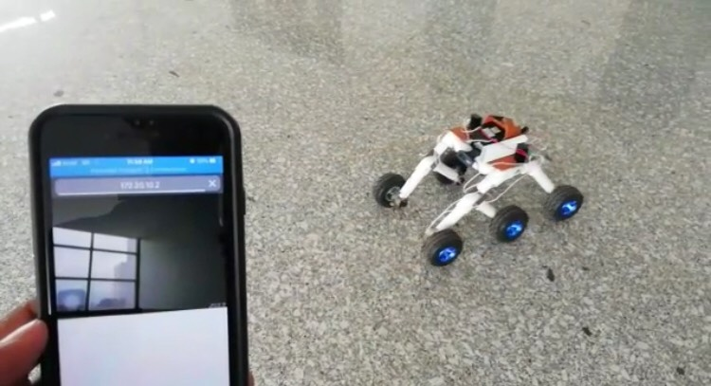

Applications:

* It has wide range of applications. For instance, consider the 26/11 Taj hotel attacks in Mumbai, where a group of terrorists had invaded the hotel. The operation Black Tornado was started by the Indian army to rescue the people in the hotel. In this mission many of our soldiers became martyrs.
* In this instance, we can first send this robot into the rescue zone (in this case hotel) before the soldiers enter. The robot can be controlled from the control room by the concerned authority and the virtual reality feature helps in precise analysis of the situation. The information from the robot is analysed and this information can be passed on from the control room to the soldiers in the rescue zone who can take necessary action.
* Consider another situation where a teacher is not able to make it to the class. By using this robot, the teacher can effectively handle a session by having the robot in the classroom and he being elsewhere. He can get real time data about the class by just moving the robot in the classroom and also can deliver a lecture.

Team Members – Roles & Responsibilities:

|  |  |  |  |
| --- | --- | --- | --- |
| **S.No** | **Member Name** | **Role** | **Justification** |
| 1 | Moulesh | Technical | Does the hardware related job. |
| 2 | Jahnavi | Technical | Does the coding related jobs. |
| 3 | Sai Sreeram | Operational | Assists in the progress of the work. |
| 4 | Monisha | Marketing | Helps in publicising the work and obtaining support from others. |
| 5 | Deekshith Patil | Operational | Supports in the management of the project and co-ordination among all. |

Hardware:

|  |  |  |  |  |
| --- | --- | --- | --- | --- |
| **COMPONENTS REQUIRED AND ESTIMATED COST** | | | | |
|  |  |  |  |  |
| **Sl No.** | **Components** | **Qty** | **Cost** | **Remarks** |
| 1 | Raspberry Pi | 1 | 3500 |  |
| 2 | Robot Chassis | 1 | 2000 | Price for both |
| 3 | Robot Wheels | 4 |
| 4 | IR Camera | 1 | 1500 |  |
| 5 | Camera | 1 | 1200 |  |
| 6 | Microphone | 1 | 200 |  |
| 7 | Joystick/Smartphone | 1 |  | Available |
| 8 | Laptop | 1 |  | Available |
| 9 | Gyroscope | 1 | 150 |  |
| 10 | VR Headset | 1 | 1500 |  |
|  | **Total** |  | **10,050** |  |

* This robot helps us to digitally teleport ourselves to the area where the robot is placed. This project will help us look at the world with new lenses all together!