**Master and Slave (Windows-Windows) Configuration:**

**Instance:**

1. Taken two aws windows 2012 R2(AMI) instances and launched with default configurations()



**Jenkins Master configuration(on Jenkins instance from above pic):**

1. Install openjdk
2. Install Jenkins on windows machine(which is nothing but our master)
3. Go to Manage Jenkins->Manage nodes and cloud->New node
4. Enter node name and select permeant agent radio button and click on “ok” button
5. Now enter configuration

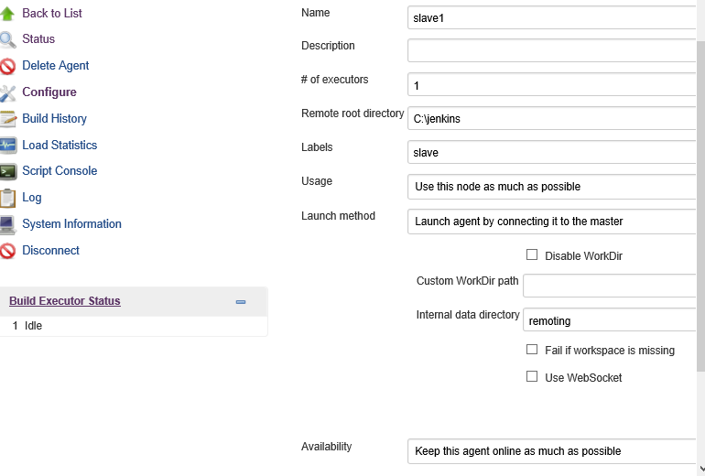

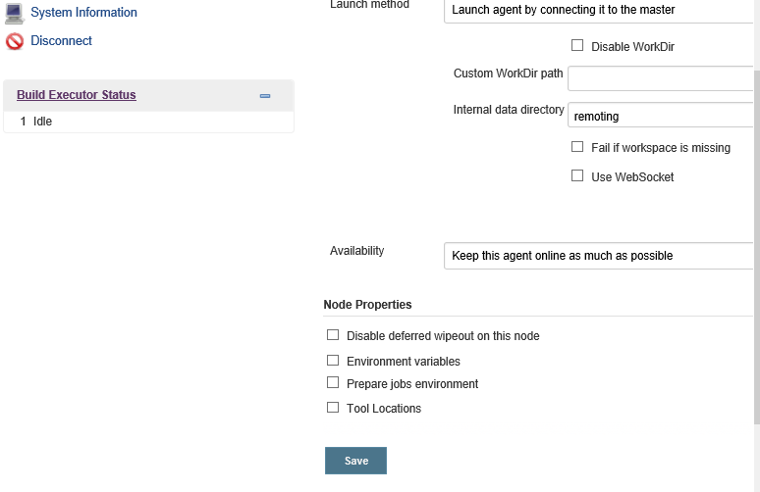

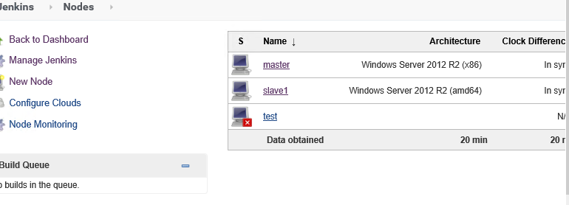

1. Now click on “test” agent

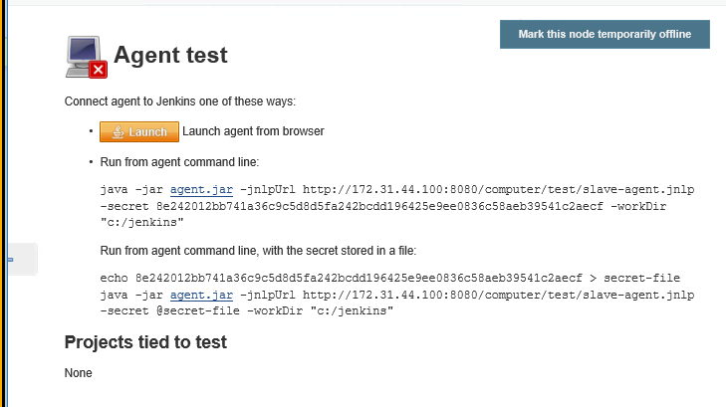

**Configure global Security:**

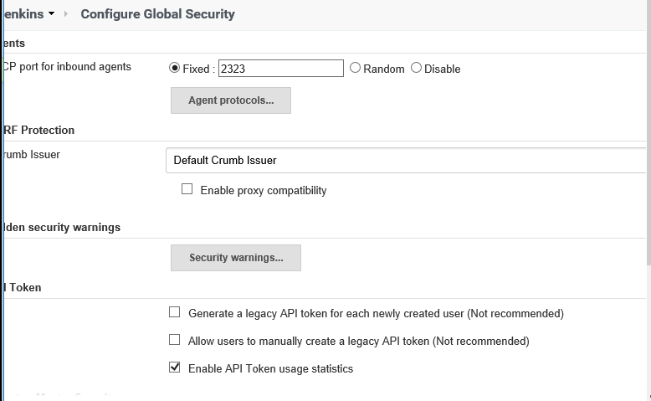

1. Once Jenkins is up and running access Jenkins with <http://localhost:8080>
2. After that we can change our Jenkins url with ip address (we need to take private ip )
3. Goto manage Jenkins->configure system
4. And change Jenkins url with ip as shown below
5. Access/check Jenkins by using with new url

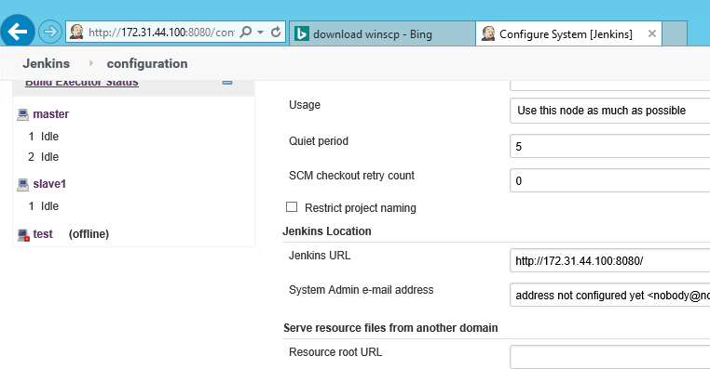

**Slave Configuration:**

1. Login to slave machine
2. Install openjdk
3. Hit master Jenkins url from slave machine
4. Go to Manage Jenkins->Manage nodes and cloud

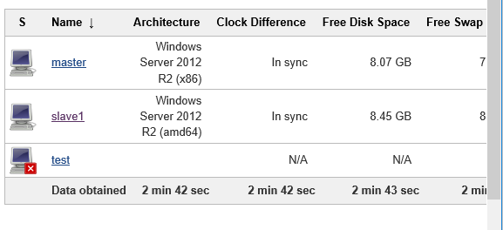

1. Click on “test” node

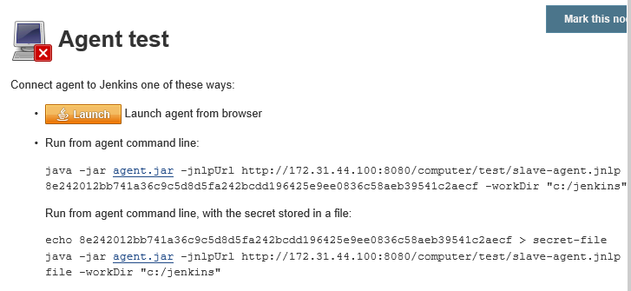

1. Download “agent.jar” from **agent.jar link** on the above command
2. It will download agent.jar
3. Now click on “launch” button and it will download “slave-agent.jnlp” file
4. Now copy this two files to our slave Jenkins working directory which was mentioned in node configuration(c:/Jenkins)
5. Execute below commands

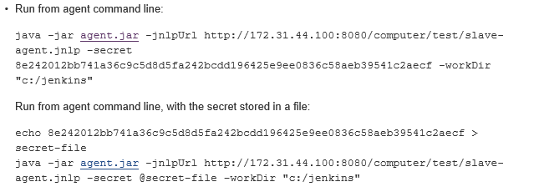

1. Now we can see below output

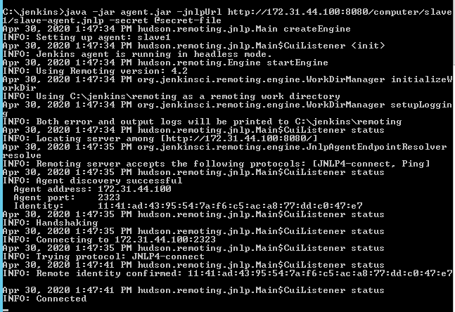

1. Now go to “master” Jenkins and check the agents

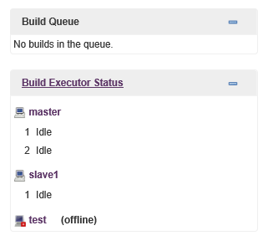

**Note:**

1. Goto master Jenkins instance in aws console
2. And goto security group and edit “inbound rule”
3. And enable the below ports

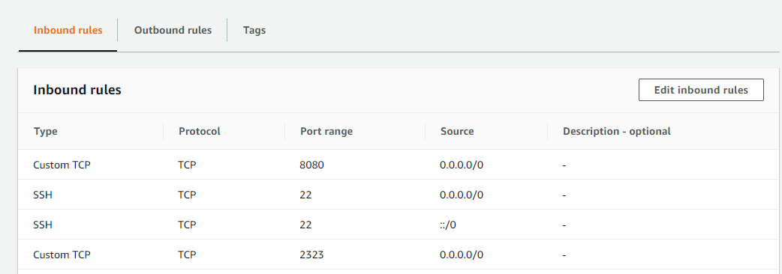

**In this we have mentioned “2323” port in master Jenkins “Configure global Security”**

**Trouble Shooting:**

1. How do I configure internet setting for an EC2 Windows instance to allow file downloads ?(follow below link)

https://aws.amazon.com/premiumsupport/knowledge-center/ec2-windows-file-download-ie/

1. After connecting to slave and when we hit master Jenkins url and if we are unable to access Jenkins than check the security group inbound rules(master instance) and allow port which we have mentioned in Jenkins **Configure global Security**