|  |  |  |
| --- | --- | --- |
|  | **KGiSL Institute of Technology**  **(An Autonomous Institution)**  Affiliated to Anna University, Approved by AICTE, Recognized by UGC, Accredited by NAAC & NBA  KGiSL Campus, Thudiyalur Road, Saravanampatti, Coimbatore – 641035. |  |

**2.implementation of single and multi level inheritance**

**Aim:**

**To implement and understand Single Level and Multilevel Inheritance in Java using simple class examples.**

Algorithms:

1. **Start the program.**
2. **Define the base class Animal:**
   * Add a method eat() that prints:  
     "This animal eats food."
3. **Define a class Mammal that extends Animal:**
   * Add a method walk() that prints:  
     "Mammals can walk."
4. **Define the child class Elephant that extends Mammal:**
   * Add a method trumpet() that prints:  
     "The elephant trumpets loudly!"
5. **In the main() method:**
   * Create an object of class Elephant.
   * Call the eat() method using the object.  
     (Inherited from *Animal*)
   * Call the walk() method using the object.  
     (Inherited from *Mammal*)
   * Call the trumpet() method using the object.  
     (Defined in *Elephant*)
6. **End the program.**

**Code:**

class Elephant {

void eat() {

System.out.println("Elephant is eating grass.");

}

}

// First level derived class (Single Inheritance)

class BabyElephant extends Elephant {

void play() {

System.out.println("Baby elephant is playing.");

}

}

// Second level derived class (Multilevel Inheritance)

class BabyAfricanElephant extends BabyElephant {

void trumpet() {

System.out.println("Baby African elephant is trumpeting.");

}

}

// Main class to run the program

public class Main {

public static void main(String[] args) {

// Creating object of base class

Elephant e = new Elephant();

e.eat();

System.out.println();

// Creating object of first derived class (Single Inheritance)

BabyElephant be = new BabyElephant();

be.eat(); // Inherited from Elephant

be.play(); // Own method

System.out.println();

// Creating object of second derived class (Multilevel Inheritance)

BabyAfricanElephant bae = new BabyAfricanElephant();

bae.eat(); // From Elephant

bae.play(); // From BabyElephant

bae.trumpet(); // Own method

}

}

**Screenshot of implemented Code:**

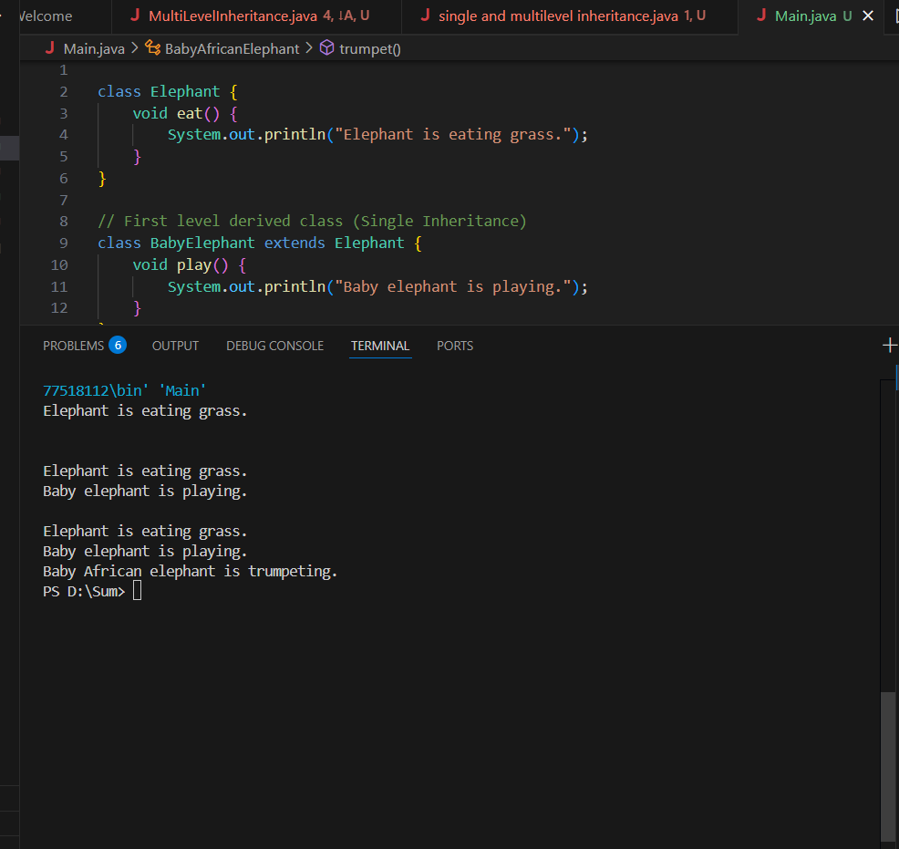

**Output:**

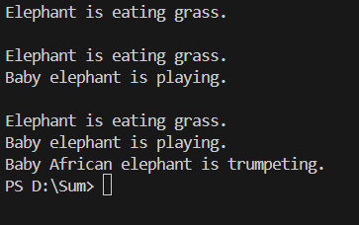

**GitHub Link:**

**https://github.com/moulidharands-beep/Sum/blob/main/experiment2.java**

**Result:**

Thus, the concept of Single Inheritance and Multilevel Inheritance in Java was successfully implemented and verified.