**Amazon EFS - Elastic File System**

Amazon Elastic File System (EFS) provides scalable, elastic file storage for use with Amazon EC2 instances in the AWS Cloud. EFS supports the Network File System version **4 (NFSv4) protocol, 2049** and can be accessed concurrently by thousands of EC2 instances. It automatically scales as you add and remove files, so your applications have the storage they need when they need it.

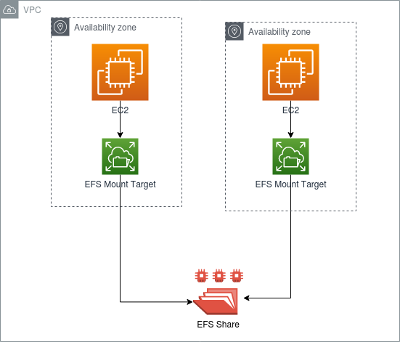

**Key Features:**

**Scalable and Elastic:** Automatically scales to accommodate workloads with varying storage requirements.

**High Availability and Durability**: Data is stored redundantly across multiple Availability Zones. Shared Access**: Multiple EC2 instances can access an EFS file system at the same time**, providing a shared data source.

**Managed Service:** Fully managed by AWS, so no need to worry about file system administration.

**Performance Modes:**

**General Purpose:**

Default mode for most applications.

Suitable for latency-sensitive use cases such as web serving environments, content management systems, home directories, etc.

**Max 1/0**:

Higher throughput and highly parallel access to the file system.

Suitable for big data and analytics, media processing, and other throughput-intensive workloads.

**Storage Classes:**

**Standard Storage Class:**

Designed for frequently accessed files.

Provides low latency and high throughput.

**Infrequent Access (IA) Storage Class:**

Designed for files that are not accessed frequently.

Lower cost compared to the standard storage class.

Supports Lifecycle Management policies to automatically transition files between storage classes.

**Key Concepts:**

**Elasticity:**

EFS automatically grows and shrinks as you add and remove files, providing storage capacity on-demand.

**NFS Support:**

EFS supports the NFSv4 protocol, making it easy to integrate with existing applications and systems.

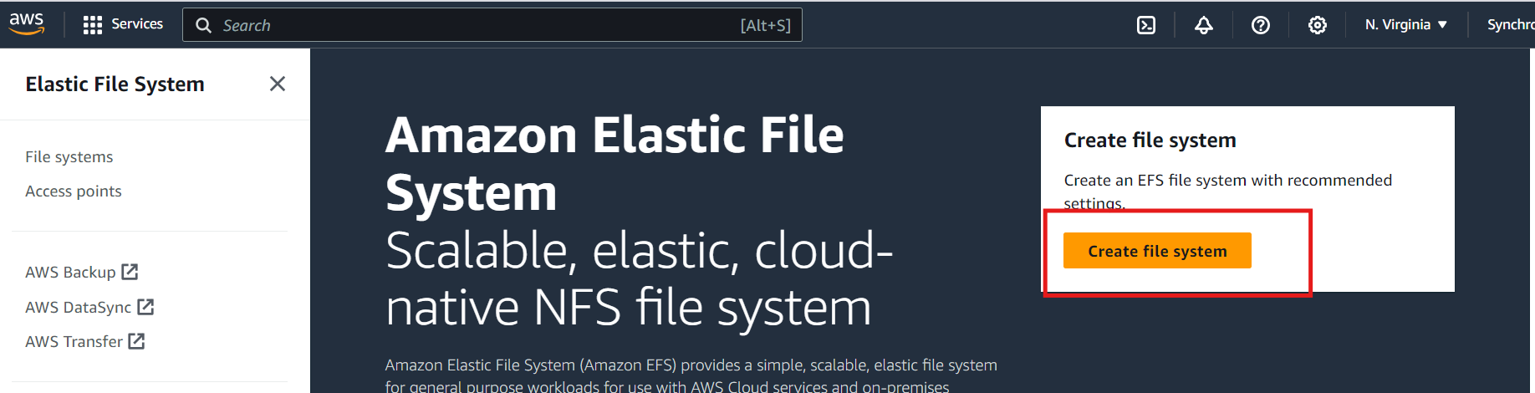

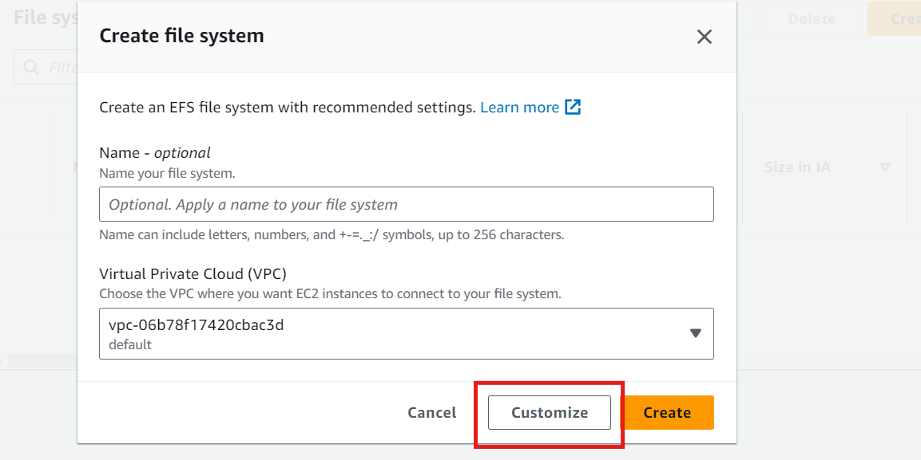

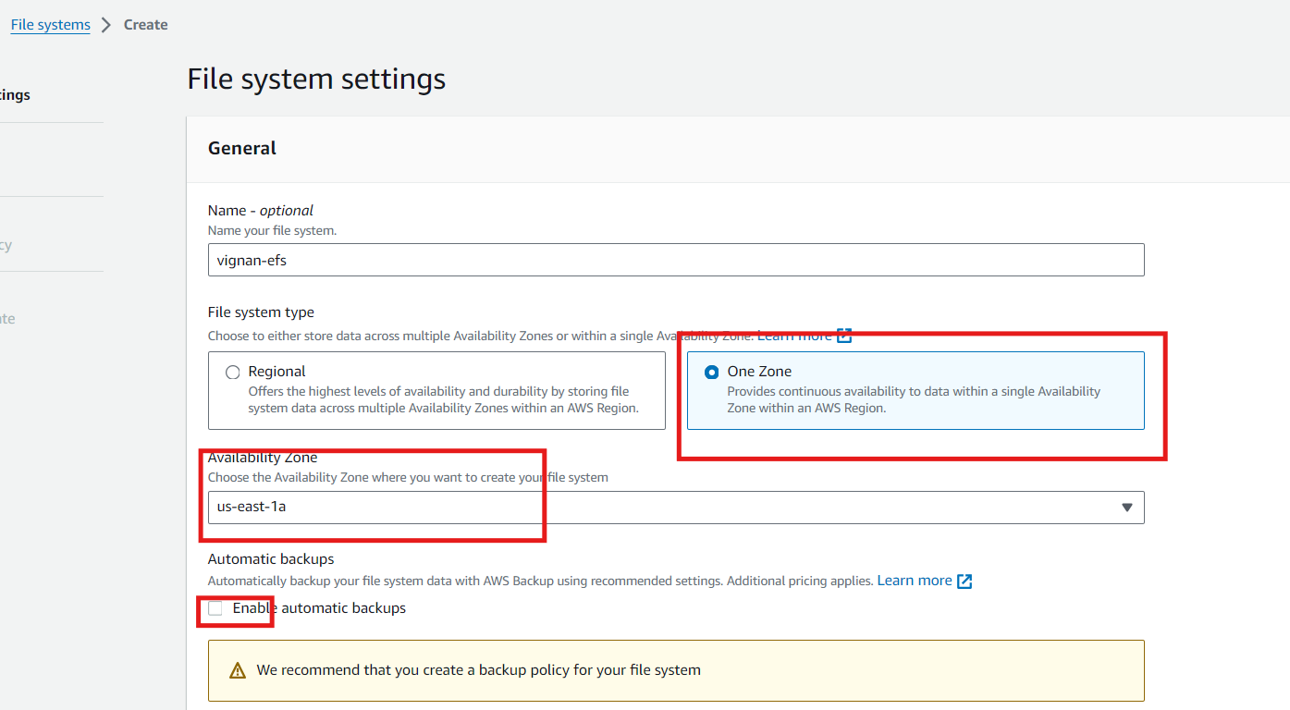

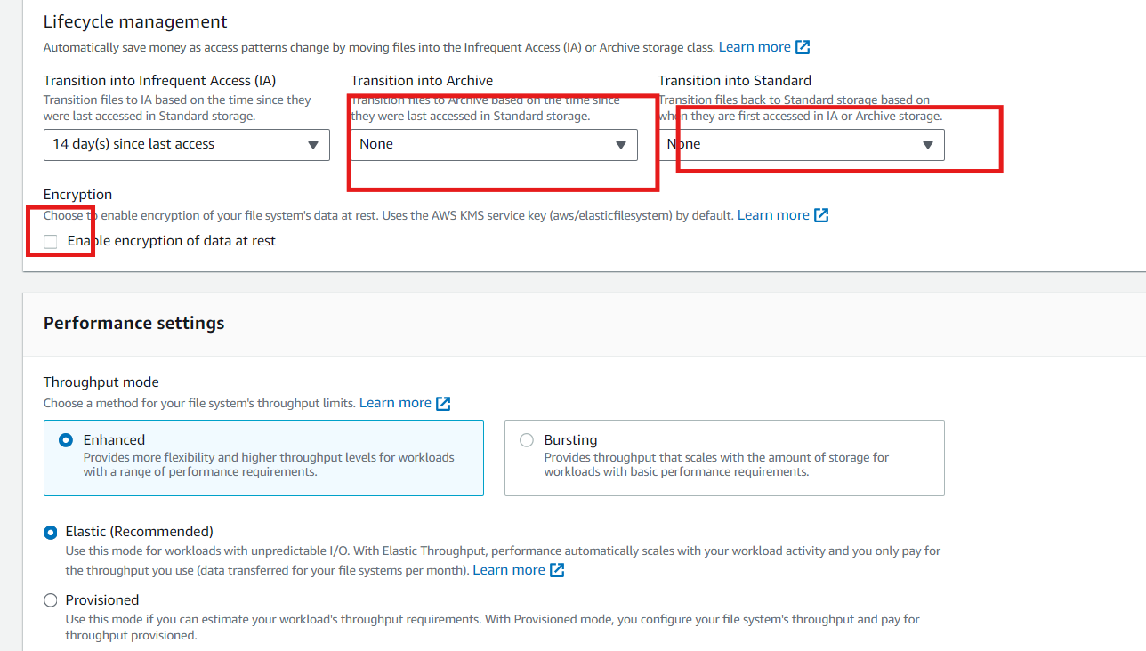

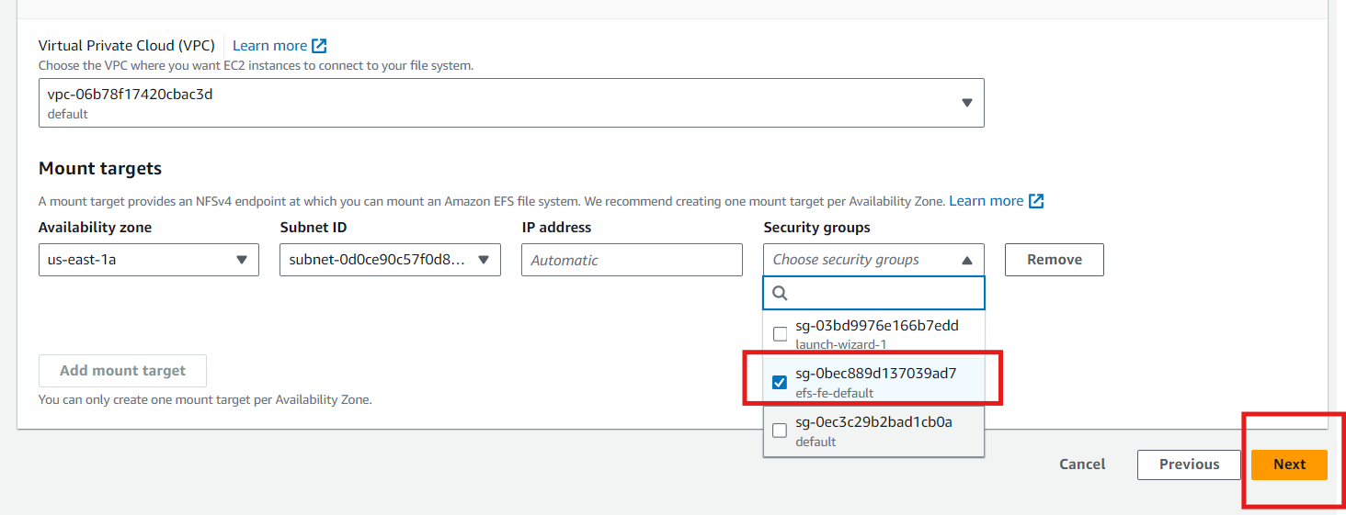

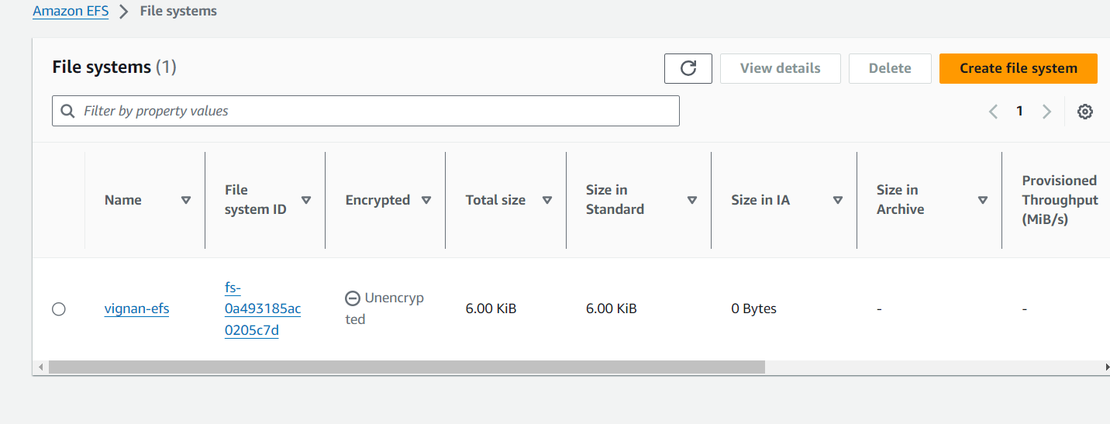

**Attach the EFS to EC2 Instance:**

**Install the EFS Utils Package (Linux Instance):**

To mount the EFS on a Linux-based EC2 instance, you need to have the EFS Utils package installed.

1. **Connect to your EC2 Instance**: Use SSH to connect to your EC2 instance.
2. **Install EFS Utils** (if not already installed):

For Amazon Linux and Amazon Linux 2:

**sudo yum install -y amazon-efs-utils**

**Mount the EFS File System**: Use the following command to mount the EFS file system.

**sudo mkdir /mnt/efs**

**sudo mount -t efs fs-0deb1434a4e34809c.efs.us-east-1.amazonaws.com /mnt/efs**