Project order

1. ACM amazon certificate manager - SSL

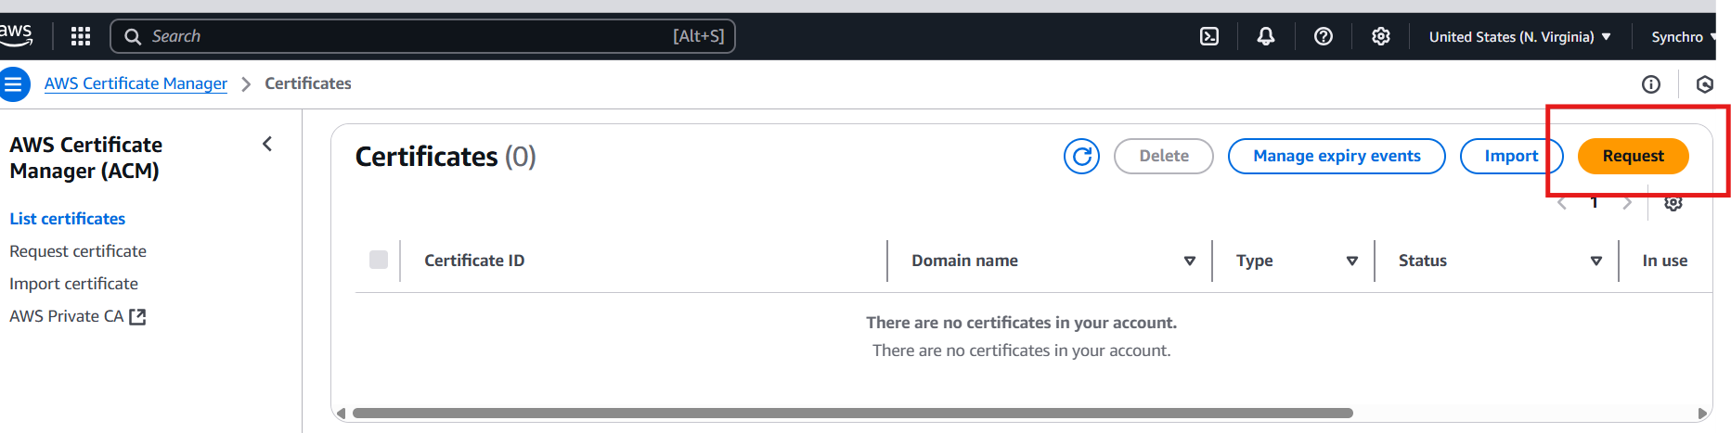

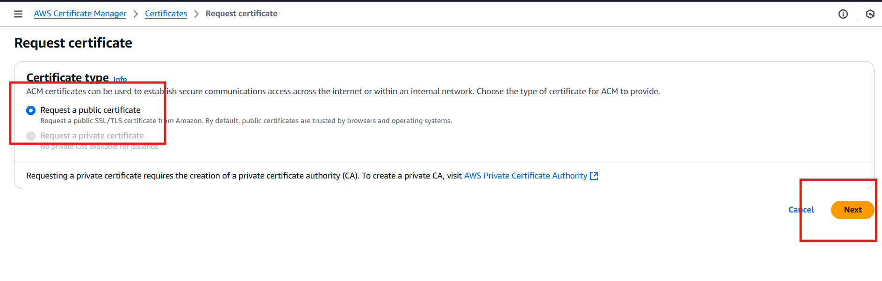

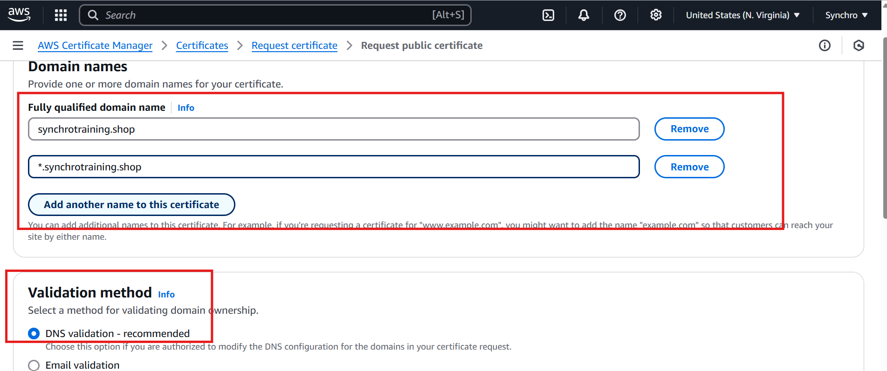

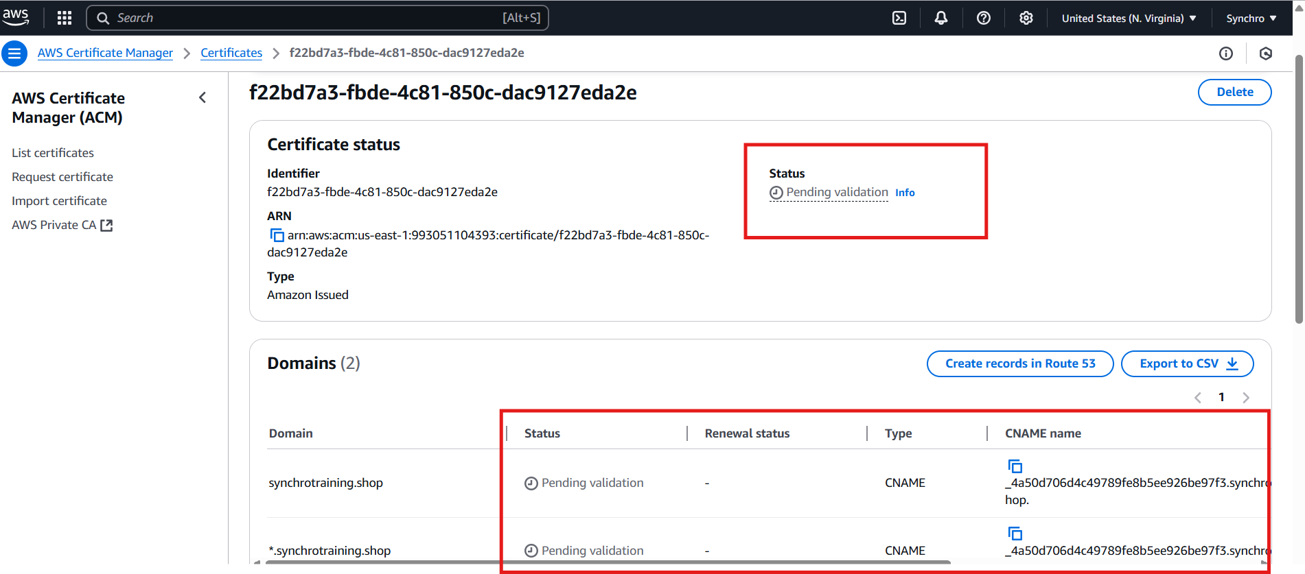

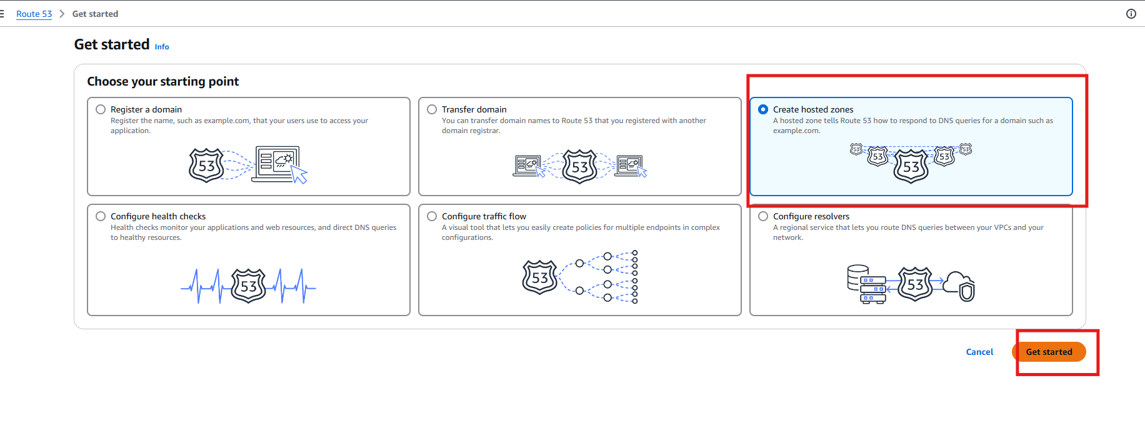

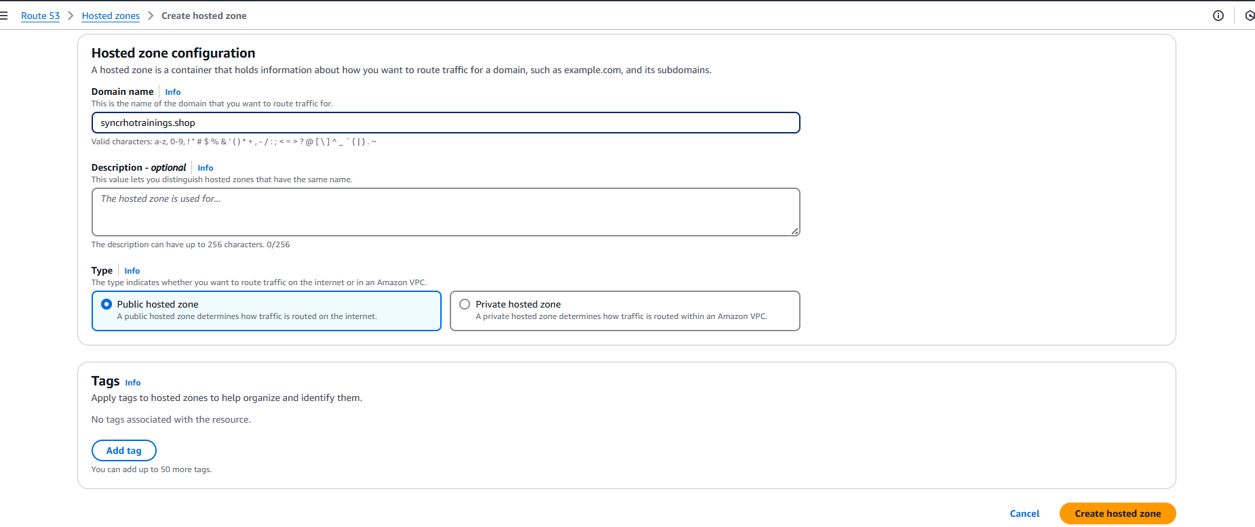

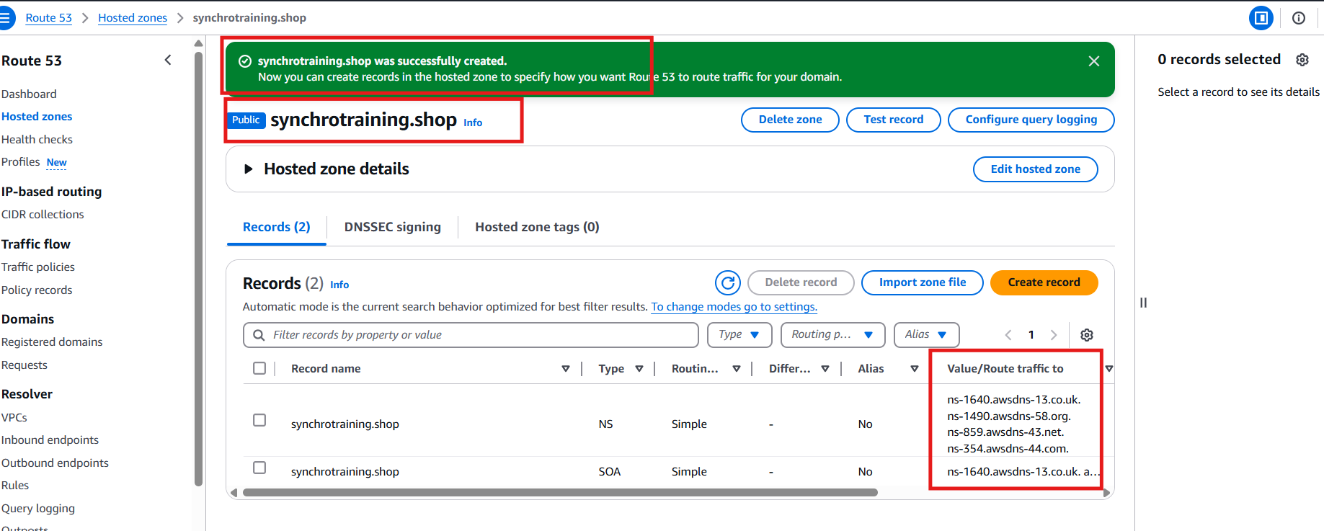

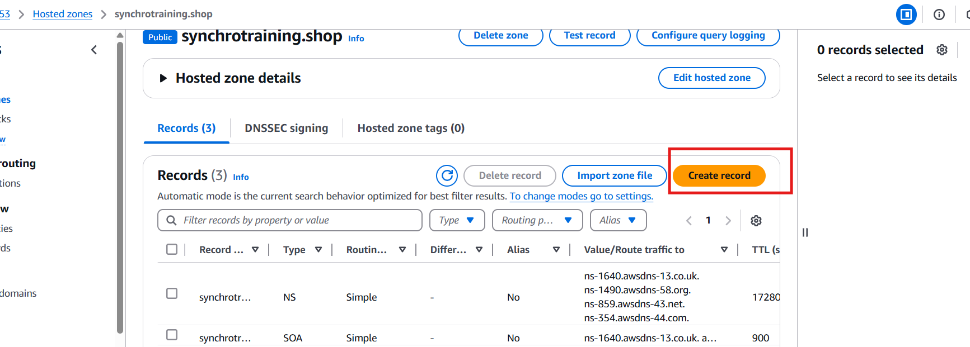

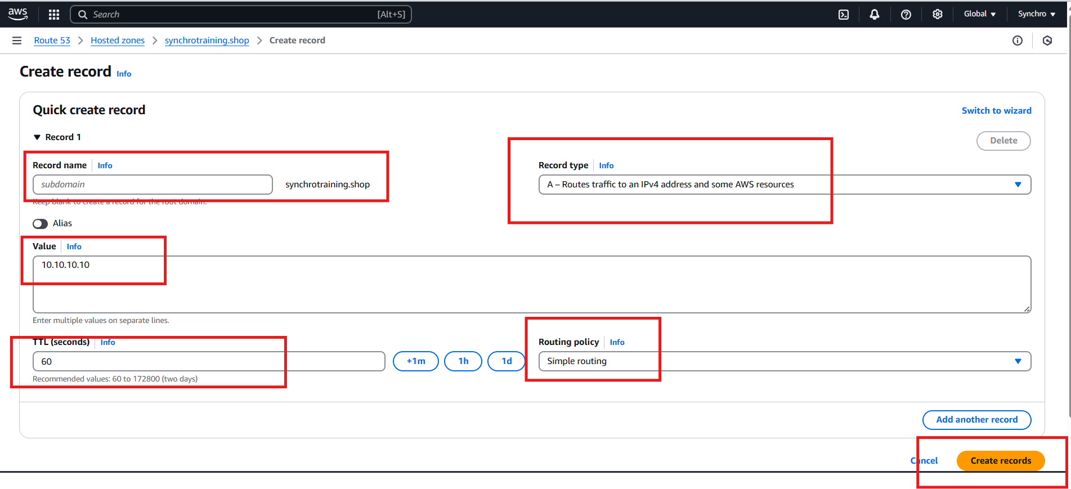

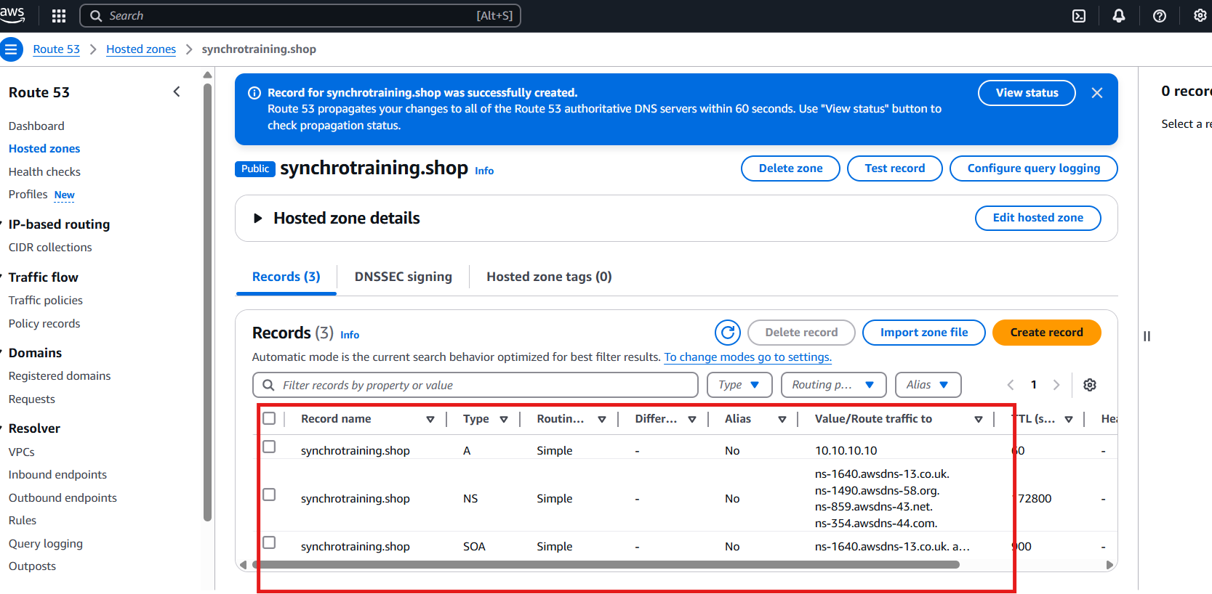

3.s3 static website

4. cloudfront CDN

A content delivery network (CDN) is a network of interconnected servers that speeds up webpage loading for data-heavy applications. CDN can stand for content delivery network or content distribution network. When a user visits a website, data from that website's server has to travel across the internet to reach the user's computer. If the user is located far from that server, it will take a long time to load a large file, such as a video or website image. Instead, the website content is stored on CDN servers geographically closer to the users and reaches their computers much faster.

