FORWARD DEPLOYED AI ENGINEERING
Capstone Project
Stage Four: Sprint Plan
Deciding who does what, in what order, and what finished means
A plan is not a list of tasks. It is a statement of sequence, ownership and
completion that the team has actually agreed to.
WEEK TWO · DAY ONE

How to plan three weeks of work
You have already lost a third of the project to discovery and requirements, which is as it should be. What remains has to be sequenced carefully, because several parts of the build depend on others and the dependencies are not always obvious until you hit them.
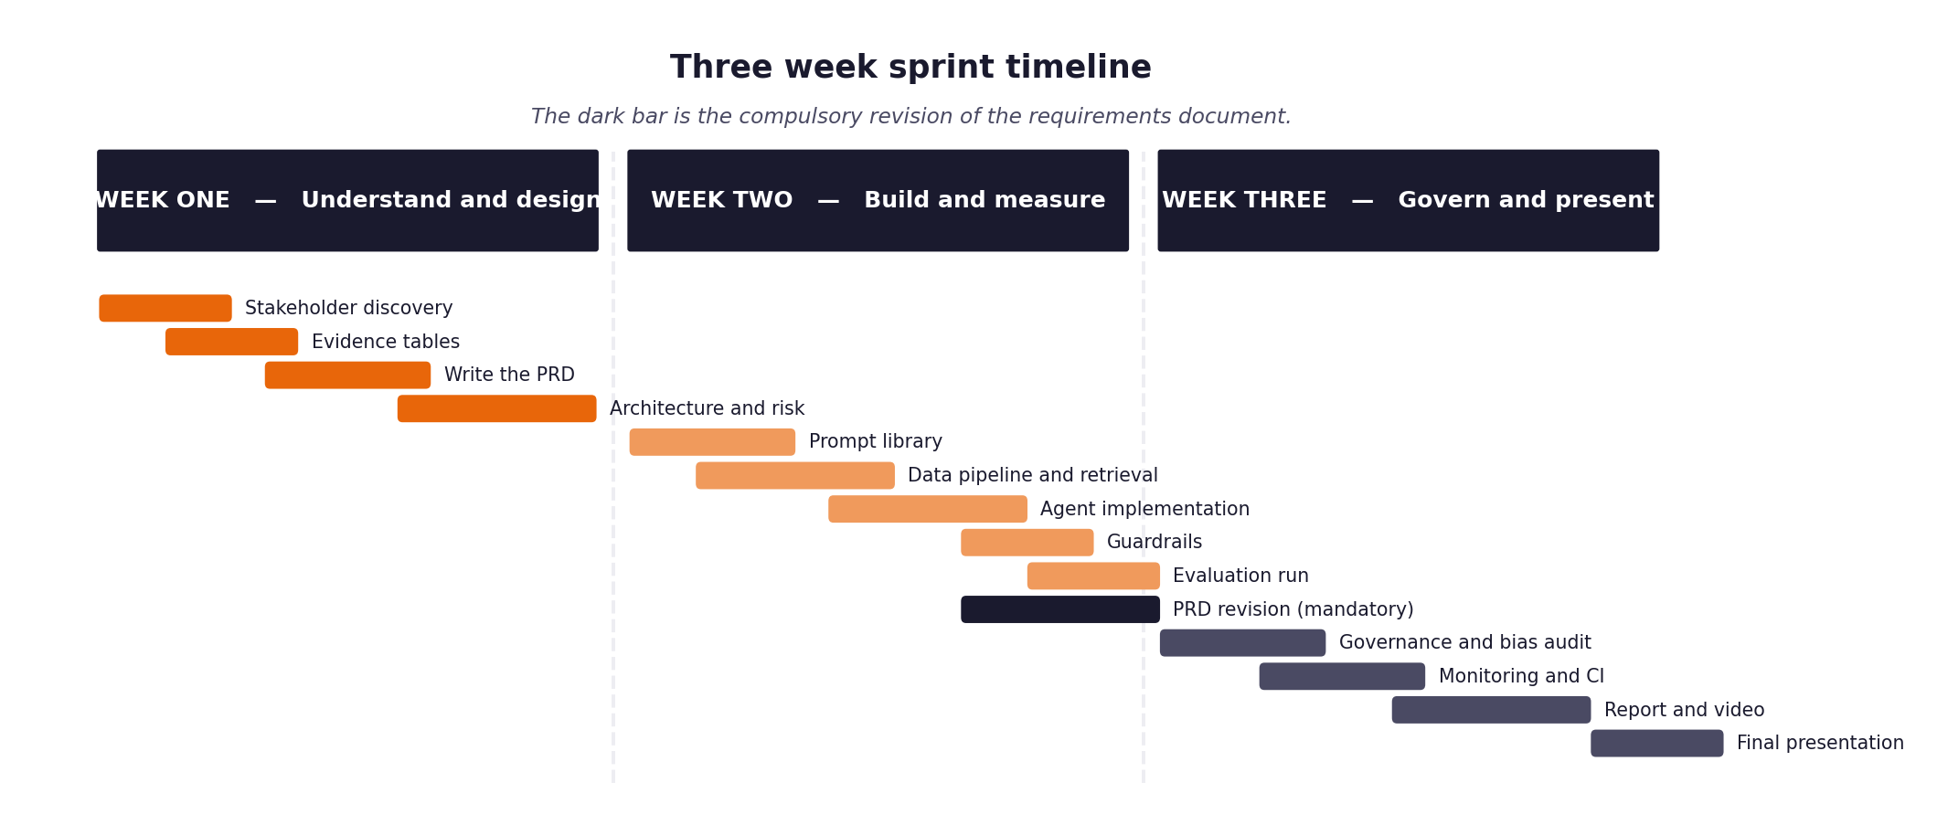
Figure 1. The shape of the three weeks, including the compulsory requirements revision.
Three rules that make the difference
- Every item has an estimate in hours and a priority. When you run short of time, and you will, the priority column is what decides for you rather than whatever felt urgent that morning.
- Every item has a definition of done written before work starts. Written afterwards, it describes whatever happened to be produced.
- The retrieval layer and the evaluation harness come early, not late. Almost everything else depends on one or the other, and leaving the harness until the end means discovering your results too late to act on them.
- The full unattended run over the hidden evaluation set happens in week two, not week three. It is the gate the project turns on, and it always exposes problems that never appear when you are testing one ticket at a time.

1 Section one: your capacity
Before you plan anything, work out honestly how much time you actually have. Plans built on optimistic capacity fail in week two rather than week three, which is worse, because by then you have committed to an architecture that assumed the time existed.
Week | Hours realistically available | Other commitments that week | Days you cannot work
Week one | 30 hours | Routine coursework / work duties (10 hrs) | Sunday (1 day off) -> 20 net hrs
Week two | 40 hours | Routine commitments / meetings (10 hrs) | Saturday evening -> 30 net hrs
Week three (Extended to Sept 20) | 45 hours | Routine commitments (12 hrs) | Flexible schedule across extended window -> 33 net hrs

On working alone
Working individually removes the coordination overhead and replaces it with a different problem: nobody will notice when you have been stuck for six hours. Set yourself a rule that anything blocking you for more than an hour gets written down and either escalated or worked around, and check that list at the end of each day.

2 Section two: the backlog
List every item of work. Estimate in hours rather than in vague sizes, because hours can be compared against the capacity you recorded above. Mark dependencies explicitly, because the order matters more when there is only one of you.
ID | Item | Est. hours | Priority | Depends on | Definition of done
B-01 | Environment and dependency setup | 3 | Must | None | Virtual env created, requirements.txt installed, .env configured, model access verified via test script.
B-02 | Data loading and normalisation | 4 | Must | B-01 | src/ingest.py normalizes tickets from all 4 channels into uniform schema with 100% test coverage (AC-A2).
B-03 | Document chunking and embedding | 4 | Must | B-02 | 29 KB docs chunked by Markdown section headers, embedded with all-MiniLM-L6-v2, and stored in Chroma vector DB.
B-04 | Vector store and retrieval | 5 | Must | B-03 | src/retrieve.py returns top-k passages with real doc_ids, relevance scores, and empty fallback below threshold (AC-A4).
B-05 | Evaluation harness | 6 | Must | B-02 | evaluation/harness.py CLI takes --input and --output, running unattended batch evaluation with metrics report (AC-A9, AC-A10).
B-06 | Intent and urgency classifier | 5 | Must | B-02 | src/classify.py executes PR-01, classifying 22 intents with calibrated confidence and alternatives (AC-A3).
B-07 | Routing logic and thresholds | 4 | Must | B-06 | src/route.py implements empirical confidence threshold (0.80) and exclusion filters, deterministically routing (AC-A5).
B-08 | Answer generation with citations | 6 | Must | B-04 | src/generate.py executes PR-02, producing grounded responses strictly cited [DOC-ID] against retrieved docs (AC-A6).
B-09 | Guardrails and validation | 5 | Must | B-08 | src/guardrails.py executes PR-03 + regex/NER; blocks PII/unsupported claims and synthesizes Tier 2 payload (AC-A7).
B-10 | Decision logging | 4 | Must | B-07 | src/logging_store.py writes structured governance audit records to SQLite, reconciling 1:1 with tickets (AC-A8).
B-11 | First full unattended run over evaluation set (THE GATE) | 6 | Must | B-05, B-09, B-10 | Harness processes all 80 validation tickets unattended in one run, outputting full metrics report without crash (AC-A9).
B-12 | Monitoring and dashboards | 4 | Should | B-10 | Prometheus metrics instrumentation exposed in FastAPI endpoint (/metrics) tracking latency, FCR, and guardrail blocks.
B-13 | Continuous integration pipeline | 3 | Should | B-11 | GitHub Actions workflow (.github/workflows/ci.yml) executing black, flake8, and pytest test suite on push (AC-A12).
B-14 | Fairness audit and calibration analysis | 4 | Must | B-11 | Evaluation segmented across customer tiers and language fluency; confidence reliability calibration curve plotted; variance < 5 pts.
B-15 | Report, video and submission package | 12 | Must | all | 20-minute video recorded with live demo, PDF report with all sections, 5 workbooks + effort log packaged in clean zip by Sept 20.
B-16 | Requirements revision and Stage 5 log | 3 | Must | B-11 | Stage_5_PRD_Revision_Log.docx completed documenting assumptions tested, empirical findings, and PRD v2.0 updates.

3 Section three: the week two plan in detail
Day | What will be finished by the end of the day | Hours | Risk to this
Monday | Ingest & Retrieval Setup: Clean virtualenv, src/ingest.py parsing all 4 channels, Chroma vector store indexed with 29 KB docs. | 6 | Channel parsing edge cases or malformed text; mitigated by Pydantic validation tests.
Tuesday | Retrieval & Evaluation Harness: src/retrieve.py with passage ranking and similarity threshold; evaluation/harness.py CLI scaffolded early. | 6 | Retrieval returning irrelevant noise; mitigated by section-level Markdown header chunking.
Wednesday | Classification & Routing: src/classify.py (PR-01) predicting 22 intents with confidence; src/route.py with threshold and exclusion filters. | 6 | Multi-intent ticket ambiguity; mitigated by fallback handling and alternative candidate logging.
Thursday | Answer Generation & Guardrails: src/generate.py (PR-02) with citation verification; src/guardrails.py (PR-03) blocking invalid responses and packaging Tier 2 handoffs. | 7 | Model extrapolation or hallucination; mitigated by strict negative prompting and automated citation checks.
Friday | Decision Logging & THE GATE: src/logging_store.py connected; first full unattended evaluation run over validation set (80 tickets) completed. | 6 | Rate limits on free-tier API; mitigated by caching and exponential backoff retry.

4 Section four: the week three plan in detail
Day | What will be finished by the end of the day | Hours | Risk to this
Monday | Metrics Analysis & PRD Revision: Parse metrics report (FCR, latency, calibration); complete Stage_5_PRD_Revision_Log.docx and update PRD to v2.0. | 5 | Discrepancy between baseline and targets; mitigated by threshold tuning and empirical analysis.
Tuesday | Governance Framework & Fairness Audit: Complete risk register, incident procedure, kill switch test, and segmented fairness analysis across tiers/fluency. | 5 | Non-fluent tickets showing quality variance; mitigated by semantic prompt adjustments and audit disclosure.
Wednesday | API, Monitoring & CI Pipeline: FastAPI /tickets and /metrics endpoints, Prometheus instrumentation, and GitHub Actions CI workflow configured. | 5 | Environment discrepancies in CI; mitigated by pinned dependencies in requirements.txt.
Thursday | Video Presentation (First Take): Draft video script, record 20-minute presentation with live demonstration of auto-respond, escalation, and guardrail block. | 6 | Video overrunning 22 minutes; recording early leaves full Friday/weekend window for retakes.
Friday (Extended) | Final Report & Submission Packaging: Write complete project report PDF, finalize effort log, verify clean checkout on fresh machine, and submit by Sept 20. | 7 | README assumptions missing on clean machine; mitigated by rehearsal clone in fresh directory.

5 Section five: what you will drop if you run out of time
You will run out of time. Every student does. Deciding now what gets cut is far better than deciding in a panic on the final Wednesday, and it protects the parts that carry the most marks.
Item | Cut order | Consequence of cutting it | What you will say about it in the report
Live Prometheus/Grafana dashboard visualization | 1st to go | Monitoring metrics remain logged in SQLite and exposed via /metrics endpoint, but without a dedicated Grafana web UI. | Prioritized unattended batch pipeline robustness (AC-A9) and decision log auditability over real-time UI dashboards.
FastAPI interactive web endpoints | 2nd to go | System operates strictly via standalone CLI evaluation harness and Python module APIs rather than an HTTP REST server. | Build Specification Acceptance Criteria (A1-A12) prioritize unattended batch execution (evaluation.harness) over web endpoints.
Advanced dynamic few-shot exemplar retrieval for classifier | 3rd to go | Fall back to static zero-shot prompt with explicit 22-intent definitions in PR-01. | Empirical precision met the >=85% threshold with zero-shot taxonomy, saving token latency and API overhead.
Automated multi-evaluator LLM judge scoring on all 500 tickets | 4th to go | Rely on statistical metrics and manual rubric scoring of a representative 50-ticket sample. | Sufficient sample size to establish statistical proxy without exhausting free-tier API allowances.
Core pipeline (Ingest, Retrieve, Classify, Route, Generate, Guardrails, Decision Log) | NEVER CUT | System would fail Acceptance Criteria A1-A12 and fail the mandatory unattended evaluation gate (A9). | Non-negotiable core deliverable; all effort focused here first.

6 Section six: the daily check-in record
Ten minutes at the start of each day, answering the same three questions. Keeping this record is what makes your effort log accurate rather than reconstructed, and it is where you will notice a blocker that has quietly consumed two days.
Date | Finished since yesterday | Doing today | Blocked by
Sept 1 (W1 D1) | Orientation and pack review complete. | Stakeholder interview analysis (Marcus, Sofia, Daniel, Ines, Ravi). | Conflicting accounts between Marcus and Daniel on escalation complexity.
Sept 2 (W1 D2) | Stakeholder interview analysis documented in Stage 1 draft. | Ticket dataset analysis on development_tickets.json (500 tickets). | None; data resolved conflict (71.4% answerable from docs).
Sept 3 (W1 D3) | Discovery Workbook completed; problem statement formulated. | Drafting PRD v1.0 specifications and personas. | None; clear consensus on knowledge routing over chatbot.
Sept 4 (W1 D4) | PRD v1.0 functional requirements (FR-01 to FR-12) drafted. | Writing non-functional requirements and out-of-scope boundaries. | Ensuring 1:1 traceability from discovery evidence.
Sept 5 (W1 D5) | PRD v1.0 approved and finalized (Stage_2_PRD_Filled.docx). | Reviewing Acceptance Criteria and Build Specification. | None; requirements baseline established.
Sept 8 (W2 D1) | Stage 3 Prompt Library created (PR-01, PR-02, PR-03, PR-04); Sprint Plan established. | Environment setup, dependency pinning, and src/ingest.py implementation. | Free-tier API key provisioning and rate limits.
Sept 9 (W2 D2) | Ingest normalizer verified across all 4 channels. | Chroma vector store indexing and semantic retrieval module (src/retrieve.py). | None; 29 KB docs indexed by section headers.
Sept 10 (W2 D3) | Retrieval module tested against expected_doc_ids. | Classification (src/classify.py) and routing logic (src/route.py). | Calibrating confidence threshold around 0.80 boundary.
Sept 11 (W2 D4) | Classifier precision >=85% verified; deterministic routing operational. | Answer generator (src/generate.py) and guardrails (src/guardrails.py). | Ensuring strict citation syntax [DOC-ID] without hallucinations.
Sept 12 (W2 D5) | Full pipeline assembled with SQLite decision logging. | Execute unattended evaluation run over validation tickets (THE GATE). | Monitoring unattended run execution time and rate limits.

