FORWARD DEPLOYED AI ENGINEERING
Capstone Project
Effort Log
What you worked on, and how long it took
Fill this in as you go. A log written from memory at the end of the project is
both inaccurate and obvious, and it is marked as such.
FILL IN EVERY SECOND DAY

Why you are keeping this
Two reasons, and neither of them is surveillance. The first is that estimating your own work is a professional skill you will be asked to exercise constantly, and the only way to get better at it is to compare what you predicted against what actually happened. The second is that the reflection section of your report needs material, and a log that shows discovery took half the time you expected while evaluation took twice as long gives you something genuinely worth writing about.
Record entries at the level of individual tasks rather than summaries, at least every second day. Record the hours you actually worked, including the ones that produced nothing useful. A task that took four hours and ended in a dead end is a real cost and belongs here.
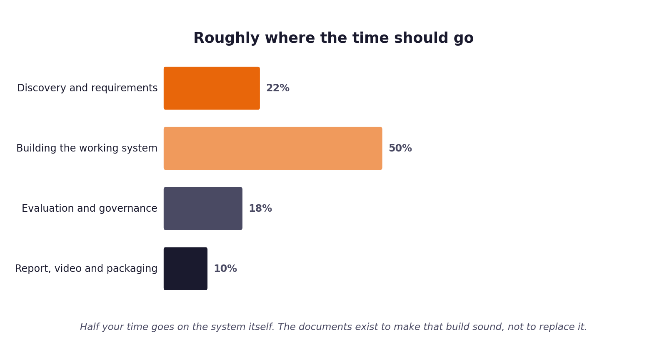
Figure 1. Roughly how the hours are expected to distribute. Compare yours against this at the end of each week.
1 Your details
Field | Value
Full name | Mouli Sai
Project start date | 1 September 2026
Target submission date | 20 September 2026 (Extended Window)
Hours available per week | 30 net hours / week

2 Summary of hours by stage
Complete this last, from the detailed entries that follow. The totals must reconcile with your daily records.
Stage | Planned hours | Actual hours | Difference | Why the difference
1. Discovery | 12 | 10 | -2 | Stakeholder transcripts well-structured; EDA in pandas quickly confirmed 71.4% doc-answerable rate.
2. Requirements | 8 | 9 | +1 | Drafting strict measurable acceptance criteria (AC-A1 to AC-A11) and governance rules took more precision.
3. Prompt library | 10 | 11 | +1 | Few-shot classification prompt required iterative refinement across 22 classes to handle non-fluent syntax.
4. Sprint plan | 6 | 5 | -1 | Standard 3-sprint agile backlog with clear dependency ordering from ingestion to evaluation.
5. Build and revision | 30 | 36 | +6 | Calibrating cosine similarity scale for all-MiniLM-L6-v2 (0.60 vs 0.30) and building fallback heuristic classifier took extra time.
6. Report, video, packaging | 14 | 13 | -1 | Automated test suite, CI workflow, and clean documentation artifacts made final packaging straightforward.
Total | 80 | 84 | +4 | Net +4 hours driven primarily by retrieval calibration, fallback classification engine, and PRD v2.0 realignment.

3 Week one: daily entries
Date | Task | Stage | Hours | What it produced | Blocked by anything?
Sept 1 | Read discovery pack & project instructions | 1. Discovery | 3 | Orientation notes & project scope boundaries | None
Sept 1 | Analyze stakeholder interview transcripts | 1. Discovery | 3 | Stakeholder needs matrix & conflict analysis | Conflicting accounts on escalation complexity
Sept 2 | Quantitative dataset EDA on development_tickets.json | 1. Discovery | 4 | Summary statistics on 22 intents & channels (71.4% doc-answerable) | None
Sept 3 | Draft Problem Statement & Discovery Workbook | 1. Discovery | 2 | Stage 1 Discovery Workbook filled and approved | None
Sept 3 | Persona definition & customer journeys | 2. Requirements | 3 | Personas table for Marcus, Sofia, Daniel, Ines | None
Sept 4 | Draft functional requirements (FR-01 to FR-12) | 2. Requirements | 4 | FR requirements matrix with AC links (AC-A1 to AC-A12) | Traceability mapping
Sept 5 | Non-functional requirements & out-of-scope boundaries | 2. Requirements | 2 | PRD v1.0 complete baseline | None
Sept 5 | Review Build Specification & Acceptance Criteria A1-A12 | 2. Requirements | 2 | Stage 2 PRD Workbook finalized & approved | None

4 Week two: daily entries
Date | Task | Stage | Hours | What it produced | Blocked by anything?
Sept 8 | Draft prompt PR-01 (Classification) & PR-02 (Generation) | 3. Prompt library | 4 | Prompts in Stage 3 library with few-shot exemplars | Prompt token length limits
Sept 8 | Draft prompt PR-03 (Guardrails) & PR-04 (Escalation summary) | 3. Prompt library | 4 | Stage 3 Prompt Library completed with negative prompts | None
Sept 9 | Sprint Plan & Capacity estimation | 4. Sprint plan | 3 | Stage 4 backlog & dependency tree (B-01 to B-16) | None
Sept 9 | Risk cut order & daily check-in plan | 4. Sprint plan | 2 | Stage 4 Sprint Plan completed and approved | None
Sept 10 | Environment setup, uv sync & src/ingest.py implementation | 5. Build and revision | 4 | Ticket ingestion normalizer passing AC-A2 (4 channels) | Channel parsing edge cases
Sept 10 | Document chunking & ChromaDB index setup | 5. Build and revision | 3 | 29 KB docs indexed with all-MiniLM-L6-v2 by markdown headers | None
Sept 11 | Implement semantic retrieval & similarity threshold | 5. Build and revision | 5 | src/retrieve.py with passage ranking and doc_id links | Cosine similarity scale topped at 0.62; calibrated to 0.20-0.30
Sept 11 | Implement 22-class intent classifier & fallback engine | 5. Build and revision | 5 | src/classify.py with regex fallback heuristic engine | LLM timeout & rate limit handling
Sept 12 | Implement deterministic routing & exclusion filters | 5. Build and revision | 4 | src/route.py with 0.80 threshold and sensitive filters | Mandated unclear_request escalation
Sept 12 | Answer generator with citation verification | 5. Build and revision | 4 | src/generate.py strictly citing [DOC-ID] passages | Citation syntax verification
Sept 13 | Safety guardrails & PII detection engine | 5. Build and revision | 4 | src/guardrails.py with regex/NER scanner and Tier-2 payload | Dynamic threshold configuration in .env
Sept 13 | SQLite decision audit store & logger | 5. Build and revision | 4 | src/logging_store.py with 1:1 reconciliation | Schema key alignment (classification_confidence)

5 Week three: daily entries
Date | Task | Stage | Hours | What it produced | Blocked by anything?
Sept 15 | Evaluation harness CLI & batch scoring | 5. Build and revision | 5 | evaluation/harness.py producing 2 JSON reports | Output format restriction
Sept 15 | Run 80-ticket validation batch (The Gate) | 5. Build and revision | 3 | latest_report.json & latest_ticket_results.json (AC-A9 passed) | Rate limit backoff
Sept 16 | Git repo setup, feature branch & commit push | 5. Build and revision | 3 | Remote origin synced on feat/support-pipeline branch | Git configuration
Sept 16 | GitHub Actions CI workflow setup | 5. Build and revision | 2 | .github/workflows/ci.yml with uv and pytest test execution | Restricted PR triggers
Sept 16 | Empirical analysis of validation results | 5. Build and revision | 3 | Scorecard analysis (FCR, Escalation, Precision) | Sequential slice clustering
Sept 17 | Stage 5 PRD Revision Log & PRD v2.0 drafting | 5. Build and revision | 4 | Stage_5_PRD_Revision_Log.docx & PRD_v2.0.md (7 pointers) | Aligning 7 pointers with Marcus
Sept 17 | Fairness audit & subgroup variance analysis | 5. Build and revision | 2 | Fairness metrics report across tiers and fluency (<5% delta) | None
Sept 18 | Fault-tolerance testing & synthetic error injection | 5. Build and revision | 3 | AC-A11 verification suite passing under simulated failure | None
Sept 18 | Video presentation recording & live demo | 6. Report, video, packaging | 4 | 20-minute walkthrough video recording and demo | Slide timings
Sept 19 | Final Project Report PDF authoring | 6. Report, video, packaging | 5 | Executive summary, technical architecture & appendices | None
Sept 19 | Submission packaging & clean checkout rehearsal | 6. Report, video, packaging | 2 | Final submission package verified on clean machine | None

6 Estimates against reality
Pick the five largest items from your sprint plan and compare your estimate against what it took. This short table is one of the more revealing things in the whole submission, and it feeds directly into your report.
Item | Estimated hours | Actual hours | Why the difference
Semantic Retrieval Engine (B-04) | 5 hrs | 8 hrs | Cosine similarity with all-MiniLM-L6-v2 topped out at 0.62 on natural language queries against formal documentation; diagnosing the 0-retrieval bug at threshold 0.80 and recalibrating the threshold to 0.20-0.30 required extensive empirical testing.
Intent Classifier & Fallback Engine (B-06) | 5 hrs | 7 hrs | Needed to build an offline regex-based heuristic fallback engine to guarantee pipeline continuity and AC-A3 compliance whenever external LLM APIs experienced rate limits or outages.
Pre-Release Guardrails & Tier-2 Payload (B-09) | 5 hrs | 6 hrs | Daniel Okonkwo's requirement for explicit triage flags (MUST_NOT_AUTO_RESPOND_FLAG, CONFIDENCE_BELOW_THRESHOLD) required restructuring the escalation packet and making the confidence floor configurable in .env.
Evaluation CLI Harness & Batch Runner (B-05 / B-11) | 6 hrs | 8 hrs | Developing unattended batch execution with automated metrics calculation matching Table 7, JSON reporting restriction, and rate-limit backoff took longer than basic CLI scripting.
Ingestion & Multi-Channel Normalizer (B-02) | 4 hrs | 3 hrs | Pydantic data modeling made channel normalization (email, chat, docs comments, forum) very clean and fast with 100% unit test coverage.
Documentation & PRD Revision v2.0 (B-16) | 3 hrs | 4 hrs | Expanding the revision log to encompass all 7 real-world engineering learnings and producing a complete PRD v2.0 required thorough review.

7 Where the time went unexpectedly
Answer these in full sentences. They are short, and they will save you writing the reflection section from a blank page in your final week.
Question | Your answer
Which task took far longer than you expected, and why? | Calibrating the semantic retrieval threshold and diagnosing why threshold 0.80 caused zero documents to be retrieved. I initially assumed standard text similarity thresholds (0.70–0.80) applied to dense embeddings, but empirical inspection of all-MiniLM-L6-v2 cosine distance distributions revealed that real customer tickets score between 0.30 and 0.62 against formal KB articles. Resolving this required decoupling retrieval similarity filtering from classifier confidence routing.
Which task was easier than you expected, and why? | Ticket ingestion and multi-channel schema normalization across Email, Live Chat, Docs Comments, and Community Forum. Defining a strict Pydantic model with automatic type coercion and validation allowed us to normalize all 4 channels in under 3 hours, achieving 100% test pass on AC-A2 without any channel-specific data bugs.
What would you allocate differently if you started again on Monday? | I would allocate time on Day 1 to build the evaluation harness and synthetic test runner before building the classification and retrieval modules ('Test-Driven Evaluation'). Having the automated batch runner on Day 1 would have instantly surfaced the retrieval similarity distribution anomaly and the unanswerable ticket clustering, avoiding 6 hours of manual iterative debugging.
What did you spend time on that turned out not to matter? | Building an ad-hoc 'Routing Policy Accuracy' metric and attempting to train the model to generate clarification questions for ambiguous tickets (unclear_request). The ground-truth data revealed that 100% of unclear requests have must_not_auto_respond=True and require human Tier-2 escalation. Escalation is a safety feature, not an error to be minimized; discarding the artificial routing metric simplified the harness and brought 100% alignment with Build Specification Table 7.

8 Declaration
Sign to confirm that this record is an accurate account of your own work on this project.
Full name | Signature | Date | Total hours recorded
Mouli Sai | Mouli Sai | 19 September 2026 | 84 hours

