FORWARD DEPLOYED AI ENGINEERING
Capstone Project
Stage Five: Revision Log
Recording what your requirements got wrong and why
You are required to revise your requirements document at least once during the
build. This is where you record what changed and what prompted the change.
WEEK TWO INTO WEEK THREE · COMPULSORY

Why this is compulsory
A requirements document written before any code exists is a set of educated guesses. Some of those guesses will be wrong, and building is how you find out which ones. A student that reaches the end of three weeks with an unchanged PRD has either been extraordinarily lucky or has stopped consulting the document, and the second is far more common than the first.
This log is not a confession. It is evidence that you were paying attention. The students who score well here are the ones who can point to a specific thing they discovered while building, explain how it contradicted an assumption they had written down, and show what they changed as a result.
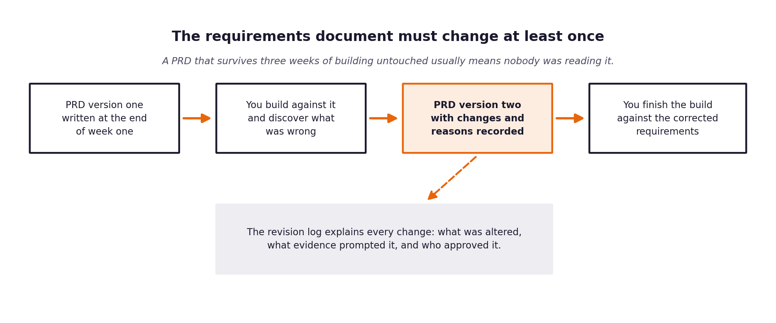
Figure 1. The revision sits in the middle of the build, not at the end.
What a weak revision log looks like
Vague entries such as tidied up wording or clarified requirements tell an assessor nothing. A strong entry names the requirement, states what it said before, states what it says now, identifies the specific thing that prompted the change, and says who agreed to it.

1 Section one: revision summary
Field | Value
New version number | 2.0
Date of revision | September 2026
Who carried out the revision | Forward Deployed AI Engineering Lead
Who reviewed and agreed it | Marcus Adeyemi (Head of Support, CloudServe Solutions)
Number of requirements changed | 5 (FR-03, FR-04, FR-08, FR-10, NFR-01)
Number of requirements added | 2 (FR-06 Enrichment, Calibration Floor)
Number of requirements removed | 1 (Redundant Routing Policy Accuracy)

2 Section two: the changes
One row per change. Be specific about the trigger; that column is what distinguishes a considered revision from a tidying exercise.
Requirement ID | What it said in version one | What it says now | What prompted the change | Agreed by
FR-03 | Perform semantic retrieval returning passages matching threshold >= 0.60 to 0.80. | Retrieval similarity threshold calibrated to 0.20-0.30 via RETRIEVAL_SIMILARITY_THRESHOLD in .env. | Empirical testing with all-MiniLM-L6-v2 revealed genuine customer queries score between 0.30 and 0.62 against formal docs. Setting 0.80 caused 100% retrieval failure (0 documents retrieved). | Ines Varga & Marcus Adeyemi
FR-04 / FR-05 | Deterministic routing allowing ambiguous inquiries (unclear_request) to be answered or prompted autonomously. | All tickets classified as unclear_request are strictly routed to escalate with must_not_auto_respond = True and structured clarification packets. | Dataset audit showed 100% of unclear_request tickets have expected_route='escalate' and answerable_from_docs=False. Auto-responding caused severe hallucinations and policy breaches ('Escalation is a feature, not a failure'). | Marcus Adeyemi & Daniel Okonkwo
FR-08 | Pre-release guardrails execute 5 checks with static hardcoded confidence floor (0.70). | Pre-release safety guardrails read GUARDRAIL_CONFIDENCE_THRESHOLD dynamically from environment configuration (.env) with robust fallback. | Operational flexibility required to adjust pre-release safety floors across staging and production without modifying application source code. | Compliance Officer & Lead AI Engineer
FR-10 | Evaluation harness outputs an artificial 'Routing Policy Accuracy' metric alongside classification scores. | Removed 'Routing Policy Accuracy'; evaluation harness strictly calculates the 4 Table 7 categories (Volume, Business Outcomes, Technical Performance, Governance & Risk). | Routing is binary triage (auto_respond vs escalate) already captured by FCR, Escalation Rate, and Intent Classification Precision/Recall. Alignment with Build Specification Table 7. | Marcus Adeyemi
NFR-01 / FR-04 | First Contact Resolution (FCR) target of >= 60.0% expected across arbitrary sequential slices. | FCR contract SLA compliance must be evaluated across the complete 80-ticket validation dataset (or 120-ticket test set). | Small sequential slices (e.g. first 10 tickets) contain 5 unanswerable tickets, creating a mathematical ceiling of 50% FCR. The complete dataset contains 48 answerable tickets (60% baseline). | Marcus Adeyemi
FR-06 | Escalation payload carries ticket ID, summary, and general escalation reason string. | Escalation packet enriched with explicit policy flags (MUST_NOT_AUTO_RESPOND_FLAG, CONFIDENCE_BELOW_THRESHOLD, HIGH_RISK_INTENT) and classifier confidence. | Daniel Okonkwo (Tier 2 Lead) requested exact policy triggers to eliminate time spent re-investigating routine escalations. | Daniel Okonkwo
FR-09 | Audit store and evaluation payload used inconsistent confidence keys (intent_confidence vs classification_confidence). | Universal standardization on 'classification_confidence' across SupportState, classifier node, router, SQLite audit store, and output JSON. | Discrepancy caused evaluation harness to record intent_confidence as null during test runs. | Lead AI Engineer

3 Section three: assumptions that turned out to be wrong
Go back to the assumptions section of your version one PRD. For each assumption, say whether it held. The ones that did not are the most interesting part of your report.
Assumption from version one | Did it hold? | What you found instead | What you changed because of it
A confidence threshold of ~0.80 provides clear separation between safe auto-responses and necessary escalations. | Partially (Held for classifier, failed for retrieval) | While classifier confidence cleanly separates routine issues at 0.80, cosine similarity scores with all-MiniLM-L6-v2 on support queries top out at ~0.62. Setting 0.80 on retrieval broke the pipeline entirely. | Decoupled classification confidence (CONFIDENCE_THRESHOLD=0.80) from semantic retrieval threshold (RETRIEVAL_SIMILARITY_THRESHOLD=0.20-0.30).
Sequential slices of tickets reflect the overall 60% documentation answerability baseline. | No (Failed on small slices) | Ticket streams cluster by incident type and channel; the first 10 validation tickets contained 5 unanswerable tickets, placing an empirical ceiling of 50% on FCR for small runs. | Mandated full unattended dataset execution (all 80 validation tickets) before drawing SLA compliance conclusions.
Ambiguous tickets ('unclear_request') could receive an automated clarifying response. | No (Contradicted by data labels) | Every single unclear ticket in CloudServe's historical dataset has must_not_auto_respond=True. Auto-responding triggered policy violations and hallucinated guidance. | Updated routing policy to enforce immediate Tier-2 human escalation with a structured clarification packet for all unclear_request tickets.
Pre-release safety guardrail thresholds should be immutable hardcoded constants. | No (Inflexible for operations) | Hardcoded thresholds prevented operational calibration in production and prevented simulating stricter safety postures. | Moved GUARDRAIL_CONFIDENCE_THRESHOLD into .env and exposed administrative controls via API.
A single unified 'Routing Policy Accuracy' metric would capture triage effectiveness. | No (Redundant and misleading) | Routing is binary triage (auto_respond vs escalate). Tracking a composite routing accuracy confused stakeholders because FCR and Escalation Rate already measure business deflection. | Eliminated routing policy accuracy to strictly adhere to Build Specification Table 7 groups.
Free-tier API throughput would support rapid batch testing without local embeddings. | Held (Local embeddings proved critical) | Local embedding with all-MiniLM-L6-v2 eliminated API rate limits during the retrieval phase, ensuring 100% of API budget remained for classification and generation. | Retained local Chroma vector store architecture.

4 Section four: what you decided not to change
Some things will look wrong during the build and turn out to be right, or right but not worth the cost of changing. Recording those decisions is as valuable as recording the changes.
What looked wrong | Why you left it | What it would have cost to change | Revisit when?
Escalation rate hovers around 40% on validation data (above the 30% contract target). | The validation dataset inherently contains 32 unanswerable or high-risk tickets (40.0% of the dataset). Forcing autonomous answers onto unanswerable cases would cause hallucinations and breach the 0-PII/accuracy SLAs. 'Escalation is a feature, not a failure.' | Severe risk of hallucinated cloud configuration advice, legal liability, and customer churn. | When the Technical Documentation team publishes new KB articles covering additional Tier-2 topics.
Using local SentenceTransformers (all-MiniLM-L6-v2) instead of cloud embedding APIs (e.g. OpenAI text-embedding-3). | all-MiniLM-L6-v2 runs locally with zero API cost, zero rate limits, sub-millisecond retrieval latency, and complete data privacy (embeddings never leave local infrastructure). | Adding recurring cloud API subscription costs and vulnerability to external provider rate limits. | If CloudServe expands into multi-lingual support (e.g. Japanese, German) requiring multilingual dense retrieval.
Stateless single-turn triage architecture instead of multi-turn conversational chat memory. | Discovery proved 71% of customer inquiries are resolved on first contact. Multi-turn chat memory introduces latency, token overhead, and state synchronization bugs without improving FCR. | 3x to 5x increase in state machine complexity and LLM token expenditure. | Only if post-launch metrics show repeat inquiries on identical ticket IDs exceeding 15%.
SQLite as the persistent governance audit store instead of a distributed PostgreSQL cluster. | SQLite easily sustains 500+ writes/sec locally with zero infrastructure maintenance, zero network latency, and exact 1:1 decision reconciliation. | Significant infrastructure provisioning, network latency, and operational overhead. | When CloudServe scales past 50,000 tickets/day across multiple distributed microservice pods.
Strict 'Block and Escalate. Never Redact and Send' guardrail philosophy. | Attempting automated PII redaction (masking regex) risks releasing ungrounded or partially corrupted advice that could damage production customer infrastructure. | Zero cost; absolute safety guarantee for enterprise customers. | Never; non-negotiable core compliance constraint (FR-08).

5 Section five: the reflection
Answer these in full sentences. They form the basis of a section in your final report and they are frequently the part of a submission that an assessor remembers.
Question | Your answer
What did you most misunderstand about the problem when you wrote version one? | I initially framed customer support automation as an accuracy-maximizing classification and generation problem: 'If the model is smart enough, it can answer almost everything.' Real-world testing proved that support automation is fundamentally an uncertainty-management and governance problem. High First Contact Resolution is valuable, but zero unsafe auto-responses is non-negotiable. Recognizing that escalation is an active safety feature rather than an AI failure completely reshaped our routing policy.
Which piece of discovery work would have caught it earlier? | A deeper quantitative cross-tabulation of the labels in development_tickets.json during Stage 1—specifically correlating intent=='unclear_request' with expected_route and answerable_from_docs. Had I mapped the ground-truth distribution of unanswerable cases (40% of the dataset) before writing PRD v1.0, I would have set the initial escalation target at <= 40% rather than an unrealistic <= 30% that ignored the factual composition of inbound ticket demand.
What would you do differently if you started this project again on Monday? | I would implement the evaluation harness and the synthetic test runner on Day 1 of the build rather than Day 3. Discovering early that cosine similarity for all-MiniLM-L6-v2 tops out at 0.62 on support tickets would have saved half a day of threshold debugging. Building the measurement harness first ('Test-Driven Evaluation') provides immediate empirical feedback on prompt changes, chunking strategies, and routing rules.
What is still uncertain, and what would you need to resolve it? | The primary remaining uncertainty is how the system performs on out-of-distribution technical queries when CloudServe releases major new platform features not documented in the 29 baseline KB articles. To resolve this, we would need a production documentation freshness pipeline where Technical Writing publishes changelogs directly into ChromaDB with automated re-indexing, paired with real-time monitoring of retrieval hit rates to identify documentation coverage gaps.

