Website Feedback
- Change Mahonet HR Consulting to MHRC
- Can we make the color more eggplant than burgundy
- Can the opening MHRC go across the page
- The orange bar has for Book Free consultation has orange lettering instead of white
- Can the burgundy script be eggplant
- Change this quote: "We believe compliance and compassion can coexist—because every team deserves both structure and support."
— Terris Albach, Founder
- Remove the Meet Terris section
- Fonts are different on the how we help
- Practical compliance excellence: Change to- No jargon, no overwhelm. We make HR regulations understandable — translating accreditation and compliance standards like CARF (Commission on Accreditation of Rehabilitation Facilities), OHMAS (Ohio Mental Health & Addiction Services), and labor laws into everyday practices that work.
- Change the about us page and break it into 2. About us and Meet Terris
- About Us
At MHRC, we partner with small businesses and behavioral health agencies to simplify compliance, strengthen leadership, and build confident, people-first workplaces. Our approach combines strategic insight with real-world HR experience, helping clients stay compliant while creating environments where employees can thrive.
Most small businesses don’t see that their growing pains are HR pains — we help you uncover the cause, strengthen your systems, and empower your team to thrive.
Vision: empower small business leaders with people-first HR expertise that builds confident teams, compliant workplaces, and thriving organizations.
Values: People Forts Partnership, Compliance Excellence, Authenticity, Growth, Empowerment
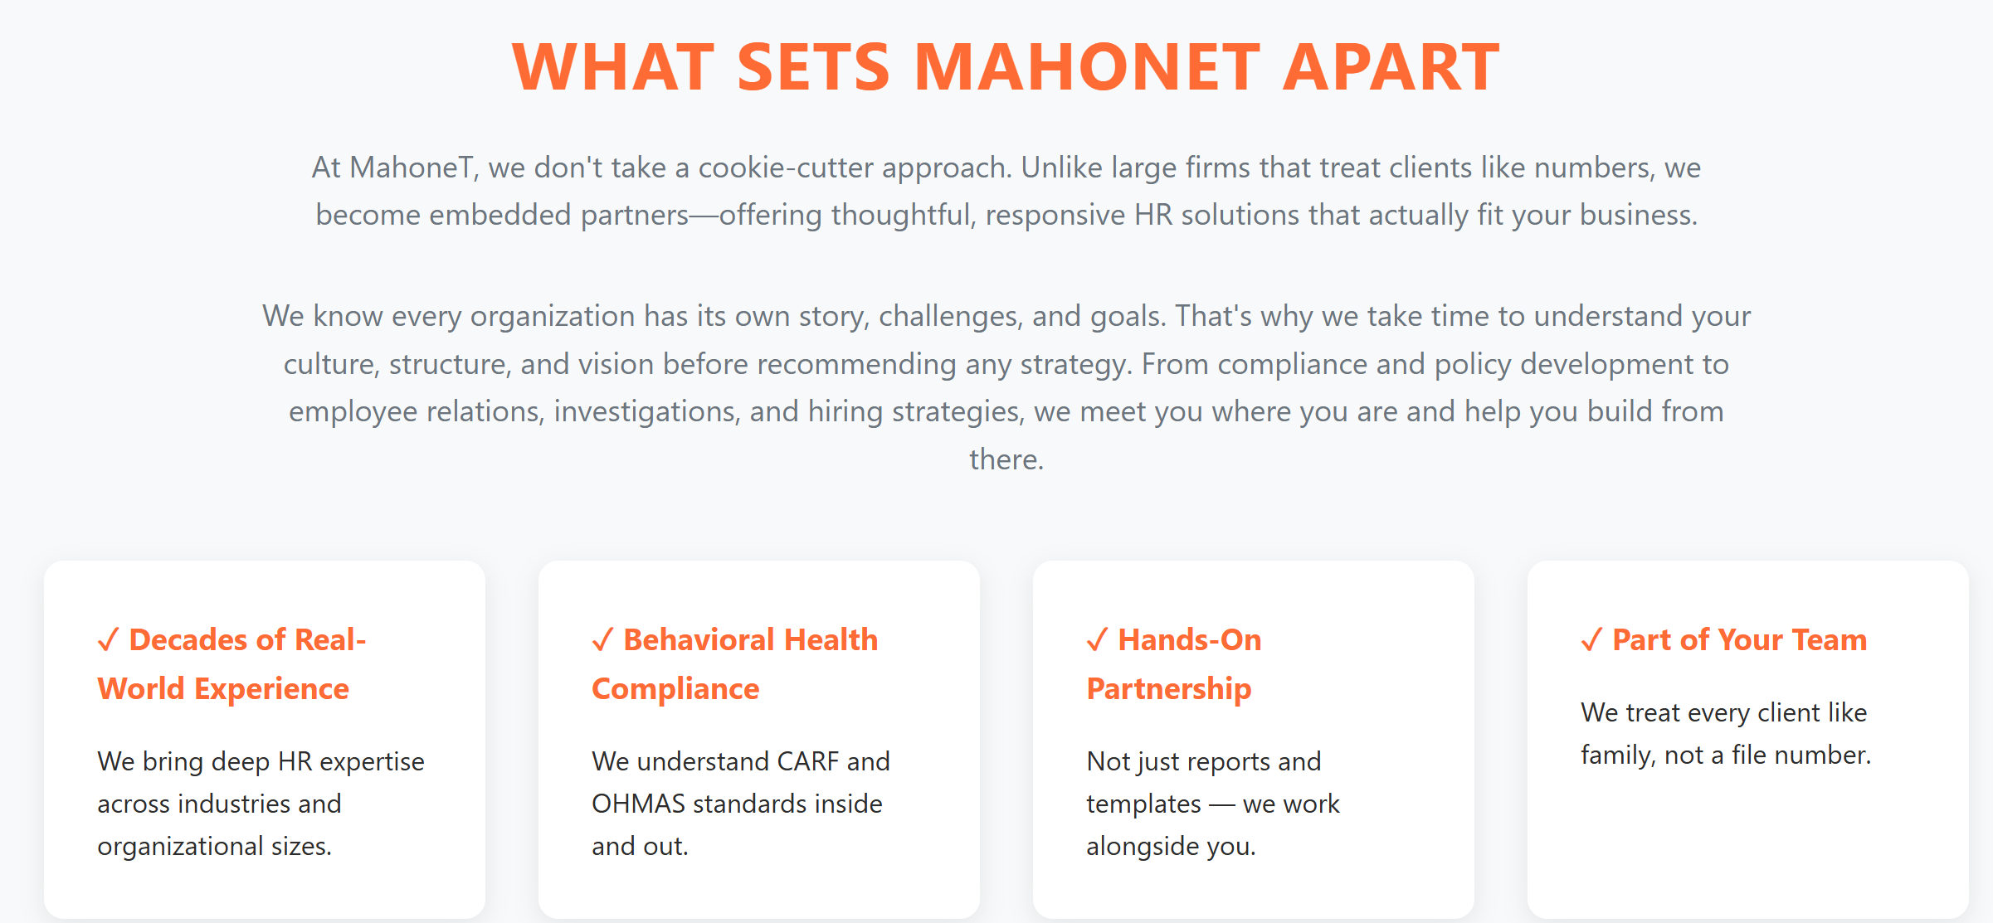

Meet Terris
Founder & HR Director, MHRC
With almost two decades of experience in corporate HR, Terris saw how easily people can get lost in the shuffle — especially in large, one-size-fits-all environments. When her role was outsourced, she didn’t see it as an ending, but as the beginning of something more personal, intentional, and impactful.
That experience inspired her to create MHRC, with one mission: to help small businesses thrive through strategic, compassionate, and compliance-driven HR support.
Terris is a connector, a builder, and a believer in people. She understands that HR isn’t just about policies — it’s about relationships, culture, and creating structure that allows both businesses and teams to grow.
Through MHRC, she combines corporate expertise with a people-first approach, helping small businesses and behavioral health agencies bridge the gap between compliance and care.
When she’s not supporting clients, Terris enjoys cycling, traveling with her family, and finding new ways to help leaders grow with confidence.

About me inspo: https://www.bloombeaconhr.com/

