**BLOOD CONTENT PREDICTION USING DEEP LEARNING TECHNIQUES**

**ABSTRACT**

Visualizing cell interactions in blood circulation is of great importance in studies of blood disease immunotherapy or drugs. However, the lack of a suitable imaging system hampers progress in this field. Deep Learning Has Recently Been Used in Image Recognition. Blood cells play a remarkable role in the human immune system. To diagnose blood-related diseases, pathologists need to consider the characteristics of blood cells. The diagnosis of blood-based diseases often involves identifying and characterizing patient blood samples. Automated methods to detect and classify blood cell subtypes have important medical applications. Object recognition is an integral part of computer vision that identifies an object in the given image irrespective of backgrounds, occlusion, the angle of view, lighting. Deep learning is a collective term for algorithm shaving a deep architecture that solves complex problems.

**KEYWORDS**: Image Recognition, medical applications, Deep learning, blood samples

1. **INTRODUCTION:**

Cancer immunotherapy plays an increasingly promising role in the treatment of kidney cancer, prostate cancer, melanoma and other types of cancer [1, 2]. A variety of immune cells may be utilized to promote an immune response to tumours, including T cells, natural killer cells, and dendritic cells (DCs). Therefore, understanding the in vivo interactions between immune cells and tumour cells is of great importance for oncological research and clinical anti-tumour treatment. Intravital imaging facilitates the visualization of tumour immune activities in living animals. The two-photon microscope has been used to visualize perivascular macrophages, which increase the permeability of blood vessels and promote tumour cell intravasation [3]. Confocal microscopy has been used to image the destruction of solid tumours following adoptive T cell therapy [4]. The processing and analysis of microscopic image is a broad field in research area. There are more than 4,000 kind of different components in blood. White Blood Cells (WBC), Red Blood Cells (RBC), Platelets and Plasma are four important constituents. Identifying the different blood cells helps to find out disease detected cells. It is difficult task to identifying and counting the blood cells manually which is carried out by human observation in laboratory. Approaching a new automated blood cell detection algorithm reduce the detecting time and produce accurate results. Segmentation over an image is performed to detect the required information in image analysis. Blood image segmenting method is used to build the separation between the cells and proper detection of different blood cells. This image processing technique of blood cell detection can also be used for different disease detection by analysing each cell accurately.

1. **LITERATURE SURVEY**

In the literature, there are many works devoted to the analysis of peripheral blood cell images, but few of them work on the whole analysis process. Most of them are dedicated to performing a single step or analysing a single cell type. Indeed, many of them focus on cell segmentation or just on cell classification, starting from manually cropped images. The classification step might be devoted to distinguishing the different cell types [[6](https://www.sciencedirect.com/science/article/pii/S0010482519303890" \l "bib6)] or the normal from the abnormal cells [[7](https://www.sciencedirect.com/science/article/pii/S0010482519303890" \l "bib7)]. Recently, due to the importance of this step and to improve classification performance, the authors adopted complex but powerful deep learning approaches [[8](https://www.sciencedirect.com/science/article/pii/S0010482519303890" \l "bib8),[9](https://www.sciencedirect.com/science/article/pii/S0010482519303890" \l "bib9)]. On the contrary, to speed up the procedure, they based the segmentation step on simple but less powerful approaches [[10](https://www.sciencedirect.com/science/article/pii/S0010482519303890" \l "bib10),[11](https://www.sciencedirect.com/science/article/pii/S0010482519303890" \l "bib11)]. Specifically, most of the time, the segmentation task was performed with pixel-based approaches, using threshold operations to segment the whole leukocyte [[12](https://www.sciencedirect.com/science/article/pii/S0010482519303890" \l "bib12)] or just the leukocyte nuclei [[13](https://www.sciencedirect.com/science/article/pii/S0010482519303890" \l "bib13)], and using k-means clustering to differentiate the five types of leukocytes [[14](https://www.sciencedirect.com/science/article/pii/S0010482519303890" \l "bib14)]. Pixel-based approaches have also been used to segment the erythrocytes, particularly through thresholding operations, computed using Otsu's method on the saturation component from the HSV colour space [[15](https://www.sciencedirect.com/science/article/pii/S0010482519303890" \l "bib15)] or Zack's algorithm on the grey level image [[16](https://www.sciencedirect.com/science/article/pii/S0010482519303890" \l "bib16)]. However, classical pixel-based approaches for segmentation are not the most appropriate for segmenting images acquired from the digital microscope. Indeed, they are often affected by uneven lighting caused by the lens and lamplight, which produces a bright central area and some shading areas towards the corners. A few papers have achieved robust segmentation performances under uneven lighting conditions, either by introducing a pre-processing that uses a low pass filter for background removal [[17](https://www.sciencedirect.com/science/article/pii/S0010482519303890" \l "bib17)] or by adopting a local approach for segmentation to manage the local variations and the presence of noise or imprecision [[18](https://www.sciencedirect.com/science/article/pii/S0010482519303890" \l "bib18)].

1. **PROPOSED FRAMEWORK**

Deep learning is a type of machine learning in which a model learns to perform classification tasks directly from images, text or sound. Deep learning is usually implemented using neural network architecture. The term deep refers to the number of layers in the network the more the layers, the deeper the network. The layers are interconnected via nodes, or neurons, with each hidden layer using the output of the previous layer as its input.

* 1. **Dataset:**

This dataset contains 12,500 augmented images of blood cells (JPEG) with accompanying cell type labels (CSV).  There are approximately 3,000 images for each of 4 different cell types grouped into 4 different folders (according to cell type).  The cell types are Eosinophil, Lymphocyte, Monocyte, and Neutrophil.

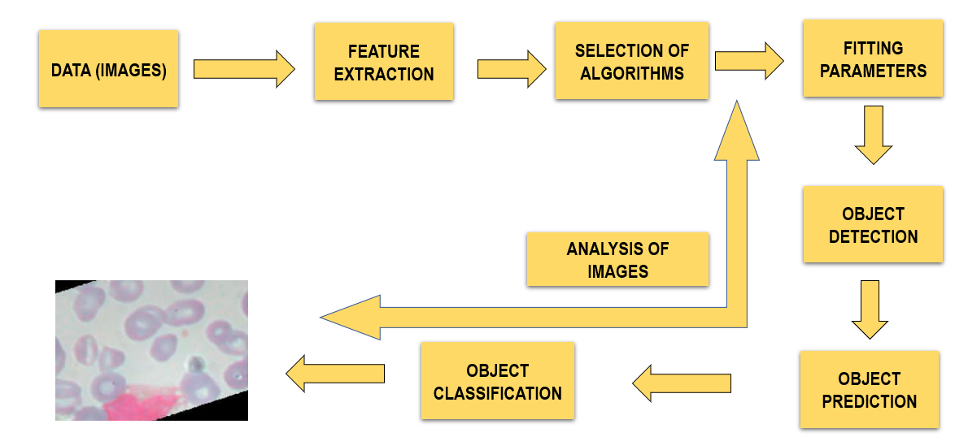

**Fig.1.1. Object Classification**

* 1. **Convolutional neural networks**

Convolutional neural networks (CNN) is one of the variants of neural networks used heavily in the field of computer vision. The hidden layers of a CNN typically consist of convolutional layers, pooling layers, fully connected layers etc. A CNN model can be thought as a combination of two components: feature extraction part and the classification part. The convolution + pooling layers perform feature extraction.  The fully connected layers then act as a classifier on top of these features, and assign a probability to provide final output.

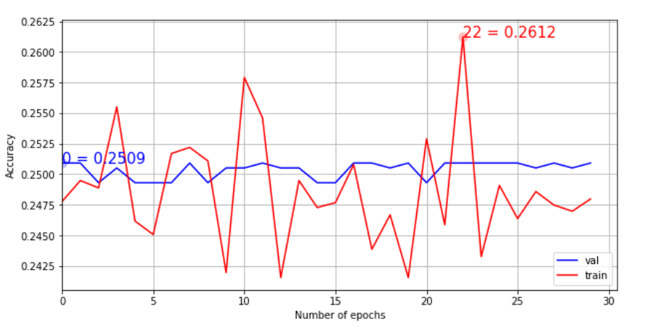

Fig.1.2. CNN results

* 1. **Inception V3**

Inception V3 by Google is the 3rd version in a series of Deep Learning Convolutional Architectures. Inception v3 is a widely-used image recognition model that has been shown to attain greater than 78.1% accuracy on the ImageNet dataset. The model is the culmination of many ideas developed by multiple researchers over the years. The image recognition model called Inception-v3 consists of two parts: Feature extraction part with a convolutional neural network. Classification part with fully-connected and SoftMax layers.

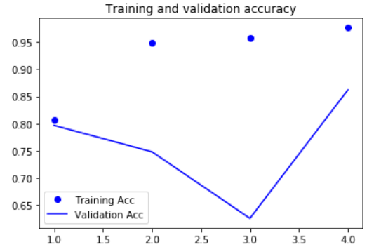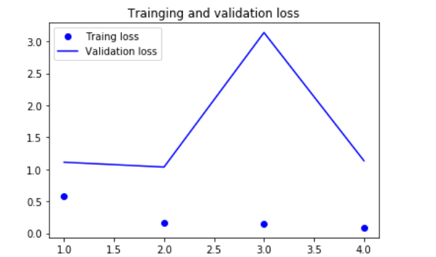

Fig.1.3. Inception V3 Results

* 1. **VGG 16**

It makes the improvement over AlexNet by replacing large kernel-sized filters (11 and 5 in the first and second convolutional layer, respectively) with multiple 3X3 kernel-sized filters one after another. With a given receptive field(the effective area size of input image on which output depends), multiple stacked smaller size kernel is better than the one with a larger size kernel because multiple non-linear layers increases the depth of the network which enables it to learn more complex features, and that too at a lower cost.

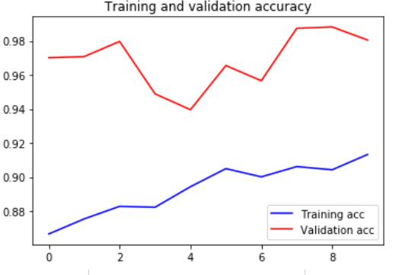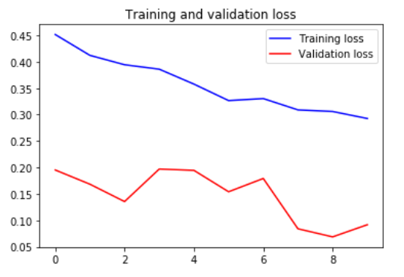

Fig.3.0. VGG 16 results

1. **Conclusion:**

The diagnosis of blood-based diseases often involves identifying and characterizing patient blood samples. Automated methods to detect and classify blood cell subtypes have important medical applications. Deep learning can be a very good help in deciding the line of treatment to be followed by extracting knowledge from such suitable databases. Our project can assist in proper treatment methods for a patient diagnosed with Blood related disease

**Reference:**

F. Bray, J. Ferlay, I. Soerjomataram, R. Siegel, L. Torre, A. JemalGlobal Cancer Statistics 2018: GLOBOCAN estimates of incidence and mortality worldwide for 36 cancers in 185 countries

CA A Cancer J. Clin. (2018)

[Google Scholar](https://scholar.google.com/scholar_lookup?title=Global%20Cancer%20Statistics%202018%3A%20GLOBOCAN%20estimates%20of%20incidence%20and%20mortality%20worldwide%20for%2036%20cancers%20in%20185%20countries&publication_year=2018&author=F.%20Bray&author=J.%20Ferlay&author=I.%20Soerjomataram&author=R.%20Siegel&author=L.%20Torre&author=A.%20Jemal)

T. Vos, A.D. Flaxman, M. Naghavi, *et al.*Years lived with disability (YLDs) for 1160 sequelae of 289 diseases and injuries 1990-2010: a systematic analysis for the global burden of disease study 2010

The Lancet, 380 (9859) (2012), pp. 2163-2196

[Article](https://www.sciencedirect.com/science/article/pii/S0140673612617292)[Download PDF](https://www.sciencedirect.com/science/article/pii/S0140673612617292/pdfft?md5=b787b62bc0c61c1a4f90dfd37af75e15&pid=1-s2.0-S0140673612617292-main.pdf)[View Record in Scopus](https://www.scopus.com/inward/record.url?eid=2-s2.0-84871051576&partnerID=10&rel=R3.0.0)[Google Scholar](https://scholar.google.com/scholar?q=Years%20lived%20with%20disability%20%20for%201160%20sequelae%20of%20289%20diseases%20and%20injuries%201990-2010:%20a%20systematic%20analysis%20for%20the%20global%20burden%20of%20disease%20study%202010)

L. PutzuComputer Aided Diagnosis Algorithms for Digital Microscopy

Ph.D. thesis

University of Cagliari (2016)

[Google Scholar](https://scholar.google.com/scholar_lookup?title=Computer%20Aided%20Diagnosis%20Algorithms%20for%20Digital%20Microscopy&publication_year=2016&author=L.%20Putzu)

O. Erhabor, T.C. AdiasHematology Made Easy

AuthorHouse (2013)

[Google Scholar](https://scholar.google.com/scholar_lookup?title=Hematology%20Made%20Easy&publication_year=2013&author=O.%20Erhabor&author=T.C.%20Adias)

A. Loddo, C. Di Ruberto, M. KocherRecent advances of malaria parasites detection systems based on mathematical morphology

Sensors, 18 (2) (2018), p. 513

[CrossRef](https://doi.org/10.3390/s18020513)[Google Scholar](https://scholar.google.com/scholar_lookup?title=Recent%20advances%20of%20malaria%20parasites%20detection%20systems%20based%20on%20mathematical%20morphology&publication_year=2018&author=A.%20Loddo&author=C.%20Di%20Ruberto&author=M.%20Kocher)

S.S. Al-jaboriy, N.N.A. Sjarif, S. Chuprat, W.M. AbduallahAcute lymphoblastic leukemia segmentation using local pixel information

Pattern Recognit. Lett., 125 (2019), pp. 85-90

[Article](https://www.sciencedirect.com/science/article/pii/S0167865519301072)[Download PDF](https://www.sciencedirect.com/science/article/pii/S0167865519301072/pdfft?md5=6770da2aa5d54b39d21cbe17b077cf25&pid=1-s2.0-S0167865519301072-main.pdf)[View Record in Scopus](https://www.scopus.com/inward/record.url?eid=2-s2.0-85064314221&partnerID=10&rel=R3.0.0)[Google Scholar](https://scholar.google.com/scholar_lookup?title=Acute%20lymphoblastic%20leukemia%20segmentation%20using%20local%20pixel%20information&publication_year=2019&author=S.S.%20Al-jaboriy&author=N.N.A.%20Sjarif&author=S.%20Chuprat&author=W.M.%20Abduallah)

S. Mishra, B. Majhi, P.K. SaTexture feature based classification on microscopic blood smear for acute lymphoblastic leukemia detection

Biomed. Signal Process. Control, 47 (2019), pp. 303-311

[Article](https://www.sciencedirect.com/science/article/pii/S1746809418302027)[Download PDF](https://www.sciencedirect.com/science/article/pii/S1746809418302027/pdfft?md5=c806994c4064f2b0b05576037272b6b1&pid=1-s2.0-S1746809418302027-main.pdf)[View Record in Scopus](https://www.scopus.com/inward/record.url?eid=2-s2.0-85052996185&partnerID=10&rel=R3.0.0)[Google Scholar](https://scholar.google.com/scholar_lookup?title=Texture%20feature%20based%20classification%20on%20microscopic%20blood%20smear%20for%20acute%20lymphoblastic%20leukemia%20detection&publication_year=2019&author=S.%20Mishra&author=B.%20Majhi&author=P.K.%20Sa)

R.B. Hegde, K. Prasad, H. Hebbar, B.M.K. SinghComparison of traditional image processing and deep learning approaches for classification of white blood cells in peripheral blood smear images

Biocybern. Biomed. Eng., 39 (2) (2019), pp. 382-392

[Article](https://www.sciencedirect.com/science/article/pii/S0208521618304819)[Download PDF](https://www.sciencedirect.com/science/article/pii/S0208521618304819/pdfft?md5=b509093a3ac550028a5c1c9022cdbf63&pid=1-s2.0-S0208521618304819-main.pdf)[View Record in Scopus](https://www.scopus.com/inward/record.url?eid=2-s2.0-85063330344&partnerID=10&rel=R3.0.0)[Google Scholar](https://scholar.google.com/scholar_lookup?title=Comparison%20of%20traditional%20image%20processing%20and%20deep%20learning%20approaches%20for%20classification%20of%20white%20blood%20cells%20in%20peripheral%20blood%20smear%20images&publication_year=2019&author=R.B.%20Hegde&author=K.%20Prasad&author=H.%20Hebbar&author=B.M.K.%20Singh)

M. Sharma, A. Bhave, R.R. JanghelWhite blood cell classification using convolutional neural network

J. Wang, G.R.M. Reddy, V.K. Prasad, V.S. Reddy (Eds.), Soft Computing and Signal Processing, Springer Singapore, Singapore (2019), pp. 135-143

[View Record in Scopus](https://www.scopus.com/inward/record.url?eid=2-s2.0-85061103706&partnerID=10&rel=R3.0.0)[Google Scholar](https://scholar.google.com/scholar_lookup?title=White%20blood%20cell%20classification%20using%20convolutional%20neural%20network&publication_year=2019&author=M.%20Sharma&author=A.%20Bhave&author=R.R.%20Janghel)

V. Acharya, P. KumarIdentification and red blood cell automated counting from blood smear images using computer-aided system

Med. Biol. Eng. Comput., 56 (3) (2018), pp. 483-489

[CrossRef](https://doi.org/10.1007/s11517-017-1708-9)[View Record in Scopus](https://www.scopus.com/inward/record.url?eid=2-s2.0-85027532536&partnerID=10&rel=R3.0.0)[Google Scholar](https://scholar.google.com/scholar_lookup?title=Identification%20and%20red%20blood%20cell%20automated%20counting%20from%20blood%20smear%20images%20using%20computer-aided%20system&publication_year=2018&author=V.%20Acharya&author=P.%20Kumar)

V.V. Quiñones, M.J. Macawile, A. Ballado, J.D. Cruz, M.V. CayaLeukocyte segmentation and counting based on microscopic blood images using hsv saturation component with blob analysis

2018 3rd International Conference on Control and Robotics Engineering, ICCRE (2018), pp. 254-258

[CrossRef](https://doi.org/10.1109/ICCRE.2018.8376475)[View Record in Scopus](https://www.scopus.com/inward/record.url?eid=2-s2.0-85050736360&partnerID=10&rel=R3.0.0)[Google Scholar](https://scholar.google.com/scholar_lookup?title=Leukocyte%20segmentation%20and%20counting%20based%20on%20microscopic%20blood%20images%20using%20hsv%20saturation%20component%20with%20blob%20analysis&publication_year=2018&author=V.V.%20Qui%C3%B1ones&author=M.J.%20Macawile&author=A.%20Ballado&author=J.D.%20Cruz&author=M.V.%20Caya)

N.H.A. Halim, M.Y. Mashor, R. HassanAutomatic blasts counting for acute leukemia based on blood samples

Int. J. Res. Rev. Comput. Sci., 2 (4) (2011), pp. 971-976

[View Record in Scopus](https://www.scopus.com/inward/record.url?eid=2-s2.0-84872009920&partnerID=10&rel=R3.0.0)[Google Scholar](https://scholar.google.com/scholar_lookup?title=Automatic%20blasts%20counting%20for%20acute%20leukemia%20based%20on%20blood%20samples&publication_year=2011&author=N.H.A.%20Halim&author=M.Y.%20Mashor&author=R.%20Hassan)

H.T. Madhloom, S.A. Kareem, H. Ariffin, A.A. Zaidan, H.O. Alanazi, B.B. ZaidanAn automated white blood cell nucleus localization and segmentation using image arithmetic and automatic threshold

J. Appl. Sci., 10 (11) (2010), pp. 959-966

[View Record in Scopus](https://www.scopus.com/inward/record.url?eid=2-s2.0-79951731170&partnerID=10&rel=R3.0.0)[Google Scholar](https://scholar.google.com/scholar_lookup?title=An%20automated%20white%20blood%20cell%20nucleus%20localization%20and%20segmentation%20using%20image%20arithmetic%20and%20automatic%20threshold&publication_year=2010&author=H.T.%20Madhloom&author=S.A.%20Kareem&author=H.%20Ariffin&author=A.A.%20Zaidan&author=H.O.%20Alanazi&author=B.B.%20Zaidan)

N. Sinha, A.G. RamakrishnanAutomation of differential blood count

TENCON Conference on Convergent Technologies for the Asia-Pacific Region, vol. 2 (2003), pp. 547-551

[CrossRef](https://doi.org/10.1109/TENCON.2003.1273221)[View Record in Scopus](https://www.scopus.com/inward/record.url?eid=2-s2.0-2342533695&partnerID=10&rel=R3.0.0)[Google Scholar](https://scholar.google.com/scholar_lookup?title=Automation%20of%20differential%20blood%20count&publication_year=2003&author=N.%20Sinha&author=A.G.%20Ramakrishnan)

C. Di Ruberto, A. Dempster, S. Khan, B. JarraAutomatic thresholding of infected blood images using granulometry and regional extrema

International Conference on Pattern Recognition, vol. 3 (2000), pp. 441-444

[View Record in Scopus](https://www.scopus.com/inward/record.url?eid=2-s2.0-33749256176&partnerID=10&rel=R3.0.0)[Google Scholar](https://scholar.google.com/scholar_lookup?title=Automatic%20thresholding%20of%20infected%20blood%20images%20using%20granulometry%20and%20regional%20extrema&publication_year=2000&author=C.%20Di%20Ruberto&author=A.%20Dempster&author=S.%20Khan&author=B.%20Jarra)

[[16]](https://www.sciencedirect.com/science/article/pii/S0010482519303890#bbib16)

H. Berge, D. Taylor, S. Krishnan, T.S. DouglasImproved red blood cell counting in thin blood smears

IEEE International Symposium on Biomedical Imaging: from Nano to Macro (2011), pp. 204-207

[CrossRef](https://doi.org/10.1109/ISBI.2011.5872388)[View Record in Scopus](https://www.scopus.com/inward/record.url?eid=2-s2.0-80055058082&partnerID=10&rel=R3.0.0)[Google Scholar](https://scholar.google.com/scholar_lookup?title=Improved%20red%20blood%20cell%20counting%20in%20thin%20blood%20smears&publication_year=2011&author=H.%20Berge&author=D.%20Taylor&author=S.%20Krishnan&author=T.S.%20Douglas)

[[17]](https://www.sciencedirect.com/science/article/pii/S0010482519303890#bbib17)

F. ScottiRobust segmentation and measurements techniques of white cells in blood microscope images

IEEE IMTC Instrumentation and Measurement Technology Conference (2006), pp. 43-48

[CrossRef](https://doi.org/10.1109/IMTC.2006.328170)[View Record in Scopus](https://www.scopus.com/inward/record.url?eid=2-s2.0-36049008464&partnerID=10&rel=R3.0.0)[Google Scholar](https://scholar.google.com/scholar_lookup?title=Robust%20segmentation%20and%20measurements%20techniques%20of%20white%20cells%20in%20blood%20microscope%20images&publication_year=2006&author=F.%20Scotti)

[[18]](https://www.sciencedirect.com/science/article/pii/S0010482519303890#bbib18)

C. Di Ruberto, L. PutzuAccurate blood cells segmentation through intuitionistic fuzzy set threshold

International Conference SITIS on Signal-Image Technology and Internet-Based Systems (2014), pp. 57-64

[View Record in Scopus](https://www.scopus.com/inward/record.url?eid=2-s2.0-84928576593&partnerID=10&rel=R3.0.0)[Google Scholar](https://scholar.google.com/scholar_lookup?title=Accurate%20blood%20cells%20segmentation%20through%20intuitionistic%20fuzzy%20set%20threshold&publication_year=2014&author=C.%20Di%20Ruberto&author=L.%20Putzu)

[[19]](https://www.sciencedirect.com/science/article/pii/S0010482519303890#bbib19)

S. Khan, A. Khan, F.S. Khattak, A. NaseemAn accurate and cost effective approach to blood cell count

Int. J. Comput. Appl., 50 (1) (2012), pp. 18-24

[CrossRef](https://doi.org/10.5120/7734-0682)[View Record in Scopus](https://www.scopus.com/inward/record.url?eid=2-s2.0-84881656388&partnerID=10&rel=R3.0.0)[Google Scholar](https://scholar.google.com/scholar_lookup?title=An%20accurate%20and%20cost%20effective%20approach%20to%20blood%20cell%20count&publication_year=2012&author=S.%20Khan&author=A.%20Khan&author=F.S.%20Khattak&author=A.%20Naseem)

[[20]](https://www.sciencedirect.com/science/article/pii/S0010482519303890#bbib20)

N.-T. Nguyen, A.-D. Duong, H.-Q. VuCell splitting with high degree of overlapping in peripheral blood smear

Int. J. Comput. Theory Eng., 3 (3) (2011), p. 473

[View Record in Scopus](https://www.scopus.com/inward/record.url?eid=2-s2.0-84880671583&partnerID=10&rel=R3.0.0)[Google Scholar](https://scholar.google.com/scholar_lookup?title=Cell%20splitting%20with%20high%20degree%20of%20overlapping%20in%20peripheral%20blood%20smear&publication_year=2011&author=N.-T.%20Nguyen&author=A.-D.%20Duong&author=H.-Q.%20Vu)

[[21]](https://www.sciencedirect.com/science/article/pii/S0010482519303890#bbib21)

L. Putzu, G. Caocci, C. Di RubertoLeucocyte classification for leukaemia detection using image processing techniques

Artif. Intell. Med., 62 (3) (2014), pp. 179-191

[Article](https://www.sciencedirect.com/science/article/pii/S0933365714001031)[Download PDF](https://www.sciencedirect.com/science/article/pii/S0933365714001031/pdfft?md5=09912bed173c7d0dd66b061e50579731&pid=1-s2.0-S0933365714001031-main.pdf)[View Record in Scopus](https://www.scopus.com/inward/record.url?eid=2-s2.0-84914110040&partnerID=10&rel=R3.0.0)[Google Scholar](https://scholar.google.com/scholar_lookup?title=Leucocyte%20classification%20for%20leukaemia%20detection%20using%20image%20processing%20techniques&publication_year=2014&author=L.%20Putzu&author=G.%20Caocci&author=C.%20Di%20Ruberto)

[[22]](https://www.sciencedirect.com/science/article/pii/S0010482519303890#bbib22)

C. Di Ruberto, A. Loddo, L. PutzuA leucocytes count system from blood smear images

Mach. Vis. Appl. (2016), pp. 1-10

[Google Scholar](https://scholar.google.com/scholar_lookup?title=A%20leucocytes%20count%20system%20from%20blood%20smear%20images&publication_year=2016&author=C.%20Di%20Ruberto&author=A.%20Loddo&author=L.%20Putzu)

[[23]](https://www.sciencedirect.com/science/article/pii/S0010482519303890#bbib23)

A. Loddo, L. Putzu, C. Di Ruberto, G. FenuA computer-aided system for differential count from peripheral blood cell images

International Conference on Signal-Image Technology Internet-Based Systems (SITIS) (2016), pp. 112-118

[CrossRef](https://doi.org/10.1109/SITIS.2016.26)[View Record in Scopus](https://www.scopus.com/inward/record.url?eid=2-s2.0-85019205691&partnerID=10&rel=R3.0.0)[Google Scholar](https://scholar.google.com/scholar_lookup?title=A%20computer-aided%20system%20for%20differential%20count%20from%20peripheral%20blood%20cell%20images&publication_year=2016&author=A.%20Loddo&author=L.%20Putzu&author=C.%20Di%20Ruberto&author=G.%20Fenu)

[[24]](https://www.sciencedirect.com/science/article/pii/S0010482519303890#bbib24)

N.H. Mahmood, P.C. Lim, S.M. Mazalan, M.A.A. RazakBlood cells extraction using color based segmentation technique

Int. J. Life Sci. Biotechnol. Pharma Res., 2 (2) (2013), pp. 233-240

[View Record in Scopus](https://www.scopus.com/inward/record.url?eid=2-s2.0-84899577891&partnerID=10&rel=R3.0.0)[Google Scholar](https://scholar.google.com/scholar_lookup?title=Blood%20cells%20extraction%20using%20color%20based%20segmentation%20technique&publication_year=2013&author=N.H.%20Mahmood&author=P.C.%20Lim&author=S.M.%20Mazalan&author=M.A.A.%20Razak)

[[25]](https://www.sciencedirect.com/science/article/pii/S0010482519303890#bbib25)

M. Yeldhos, K.P. PeeyushRed blood cell counter using embedded image processing techniques

Res. Rep., 2 (2018), pp. 1-5

[View Record in Scopus](https://www.scopus.com/inward/record.url?eid=2-s2.0-85072901480&partnerID=10&rel=R3.0.0)[Google Scholar](https://scholar.google.com/scholar_lookup?title=Red%20blood%20cell%20counter%20using%20embedded%20image%20processing%20techniques&publication_year=2018&author=M.%20Yeldhos&author=K.P.%20Peeyush)

[[26]](https://www.sciencedirect.com/science/article/pii/S0010482519303890#bbib26)

L.A. Bhavnani, U.K. Jaliya, M.J. JoshiSegmentation and counting of wbcs and rbcs from microscopic blood sample images

Int. J. Image Graph. Signal Process., 8 (11) (2016), pp. 32-40

[CrossRef](https://doi.org/10.5815/ijigsp.2016.11.05)[View Record in Scopus](https://www.scopus.com/inward/record.url?eid=2-s2.0-85046377039&partnerID=10&rel=R3.0.0)[Google Scholar](https://scholar.google.com/scholar_lookup?title=Segmentation%20and%20counting%20of%20wbcs%20and%20rbcs%20from%20microscopic%20blood%20sample%20images&publication_year=2016&author=L.A.%20Bhavnani&author=U.K.%20Jaliya&author=M.J.%20Joshi)

[[27]](https://www.sciencedirect.com/science/article/pii/S0010482519303890#bbib27)

M. Alilou, V. KovalevAutomatic object detection and segmentation of the histocytology images using reshapable agents

Image Anal. Stereol., 32 (2) (2013), pp. 89-99

[CrossRef](https://doi.org/10.5566/ias.v32.p89-99)[Google Scholar](https://scholar.google.com/scholar_lookup?title=Automatic%20object%20detection%20and%20segmentation%20of%20the%20histocytology%20images%20using%20reshapable%20agents&publication_year=2013&author=M.%20Alilou&author=V.%20Kovalev)

[[28]](https://www.sciencedirect.com/science/article/pii/S0010482519303890#bbib28)

M.J. Macawile, V.V. Quiñones, A. Ballado, J.D. Cruz, M.V. CayaWhite blood cell classification and counting using convolutional neural network

2018 3rd International Conference on Control and Robotics Engineering (ICCRE) (2018), pp. 259-263

[CrossRef](https://doi.org/10.1109/ICCRE.2018.8376476)[View Record in Scopus](https://www.scopus.com/inward/record.url?eid=2-s2.0-85050717943&partnerID=10&rel=R3.0.0)[Google Scholar](https://scholar.google.com/scholar_lookup?title=White%20blood%20cell%20classification%20and%20counting%20using%20convolutional%20neural%20network&publication_year=2018&author=M.J.%20Macawile&author=V.V.%20Qui%C3%B1ones&author=A.%20Ballado&author=J.D.%20Cruz&author=M.V.%20Caya)

[[29]](https://www.sciencedirect.com/science/article/pii/S0010482519303890#bbib29)

R. Girshick, J. Donahue, T. Darrell, J. MalikRich feature hierarchies for accurate object detection and semantic segmentation

IEEE Conference on Computer Vision and Pattern Recognition, IEEE Computer Society (2014), pp. 580-587

[CrossRef](https://doi.org/10.1109/CVPR.2014.81)[View Record in Scopus](https://www.scopus.com/inward/record.url?eid=2-s2.0-84911400494&partnerID=10&rel=R3.0.0)[Google Scholar](https://scholar.google.com/scholar_lookup?title=Rich%20feature%20hierarchies%20for%20accurate%20object%20detection%20and%20semantic%20segmentation&publication_year=2014&author=R.%20Girshick&author=J.%20Donahue&author=T.%20Darrell&author=J.%20Malik)

[[30]](https://www.sciencedirect.com/science/article/pii/S0010482519303890#bbib30)

S. McMahon, N. Sünderhauf, B. Upcroft, M. MilfordandHow good are edge boxes, really?

Workshop on Scene Understanding (SUNw), IEEE Conf. On Computer Vision and Pattern Recognition (CVPR) (2015), pp. 1-2

[View Record in Scopus](https://www.scopus.com/inward/record.url?eid=2-s2.0-85006224299&partnerID=10&rel=R3.0.0)[Google Scholar](https://scholar.google.com/scholar?q=How%20good%20are%20edge%20boxes,%20really)

[[31]](https://www.sciencedirect.com/science/article/pii/S0010482519303890#bbib31)

K.E.A. Van de Sande, J.R.R. Uijlings, T. Gevers, A.W.M. SmeuldersSegmentation as selective search for object recognition

2011 International Conference on Computer Vision (2011), pp. 1879-1886

[CrossRef](https://doi.org/10.1109/ICCV.2011.6126456)[View Record in Scopus](https://www.scopus.com/inward/record.url?eid=2-s2.0-84856655938&partnerID=10&rel=R3.0.0)[Google Scholar](https://scholar.google.com/scholar_lookup?title=Segmentation%20as%20selective%20search%20for%20object%20recognition&publication_year=2011&author=K.E.A.%20Van%20de%20Sande&author=J.R.R.%20Uijlings&author=T.%20Gevers&author=A.W.M.%20Smeulders)

[[32]](https://www.sciencedirect.com/science/article/pii/S0010482519303890#bbib32)