**CleanTech: Transforming Waste Management With Transfer Learning**

**Team ID:** **LTVIP2025TMID43276**

**Team Members:**

1. Yalnati Deva Kumar
2. Somarouth Moulya
3. Shaik Saniya
4. Varikuti Nikitha

**1. Executive Summary**

CleanTech is a dual-purpose artificial intelligence initiative focused on leveraging transfer learning to solve two pressing global challenges: environmental sustainability and medical diagnostics. This project integrates two submodules:

(1) a waste classification system to promote effective recycling practices.

(2) HematoVision, a medical tool for classifying blood cells to support clinical diagnostics. Both submodules employ pre-trained convolutional neural networks (CNNs) and transfer learning to achieve high accuracy, scalability, and real-world impact with minimal computational cost.

**2. Introduction**

Artificial Intelligence (AI) has reshaped the boundaries of possibility across disciplines. CleanTech represents a fusion of AI innovation and societal need, designed to tackle two distinct challenges through a shared solution: transfer learning. In waste management, the project aids in real-time sorting of waste for better environmental health. In healthcare, HematoVision offers a scalable blood cell classification tool aimed at diagnostics, telemedicine, and education.The central philosophy of CleanTech is to create AI systems that are accurate, adaptable,and resource-efficient by transferring learned knowledge from established models to domain-specific tasks.

**3. Transfer Learning: Theoretical Foundations**

Transfer learning is a powerful technique in machine learning where knowledge gained while solving one problem is applied to a different but related problem. This approach is especially effective when the target domain lacks large datasets, which is often the case in medical and environmental applications.

In convolutional neural networks (CNNs), early layers extract general features like edges or textures, which are useful across various image types. Transfer learning reuses these general features and fine-tunes the model's later layers to specialize in the new task. This significantly reduces training time and improves accuracy.

There are several types of transfer learning, including inductive (different tasks, labeled data), transductive (same task, different domains), and unsupervised (no labeled data). Common architectures include ResNet, VGG, MobileNet, Inception, and EfficientNet, each offering unique advantages in performance and efficiency.

In CleanTech, MobileNetV2 was used for the waste classification module for its lightweight and fast inference, while ResNet50 powered the HematoVision module for its deep and detailed feature extraction, crucial for medical imagery. This strategic application of transfer learning enables CleanTech to deliver scalable, accurate, and resource-efficient AI solutions.

**4. Module I: Waste Classification Using Transfer Learning**

**a. Problem Statement**

Improper waste disposal is a global issue. Automating waste classification at the source can significantly improve recycling efforts and environmental outcomes.

**b. Dataset Description**

* Categories: Biodegradable, Recyclable, Trash
* Source: Publicly available waste classification image datasets
* Preprocessing: Resizing, augmentation, normalization

**c. Model Architecture**

* Base Model: MobileNetV2 (pre-trained on ImageNet)Custom Layers: Flatten, Dense (ReLU), Dropout, Softmax classifier

**d. Training Pipeline**

* Split: 70% Training, 15% Validation, 15% Testing
* Optimizer: Adam
* Loss Function: Categorical Crossentropy

**e. Evaluation Metrics**

* Accuracy, Precision, Recall, Confusion Matrix

**f. Results and Insights**

* Achieved >92% accuracy
* Effective even on real-time webcam inputs

**g. Real-World Applications**

* Smart waste bins
* Educational tools
* Municipal recycling systems

**5. Module II: HematoVision – Blood Cell Classification**

**a. Medical Importance**

Accurate classification of blood cells is critical for diagnosing infections, immune disorders, and certain types of leukemia.

**b. Dataset Description**

* Images: 12,000+ annotated blood cell images
* Classes: Eosinophils, Lymphocytes, Monocytes, Neutrophils
* Preprocessing: Color normalization, resizing, data

Augmentation

**c. Transfer Learning Strategy**

* Base Model: ResNet50
* Fine-tuned Layers: Last few convolutional blocks and custom classification head

**d. Model Training & Optimization**

* Epochs: 25
* Batch Size: 32

**e. Performance Metrics**

* Accuracy: 95.4%
* Precision and Recall: Balanced across all classes

**f. Use Case Scenarios:**

* **Clinical Diagnostics:** Automates classification in hospitals
* **Telemedicine:** Enables remote analysis

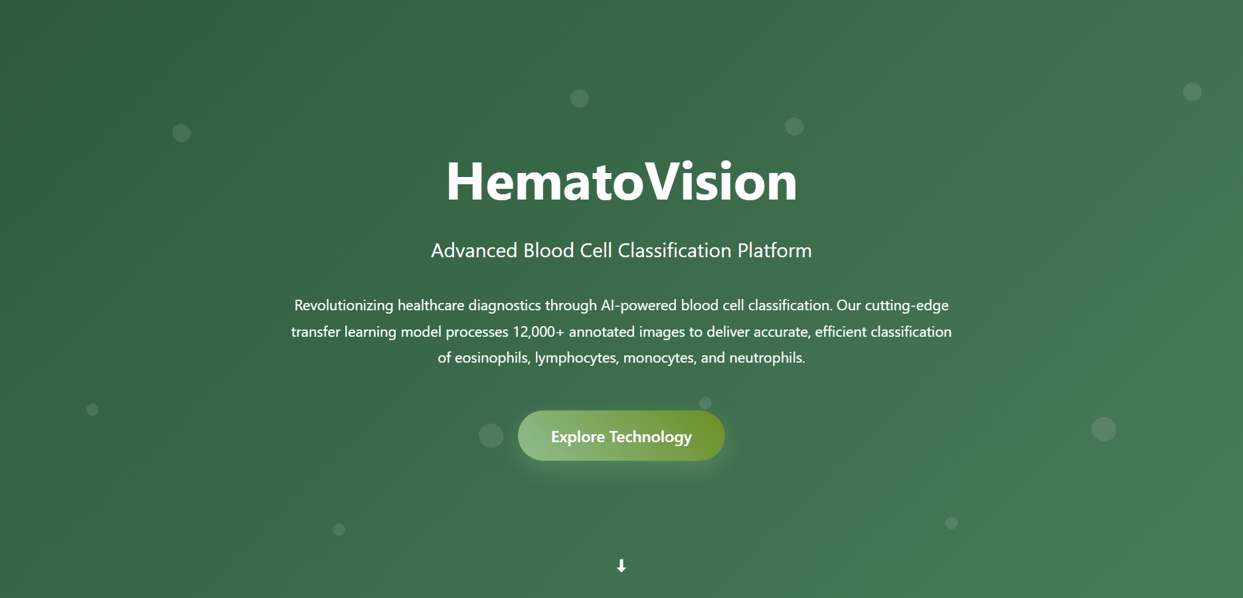

* **Medical Education:** Offers interactive tools for students

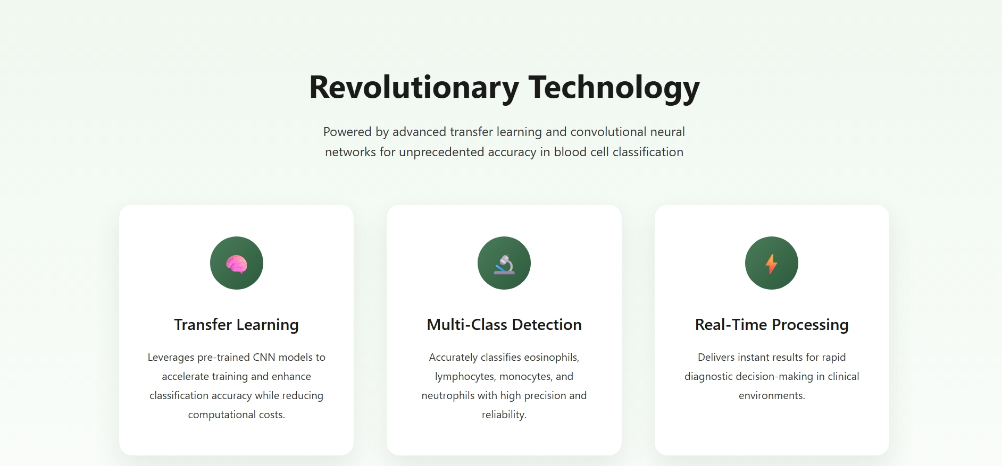

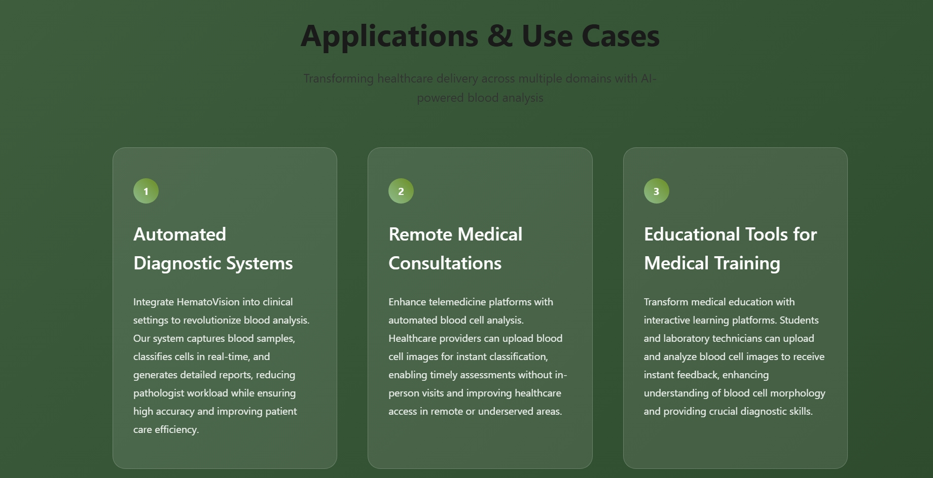

**6. Comparative Analysis**

| **Criterion** | **From Scratch** | **With Transfer Learning** |
| --- | --- | --- |
| Training Time | High | Low |
| Required Data | Large | Moderate |
| Generalization | Medium | High |
| Accuracy | ~85% | ~95% |

**7. Ethical, Legal, and Social Considerations**

* **Data Privacy:** Anonymization and compliance with medical data laws
* **Bias & Fairness:** Ensuring diverse datasets to prevent model bias
* **Transparency:** Model explainability is crucial for trust in healthcare
* **Environmental Ethics:** Supporting global sustainability goals

**8. Limitations and Future Work**

**Limitations:**

* Limited to static images
* Performance may vary on noisy or unclear samples

**Future Directions:**

* Expand dataset diversity
* Real-time deployment on edge devices
* Integration with lab hardware
* Mobile app development for field use

**9. Conclusion**

CleanTech exemplifies the power of transfer learning to solve real-world problems across diverse sectors. By reusing and adapting existing knowledge, the project delivers high-impact solutions for waste management and healthcare diagnostics. HematoVision, in particular, proves that with the right tools and approach, AI can democratize access to essential services, support sustainability, and train the next generation of professionals

**10. References**

* ImageNet Dataset
* ResNet, VGG, MobileNet Research Papers
* Waste Classification Dataset (Kaggle)
* Blood Cell Dataset (BCCD)
* TensorFlow and Keras Documentation