

**CSE 301: Database Systems**

**[Summer 2020]**

**Project Report**

**Formula 1 Championship**

**Project URL/Link:**

https://apex.oracle.com/pls/apex/formula1/r/formula-1-championship1/home?session=714691396177452

**Course Code and Section: CSE301 (2)**

**Submitted by:**

|  |  |  |
| --- | --- | --- |
| **Student ID** | **Student Name** | **Contribution Percentage** |
| 2017-2-60-007 | Moumita Chowdhury | 50% |
| 2017-2-60-052 | Anika Tabassum Nizhum | 50% |

# Final version of the E-R Model of the Project

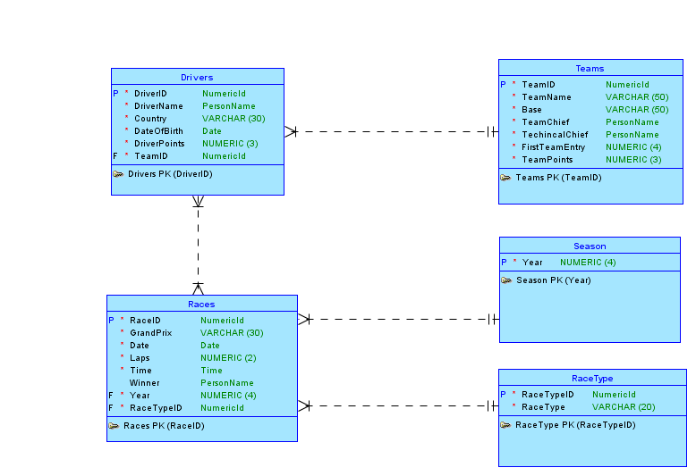

# Final Version of the Relational Data Model of the Project

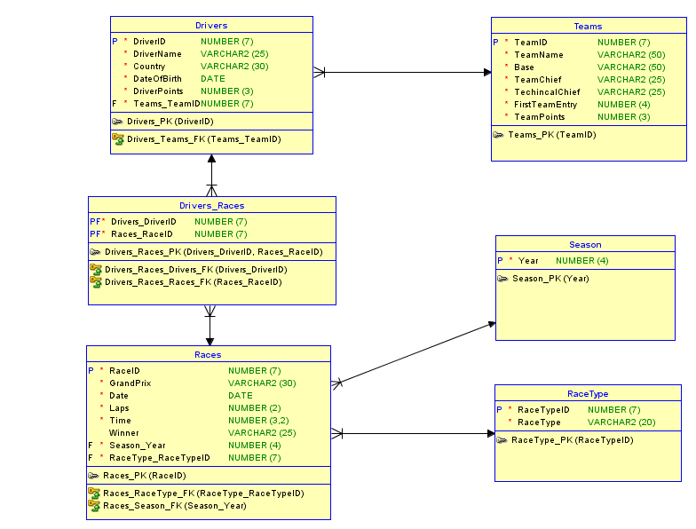

# Implementation Checklist

|  |  |
| --- | --- |
| Description | Remarks |
| Project ID | Application - 119786 Formula_1_Championship |
| Workspace Name | formula1 |
| Workspace Email | 2017-2-60-007@std.ewubd.edu |
| Workspace Password | m007n052 |
|  |  |
| Authentication Type | Custom |
| Username and Password to Login |  |
| admin | admin123 |
| regular_user_1 | user123 |
| regular_user_2 | user223 |
|  |  |
| Uploaded and Displayed Images in Reports | yes |
| Implemented Page-wise Authorization | yes |
|  |  |
| Number of Reports with Forms | 5 |
| Number of Master-detail Forms | 1 |
| Number of Reports based on Queries, Aggregate Queries | 7 |
| Number of Parameterized Reports | 5 |
| Number of Graphs/Charts | 5 |
|  |  |
| Included any trigger/other feature which is not taught in class. If yes, please explain briefly. |  |
| Write the most unique feature/functionality in your application or the page of your application which you are proud of. Explain briefly. |  |

# Reports with Forms

|  |  |  |
| --- | --- | --- |
| Report Page Number and Name | Form Page Number and Name | Table |
| 6 - Races Report | 7 - Races Form | Races |
| 8 – RaceType Report | 9 – RaceType Form | RaceType |
| 10 – Season Report | 11 – Season Form | Season |
| 20 – Drivers | 21 – Drivers Form | Drivers |
| 3 – Teams | 22 – Teams Form | Teams |

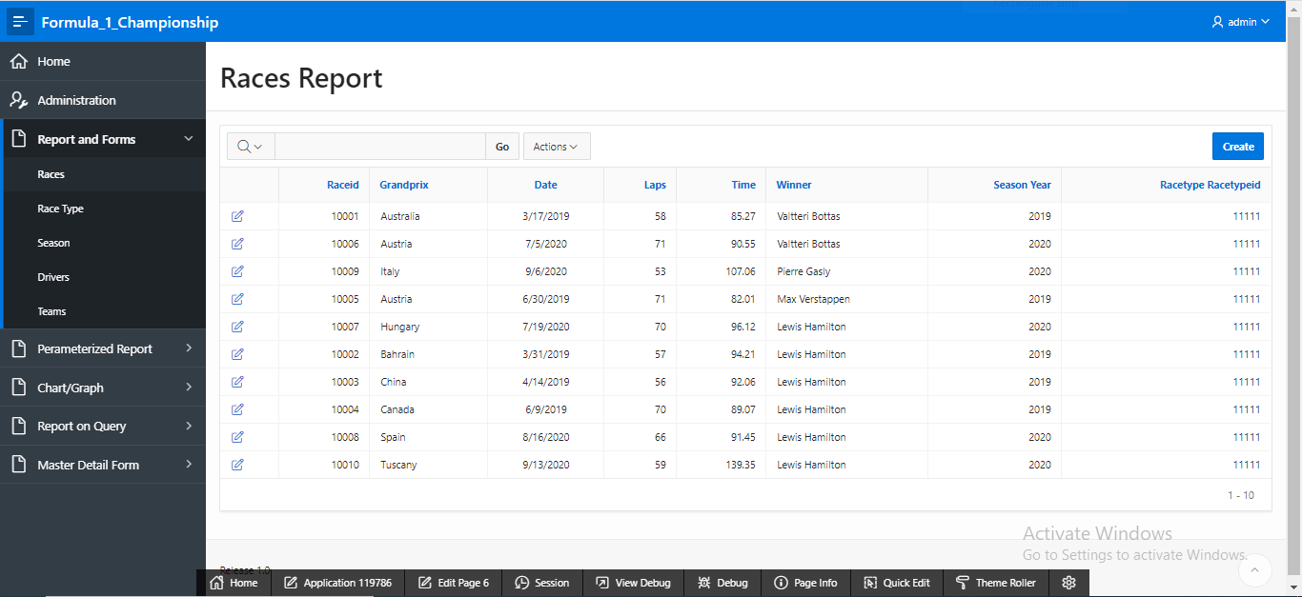

Figure: 4.1

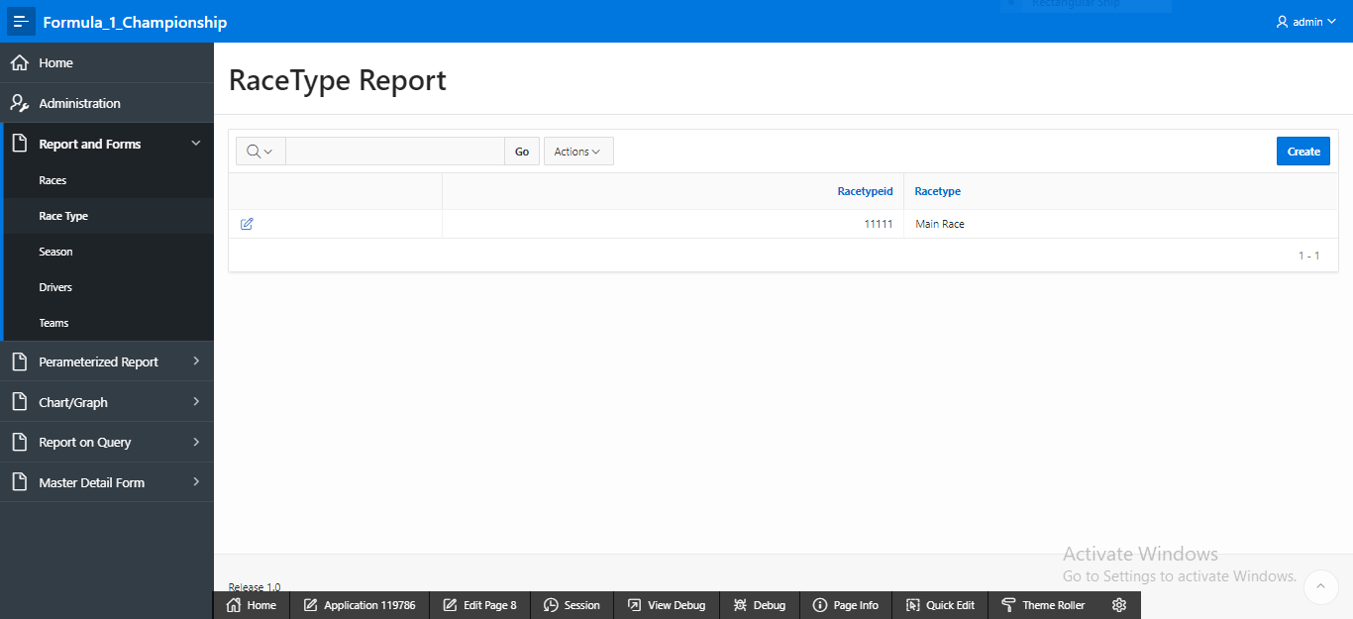

Figure: 4.2

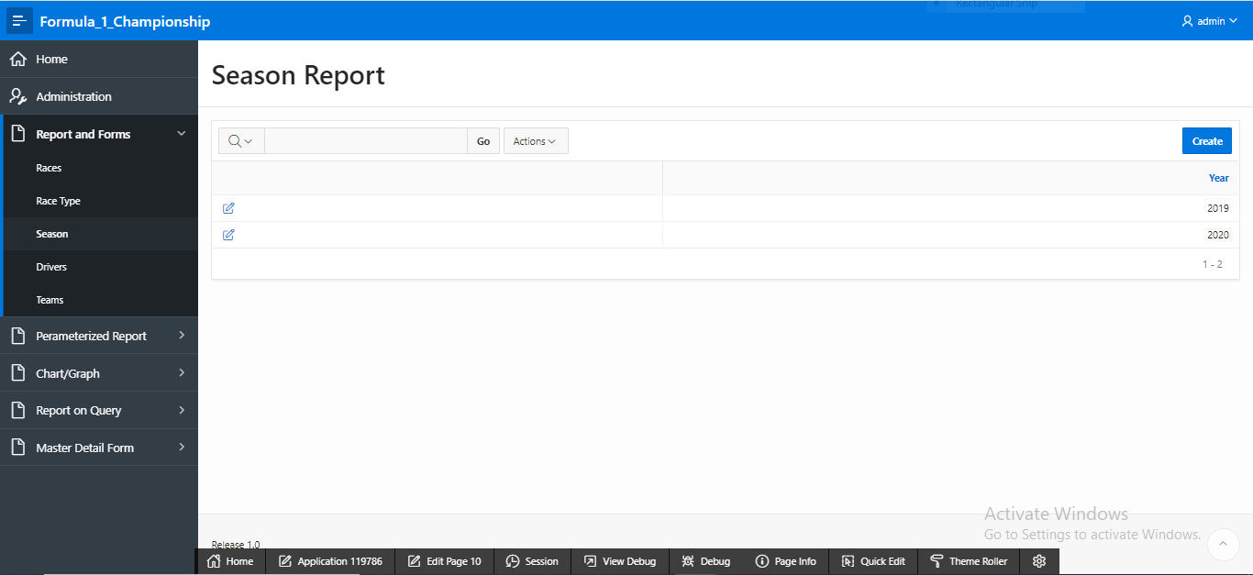

Figure: 4.3

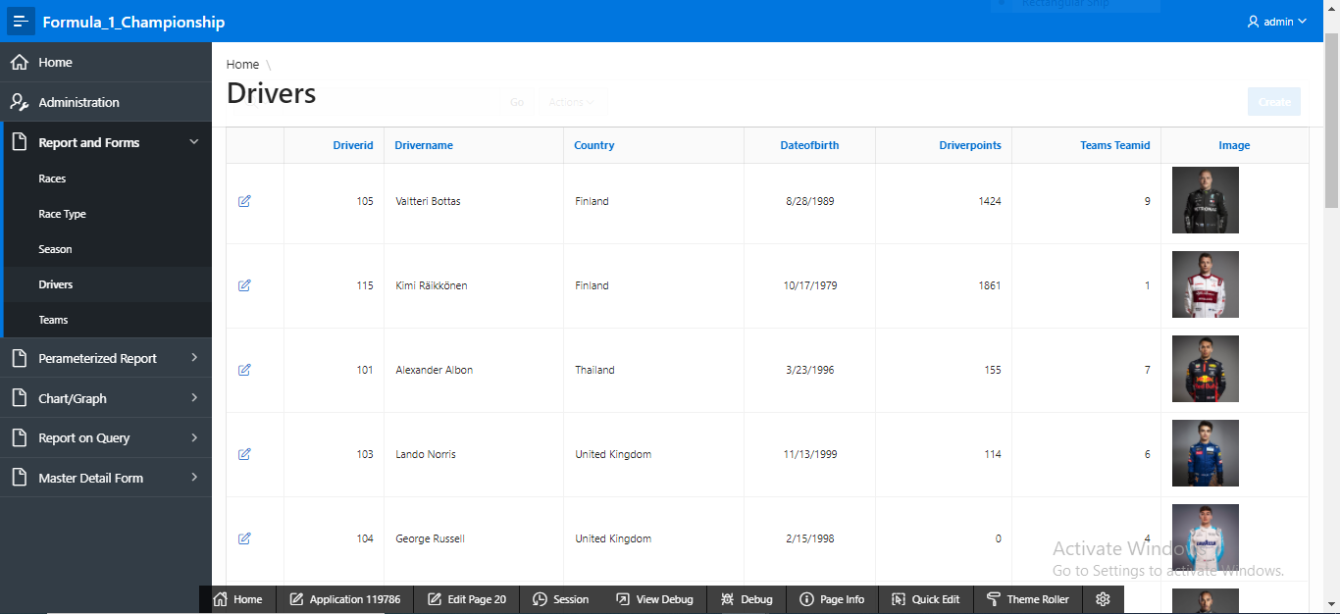

Figure: 4.4

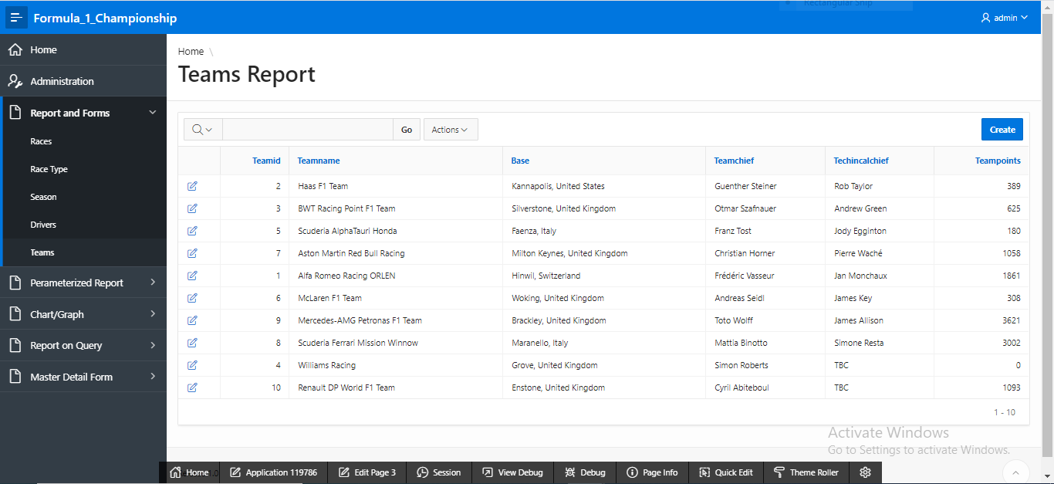

Figure: 4.5

# Master-Detail Form

|  |  |  |
| --- | --- | --- |
| Page Number and Name | Master Table (Parent) | Detail Table (Child) |
| 23 – Team-wise driver | Teams | Drivers |
|  |  |  |

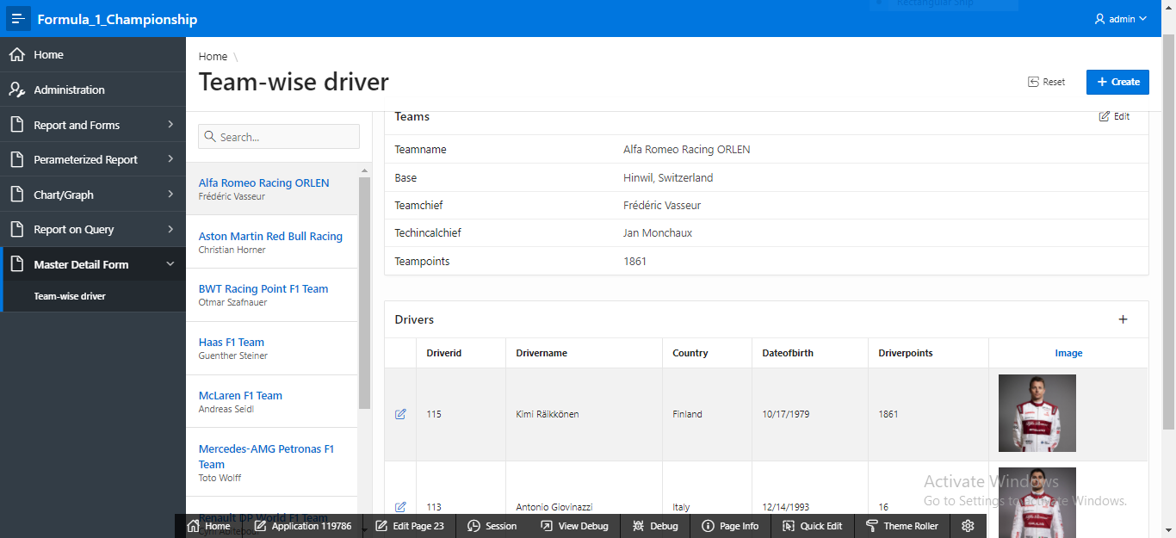

Figure 5.1

# Reports based on Multi-Table and Aggregate Queries

|  |  |  |
| --- | --- | --- |
| Page Number and Name | Query Type | Report description |
| 44 – Driver ranking by points | Single-table | This report shows drivers ranking by points. |
| 45 – Team ranking by points | Single-table | This report shows teams ranking by points. |
| 46 – Number of drivers for each team | Aggregate | This report shows total number of drivers for each team. |
| 49 – Number of drivers from each country | Aggregate | This report shows total number of drivers from each country. |
| 53 – Number of wins per season | Aggregate | This report shows total wins for each winner on each season. |
| 55 – Maximum laps of winner | Aggregate | This report shows maximum laps taken by each winner. |
| 56 – Minimum lap time of winner | Aggregate | This report shows minimum lap time taken by each winner. |

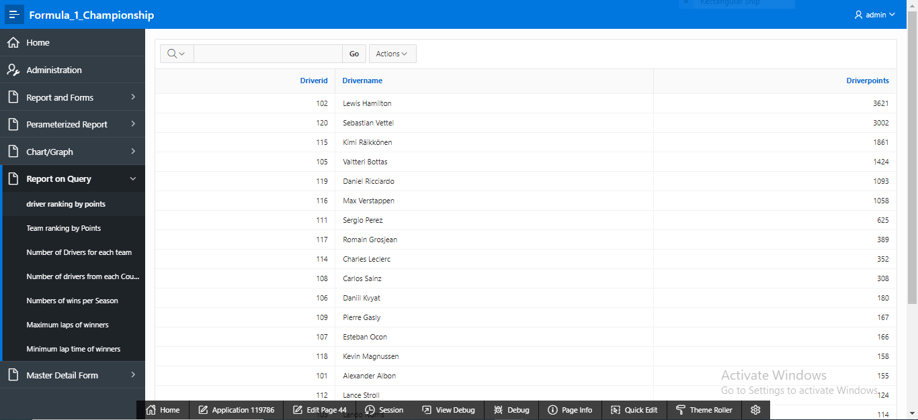

Figure 6.1

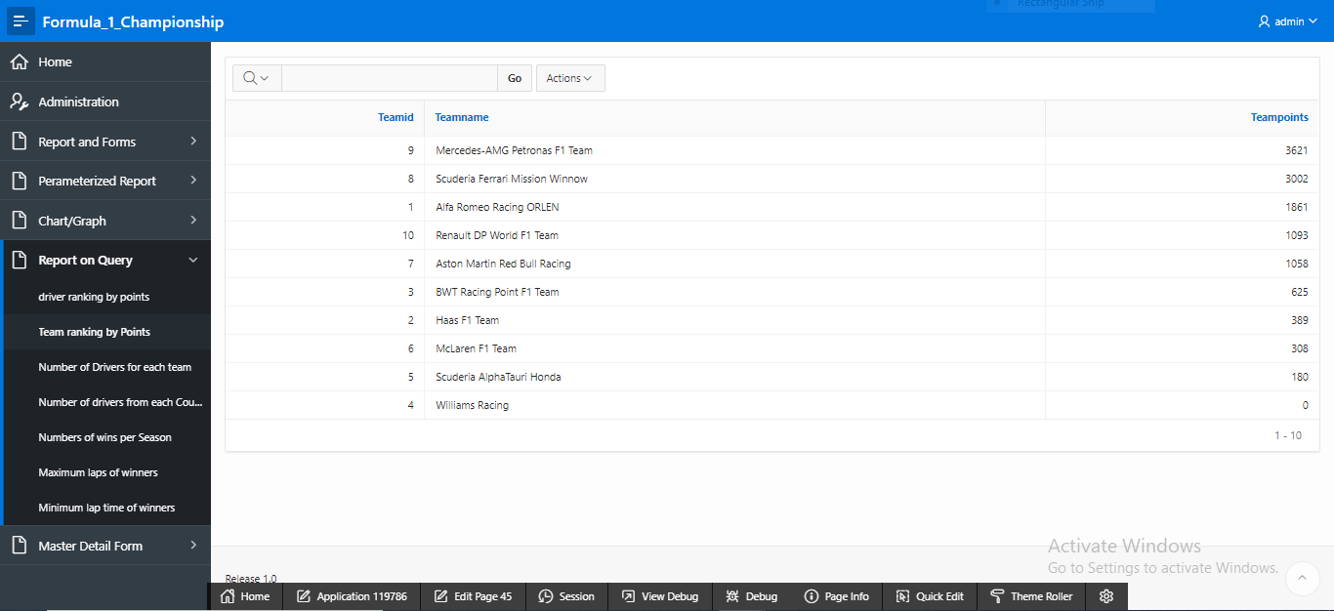

Figure 6.2

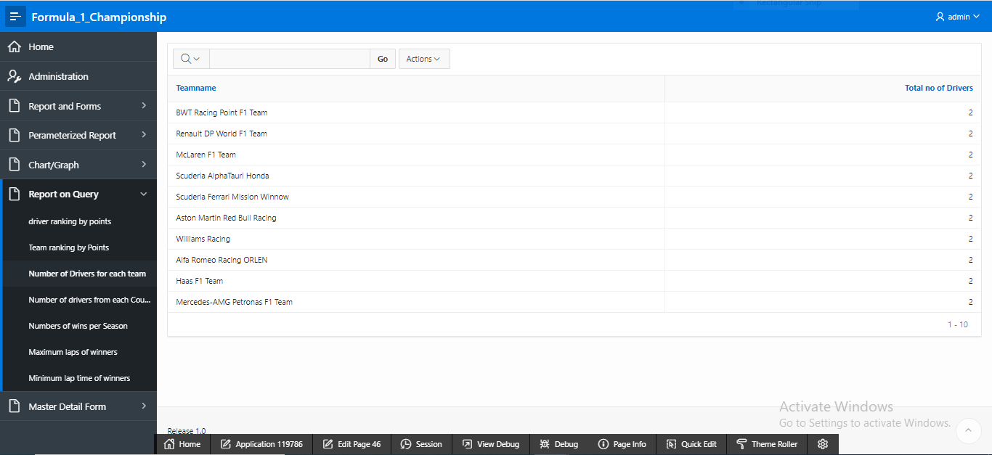

Figure 6.3

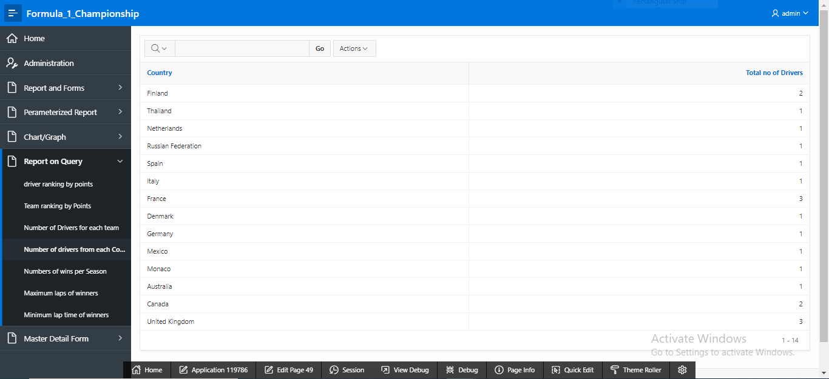

Figure 6.4

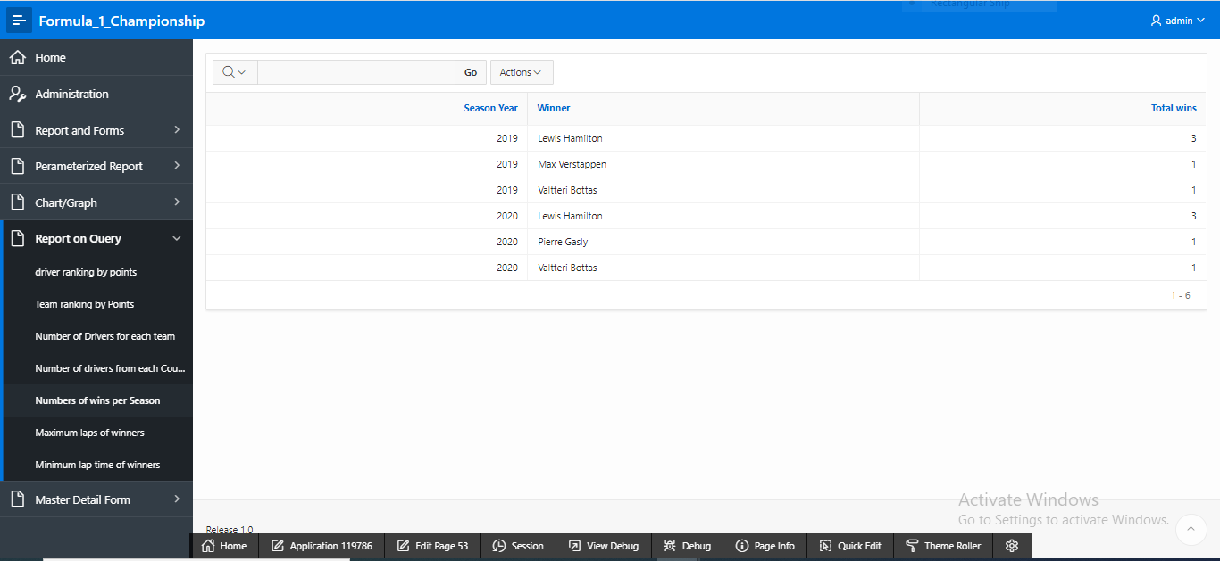

Figure 6.5

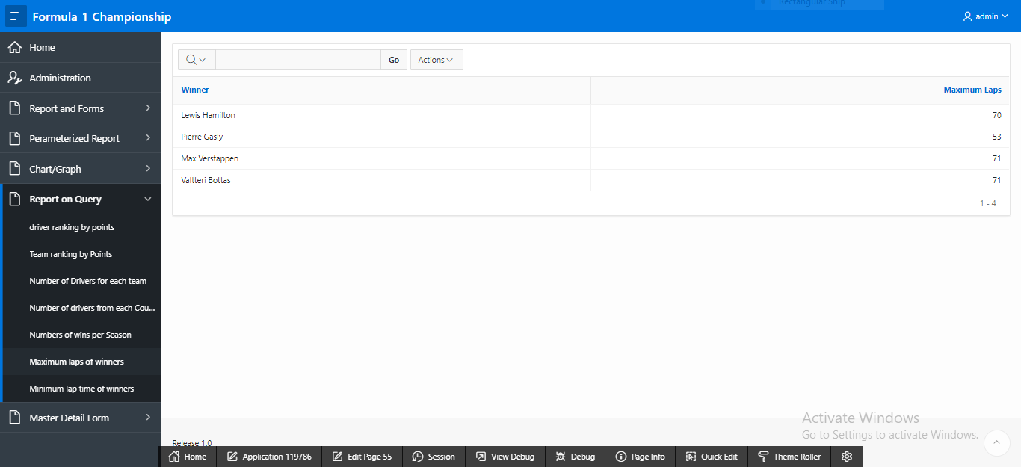

Figure 6.6

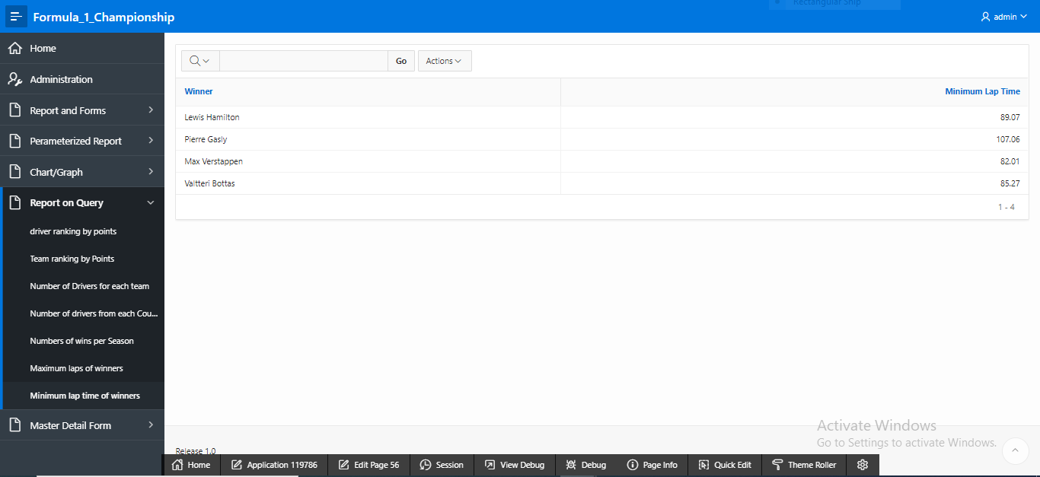

Figure 6.7

# Parameterized Reports

|  |  |  |
| --- | --- | --- |
| Page Number and Name | Given Input | Report description |
| 14 – Points Earned by Drivers | Drivers | This report shows the points earned by the drivers. |
| 15 – Points Earned by Teams | Teams | This report shows the points earned by the teams. |
| 37 – Drivers from Different Countries | Country | This report shows drivers from different countries. |
| 50 – Races held per season | Season | This report shows race information per season. |
| 52 – Team Information of Drivers | Select Driver Name | This report shows team information of drivers. |

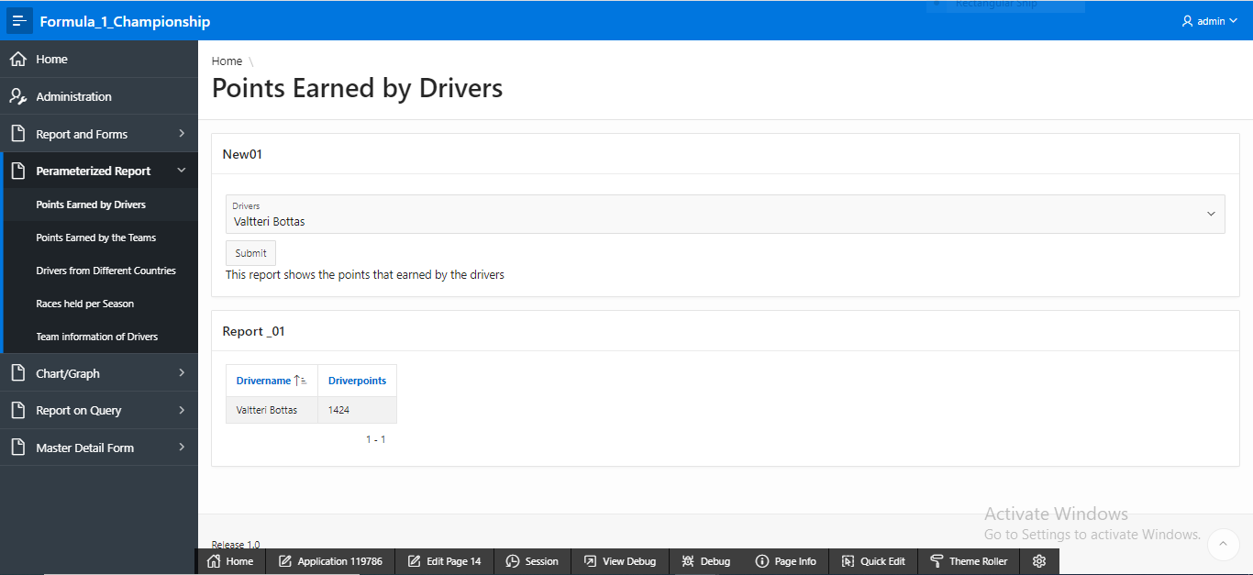

Figure 7.1

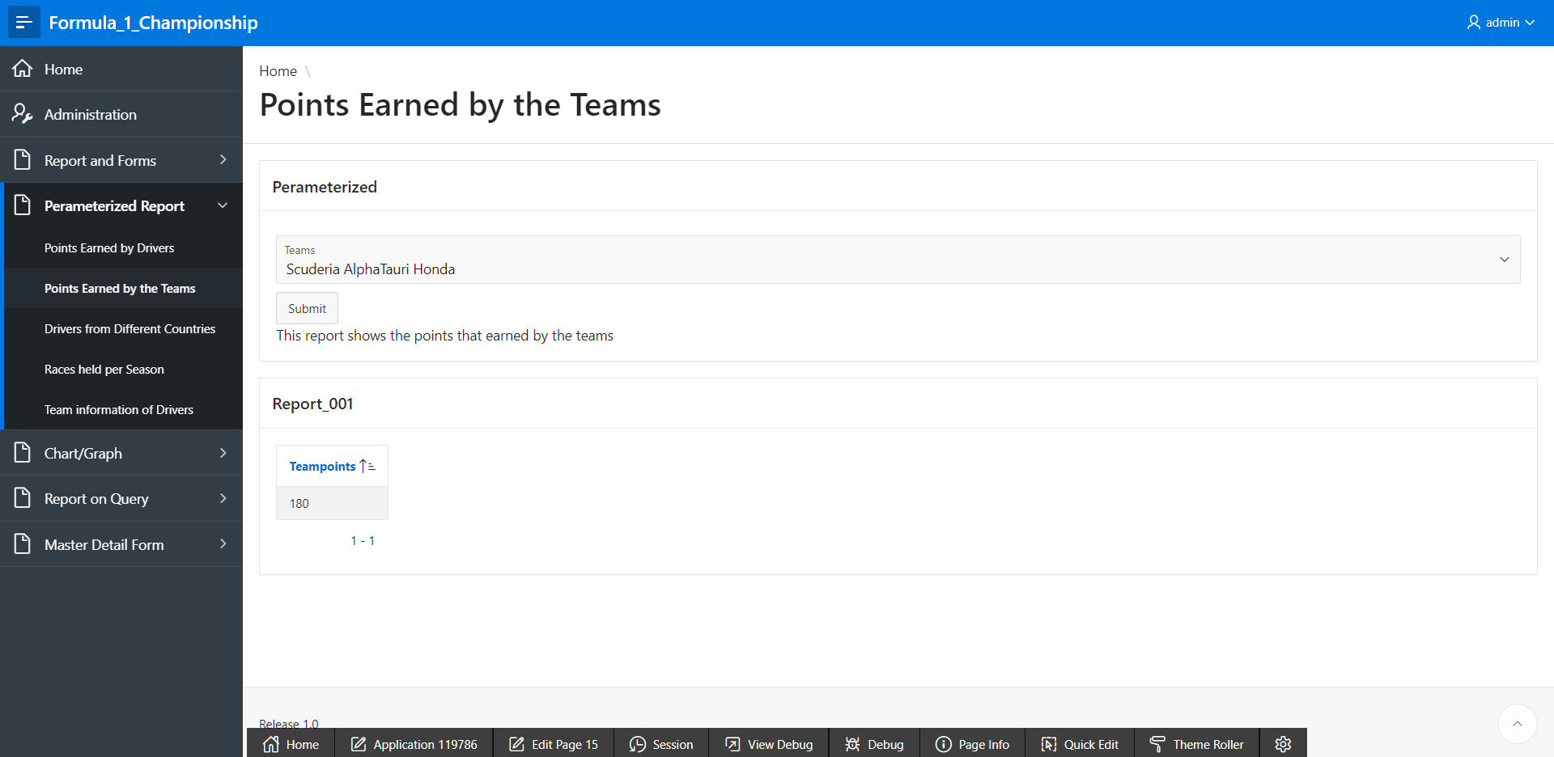

Figure 7.2

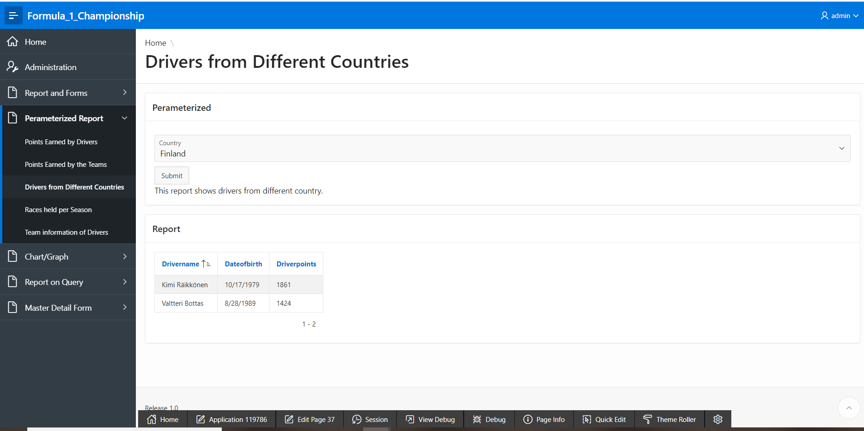

Figure 7.3

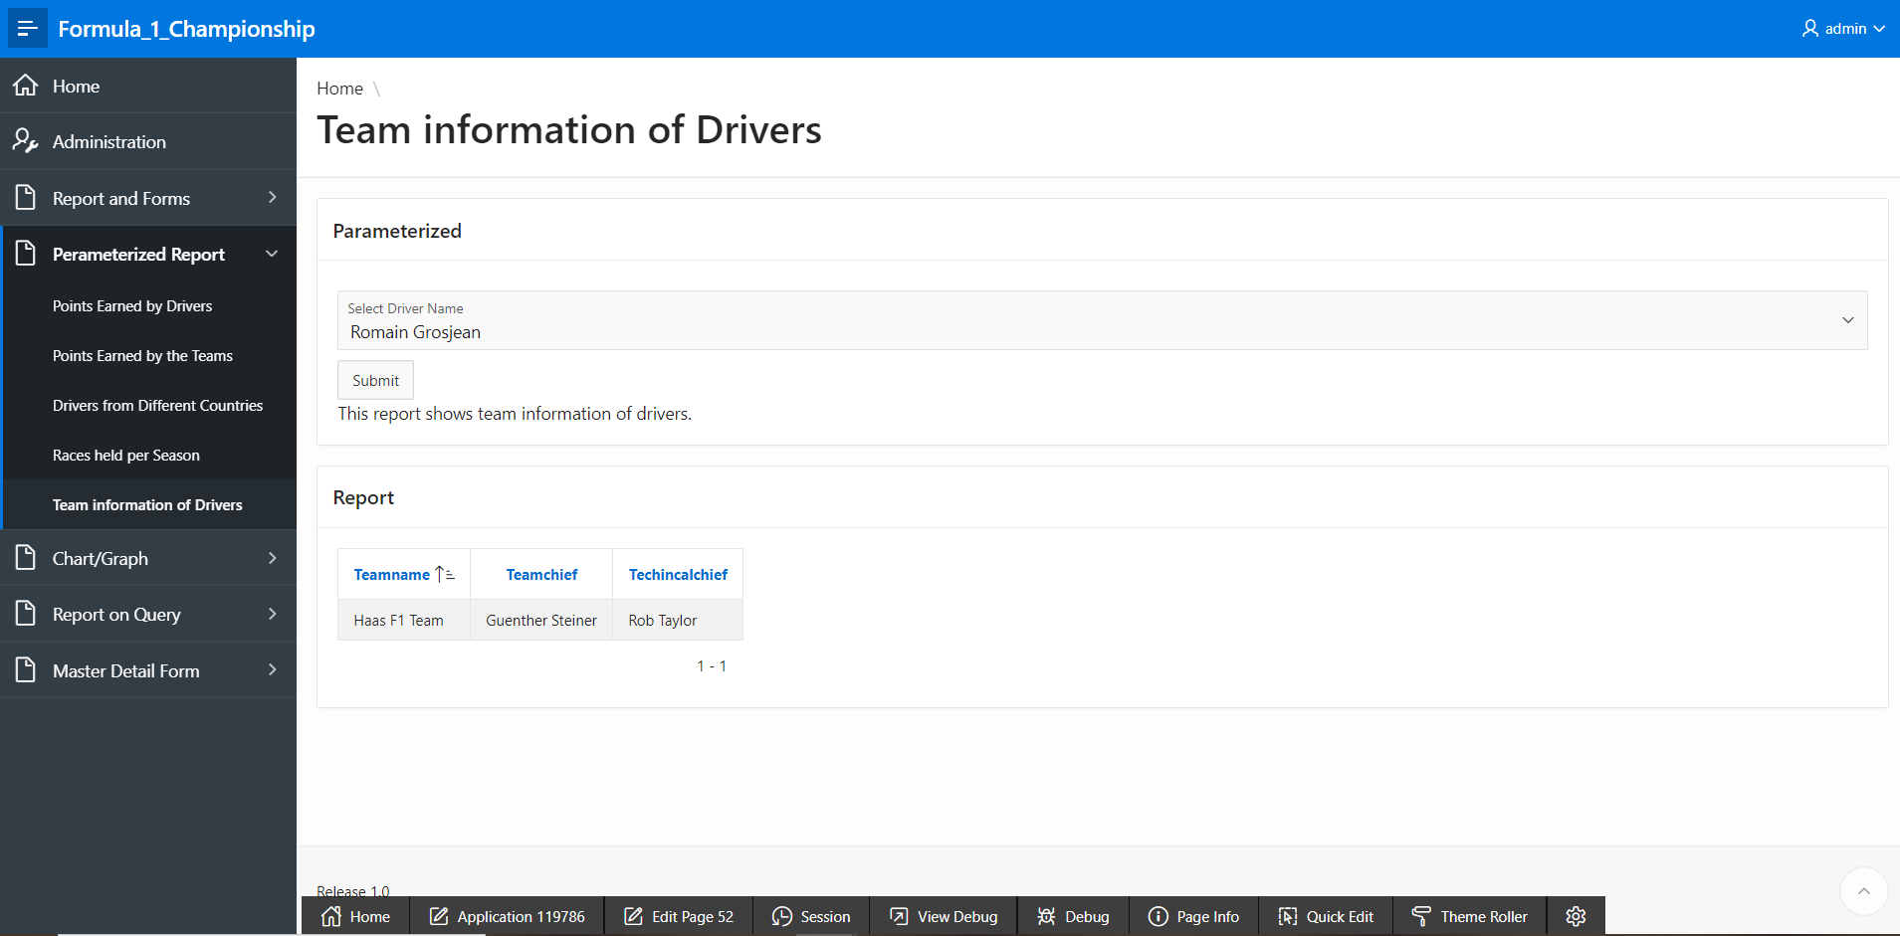

Figure 7.4

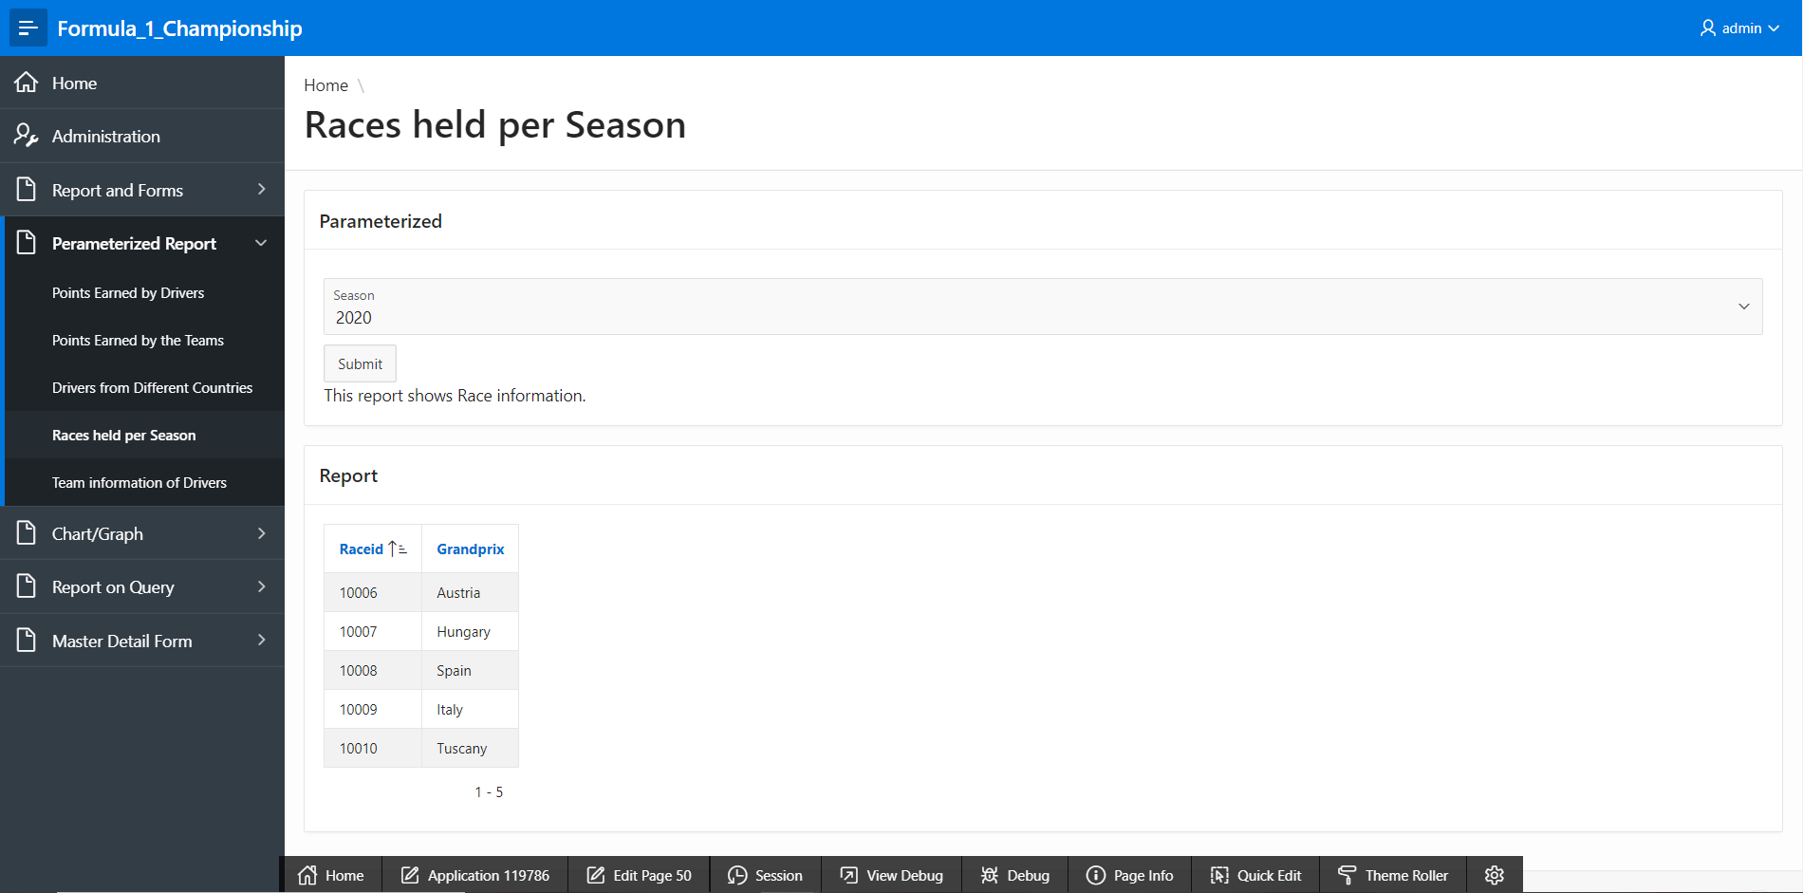

Figure 7.5

# Charts

|  |  |
| --- | --- |
| Page Number and Name | Chart description |
| 25 - chart [points /driver] | This bar chart shows the points of each driver. |
| 26 - chart [points /team] | This bar chart shows the points of each team. |
| 41 – chart [drivers/country] | This bar chart shows the total number of drivers of each country. |
| 48 – chart [races/season] | This bar chart shows the total number of races held per season. |
| 54 – chart [total wins/winner] | This bar chart shows total wins of each winner. |

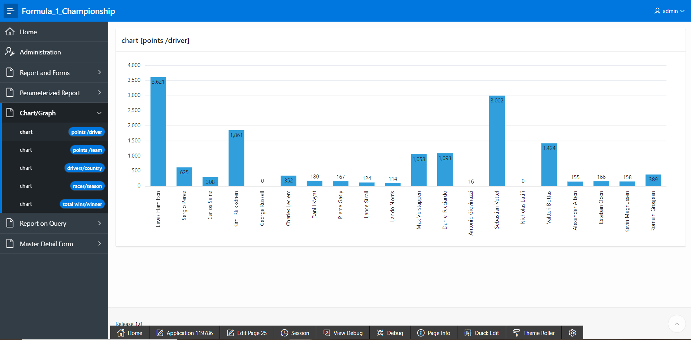

Figure 8.1

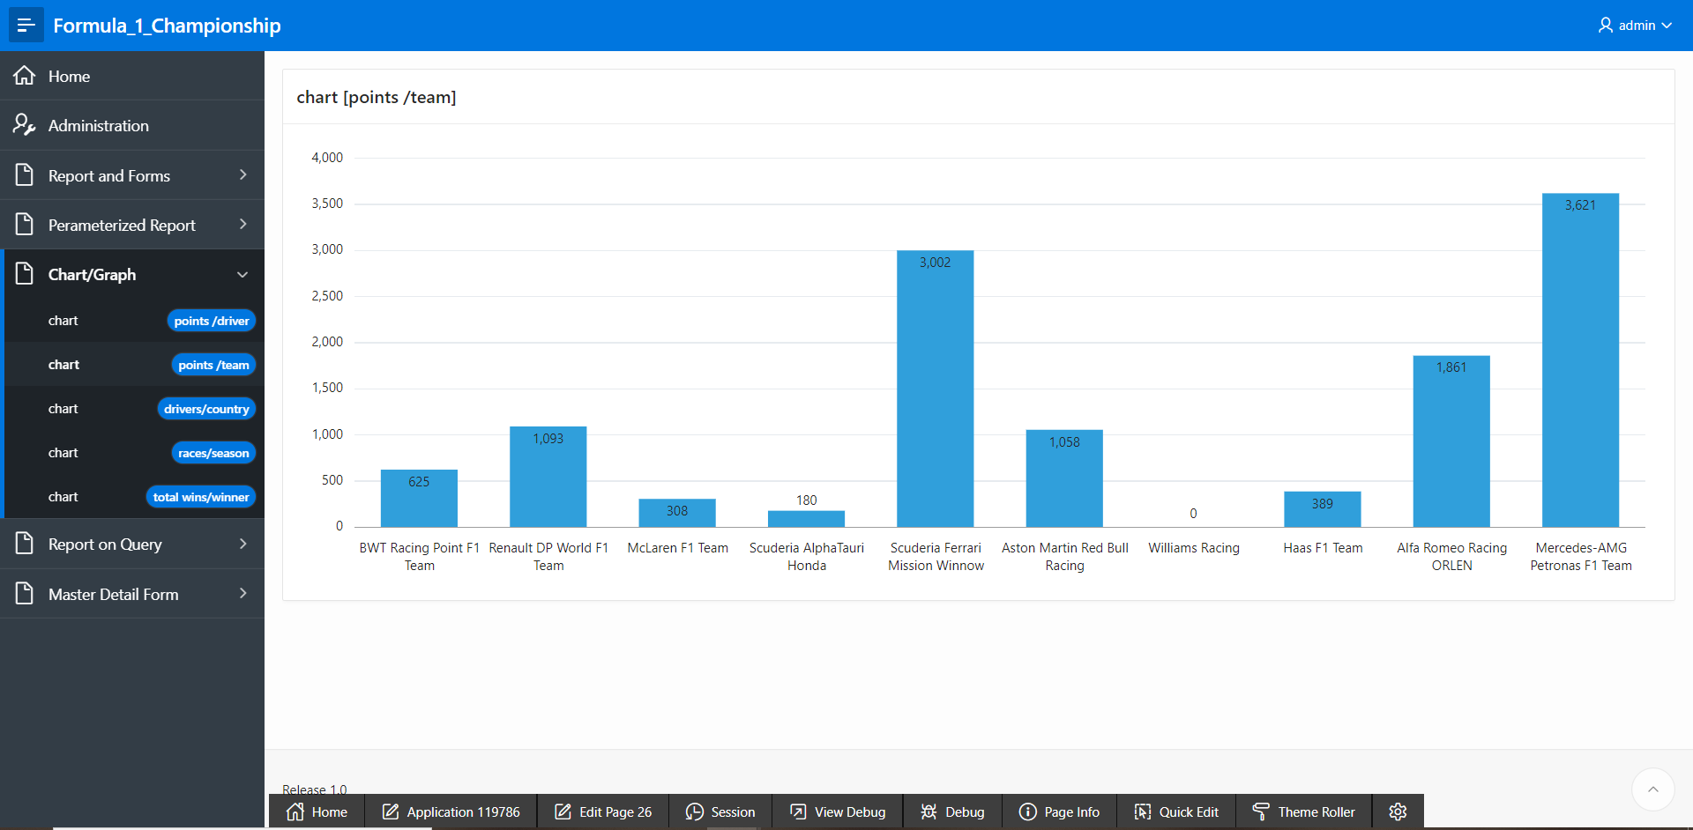

Figure 8.2

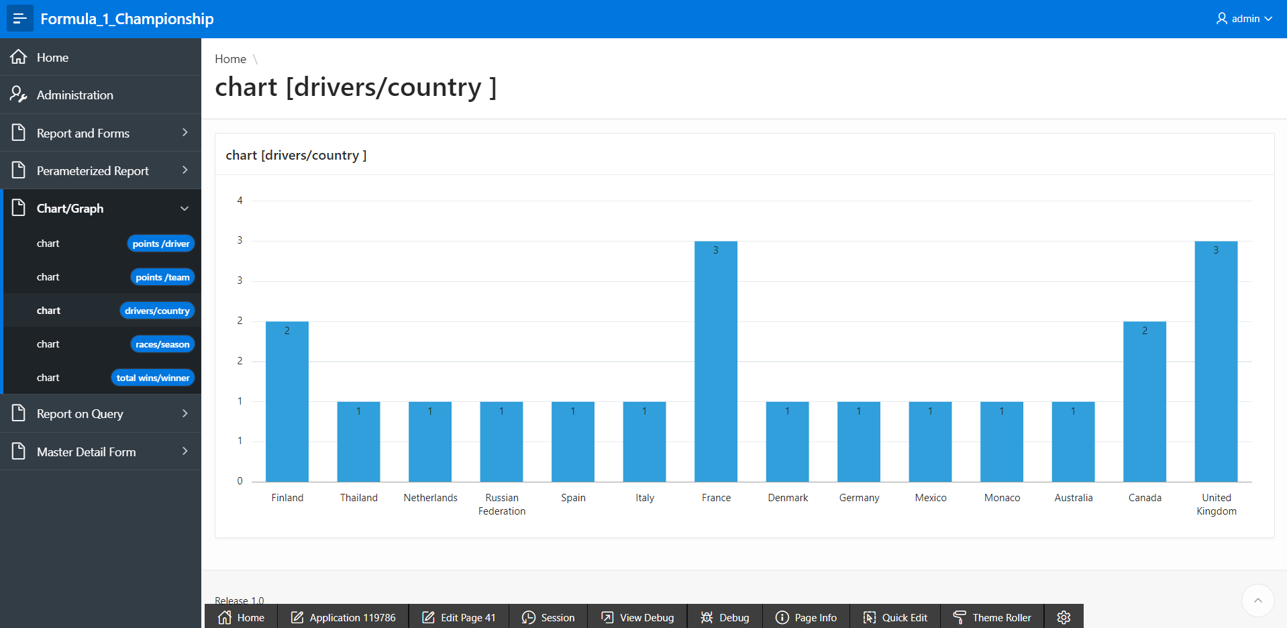

Figure 8.3

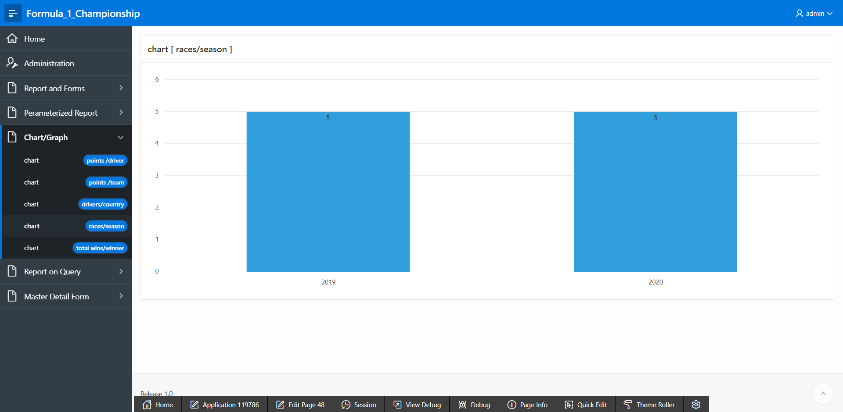

Figure 8.4

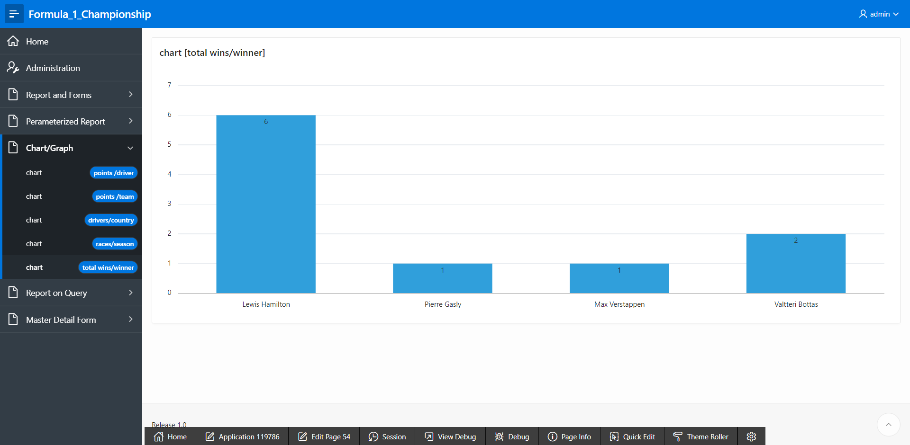

Figure 8.5

# Authorization and User Role Assignment

**User Role Assignment**

|  |  |  |
| --- | --- | --- |
| User name | Password | Role |
| admin | admin123 | Administrator |
| reguler_user_1 | user123 | Reader |
| regular_user_2 | user223 | Contributor |

**Page-wise Authorization Information**

|  |  |
| --- | --- |
| Page number and name | Authorization Level |
| 6 – Races | Reader |
| 8 - Racetype | Reader |
| 10 - Season | Reader |
| 20 - Drivers | Reader |
| 3 - Teams | Reader |
| 10000 - Administration | Administration |
| 1 – home | Administration |

# Concluding Remarks

We really tried hard for this project. We have faced many problems, got sick, but worked on this project till the last hour of submission. However, we have learned so many things because of this project. We will try to create more applications like this to learn better in the future.