

**CSE 301/CSE302: Database Systems**

**[Summer 2020]**

**Project Report**

Project/Application Title

Project URL/Link

**Course Code and Section:**

**Submitted by:**

|  |  |  |
| --- | --- | --- |
| **Student ID** | **Student Name** | **Contribution Percentage** |
|  |  |  |
|  |  |  |
|  |  |  |

*The difference between maximum and minimum contribution among the students must be at least 10%. Otherwise, penalty will be given to every member of the team. Remove this line when you prepare the report.*

# Final version of the E-R Model of the Project

Insert the figure of the relational data model.

Mention assumptions if any.

You may change the orientation of this page if required (from portrait to landscape)

# Final Version of the Relational Data Model of the Project

Insert the figure of the relational data model.

Mention assumptions if any.

You may change the orientation of this page if required (from portrait to landscape)

# Implementation Checklist

|  |  |
| --- | --- |
| Description | Remarks |
| Project ID |  |
| Workspace Name |  |
| Workspace Email |  |
| Workspace Password |  |
|  |  |
| Authentication Type | Application Express/Custom (keep the relevant one) |
| Username and Password to Login |  |
| write username like admin | write password like *admin123* |
| if you have multiple users, write all username and password correctly |  |
|  |  |
|  |  |
| Uploaded and Displayed Images in Reports | yes/no |
| Implemented Page-wise Authorization | yes/no |
|  |  |
| Number of Reports with Forms |  |
| Number of Master-detail Forms |  |
| Number of Reports based on Queries, Aggregate Queries |  |
| Number of Parameterized Reports |  |
| Number of Graphs/Charts |  |
|  |  |
| Included any trigger/other feature which is not taught in class. If yes, please explain briefly. |  |
| Write the most unique feature/functionality in your application or the page of your application which you are proud of. Explain briefly. |  |

# Reports with Forms

|  |  |  |
| --- | --- | --- |
| Report Page Number and Name | Form Page Number and Name | Table |
| write your report page number and name here | write your form page number and name here | write the name of the table for which pages are created |
|  |  |  |
|  |  |  |
|  |  |  |
|  |  |  |
|  |  |  |

Use more rows if necessary.

Put screenshots of each of your reports and forms used for data input mentioning the name of the table in your database schema. Number your figures like 4.1, 4.2 and so on.

# Master-Detail Form

|  |  |  |
| --- | --- | --- |
| Page Number and Name | Master Table (Parent) | Detail Table (Child) |
| write your master-detail page number and name here | write the master table name here | write the detail table name here |
|  |  |  |
|  |  |  |
|  |  |  |
|  |  |  |
|  |  |  |

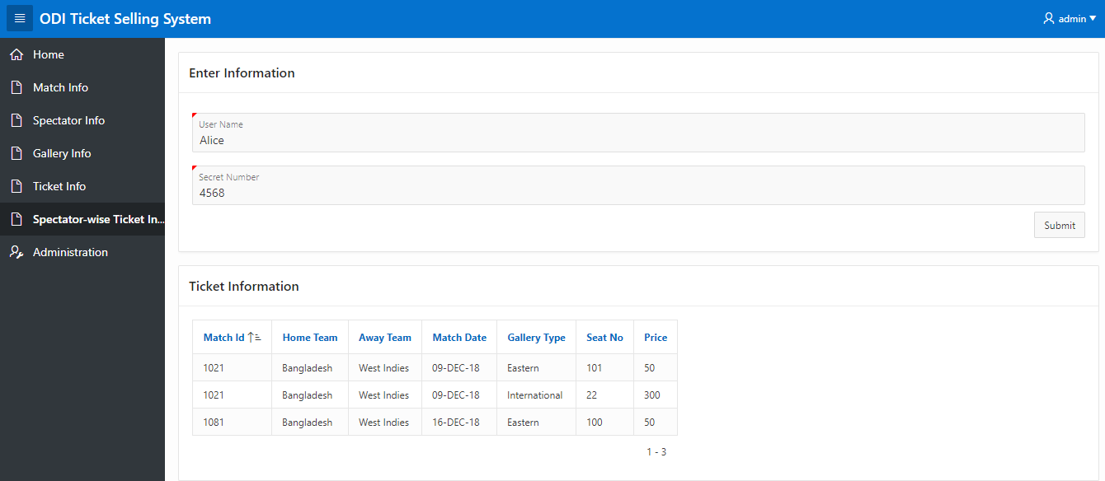

(Example of Screenshot) Figure 5.1: Spectator-wise Ticket Information

Use more rows if necessary.

Put screenshots of each of your master detail forms. Number your figures like 5.1, 5.2 and so on.

# Reports based on Multi-Table and Aggregate Queries

|  |  |  |
| --- | --- | --- |
| Page Number and Name | Query Type | Report description |
| write your report page number and name here | Multi-table/Aggregate | write the description of the report in a simple sentence such as this report shows the total number of instructors per department. |
|  |  |  |
|  |  |  |
|  |  |  |
|  |  |  |
|  |  |  |

Use more rows if necessary.

Put screenshots of such type of reports. Number your figures like 6.1, 6.2 and so on.

# Parameterized Reports

|  |  |  |
| --- | --- | --- |
| Page Number and Name | Given Input | Report description |
| write your page number and name here | write the name of the attribute which will be given by user | write the description of the report in a simple sentence such as this report shows the courses taught by the given instructor. |
|  |  |  |
|  |  |  |
|  |  |  |
|  |  |  |
|  |  |  |

Use more rows if necessary.

Put screenshots of Parameterized reports. Number your figures like 7.1, 7.2 and so on.

# Charts

|  |  |
| --- | --- |
| Page Number and Name | Chart description |
| write your page number and name here | write the description of the chart in a simple sentence such as this bar chart shows the number of students enrolled per semester at each year. |
|  |  |
|  |  |
|  |  |
|  |  |
|  |  |

Use more rows if necessary.

Put screenshots of Parameterized reports. Number your figures like 8.1, 8.2 and so on.

# Authorization and User Role Assignment

**User Role Assignment**

|  |  |  |
| --- | --- | --- |
| User name | Password | Role |
| Example: admin | Example: admin123 | Example: Administrator |
|  |  |  |
|  |  |  |
|  |  |  |

**Page-wise Authorization Information**

|  |  |
| --- | --- |
| Page number and name | Authorization Level |
| Example: P1. Home | Reader |
| Example: P10000: Administration | Administrator |
|  |  |
|  |  |
|  |  |
|  |  |

Use more rows if necessary.

# Concluding Remarks

Write briefly about your experience during the project development. Write your raw feelings without any fear. I want to hear it! Thank you and Good Luck.