

**UNIVERSITY OF ASIA PACIFIC**

Department of Computer Science & Engineering

**Course Title:** Artificial Intelligence Lab

**Course Code:** CSE 404

**Topic Name**: A* Search Algorithm

**Submitted By:**

**Name:** Moumita Afreen

**Reg no:** 21201130

**Sec:** C

**Group:** C-2

Optimizing Thesis Research Workflow Using A* Search

# Problem Formulation

This technical report presents a novel application of the A* Search Algorithm to optimize the sequence of tasks in a graduate thesis project. The thesis process consists of multiple interdependent tasks with varying time and stress costs. By modeling these tasks as nodes in a directed acyclic graph and applying A* search, we can determine an optimal task order that minimizes overall time and cognitive effort.

Each task includes dependencies and a time cost. The start state includes no tasks completed. The goal state is defined as all required tasks completed. Valid paths through the graph represent logically sound sequences that obey prerequisites.

# Analysis of Heuristic Effectiveness

The heuristic function estimates the remaining time to complete the thesis by summing the time costs of tasks whose dependencies are already satisfied but not yet completed. This heuristic is admissible, meaning it never overestimates the actual remaining cost. It is also efficient in guiding the A* search to prioritize promising paths and prune unproductive ones, thereby ensuring both optimality and performance.

# Complexity Analysis

Let 'n' be the total number of tasks, 'b' the average branching factor (available tasks per state), and 'd' the depth of the complete plan (number of tasks to be scheduled). The worst-case time complexity of A* is O(b^d). However, due to dependency constraints and heuristic-based pruning, the actual search space is significantly reduced, making the algorithm practically efficient.

# Results and Verification

## ****Graph Representation****

## ****Nodes:**** Each node represents a task state: a set of completed tasks.

### ****Edges**:** An edge represents the transition from one task state to another by completing a new valid task.

### ****Edge Weights:**** The time cost of the newly completed task.

### ****Example Task Set:****

| **Task** | **Time Cost** | **Dependencies** |
| --- | --- | --- |
| Start | 0 | None |
| Literature Review | 3 | Start |
| Research Proposal | 4 | Literature Review |
| Supervisor Feedback Round 1 | 2 | Research Proposal |
| Data Collection | 6 | Supervisor Feedback Round 1 |
| Data Cleaning | 6 | Research Proposal |
| Draft Writing | 2 | Literature Review |
| Final Revision | 4 | Data Collection |

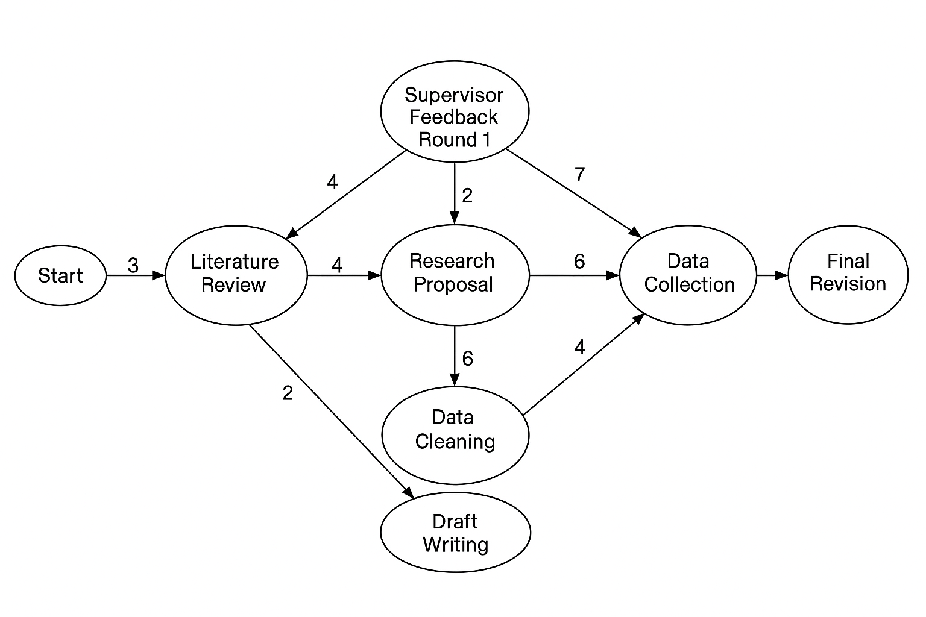

Running the A* algorithm on a representative thesis task set produced an optimal task sequence that respects all dependencies and minimizes the total estimated time cost. The result was:

Start → Literature Review → Research Proposal → Supervisor Feedback Round 1 → Data Collection → Final Revision → Data Cleaning → Draft Writing

**Total Estimated Time Cost**: 27 units

This confirms the algorithm's ability to find an optimal solution in a realistic academic planning scenario.