**Guidance**

1. DDL: 2月份前；
2. 重点文章：‘Predictive compensator based ev…vehicle under cyber-attacks’

-> “event trigged control”

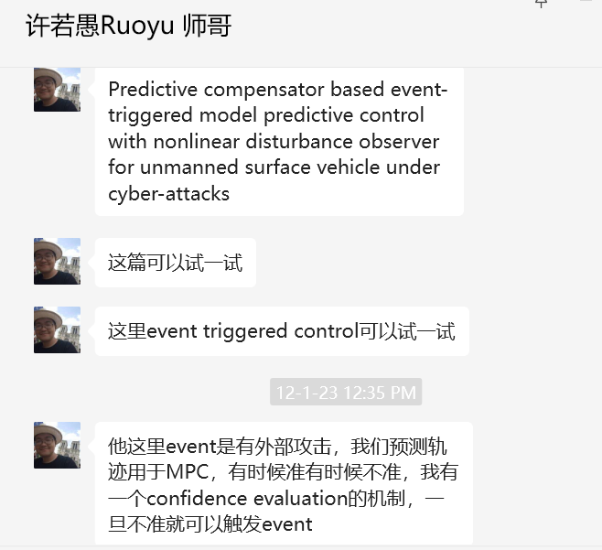

1. MATLAB具体细节：
   1. Using CasADi;
   2. 
   3. 目前首先考虑三维即可；
   4. 