At the beginning:

Some of the materials below is based on the Mohamed W. Mehrez’s Slides, you can find them by the following link:

‘https://github.com/MMehrez/MPC-and-MHE-implementation-in-MATLAB-using-Casadi’

Report_Part:

1. What Characterizes an Optimization Problem?

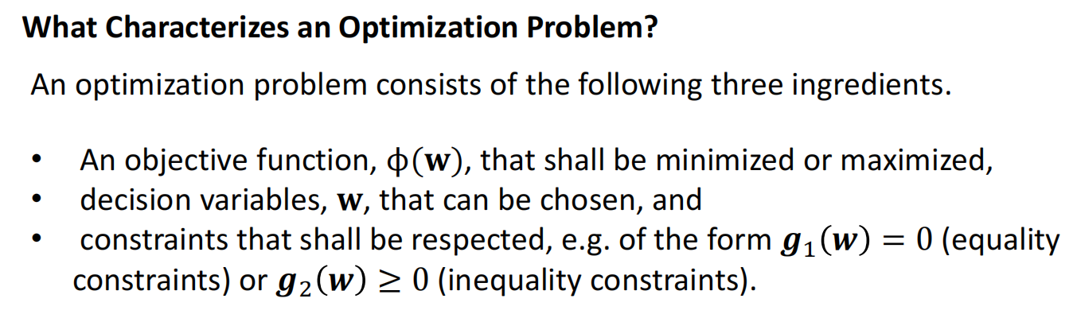

1. NLP(Nonlinear Programming Program)

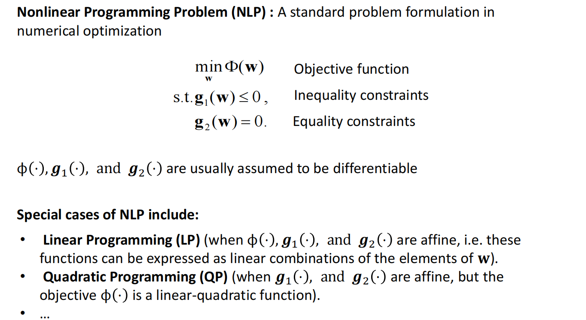

1. Solution of optimization problem

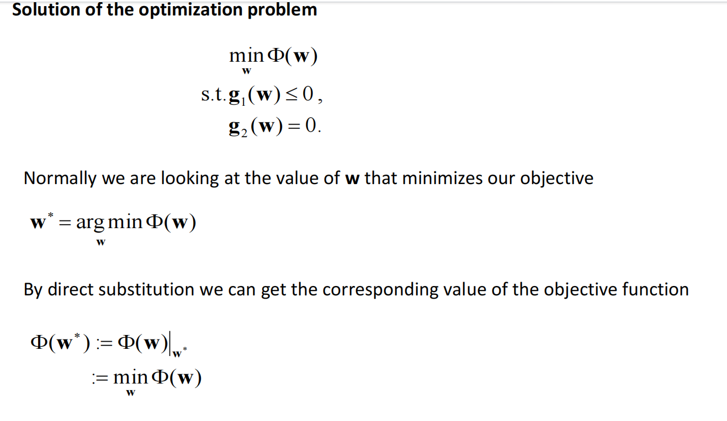

1. Code example of using CasADi

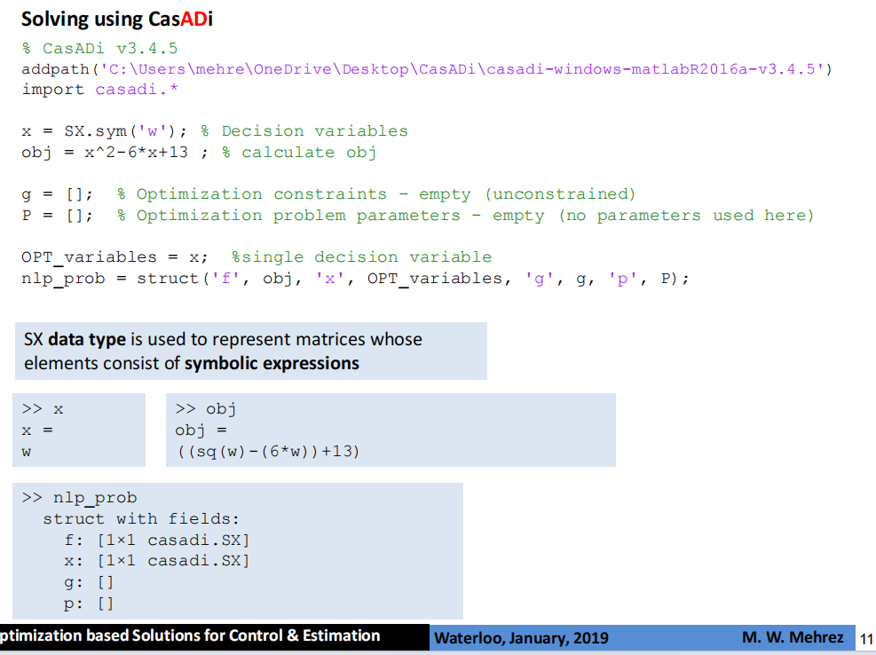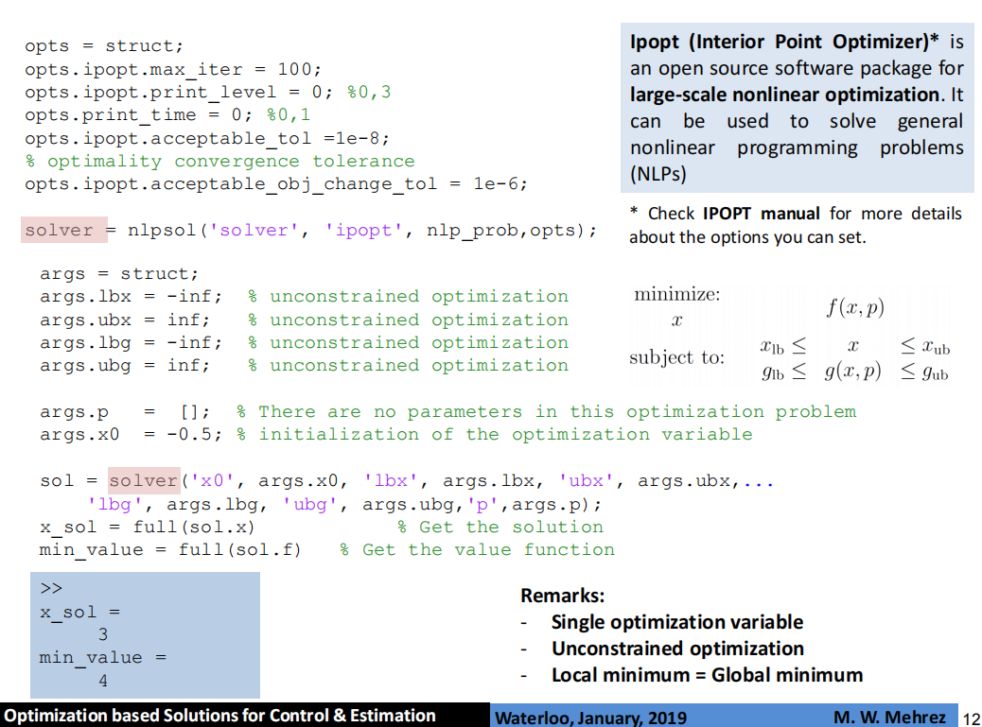

Another example:

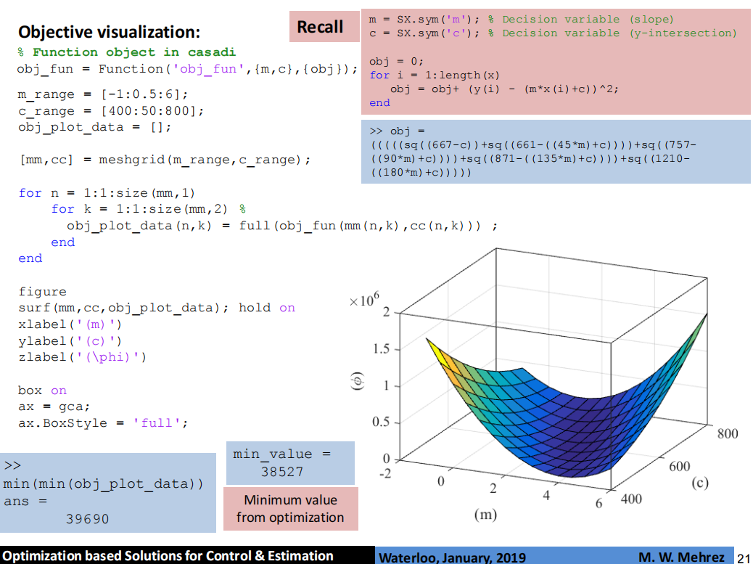

1. MPC(Model Predictive Control)

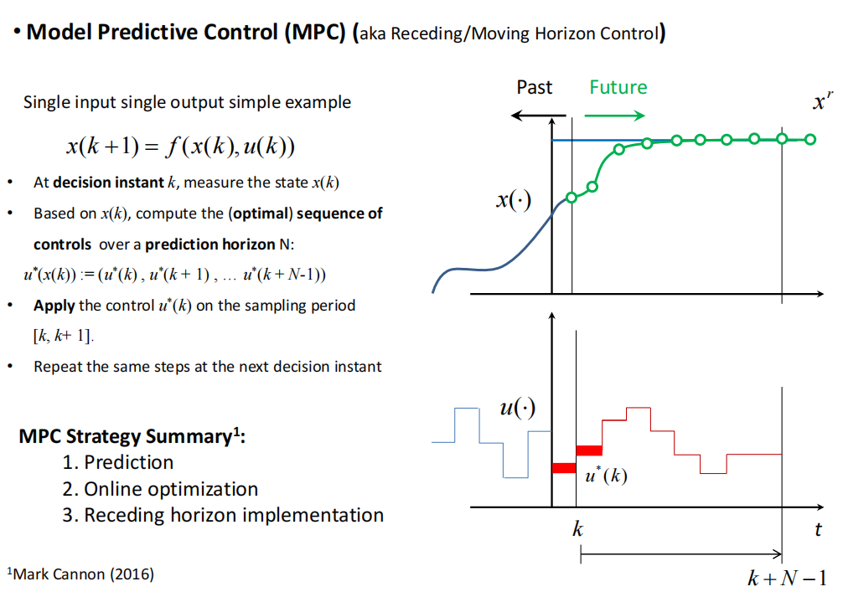

•Optimal Control Problem (OCP): to find a minimizing control sequence: to find a minimizing

control sequence

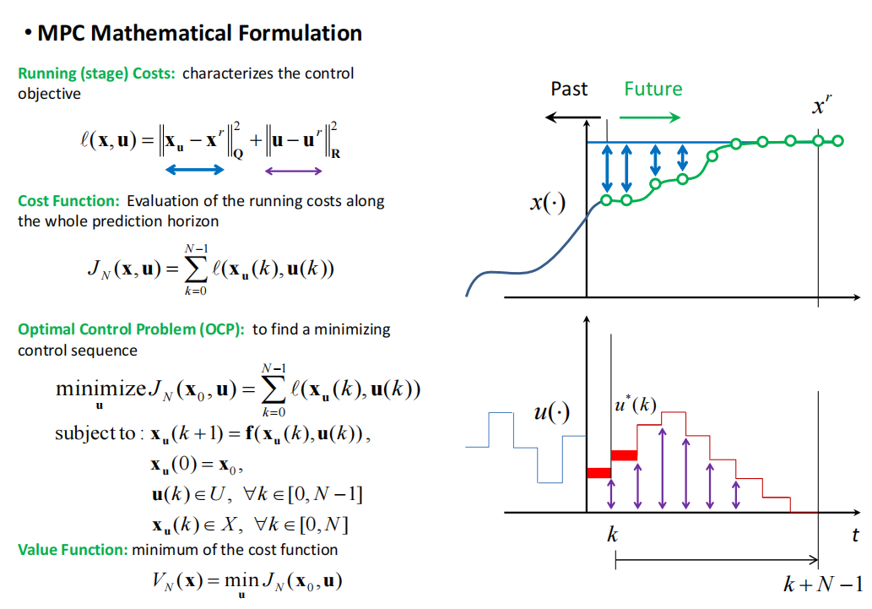

A question? : What is the principle of controlling machine/robots using AI/GPT? Is that another kind of MPC?

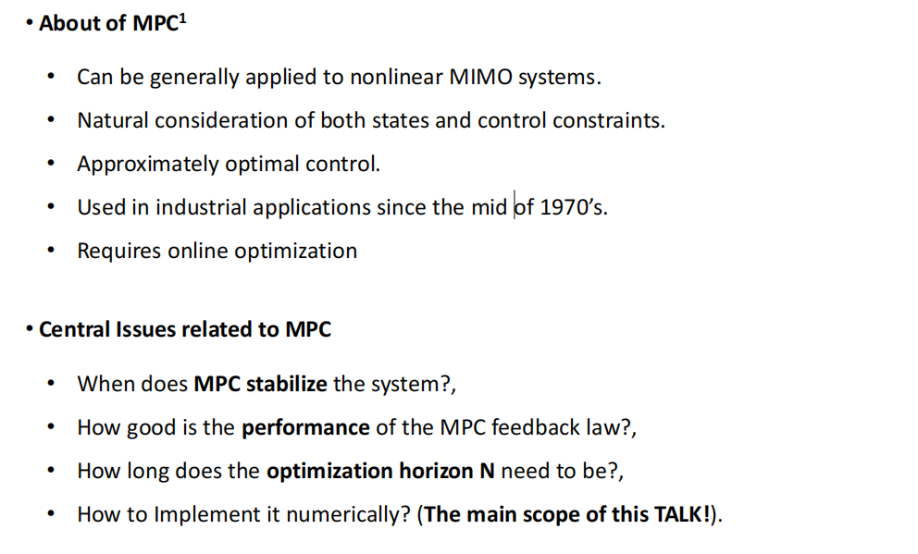

•MPC Implementation to Mobile Robots control:

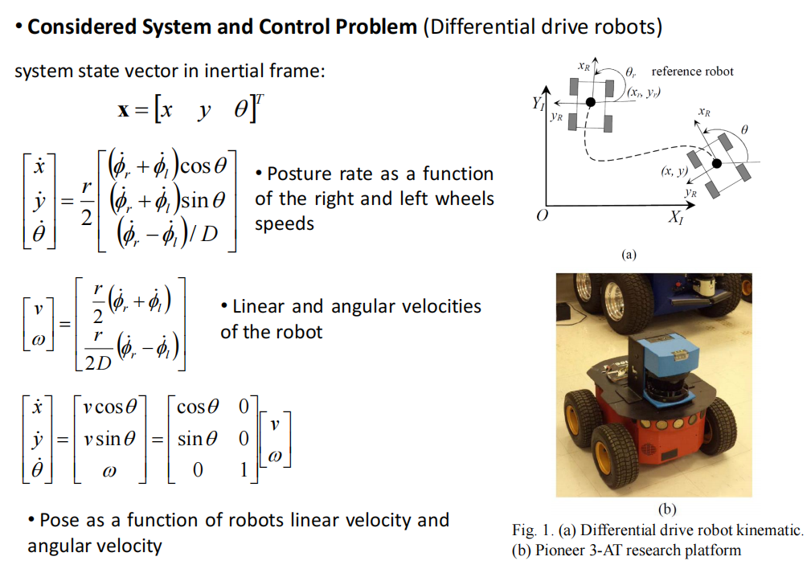

Considered System and Control Problem (Differential drive robots)

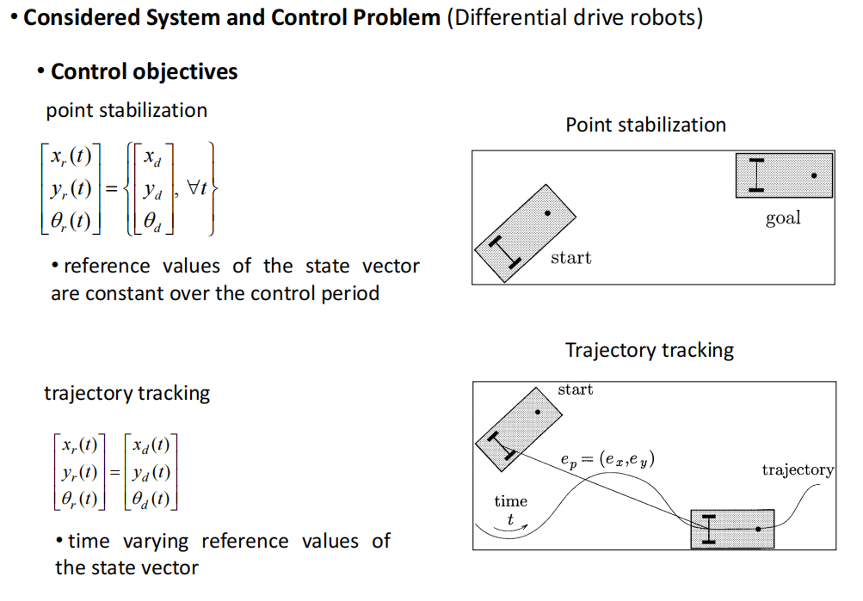

Model:

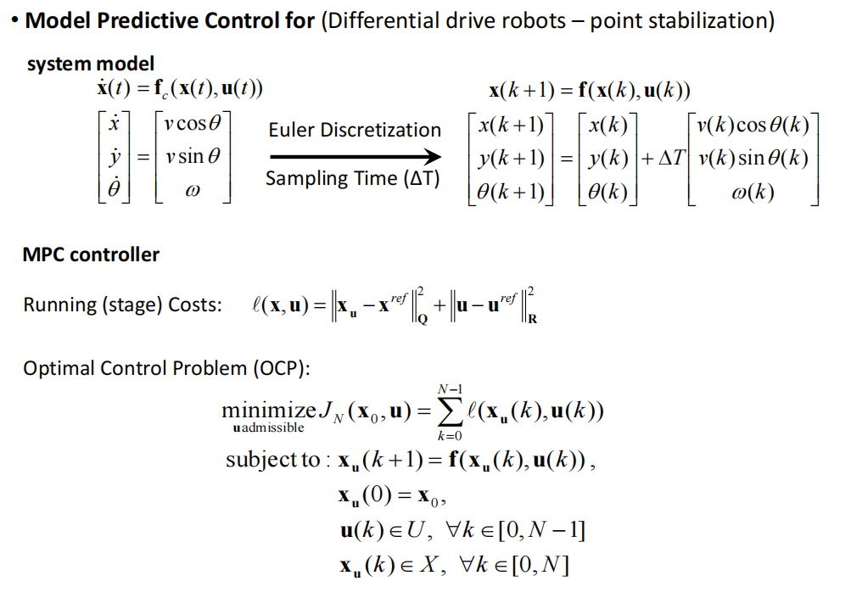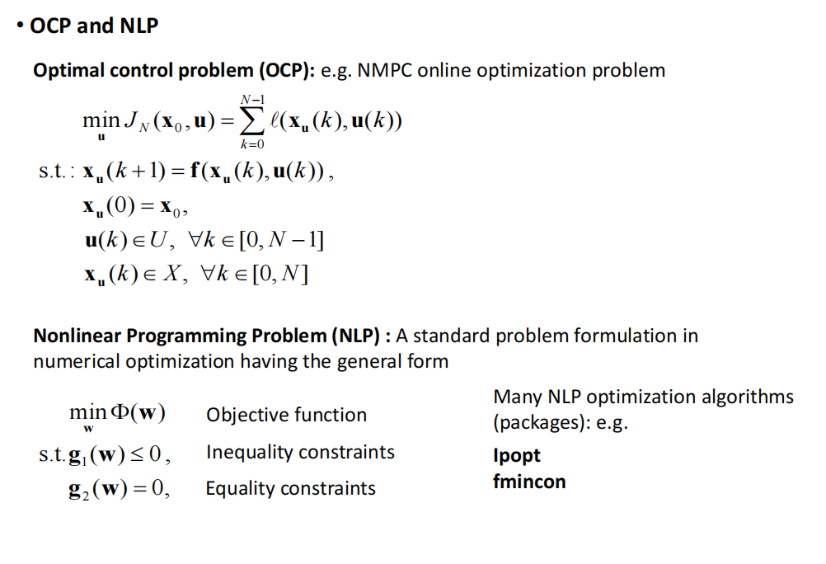

• OCP(Optimal Control Problem) and NLP(Nonlinear Programming Problem)

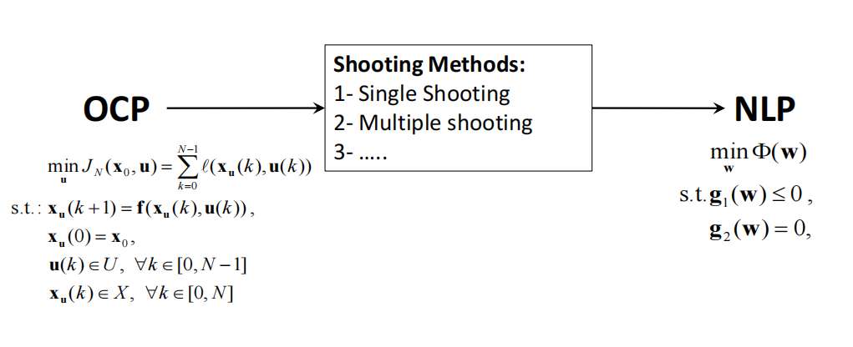

1. Single shooting to transform the OCP into an NLP1(Sim_1_MPC_Robot_PS_sing_shooting.m)

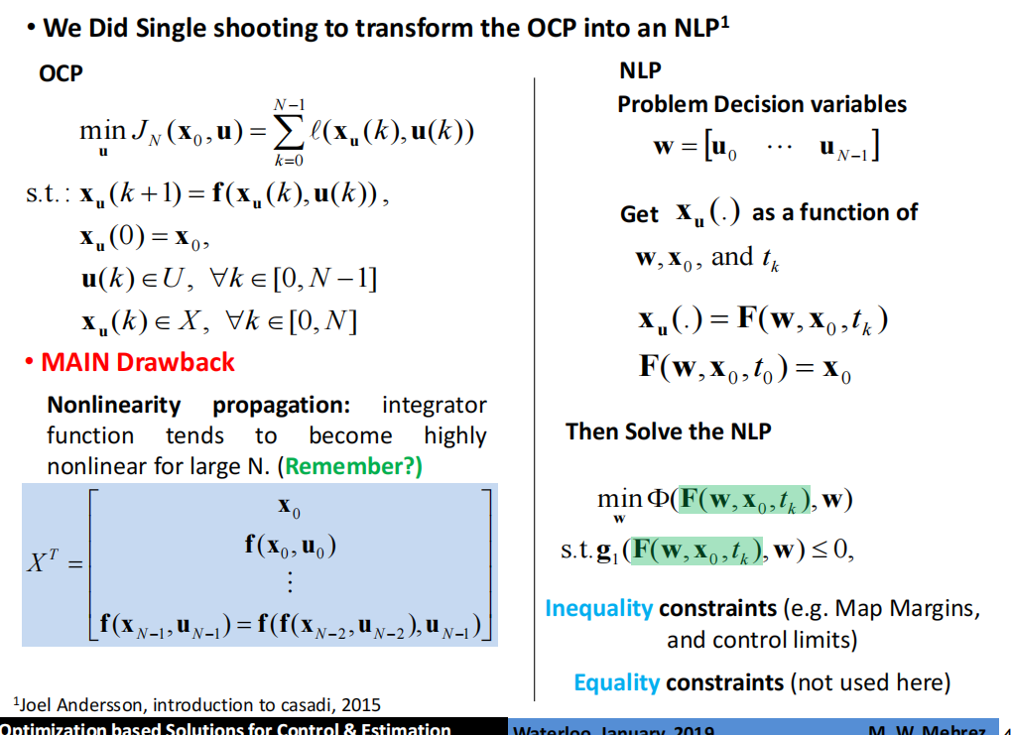

1. Multi shooting to transform the OCP into an NLP1(Sim_2_MPC_Robot_PS_mul_shooting.m)

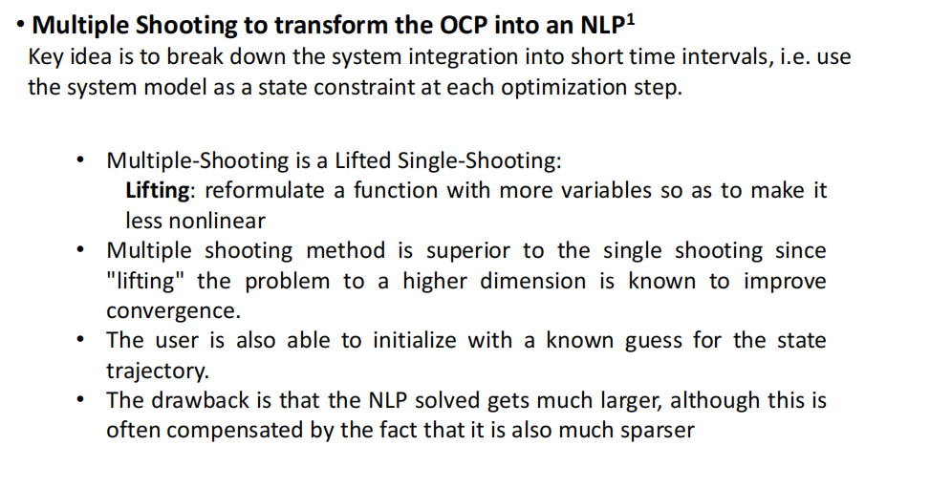

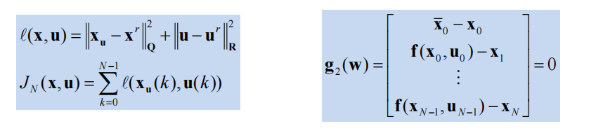

1. Concluding remarks about MPC and MHE(Actually not consider here)

