Project overview:

Enron Corp was one of the largest companies in the US, that collapsed in 2002 due to fraud. During the investigation, thousands of email and financial data went public.
The goal of this project is to create a model capable of predicting people of interests based on their emails and financial information. We use emails of 146 executives at Enron to identify the persons of interest in the fraud case.
We will start by investigating and cleaning our data, then comparing two algorithms and validating the one that provided more significance and precision.

Enron data:
We plot the data to check for outliers, and to get a view about how it is ditributed, from the plot 1,
we notice one clear outlier, when we check in the data, we see that it is the total of salaries and bonuses, that’s one outlier to remove.
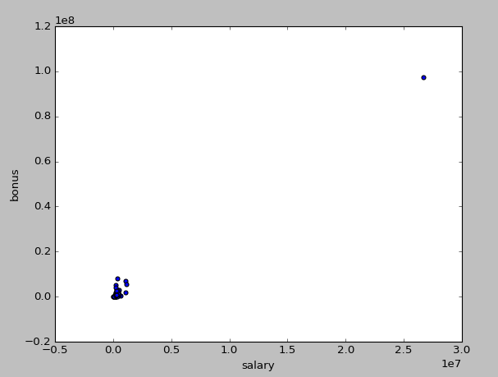
Plot 1: before removing total

Now the data looks much better , of course there still other outliers, but those are information of person that we will want to keep and investigate.
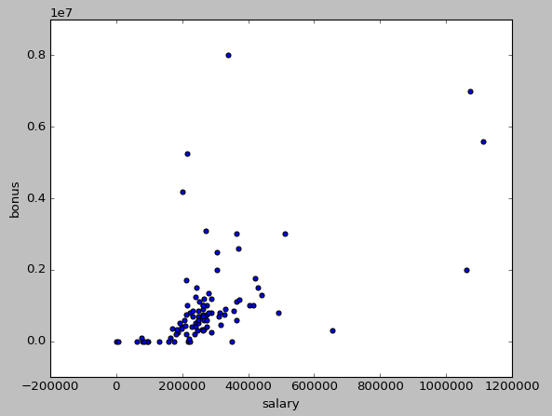
Plot 2: After removing total

Features processing:
We first added new features called to_person and from_person, and appened them to the dataset
to_person=from_poi_to_person/to_messages
from_person=from_person_to_poi/from_messages

then we selected the best 14 features with Kbest algorithm

Features selected by SelectKBest:
['salary', 'total_payments', 'loan_advances', 'bonus', 'deferred_income', 'total_stock_value', 'expenses', 'exercised_stock_options', 'other', 'long_term_incentive', 'restricted_stock', 'from_poi_to_this_person', 'shared_receipt_with_poi', 'from_person']

only one feature is present, but we won’t selected otherwise we will have two correlated features, so we leave 'from_poi_to_this_person’ only.
This is the list we will be working with.
print features_selected
features_list=['poi','salary', 'total_payments', 'loan_advances', 'bonus', 'deferred_income', 'total_stock_value', 'expenses', 'exercised_stock_options','other', 'long_term_incentive', 'restricted_stock', 'from_poi_to_this_person', shared_receipt_with_poi']

Choice of Algorithm:

